(Large Print)

Springfield Presbyterian Church (USA)
7300 Spout Hill Road, Sykesville, MD 21784 410-795-6152

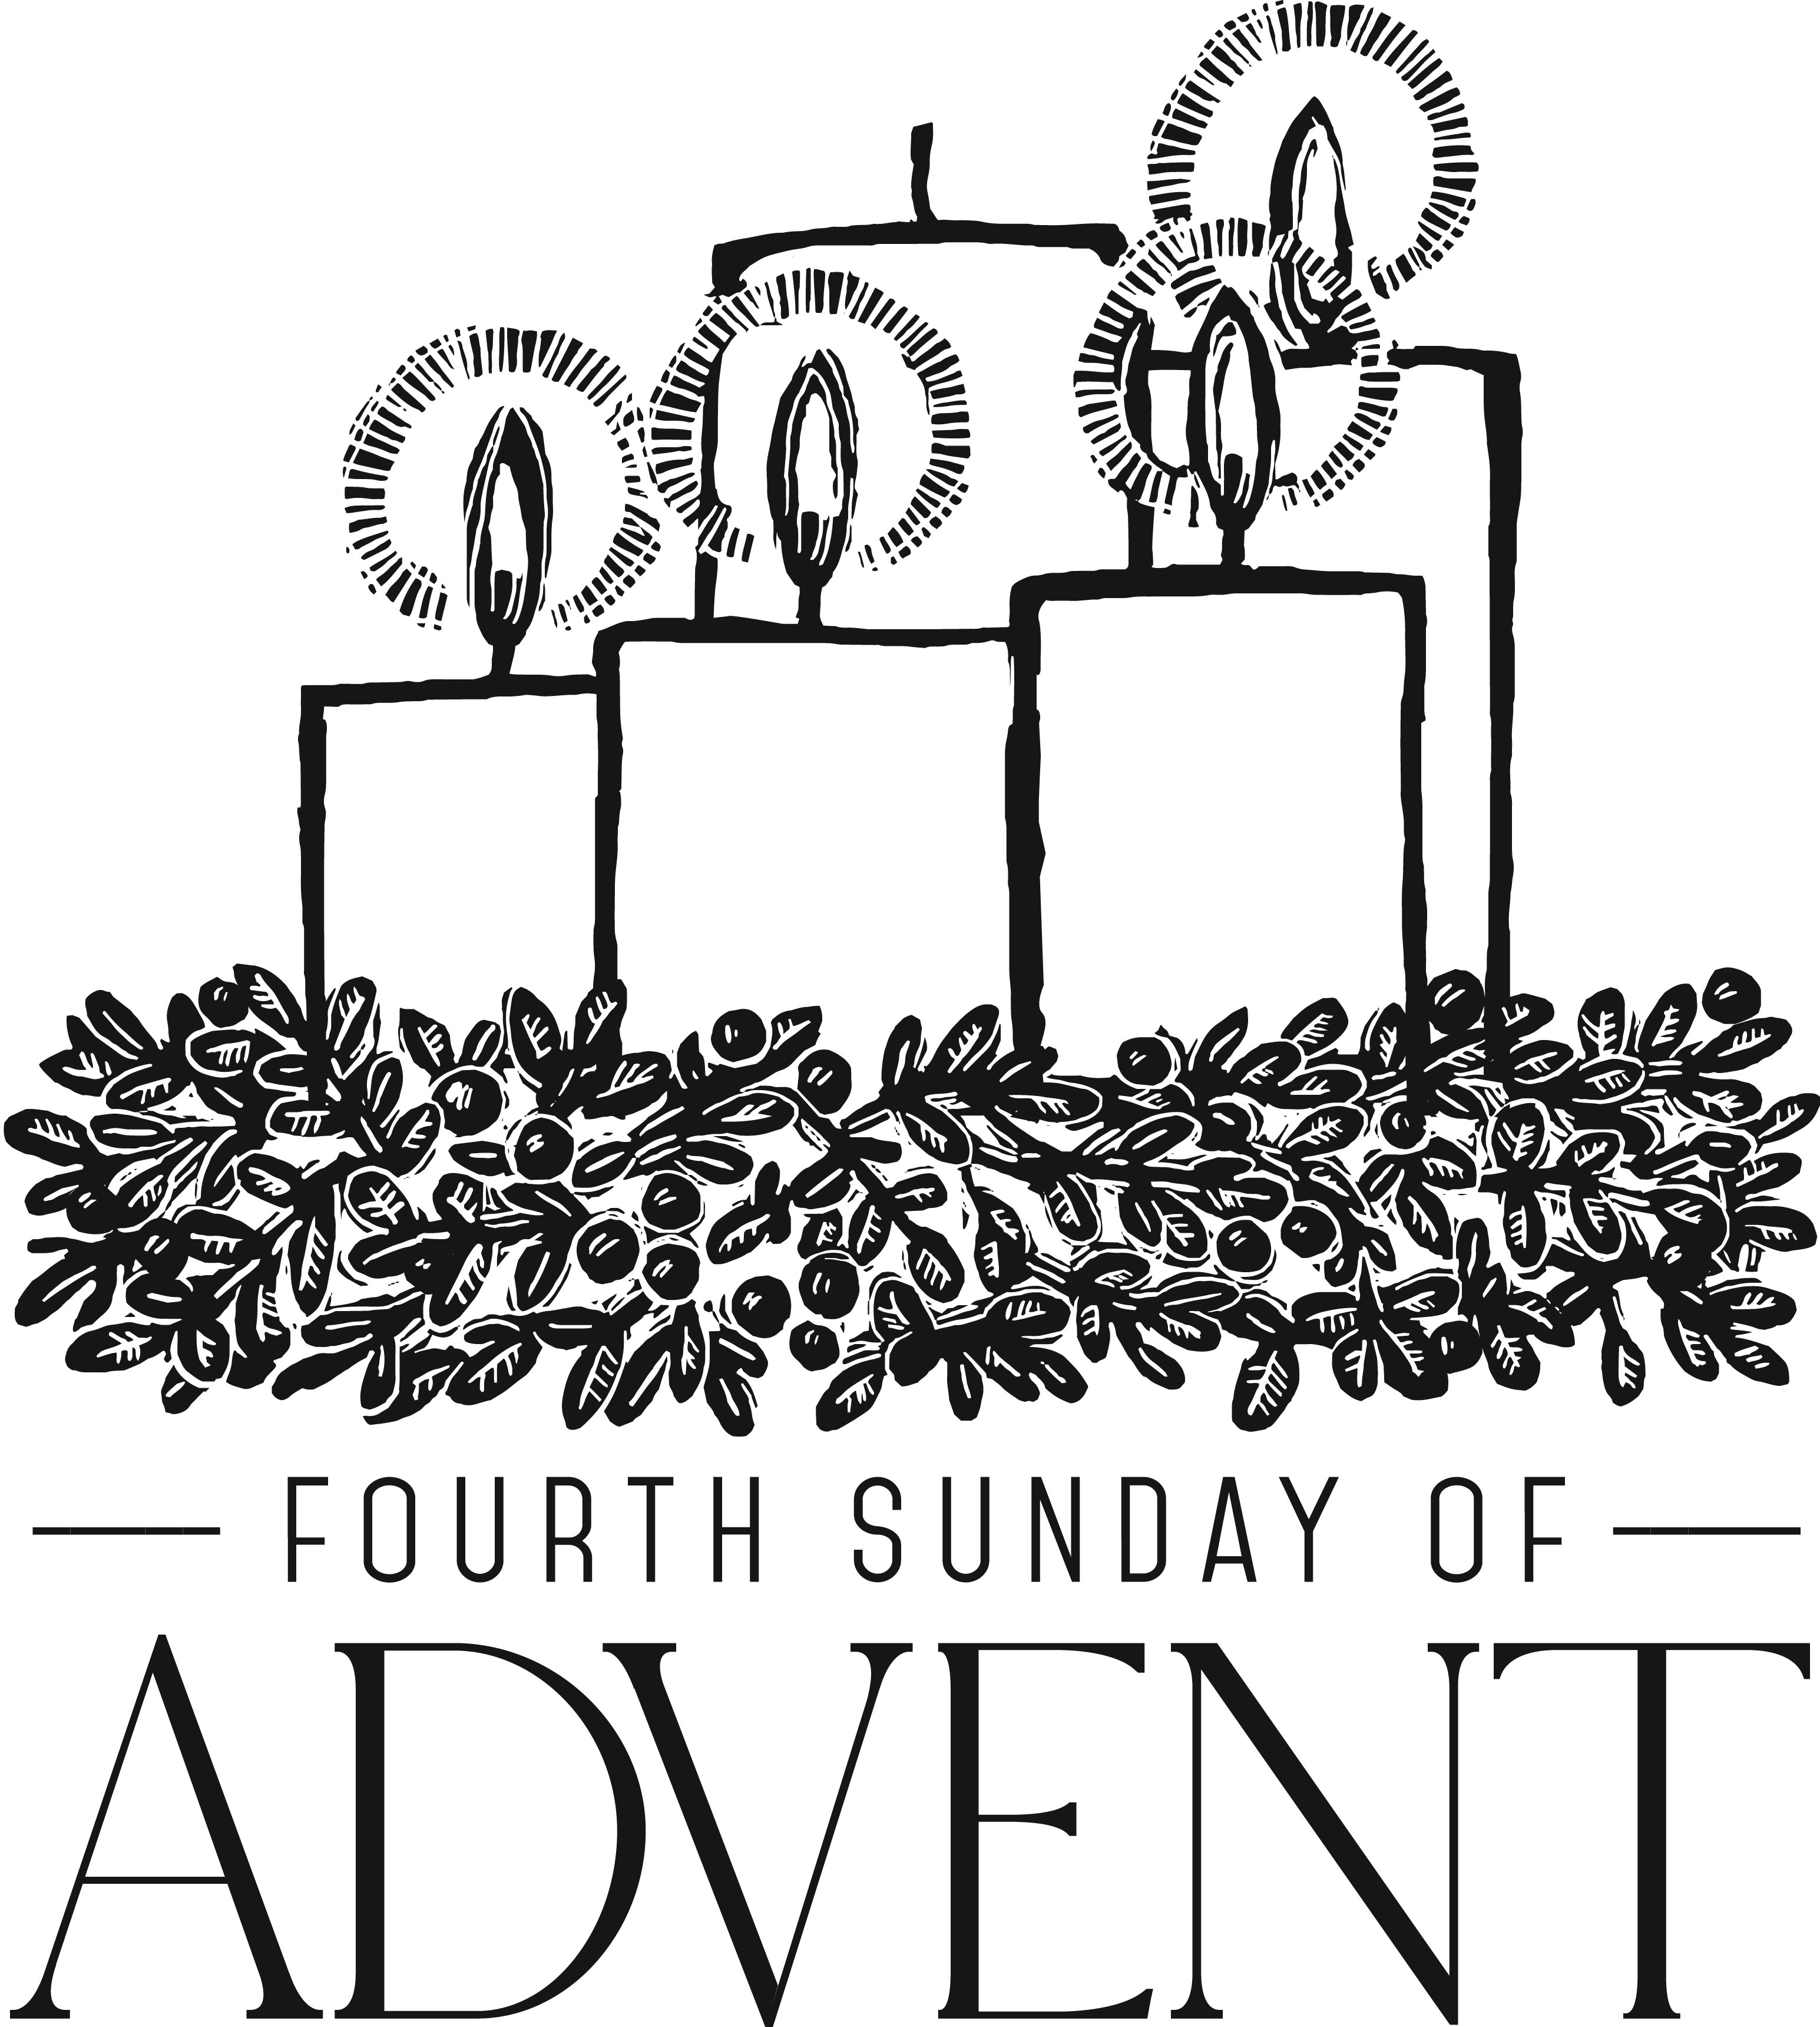

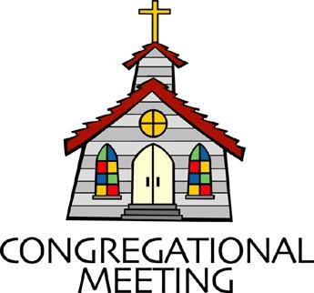
December 23, 2018 - 10:30 am

WELCOME VISITORS! We're glad you are here! Cards at the ends of each pew are for you to fill out and drop in the Offering Plate. Please let us know you are visiting, and join us for refreshments and fellowship following the service. The Sanctuary has an induction loop system to assist the hearing impaired. The system will also work on the telephone setting of hearing aids.

Springfield Presbyterian Church is rooted in the gospel of Jesus Christ, led by the Holy Spirit, and called to loving relationships through vibrant worship and service. Valuing all people, we are committed to developing disciples and fostering stewardship.
PREPARATION FOR THE WORD
(* those who are able are invited to stand)

Please prepare for worship by listening to the music of the Prelude.

PRELUDE O Little Town Medley arr. by D. Clydesdale

GATHERING OF THE PEOPLE

The Lord be with you! And also with you! (Greeting)

ADVENT CANDLE LIGHTING
Advent Reading - Week 4 Love [Psalm 89:1]
The fulfilment of God’s promises were ultimately to be displayed in a kingdom founded on love: “I will sing of your steadfast love, O Lord, forever; with my mouth I will proclaim your faithfulness to all generations.” [H. Ernest Nichol, 1896]

Lighting of the Candle
The darkness shall turn to dawning, and the dawning to noonday bright; and Christ’s great kingdom shall come on earth, the kingdom of love and light.

Congregation joins choir in singing: Light the Candle
Light the candle of LOVE today, the Giver of love is here!
Welcome the love we live and die for, but only Christ can give.
Flicker and flame and glow - with love, light up the world around you.
Flicker and flame and glow - with love, light up the world around you.

CALL TO WORSHIP
Leader: God came near,
People: So that hope could be seen in unexpected places.
Leader: God came near,
People: So peace would take on a whole new meaning.

Leader: God came near,
People: So our joy would be complete.
Leader: God came near,
People: So love would reign.
Leader: For in Christ’s coming,
People: We abide in hope, peace, joy, and love.
ALL: Let us praise our God!

PRAYER OF CONFESSION
Generous God, in our cynicism, we claim that hope is a false reality. In the hectic lives we lead, we no longer sense peace. In the daunting responsibilities of the season, we lose sight of joy. In our own pain, we forget that in Christ, you brought us unconditional love. Forgive us, O God, and realign our hearts to feel hope, peace, joy, and love in a new and brilliant way this Christmas. Amen.

SILENT PRAYERS OF CONFESSION

WORDS OF ASSURANCE
Leader: In this Advent season, we remember that Christ has come to offer us great hope, peace, joy, and love. In Christ’s coming and our repentance, we are made new again!
People: We rejoice in God’s forgiveness, offered as God’s holy gift to us. Praise be to God!

PASTORAL PRAYER AND THE LORD’S PRAYER
“For this I pray to God.” / “For this I give thanks to God.”
Congregational Response: “Hear our prayer, O God.”

CHRISTMAS PAGEANT
Springfield Choir and Youth
Music and Arrangements by Tom Fettke & Narration by Max Lucado

Musical Selections:

God Came Near: Overture
Advent Celebration
Nothing Is Impossible with God
On This Holy Night
The Night Was Ordinary No More
A Child and Yet a King
Magi from the East
The Christmas Gifts
Light and Life

OFFERING
Offering Plates can be found in the Narthex and we greatly appreciate any gift you may offer to show forth hope, peace, joy, and love in Christ to our community and to our world.

* BENEDICTION

* UNISON AMEN

POSTLUDE Hallelujah Chorus by Handel
Congregation Sing-Along

Sunday December 30 Lectionary
1 Samuel 2:18-20, 26; Psalm 148; Colossians 3:12-17; Luke 2:41-52
Assisting in Worship: We appreciate those who serve:

Today 12/23 Christmas Eve 12/24
Sunday Opener Sandy Newsome Jennifer Wise
Greeters & Ushers Jim & Mary Steve & Donna
Rhodes Mazer (8:00 pm)
Lay Leader Christmas Pageant Charlie Sperling (5:30 pm)
Linda Black (8:00 pm)
Sunday School Christmas Pageant N/A
Fellowship Leah & Natalie Halvorson N/A

Christmas Eve Communion Servers:
5:30 pm Service 8:00 pm Service
1. Diana Steppling 1. Don Vasbinder 6. Sharon Pappas
2. Bob Steppling 2. Jim Wise 7. Barbara Nickell
3. Connie Robinson 3. Sue Holmes 8. Ed Newsome
4. Charlie Sperling 4. Diana Steppling 9. Linda Black
5. Bob Rogers

Church Attendance: December 9 - 51 December 16 - 40
Concert - 22

Church Cleaning: Dec. 28, 29 or 30 - Jim & Mary Rhodes

Happy Anniversary! December 27 - Leah & Jeff Halvorson

Happy Birthday! December 31 - Lindsey Mazer

Announcements

Christmas Joy Offering: This offering goes to the Assistance Program of the Board of Pensions for clergy and church workers; Schools and Colleges Equipping Communities of Color; and Leadership Development for People of Color. Please help support our leaders around the globe - past, present, and future. Write “Christmas Joy” on the memo line of your check. Thank you!

SERRV Sale: TODAY after Worship, once again the Mission Committee has arranged for a consignment SERRV sale. Shop SERRV's unique, handcrafted, fair trade items from around the world. Fill your home and kitchen with authentic decor, handmade dishware and stunning handcrafted baskets. Adorn yourself with gorgeous fair trade jewelry, scarves and bags. Indulge in delicious chocolate and fair trade gourmet coffee. Give special fair trade gifts that will impact so many lives. Items sold through SERRV will help to fight poverty and build the communities of impoverished artisans and farmers. These artisans and farmers live in challenging circumstances and work diligently to provide for themselves and their families.

Newsletter Deadline: The deadline for submission of information for the January newsletter is TODAY. Please submit your info to spc.office@verizon.net.

2019 Sunday School: New beginnings! Starting in January, 2019, Sunday School will begin after the sermon. Stay tuned for further information…

Weekly Announcements: If you have an announcement to include with next week’s bulletin, please call the Office at 410-795-6152 or email to spc.office@verizon.net by Wednesday each week.

Prayers & Thanksgivings

~ Prayers of comfort for Belle Vasbinder and her family on the sudden loss of her sister, Janet Sevits, on December 14. The graveside service is planned for December 27 in Somerset, PA, and a memorial service will be held at a later date.
~ Prayers for Mt. Hebron Presbyterian from our Ministry Group.

The Congregational Care team wants to know what YOU or someone you know needs...a visit...a call...a meal. Please contact Diana Steppling or Connie Robinson.

Today:
Sunday December 23 - 4th Sunday of Advent
10:30 am Christmas Pageant

This Week:
Monday December 24 - Christmas Eve
5:30 pm Family Christmas Eve Service
8:00 pm Traditional Christmas Eve Service
11:00 pm Contemplative Christmas Eve Service
Wednesday December 26
No Choir Practices

Looking Ahead:
Sunday December 30
10:30 am Worship & Sunday School
11:30 am Fellowship
Wednesday January 2
6:30 pm Bell Choir Practice
7:45 pm Adult Choir Practice

Office Hours: Tuesday, Wednesday, Friday 9:00 am - 3:00 pm
Springfield Presbyterian Church

10:30 am Worship & Sunday School
11:30 am Fellowship
Website: www.springfield-church.org Church Office: 410-795-6152
Like us on Facebook: www.facebook.com/SpringfieldPresbyterianChurch
Pastor: Rev. Becca Crate
Email: springfieldpastor@gmail.com
Clerk of Session: Sharon Pappas
Minister of Music: Linda Caviglia
Accompanist: Aaron Thacker Organist: Jennifer Wise
Youth Group Coordinators: Charles & Deb Sperling
Sunday School Coordinator: Connie Robinson
Administrative Assistant: Donna Mazer
e-mail: spc.office@verizon.net

