(Large Print)

Springfield Presbyterian Church (USA)
7300 Spout Hill Road, Sykesville, MD 21784 410-795-6152
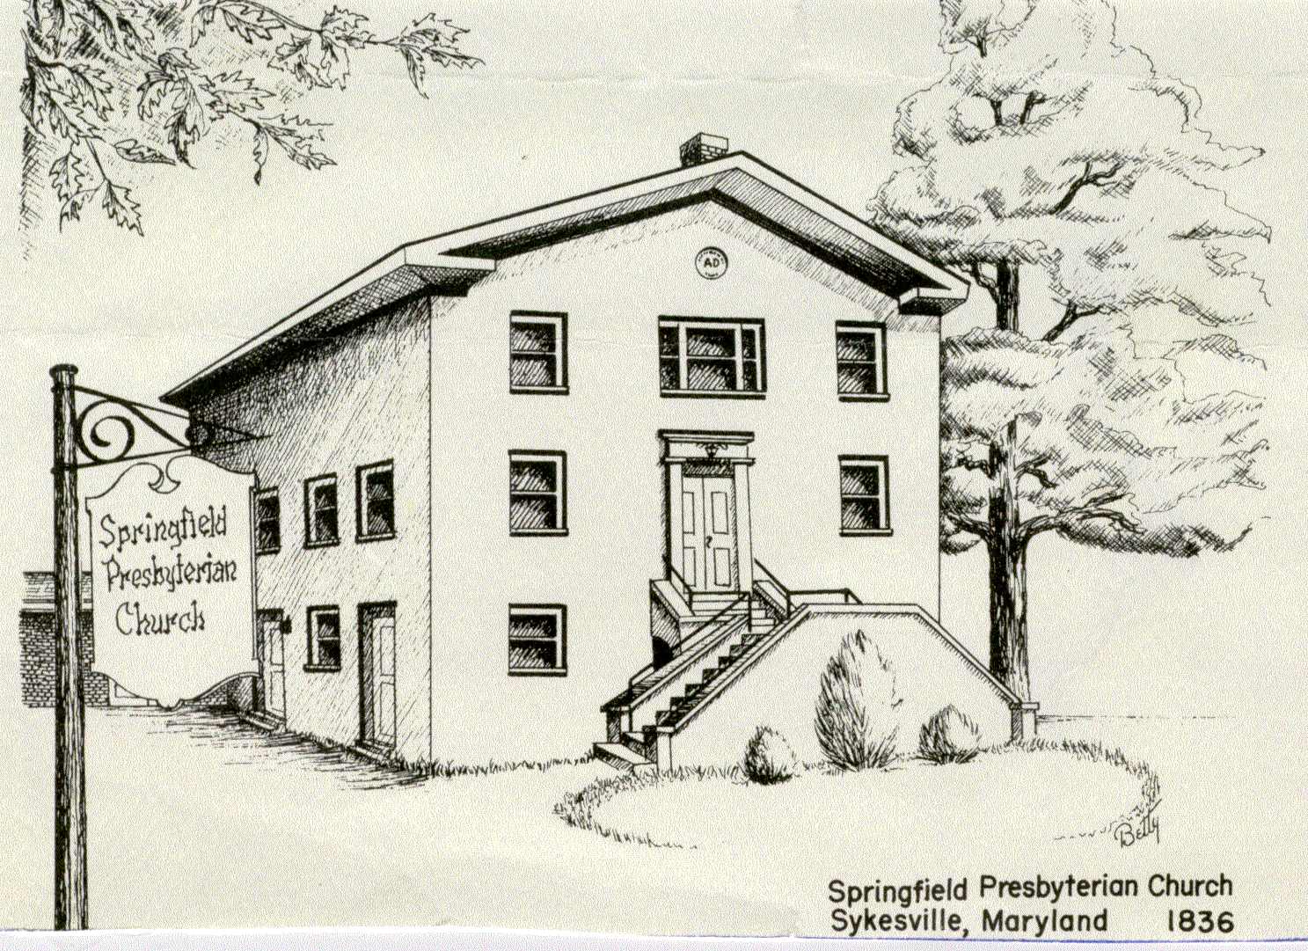

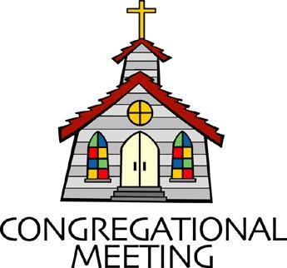
March 19, 2023 - 10:30 am

Palm Sunday, April 2, 2023

WELCOME VISITORS!
We're glad you are here! Cards at the ends of each pew are for you to fill out and drop in the Offering Plate. Please let us know you are visiting, and join us for refreshments and fellowship following the service. The Sanctuary has an induction loop system to assist the hearing impaired. The system will also work on the telephone setting of hearing aids.

Springfield Presbyterian Church is rooted in the gospel of Jesus Christ, led by the Holy Spirit, and called to loving relationships through vibrant worship and service. Valuing all people, we are committed to developing disciples and fostering stewardship.

PREPARATION FOR THE WORD
(* those who are able are invited to stand)

PRELUDE

GATHERING OF THE PEOPLE

The Lord be with you! And also with you!

(Greetings and Announcements)

LIGHTING THE CHRIST CANDLE
Leader: Whenever we light this candle we proclaim:
People: Christ is the Light of the world and the center of our lives.

CHORAL INTROIT Lord, What a Parade!

CALL TO WORSHIP
Leader: Where is Jesus going? Isn’t he from Nazareth?
People: Can anything good come from Nazareth? Or is he headed to Jerusalem?
Leader: Have you ever felt like hope was out of reach?
People: Have you ever wondered, can these bones live?
Leader: Do you think Jerusalem is safe? Does he know that Pilate is here?
People: Where is he going? Does he know the city is dangerous? Does he see the Pharisees watching?
Leader: Is this the one we’ve been waiting for?
Could this be the Messiah?
Leader: We hear the crowds singing, “Hosanna!” Should we lay down our cloaks?
People: Is this the beginning of the end? Should we follow? Should we watch? Should we sing, “Hosanna!”?
All: Let us worship God. Hosanna! Amen.
*HYMN Hosanna, Loud Hosanna #197
1. Hosanna, loud hosanna, the little children sang; through pillared court and temple the joyful anthem rang. To Jesus, who had blessed them, close folded to his breast, the children sang their praises, the simplest and the best.
2. From Olivet they followed mid an exultant crowd, the victor palm branch waving, and chanting clear and loud; the Lord of earth and heaven rode on in lowly state, not scorned that little children should on his bidding wait.
3. “Hosanna in the highest!” That ancient song we sing, for Christ is our Redeemer; the Lord of heaven, our King. O may we ever praise him with heart and life and voice, and in his blissful presence eternally rejoice.

CALL TO CONFESSION
For today’s prayer of confession, we are going to read the Palm Sunday story together. As we read through the story, we will pause to admit the places where we so often and so easily could change the narrative.

So read with me, trusting that no matter what we do or don’t do, this story ends with love. Let us pray.

PRAYER OF CONFESSION [Matthew 21:1-11]
Leader: As they approached Jerusalem and came to Bethphage on the Mount of Olives, Jesus sent two disciples, saying to them, “Go to the village ahead of you, and at once you will find a donkey tied there, with her colt by her. Untie them and bring them to me. If anyone says anything to you, say that the Lord needs them, and he will send them right away.”
People: God, forgive us for the times when we do not trust your word and do not follow where you lead. We long to be the ones who can go into the village ahead of you. Forgive us when we rely on safety.
Leader: This took place to fulfill what was spoken through the prophet: “Say to Daughter Zion, ‘See, your king comes to you, gentle and riding on a donkey and on a colt, the foal of a donkey.”
People: God, forgive us for forgetting that you are always coming toward us. You are drawing near, like a king on a donkey. Help us find you in our midst.
Leader: The disciples went and did as Jesus had instructed them. They brought the donkey and the colt and placed their cloaks on them for Jesus to sit on. A very large crowd spread their cloaks on the road, while others cut branches from the trees and spread them on the road.
People: Creator God, forgive us for the moments when we choose greed over generosity, or when we choose our self-image over our loyalty to you. Give us the courage to be unabashed in our faith. Give us the strength to throw our coats on the ground.
Leader: The crowds that went ahead of him and those that followed shouted, “Hosanna to the Son of David!”. “Blessed is he who comes in the name of the Lord!”. “Hosanna in the highest heaven!”.
People: Son of David, give us the conviction to shout your name from the rooftop. Give us the wisdom to sing, “Hosanna!”
Leader: When Jesus entered Jerusalem, the whole city was stirred and asked, “Who is this?” The crowds answered, “This is Jesus, the prophet from Nazareth in Galilee.”
People: Nothing can separate us from God’s love. We are loved, forgiven, and sent out to serve. Hosanna! Amen.
SILENT PRAYERS OF CONFESSION
RESPONSE O Lord, Hear My Prayer Tune #471 (sing twice)
O Lord, hear my prayer. O Lord, hear my prayer. When I call, answer me.
O Lord, hear my prayer. O Lord, hear my prayer. Come and listen to me.

WORDS OF ASSURANCE
Leader: Family of faith, there will be days when we withhold our praise. There will be days when we dare not follow. There will be days when we ignore God’s call, when we choose comfort over courage, and ourselves over others. But even on those days, even on our worst days, we belong to God. Hear and believe the good news of the Gospel:
People: Nothing can separate us from God’s love. We are loved, forgiven, and sent out to serve. Hosanna! Amen.

* MUSICAL RESPONSE OF PRAISE Come, Thou Almighty King
To thee, great One in Three, eternal praises be, hence evermore!
Thy sovereign majesty may we in glory see, and to eternity love and adore.

* THE PEACE The peace of Christ be with you! And also with you!
(You may greet those around you.)

* RESPONSE Here I Am, Lord
Here I am, Lord, Is it I, Lord? I have heard you calling in the night.
I will go, Lord, if you lead me. I will hold your people in my heart.

THE PROCLAMATION OF THE WORD

PRAYER OF ILLUMINATION
Holy God,
Sometimes it’s hard to hear you over the Hosannas. Sometimes it’s hard to hear you over the noise of city streets. Sometimes it’s hard
to hear you in this noisy world. So just as you stopped traffic in Jerusalem, stop traffic here. Pause the rush. Open the gates. Dwell among us, until your Word is all we can hear. We are listening. We are laying down our cloaks. Amen.
FIRST SCRIPTURE LESSON Matthew 27:11-31 NT pg. 30
Now Jesus stood before the governor, and the governor asked him, “Are you the king of the Jews?” Jesus said, “You say so.” But when he was accused by the chief priests and elders, he did not answer. Then Pilate said to him, “Do you not hear how many accusations they make against you”? But he gave him no answer, not even to a single charge, so that the governor was greatly amazed.

Barabbas or Jesus?
Now at the festival, the governor was accustomed to release a prisoner for the crowd, anyone whom they wanted. At that time they had a notorious prisoner called Barabbas. So after they had gathered, Pilate said to them, “Whom do you want me to release for you, Barabbas or Jesus who is called the Messiah?” For he realized that it was out of jealousy that they had handed him over. While he was sitting on the judgment seat, his wife sent word to him, “Have nothing to do with that innocent man, for today I have suffered a great deal because of a dream about him.” Now the chief priests can the elders persuaded the crowds to ask for Barabbas and to have Jesus killed. The governor again said, “Barabbas.” Pilate said to them, “Then what should I do with Jesus who is called the Messiah?” All of them said, “Let him be crucified!” Then he asked, “Why, what evil has he done?” But they shouted all the more, “Let him be crucified!”

Pilate Hands Jesus Over to Be Crucified
So when Pilate saw that he could do nothing but rather that a riot was beginning, he took some water and washed his hands before the crowd, saying, “I am innocent of this man’s blood; see to it yourselves.” Then the people as a whole answered, “His blood be on us and on our children!” So he released Barabbas for them, and after flogging Jesus he handed him over to be crucified.

The Soldiers Mock Jesus
Then the soldiers of the governor took Jesus into the governor’s headquarters, and they gathered the whole cohort around him. They stripped him and put a scarlet robe on him, and after twisting some thorns into a crown they put it on his head. They put a reed in his right hand and knelt before him and mocked him, saying, “Hail, King of the Jews!” They spat on him and took the reed and struck him on the head. After mocking him, they stripped him of the robe and put his own clothes on him. Then they led him away to crucify him.

SECOND SCRIPTURE LESSON Matthew 27:32-54 NT pg. 32
The Crucifixion of Jesus
As they went out, they came upon a man from Cyrene named Simon; they compelled this man to carry his cross. And when they came to a place called Golgotha (which means Place of a Skull), they offered him wine to drink, mixed with gall, but when he tasted it, he would not drink it. And when they had crucified him, they divided his clothes among themselves by casting lots; then they sat down there and kept watch over him. Over his head they put the charge against him, which read, “This is Jesus, the King of the Jews.”

Then two rebels were crucified with him, one on his right and one on his left. Those who passed by derided him, shaking their heads and saying, “You who would destroy the temple and build it in three days, save yourself! If you are the Son of God, come down from the cross.” In the same way the chief priests also, along with the scribes and elders, were mocking him, saying, “He saved others; he cannot save himself. He is the King of Israel; let him come down from the cross now, and we will believe in him. He trusts in God; let God deliver him now, if he wants to, for he said, ‘I am God’s Son.’” The rebels who were crucified with him also taunted him in the same way.

The Death of Jesus
From noon on, darkness came over the whole land until three in the afternoon. And about three o’clock Jesus cried with a loud voice, “Eli, Eli, lema sabachthani? That is, “My God, why have you forsaken me?” When some of the bystanders heard it, they said, “This man is calling for Elijah.” At once one of them ran and got a sponge, filled it with sour wine, put it on a stick, and gave it to him to drink. But the others said, “Wait, let us see whether Elijah will come to save him.” Then Jesus cried again with a loud voice and breathed his last. At that moment the curtain of the temple was torn in two, from top to bottom. The earth shook, and the rocks were split. The bombs also were opened, and many bodies of the saints who had fallen asleep were raised. After his resurrection they came out of the tombs and entered the holy city and appeared to many. Now when the centurion and those with him, who were keeping watch over Jesus, saw the earthquake and what took place, they were terrified and said, “Truly this man was God’s Son!”

SERMON Where Are You Headed? Rev. Becca Price

THE RESPONSE TO THE WORD

*HYMN When I Survey the Wondrous Cross #223
1. When I survey the wondrous cross on which the Prince of glory died, my richest gain I count but loss, and pour contempt on all my pride.
2. Forbid it, Lord, that I should boast, save in the death of Christ my God; all the vain things that charm me most, I sacrifice them to his blood.
3. See, from his head, his hands, his feet, sorrow and love flow mingled down; did e’er such love and sorrow meet, or thorns compose so rich a crown?
4. Were the whole realm of nature mine, that were a present far too small; love so amazing, so divine, demands my soul, my life, my all.

PASTORAL PRAYER AND OUR LORD’S PRAYER

OFFERTORY Ah, Holy Jesus Arr. Craig Courtney
* SONG OF THANKS Lord of All Good Tune #711
Lord of all good, our gifts we bring to you; use them your holy purpose to fulfill,
Tokens of love and pledges brought anew, that our whole life is offered to your will.
* PRAYER OF DEDICATION

* HYMN What Wonderous Love is This #215

1. What wondrous love is this, O my soul, O my soul, what wondrous love is this, O my soul! What wondrous love is this that caused the Lord of bliss to bear the dreadful curse for my soul, for my soul, to bear the dreadful curse for my soul?
2. When I was sinking down, sinking down, sinking down, when I was sinking down, sinking down, when I was sinking down beneath God’s righteous frown, Christ laid aside his crown for my soul, for my soul, Christ laid aside his crown for my soul!
3. To God and to the Lamb, I will sing, I will sing, to God and to the Lamb, I will sing; to God and to the Lamb who is the great I AM, while millions join the theme, I will sing, I Will sing; while millions join the theme, I will sing!
4. And when from death I’m free, I’ll sing on, I’ll sing on; and when from death I’m free, I’ll sing on; and when from death I’m free, I’ll sing and joyful be, and through eternity, I’ll sing on, I’ll sing on; and through eternity I’ll sing on.

* CHARGE AND BENEDICTION
Leader: As you leave this place, may God bless you with seeking.
People: We will seek out the hungry, the weary, the good in every person we pass.
Leader: Go to seek out the hopeful, the faithful, the God in each of us.
People: We shall seek and wonder.
Leader: And so, may we find what we are looking for. In the name of our loving God, who is always seeking us, let us go in peace. Amen.

* UNISON AMEN
POSTLUDE
Assisting in Worship: We appreciate those who serve:

Today 4/2 Next Week 4/9
Ushers/Greeters: Brenda McClung Beth Oates
Kari Anderson Bob Rogers
Lay Leader: Alex McClung Max Carroll
Church Opener: Ron Holmes Beth Oates

Communion Servers Easter Sunday 4/9/23
1. Barbara Cornell 2. Barbara Nickell 3. Linda Black
4. Sharon Pappas 5. Diana Steppling 6. Bob Steppling
7. Alex McClung 8. Beth Oates 9. Elizabeth M.

Happy Birthday! April 3 – Barbara Cornell
April 3 – India Oates
April 7 – Wes McClung
April 12 – Lisa Rogers
April 13 – Kelsey Robinson
April 15 – Belle Vasbinder
April 19 – Debbie Sperling
April 23 – Morgan Mazer

Sunday April 9, 2023 Lectionary
Acts 10:34-43 or Jer. 31:1-6 and Ps. 118:1-2, 14-24; Col.3:1-4 or Acts 10:34-43; Matt. 28:1-10
Announcements

Today: Begins the “Flowering of the Cross” through Easter

Concert Series: April 16 at 3:00 p.m. featuring our own Aaron Thacker playing Classical Piano.

One Great Hour of Sharing: Our church is a Four for Four church, meaning it receives all four of the special offerings of PC(USA). The first, One Great Hour of Sharing, is received during Lent. With this offering we support rebuilding hope through Presbyterian Disaster Assistance; the growing food insecurity with the Presbyterian Hunger Program; and we partner in progress through the Self-Development of People. Donations go equally to all three programs. As we watch the news, we know the importance of all three of these needs. You may use the separate envelope included in your bulletin, or include a donation with your pledge with a note for OGHS. Or, if you have strong preferences for one of the three programs, you may note on your check how you want it divided. Your gifts will help so many. Thank you.

Comfort Bags: Do you know of anyone who is in need of a little comfort? New comfort bags are now available in the Narthex. Feel free to scoop one up and pass it along to someone in need. “No act of kindness, no matter how small, is ever wasted.” ~ Aesop

Springfield Membership: Are you interested in finding out more about our faith community and becoming a member? We would love to answer any questions you have. Please contact Pastor Becca at springfieldpastor@gmail.com for more information.

Congregational Care / Mission & Outreach (CoCaMO): Do you know of a member or friend of our church family who is ill, needs prayers, would like call, a visit or a card, or might benefit from meal train? If so, please contact the Church Office (410-795-6152), Cathy Marsh (410-549-6916) or Diana Steppling (862-266-2242).

Today:
Sunday April 2
10:30 am Worship
11:30 am Fellowship
This Week:
Monday April 3
7:00 pm Headhuggers
Wednesday April 5
6:15 – 7:15 pm Bell Choir Practice
7:30 – 8:45 pm Adult Choir Practice
Thursday April 6
7:00 p.m. Maundy Thursday Service

Office Hours: Tuesday, Wednesday and Friday, 10:00 am - 3:00 pm
Springfield Presbyterian Church

10:30 am Worship
11:30 am Fellowship
Website: www.springfield-church.org Church Office: 410-795-6152
Like us on Facebook: www.facebook.com/SpringfieldPresbyterianChurch
Pastor: Rev. Becca Price
Email: springfieldpastor@gmail.com
Clerk of Session: Sharon Pappas
Minister of Music: Linda Caviglia
Accompanist/Organist: Aaron Thacker
Youth Group Coordinator: Dylan Vasbinder
Administrative Assistant: Donna Mazer e-mail: spc.office@verizon.net

