(Large Print)

Springfield Presbyterian Church (USA)
7300 Spout Hill Road, Sykesville, MD 21784 410-795-6152
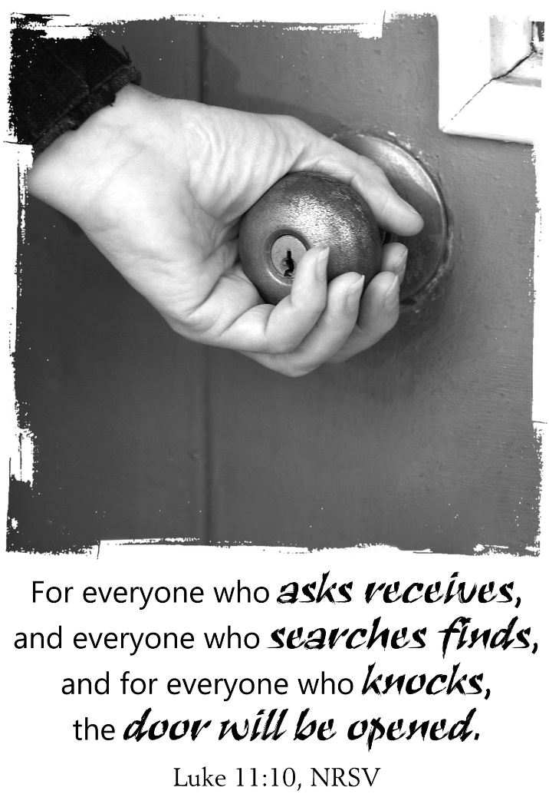

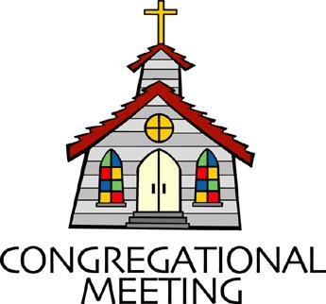
July 28, 2019 - 10:30 am

WELCOME VISITORS! We're glad you are here! Cards at the ends of each pew are for you to fill out and drop in the Offering Plate. Please let us know you are visiting and join us for refreshments and fellowship following the service. The Sanctuary has an induction loop system to assist the hearing impaired. The system will also work on the telephone setting of hearing aids.

Springfield Presbyterian Church is rooted in the gospel of Jesus Christ, led by the Holy Spirit, and called to loving relationships through vibrant worship and service. Valuing all people, we are committed to developing disciples and fostering stewardship.
PREPARATION FOR THE WORD
(* those who are able are invited to stand)

PRELUDE

GATHERING OF THE PEOPLE

The Lord be with you! And also with you! (Greeting)

LIGHTING THE CHRIST CANDLE
Leader: Whenever we light this candle we proclaim:
People: Christ is the Light of the world and the center of our lives.

CALL TO WORSHIP [from Thom Shuman’s “Lectionary Liturgies”]
Leader: It is in this place of holiness that we can come with our fears, our doubts, all the questions of our hearts.
People: We come to this place, to hear the words of peace, of hope, of joy God speaks to us.
Leader: It is in this place of discovery that we can come searching.
People: We come to this place to find the One who has been looking for us.
Leader: It is in this place of openness that we can come knocking.
People: We come to this place, to be embraced by the One whose heart is never locked.

* HYMN Open My Eyes, That I May See

Open my eyes, that I may see glimpses of truth thou hast for me.
Place in my hands the wonderful key that shall unclasp and set me free.
Silently now I wait for thee, ready, my God, thy will to see.
Open my eyes; illumine me, Spirit divine!

Open my ears, that I may hear voices of truth thou sendest clear.
And while the wave notes fall on my ear, everything false will disappear.
Silently now I wait for thee, ready, my God, thy will to see.
Open my ears; illumine me, Spirit divine!

Open my mouth, and let me bear gladly the warm truth everywhere.
Open my heart, and let me prepare love with thy children thus to share.
Silently now I wait for thee, ready, my God, thy will to see.
Open my heart; illumine me, Spirit divine!

PRAYER OF CONFESSION (Unison)
Merciful God, in your gracious presence we confess our sin and the sin of this world. Although Christ is among us as our peace, we are a people divided against ourselves as we cling to the values of a broken world. The profit and pleasures we pursue lay waste the land and pollute the seas. The fears and jealousies that we harbor set neighbor against neighbor and nation against nation. We abuse your good gifts of imagination and freedom, of intellect and reason, and have turned them into bonds of oppression. Lord, have mercy upon us; heal and forgive us. Set us free to serve you in the world as agents of your reconciling love in Jesus Christ. Amen.

SILENT PRAYERS OF CONFESSION

RESPONSE Remember Not, O God
O Lord, our Savior, help, and glorify your name;
Deliver us from all our sins and take away our shame.

WORDS OF ASSURANCE [Isaiah 43:1, 19]
Leader: Do not fear, says the Lord, for I have redeemed you. I have called you by name, you are mine.
People: God is doing a new thing; now it springs forth! By the grace of Jesus Christ we are a forgiven people! Alleluia! Amen.

* MUSICAL RESPONSE OF PRAISE Great Is Thy Faithfulness
Great is thy faithfulness! Great is thy faithfulness! Morning by morning new mercies I see. All I have needed thy hand hath provided. Great is thy faithfulness Lord unto me.

* THE PEACE The peace of Christ be with you! And also with you!
(You may greet those around you.)

* RESPONSE Here I Am, Lord
Here I am, Lord, Is it I, Lord? I have heard you calling in the night.
I will go, Lord, if you lead me. I will hold your people in my heart.

THE PROCLAMATION OF THE WORD

FIRST SCRIPTURE LESSON Psalm 85
¹ Lord, you were favorable to your land; you restored the fortunes of Jacob. ² You forgave the iniquity of your people; you pardoned all their sin. ³ You withdrew all your wrath; you turned from your hot anger.
⁴ Restore us again, O God of our salvation, and put away your indignation towards us. ⁵ Will you be angry with us for ever? Will you prolong your anger to all generations? ⁶ Will you not revive us again, so that your people may rejoice in you? ⁷ Show us your steadfast love, O Lord, and grant us your salvation. ⁸ Let me hear what God the Lord will speak, for he will speak peace to his people, to his faithful, to those who turn to him in their hearts. ⁹ Surely his salvation is at hand for those who fear him, that his glory may dwell in our land. ¹⁰ Steadfast love and faithfulness will meet; righteousness and peace will kiss each other. ¹¹ Faithfulness will spring up from the ground, and righteousness will look down from the sky. ¹² The Lord will give what is good, and our land will yield its increase. ¹³ Righteousness will go before him, and will make a path for his steps.

SECOND SCRIPTURE LESSON Luke 11:1-13
He was praying in a certain place, and after he had finished, one of his disciples said to him, ‘Lord, teach us to pray, as John taught his disciples.’ ²He said to them, ‘When you pray, say: Father, hallowed be your name. Your kingdom come. ³Give us each day our daily bread.
⁴And forgive us our sins, for we ourselves forgive everyone indebted to us. And do not bring us to the time of trial.’ ⁵And he said to them, ‘Suppose one of you has a friend, and you go to him at midnight and say to him, “Friend, lend me three loaves of bread; ⁶for a friend of mine has arrived, and I have nothing to set before him.” ⁷And he answers from within, “Do not bother me; the door has already been locked, and my children are with me in bed; I cannot get up and give you anything.” ⁸I tell you, even though he will not get up and give him anything because he is his friend, at least because of his persistence he will get up and give him whatever he needs. ⁹ ‘So I say to you, Ask, and it will be given to you; search, and you will find; knock, and the door will be opened for you. ¹⁰For everyone who asks receives, and everyone who searches finds, and for everyone who knocks, the door will be opened. ¹¹Is there anyone among you who, if your child asks for a fish, will give a snake instead of a fish? ¹²Or if the child asks for an egg, will give a scorpion? ¹³If you then, who are evil, know how to give good gifts to your children, how much more will the heavenly Father give the Holy Spirit to those who ask him!’

Leader: Hear what the Spirit is saying to the Church.
All: Thanks be to God.

TIME WITH YOUNG PEOPLE

SERMON Unlock the Door Rev. Becca Crate

THE RESPONSE TO THE WORD

* HYMN Our Father, Which Art in Heaven

Our Father, which art in heaven: hallowed-a be thy name.
Thy kingdom come; thy will be done: hallowed-a be thy name.

On earth as it is in heaven: hallowed-a be thy name.
Give us this day our daily bread: hallowed-a be thy name.

And forgive us all our debts: hallowed-a be thy name.
As we forgive our debtors: hallowed-a be thy name.

And lead us not into temptation: hallowed-a be thy name.
But deliver us from evil: hallowed-a be thy name.

For thine is the kingdom, the power, and the glory:
hallowed-a be thy name.
Forever and ever, amen: hallowed-a be thy name.

PASTORAL PRAYER AND THE LORD’S PRAYER
“For this I pray to God.” / “For this I give thanks to God.”
Congregational Response: “Hear our prayer, O God.”

PRESENTATION OF TITHES AND OFFERINGS
OFFERTORY

* SONG OF THANKS As Those of Old Their Firstfruits Brought
In gratitude and humble trust we bring our best today,
To serve your cause and share your love with all along life’s way.
O God who gave yourself to us in Jesus Christ your Son,
Help us to give ourselves each day until life’s work is done.

* PRAYER OF DEDICATION

* HYMN Seek Ye First

Seek ye first the kingdom of God and its righteousness,
And all these things shall be added unto you.
Allelu, alleluia.

Ask, and it shall be given unto you; seek, and you shall find;
Knock, and the door shall be opened unto you.
Allelu, alleluia.

You shall not live by bread alone, but by every word
That proceeds from the mouth of God.
Allelu, alleluia.

* CHARGE AND BENEDICTION
Leader: You have heard the words of peace and hope from God, so go.
People: We will go to speak to those filled with fear and doubt.
Leader: You have been reminded of the One who came looking for us, so go.
People: We will go to search for all tossed aside by the world.
Leader: You have been embraced in the love and grace of the Spirit, so go.
People: We will go to open our hearts to all searching for hope.

* UNISON AMEN

POSTLUDE

Sunday August 4 Lectionary
Hosea 11:1-11; Psalm 107:1-9, 43; Colossians 3:1-11; Luke 12:13-21

Assisting in Worship: We appreciate those who serve:

Today 7/28 Next Week 8/4
Sunday Opener Beth Oates Bob Rogers
Greeters & Ushers Cynthia Smith & Jim Wise &
Amy Vasbinder Connie Robinson
Lay Leader Kathy Russ Tony Caviglia
Children’s Activity Connie Robinson Connie Robinson
Fellowship Connie Gibbons & Jennifer Wise
Cathy Marsh Pancakes!

Church Attendance: July 14 – 37 July 21 - 24

Church Cleaning: August 9, 10 or 11 – Deb & Charlie Sperling

Happy Birthday! July 29 – Elaine Cleland
July 31 – Tim Doyle

Announcements

Town Hall: Join us for a Town Hall in the Sanctuary on Wednesday, August 7 at 7:00 pm to share ideas about how to serve and make a tangible plan on a way to respond to the refugee crisis.

Red Cross Blood Drive: Wesley Freedom United Methodist Church is hosting a Red Cross blood drive on August 10 from 7:30 am to 1pm at 961 Johnsville Road in Eldersburg.

Caregiving: If anyone needs help with caregiving or knows of someone who needs help, Jessica Lane is a certified caregiver and has plenty of references. She can be contacted at 443-789-7204.

Interested in trying out bell ringing? Linda Caviglia is holding introductory bell sessions on August 4, and August 18, 9:15 to 10:00 am. There is a signup sheet on the bulletin board in the Narthex if you are interested (Fall 2019 going into 4th grade and up).

Summer Music for Worship: If you'd like to share some of your musical talents (all levels of accomplishment) over the summer while the choir and bell choir take a rest, we'd love to have you participate. There is a sign-up sheet in the Narthex for each Sunday over the summer. Please talk with Linda Caviglia about your thoughts/plans if you need Aaron to accompany you, or would like some other "backup" music.

Suggestion Box for Aaron: During the prelude and postlude time each Sunday, Aaron (our pianist) plays a wide variety of music for us. He’s asked for suggestions from the congregation on pieces you might like to hear him play, so we’ve put a “suggestion box” in the Narthex. We look forward to getting lots of participation! If you’d like to add a note about why a particular piece speaks to you, that would be added inspiration for Aaron!

Blessing Bags are in the Narthex. Please feel free to pick up a few. Handing one out to someone in need gives you a very real way to meet their immediate needs by providing them with some basic supplies.

Weekly Announcements: If you have an announcement to include with next week’s bulletin, please call the Office at 410-795-6152 or email to spc.office@verizon.net by Wednesday each week.

Prayers & Thanksgivings

~ Continued prayers of healing for Shona Klein who had surgery.
~ Prayers for St. Andrews of Mt. Airy from our Ministry Group.

The Congregational Care team wants to know what YOU or someone you know needs...a visit...a call...a meal. Please contact Diana Steppling or Connie Robinson.

Today:
Sunday July 28
10:30 am Worship
11:30 am Fellowship

This Week:
Thursday August 1 – Saturday August 3
Big Tent - Baltimore

Looking Ahead:
Sunday August 4
10:30 am Worship
11:30 am Fellowship – Pancake Breakfast
Wednesday August 7
7:00 pm Town Hall - Sanctuary

Office Hours: Tuesday, Wednesday, Friday 9:00 am - 3:00 pm

Springfield Presbyterian Church

10:30 am Worship
11:30 am Fellowship
Website: www.springfield-church.org Church Office: 410-795-6152
Like us on Facebook: www.facebook.com/SpringfieldPresbyterianChurch
Pastor: Rev. Becca Crate
Email: springfieldpastor@gmail.com
Clerk of Session: Sharon Pappas
Minister of Music: Linda Caviglia
Accompanist: Aaron Thacker Organist: Jennifer Wise
Youth Group Coordinators: Charles & Deb Sperling
Sunday School Coordinator: Connie Robinson
Administrative Assistant: Donna Mazer
e-mail: spc.office@verizon.net

