Springfield Presbyterian Church (USA)
7300 Spout Hill Road, Sykesville, MD 21784 410-795-6152
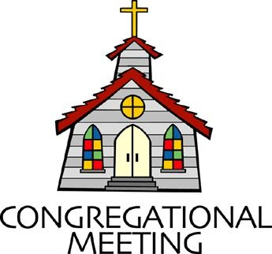

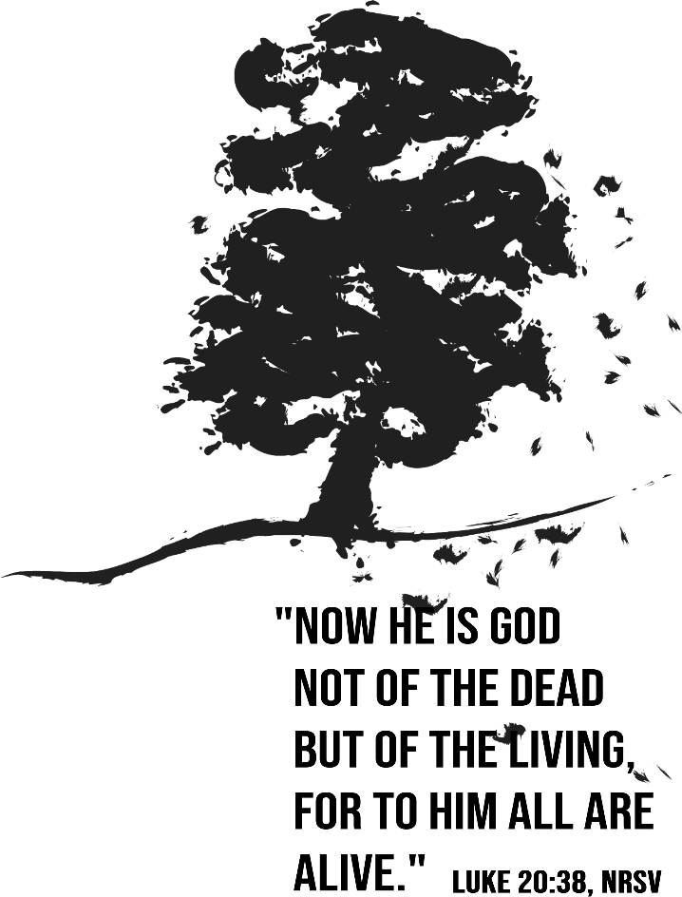

November 9, 2025 - 10:30 am

WELCOME VISITORS!

We're glad you are here! Cards at the ends of each pew are for you to fill out and drop in the Offering Plate. Please let us know you are visiting and join us for refreshments and fellowship following the service. The Sanctuary has an induction loop system to assist the hearing impaired. The system will also work on the telephone setting of hearing aids.

Springfield Presbyterian Church is rooted in the gospel of Jesus Christ, led by the Holy Spirit, and called to loving relationships through vibrant worship and service. Valuing all people, we are committed to developing disciples and fostering stewardship.

PREPARATION FOR THE WORD
(* those who are able are invited to stand)

PRELUDE

GATHERING OF THE PEOPLE

The Lord be with you! And also with you! (Greetings and Announcements)

LIGHTING THE CHRIST CANDLE
Leader: Whenever we light this candle we proclaim:
People: Christ is the Light of the world and the center of our lives.

CALL TO WORSHIP Psalm 48:4-6
Leader: “Make a joyful noise to the Lord, all the earth; break forth into joyous song and sing praises. Sing praises to the Lord with the lyre, with the lyre and the sound of melody. With trumpets and the sound of the horn make a joyful noise before the King, the Lord.” Come, make a joyful noise, sing praises!
All: Come, let us worship the Lord!

* HYMN I Greet Thee, Who My Sure Redeemer Art (v. 1, 4 & 5) GTG #624

I greet thee, who my sure Redeemer art,
my only trust and Savior of my heart,
who pain didst undergo for my poor sake;
I pray thee from our hearts all cares to take.

Thou hast the true and perfect gentleness;
no harshness hast thou and no bitterness.
O grant to us the grace we find in thee,
that we may dwell in perfect unity.

Our hope is in no other save in thee;
our faith is built upon thy promise free;
Lord, give us peace, and make us calm and sure,
that in thy strength we evermore endure.

CALL TO CONFESSION Psalm 145:18
Leader: “The Lord is near to all who call on him, to all who call on him in truth.”
So, with the assurance of God’s presence, with the assurance of God’s steadfast love, with the assurance of God’s overwhelming mercy, let us confess our sins before God and one another.

PRAYER OF CONFESSION
Holy God we come before you a broken people in a broken world. We confess we have ignored, yet again, your assured presence. We have charted our own paths, gone our own ways. We cling to our own understandings. In the name of freedom we have ignored anyone but ourselves. We have ignored your way of help, your presence, your comfort, your peace. We have called upon you when we needed you, in our desperation. We have not recalled your mighty and faithful acts in all of time, in all places. Forgive us. You have been with us in exile and in liberation; be with us even now. Amen.

SILENT PRAYERS OF CONFESSION

RESPONSE Remember Not, O God GTG #430 (v. 1)
Remember not, O God, the sins of long ago;
In tender mercy visit us, distressed and humbled low.

WORDS OF ASSURANCE Psalm 45:17, 19, 21
Leader: “The Lord is just in all his ways and kind in all his doings. He fulfills the desire of all who fear him; he also hears their cry and saves them. My mouth will speak the praise of the Lord, and all flesh will bless his holy name forever and ever.” Just as we confessed with the assurance of God’s presence, steadfast love, and overwhelming mercy, so we also are now assured: in Jesus Christ, we are forgiven.
All: Praise the Lord, and bless God’s holy name forever.

* MUSICAL RESPONSE OF PRAISE How Great Thou Art (refrain only) #625
Then sings my soul, my Savior God, to thee:
How great thou art! How great thou art!
Then sings my soul, my Savior God, to thee:
How great thou art! How great thou art!
* THE PEACE The peace of Christ be with you! And also with you!
(You may greet those around you.)

* RESPONSE Here I Am, Lord GTG #69
Here I am, Lord. Is it I, Lord? I have heard you calling in the night.
I will go, Lord, if you lead me. I will hold your people in my heart.

THE PROCLAMATION OF THE WORD

PRAYER FOR ILLUMINATION
God of wisdom, by your Sprit may your Word be proclaimed, that we may know good news in our hearts and in our minds. May we bear witness to the glory of our Lord Jesus Christ in word and deed. Quiet in us any voice but your own,
that we might hear your Word to us today. Amen.

FIRST SCRIPTURE LESSON Job 19:23-27 OT page 443
²³ O that my words were written down! O that they were inscribed in a book!
²⁴ O that with an iron pen and with lead they were engraved on a rock forever!
²⁵ For I know that my vindicator lives and that in the end he will stand upon the earth; ²⁶ and after my skin has been destroyed, then in my flesh I shall see God,
²⁷ whom I shall see on my side, and my eyes shall behold, and not another. My heart faints within me!

SECOND SCRIPTURE LESSON Luke 20:27-38 NT page 79
²⁷ Some Sadducees, those who say there is no resurrection, came to him ²⁸ and asked him a question: “Teacher, Moses wrote for us that if a man’s brother dies leaving a wife but no children, the man shall marry the widow and raise up children for his brother. ²⁹ Now there were seven brothers; the first married a woman and died childless; ³⁰ then the second ³¹ and the third married her, and so in the same way all seven died childless. ³² Finally the woman also died. ³³ In the resurrection, therefore, whose wife will the woman be? For the seven had married her.” ³⁴ Jesus said to them, “Those who belong to this age marry and are given in marriage, ³⁵ but those who are considered worthy of a place in that age and in the resurrection from the dead neither marry nor are given in marriage. ³⁶ Indeed, they cannot die anymore, because they are like angels and are children of God, being children of the resurrection. ³⁷ And the fact that the

dead are raised Moses himself showed, in the story about the bush, where he speaks of the Lord as the God of Abraham, the God of Isaac, and the God of Jacob. ³⁸ Now he is God not of the dead but of the living, for to him all of them are alive.”

Leader: Hear what the Spirit is saying to the Church.
All: Thanks be to God.

SERMON So Right and So Wrong By Rev. Andrea Taylor

THE RESPONSE TO THE WORD

* HYMN Thine Is the Glory GTG #238

Thine is the glory, risen, conquering Son;
Endless is the victory thou o'er death hast won.
Angels in bright raiment rolled the stone away,
Kept the folded grave-clothes where thy body lay.

Refrain:
Thine is the glory, risen, conquering Son;
Endless is the victory thou o'er death hast won.

Lo! Jesus meets us, risen from the tomb;
Lovingly he greets us, scatters fear and gloom.
Let the church with gladness hymns of triumph sing,
For the Lord now liveth; death hath lost its sting. [Refrain]

No more we doubt thee, glorious Prince of life!
Life is naught without thee; aid us in our strife.
Make us more than conquerors through thy deathless love;
Bring us safe through Jordan to thy home above. [Refrain]

PASTORAL PRAYER AND THE LORD’S PRAYER

PRESENTATION OF TITHES AND OFFERINGS
OFFERTORY
* SONG OF THANKS We Give Thee but Thine Own GTG #708 (v. 1)
We give thee but thine own, what-e’er the gift may be;
All that we have is thine alone, a trust, O Lord, from thee.
* PRAYER OF DEDICATION

* HYMN Sing Praise to God Who Reigns Above GTG #645

Sing praise to God who reigns above, the God of all creation,
The God of power, the God of love, the God of our salvation.
With healing balm my soul is filled, and every faithless murmur stilled: to God all praise and glory!

What God’s almighty power has made God's gracious mercy keepeth;
By morning glow or evening shade God's watchful eye ne'er sleepeth.
Within the kingdom of God's might, lo! all is just and all is right:
To God all praise and glory!

The Lord is never far away, but, through all grief distressing,
An ever-present help and stay, our peace and joy and blessing,
As with a mother's tender hand God gently leads the chosen band:
To God all praise and glory!

Thus all my toilsome way along I sing aloud thy praises,
That all may hear the grateful song my voice unwearied raises.
Be joyful in the Lord, my heart; both soul and body, take your part:
To God all praise and glory!

* CHARGE AND BENEDICTION

* UNISON AMEN

POSTLUDE

Sunday November 16, 2025 Lectionary
Isaiah 65:17-25; Isaiah 12; 2 Thessalonians 3:6-13; Luke 21:5-19

Assisting in Worship: We appreciate those who serve:

Today 11/9 Next Week 11/16
Sunday Opener: Ron Holmes Barbara Cornell
Ushers/Greeters: Steve & Donna Mazer Sharon Pappas
Elizabeth Meirowitz
Lay Leader: Bob Steppling Linda Caviglia
Pulpit Supply: Rev. Andrea Taylor Bob Steppling
Fellowship Hosts: Barbara Nickell Giving Thanks Luncheon
Offering Count: Andrea Kwako & Ron H. Andrea Kwako & Linda C.

Happy Anniversary! November 9 – Morgan (Mazer) & Chris Shackleton
November 9 – Steve & Donna Mazer

Happy Birthday! November 11 – Rebekah Schermer

Announcements

Welcome! We welcome Rev. Andrea Taylor to our pulpit today! Ordained in the Baptist tradition, Andrea and her husband, Scott, worship regularly at 1st Presbyterian of Howard County. They have two young adult bicoastal daughters, in CA and Sykesville, neither of which they see often enough.

Fall Clean-up: Saturday, November 15, 9-11 am. A day for checking the building and grounds for safety and maintenance issues also asks for your help in noting those areas needing attention. We need your help in clearing stairwells, trimming bushes, gathering fallen branches, cleaning the white kickboard before the chancel area and the risers to the loft area, maybe touching up the edges of the white lectern, communion table, and pulpit. Let Ron, Donna or Sharon know of an area needing attention. Bring your tools and work gloves, stay as long as you can!

Congregational Meeting: The Session has called a congregational meeting on Sunday, November 16 after worship to vote on the Dissolution of the Pastoral Relationship with Pastor Becca and that Dissolution Agreement. Copies of those documents will be available at the meeting for you to see and will be visible on Zoom. We will include a time for clarifying questions. Members must be present, in the Sanctuary or on Zoom, to vote.

Our Giving Thanks Stewardship Potluck: November 16 is Stewardship Sunday! We'll celebrate with a potluck lunch. It's a true potluck--bring what you like, as long as you bring yourself--but if you want to tell us what you plan to bring, there is a sign-up sheet. Our table will feature a special dish-- Stone Soup! Following the folktales of this special community soup, we ask you to bring a little something, like a cup or so of chopped veggies, to put into our pot. The pot will simmer while we have our worship service.

It’s Time to Order Christmas Flowers! Attached is the Christmas flower order form. Orders are due by November 18. Extra order forms are available in the Narthex.

Zoom Link for Worship Services: The Zoom link for church services is on the SPC website, not on the Facebook page. The Bulletin is also available on the website as well.

Bible Study - "Together on Tuesday": Rev. Amy Carlson, Mt. Hebron, has offered the zoom link to her Tuesday, 7:30 pm study The Word Became Flesh, a study of John's Gospel. You can email her to be added to the mailing, which she usually emails out on Monday or Tuesday, at amycarlson@mthebronpc.org.

Collecting Pill Bottles: Have you wondered what's the best way to recycle/re-purpose plastic pill bottles? An organization called Matthew 25: Ministries (m25m.org) collects them to send along with donations of medical supplies.
We will have a collection box at Fellowship for several weeks or until we fill it up!
~ Thanks, Barbara Cornell

Congregational Care: If you know of someone who would benefit from a card or a phone call, please text or call Connie Gibbons at 410-935-3467.

Electronic Giving: Below is a QR code you can scan to make your contribution a new way! The page you get will ask for your name, email and phone

number. You can choose from a dropdown menu for selecting where the donation should go: General Fund, Capital Fund, Concert, Memorial. There is a fee for using a credit card, and you will be given the option to pay that fee along with your donation, but you don’t have to include it if you don’t want to.

Today:
Sunday November 9
10:30 am Worship
11:30 am Fellowship

This Week:
Wednesday November 12
6:15 – 7:15 pm Bell Choir Practice
7:30 – 8:45 pm Adult Choir Practice
Thursday November 13
7:00 pm Session Meeting (Manse)
Saturday November 15
9:00 – 11:00 am Fall Clean-up (Church grounds)

Next Week:
Sunday November 16 – Stewardship Sunday
10:30 am Worship
11:30 am Called Congregational Meeting (Sanctuary)
12:00 noon Giving Thanks Stewardship Potluck Luncheon
Tuesday November 18
7:00 pm CoCaMO Meeting (Manse)
Wednesday November 19
6:15 – 7:15 pm Bell Choir Practice
7:30 – 8:45 pm Adult Choir Practice
Saturday November 22
7:00 pm Family Game Night (Fellowship Room)

Office Hours: Tuesday, Wednesday, Friday, 10 am – 3 pm

Springfield Presbyterian Church
10:30 am Worship (and Sunday School 1st & 3rd Sundays)
11:30 am Fellowship
Website: www.springfield-church.org Church Office: 410-795-6152
Like us on Facebook: www.facebook.com/SpringfieldPresbyterianChurch
Pastor: Vacant
Email: spc.office@verizon.net
Clerk of Session: Sharon Pappas
Minister of Music/Accompanist: Aaron Thacker
Bell Choir Director: Vacant
Youth Group Coordinator: Dylan Vasbinder
Administrative Assistant: Donna Mazer Email: spc.office@verizon.net

