Springfield Presbyterian Church (USA)
7300 Spout Hill Road, Sykesville, MD 21784 410-795-6152
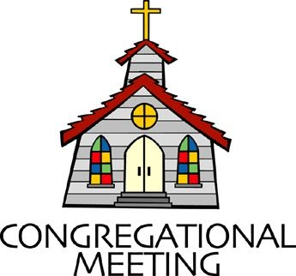

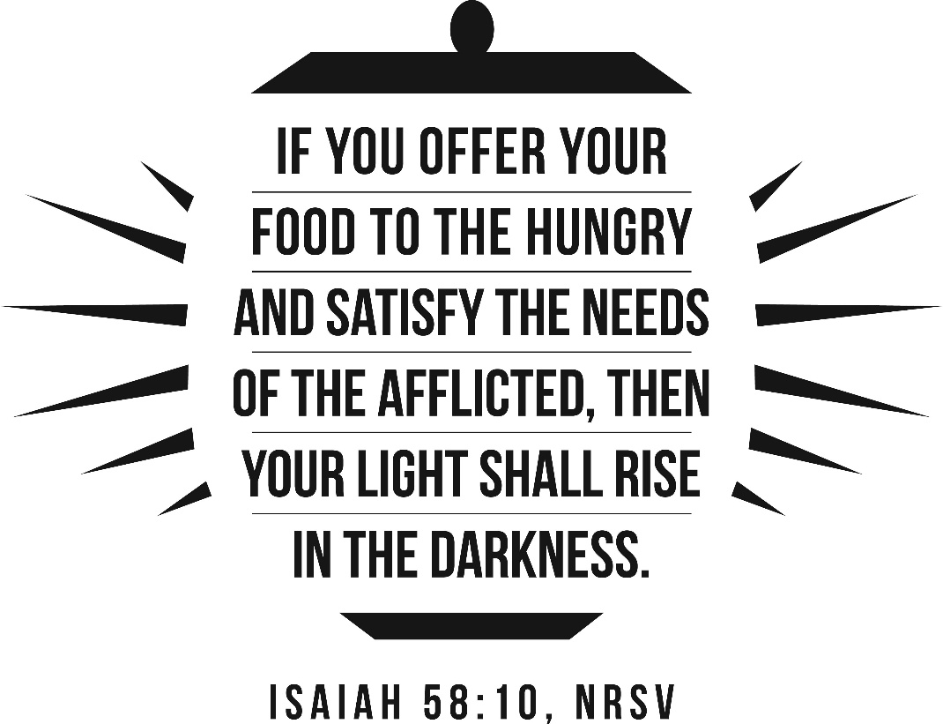

February 8, 2026 - 10:30 am

WELCOME VISITORS!

We're glad you are here! Cards at the ends of each pew are for you to fill out and drop in the Offering Plate. Please let us know you are visiting and join us for refreshments and fellowship following the service. The Sanctuary has an induction loop system to assist the hearing impaired. The system will also work on the telephone setting of hearing aids.

Springfield Presbyterian Church is rooted in the gospel of Jesus Christ, led by the Holy Spirit, and called to loving relationships through vibrant worship and service. Valuing all people, we are committed to developing disciples and fostering stewardship.

PREPARATION FOR THE WORD
(* those who are able are invited to stand)

PRELUDE

GATHERING OF THE PEOPLE

The Lord be with you! And also with you! (Greetings and Announcements)

LIGHTING THE CHRIST CANDLE
Leader: Whenever we light this candle we proclaim:
People: Christ is the Light of the world and the center of our lives.

CALL TO WORSHIP
Leader: Blessed is the name of the Lord from this time on and forevermore.
People: From the rising of the sun to its setting the name of the Lord is to be praised.
Leader: The Lord is high above all nations, and God’s glory above the heavens.
People: Praise the name of the Lord!

* HYMN Praise Ye the Lord, the Almighty GTG #35

Praise ye the Lord, the Almighty, the King of creation!
O my soul, praise him, for he is thy health and salvation!
All ye who hear, now to his temple draw near;
Join me in glad adoration!

Praise ye the Lord, who o'er all things so wondrously reigneth,
Shelters thee under his wings, yea, so gently sustaineth!
Hast thou not seen how thy desires e'er have been
Granted in what he ordaineth?

Praise ye the Lord! O let all that is in me adore him!
All that hath life and breath, come now with praises before him!
Let the amen sound from his people again;
Gladly for aye we adore him.

CALL TO CONFESSION
Leader: As we just sang, we are called to adore God gladly and with our whole being. We have not done that and yet God promises to shelter and sustain us. In that knowledge, let us be bold to confess our sins.

PRAYER OF CONFESSION
Holy and merciful God, in your presence we confess our failure to be what you created us to be. You alone know how often we have sinned in wandering from your ways, in wasting your gifts, in forgetting your love. By your loving mercy, help us to live in your light and abide in your ways, through Jesus Christ our Savior.

SILENT PRAYERS OF CONFESSION

RESPONSE Just as I Am, without One Plea GTG #442 (v. 3)
Just as I am, thou wilt receive, wilt welcome, pardon, cleanse, relieve;
Because thy promise I believe, O Lamb of God, I come; I come!

WORDS OF ASSURANCE
Leader: If we have died with Christ, we believe that we will also live with him. Therefore, consider yourselves dead to sin and alive to God in Jesus Christ.
All: Thanks be to God.

* MUSICAL RESPONSE OF PRAISE We Praise You, O God GTG #612 (v. 3)
With voices united our praises we offer and gladly our songs of thanksgiving we raise.
With you, Lord, beside us, your strong arm will guide us. To you, our great Redeemer, forever be praise!

* THE PEACE The peace of Christ be with you! And also with you!
(You may greet those around you.)

* RESPONSE Here I Am, Lord GTG #69
Here I am, Lord. Is it I, Lord? I have heard you calling in the night.
I will go, Lord, if you lead me. I will hold your people in my heart.

THE PROCLAMATION OF THE WORD

PRAYER OF ILLUMINATION
Gracious God, the words we read are ancient and true. On this day, may we hear them anew. Grant us hearts to discern your Spirit within them, and grant us courage to follow them in our lives this day. Amen.

FIRST SCRIPTURE LESSON Psalm 112:1-10 OT page 532
¹Praise the Lord! Happy are those who fear the Lord, who greatly delight in his commandments. ²Their descendants will be mighty in the land; the generation of the upright will be blessed. ³Wealth and riches are in their houses, and their righteousness endures forever. ⁴They rise in the darkness as a light for the upright; they are gracious, merciful, and righteous. ⁵It is well with those who deal generously and lend, who conduct their affairs with justice. ⁶For the righteous will never be moved; they will be remembered forever. ⁷They are not afraid of evil tidings; their hearts are firm, secure in the Lord. ⁸Their hearts are steady, they will not be afraid; in the end they will look in triumph on their foes. ⁹They have distributed freely, they have given to the poor; their righteousness endures forever; their horn is exalted in honor. ¹⁰The wicked see it and are angry; they gnash their teeth and melt away; the desire of the wicked comes to nothing.

SECOND SCRIPTURE LESSON Isaiah 58:1-11 OT page 647
¹Shout out, do not hold back! Lift up your voice like a trumpet! Announce to my people their rebellion, to the house of Jacob their sins. ²Yet day after day they seek me and delight to know my ways, as if they were a nation that practiced righteousness and did not forsake the ordinance of their God; they ask of me righteous judgments, they delight to draw near to God. ³"Why do we fast, but you do not see? Why humble ourselves, but you do not notice?" Look, you serve your own interest on your fast day, and oppress all your workers. ⁴Look, you fast only to quarrel and to fight and to strike with a wicked fist. Such fasting as you do today will not make your voice heard on high. ⁵Is such the fast that I choose, a day to humble oneself? Is it to bow down the head like a bulrush, and to lie in sackcloth and ashes? Will you call this a fast, a day acceptable to the Lord?
⁶Is not this the fast that I choose: to loose the bonds of injustice, to undo the thongs of the yoke, to let the oppressed go free, and to break every yoke?

⁷Is it not to share your bread with the hungry, and bring the homeless poor into your house; when you see the naked, to cover them, and not to hide yourself from your own kin? ⁸Then your light shall break forth like the dawn, and your healing shall spring up quickly; your vindicator shall go before you, the glory of the Lord shall be your rear guard. ⁹Then you shall call, and the Lord will answer; you shall cry for help, and he will say, Here I am. If you remove the yoke from among you, the pointing of the finger, the speaking of evil, ¹⁰if you offer your food to the hungry and satisfy the needs of the afflicted, then your light shall rise in the darkness and your gloom be like the noonday. ¹¹The Lord will guide you continually, and satisfy your needs in parched places, and make your bones strong; and you shall be like a watered garden, like a spring of water, whose waters never fail.

Leader: Hear what the Spirit is saying to the Church.
All: Thanks be to God.

SERMON God’s Economy By Kathy Welsh Smith

THE RESPONSE TO THE WORD

* HYMN You Are My Strength When I Am Weak GTG #519

You are my strength when I am weak;
You are the treasure that I seek;
You are my all in all.
When I fall down, you pick me up;
When I am dry, you fill my cup;
You are my all in all.
Jesus, Lamb of God, worthy is your name!
Jesus, Lamb of God, worthy is your name!

PASTORAL PRAYER AND THE LORD’S PRAYER

PRESENTATION OF TITHES AND OFFERINGS
OFFERTORY

* SONG OF THANKS For the Life That You Have Given GTG #717
For the life that you have given, for the love in Christ made known,
With these fruits of time and labor, with these gifts that are your own:
Here we offer, Lord, our praises; heart and mind and strength we bring;
Give us grace to love and serve you, living what we pray and sing.
* PRAYER OF DEDICATION

* HYMN Alleluia! Laud and Blessing GTG #755

Alleluia! Laud and blessing to our God, whose Word is sure;
By whose grace we find redemption, in whose love we live secure.
Righteousness and rich compassion shall attend us all our days;
My God’s promise to be faithful echo through our songs of praise!

Alleluia! God sustains us; matchless are the gifts we share:
Light in darkness, hope in conflict, answers to our deepest prayer.
Ours to give as we are given: arms to lift when others fall;
Images of God’s great goodness, faithful servants to God’s call.

Alleluia! Holy Parent, all your children now reclaim;
May our lives reflect your justice, heirs to your most sacred name.
Fill our hearts with understanding, brace our weakness by your might;
Awesome honor, born in wisdom; your great glory, our delight!
* CHARGE AND BENEDICTION
Leader: Go out and live a life this week that reflects God’s justice, love, and provision, given to us to share with all in need. And the Lord will guide you continually, satisfying your needs in parched places, making you like a spring of water that never runs dry.

* UNISON AMEN GTG #601

POSTLUDE

Sunday February 15, 2026 Lectionary
Exodus 24:12-18; Psalm 2; 2 Peter 1:16-21; Matthew 17:1-9
Assisting in Worship: We appreciate those who serve:

Today 2/8 Next Week 2/15
Sunday Opener: Barbara Cornell Beth Oates
Ushers/Greeters: Tim & Beth Oates Sharon Pappas
Connie Gibbons
Lay Leader: Alex McClung Tim Oates
Pulpit Supply: Kathy Welsh Smith Rev. Christa Burns
Fellowship Hosts: Souper Bowl Luncheon

Happy Birthday! February 12 – Megan Anderson

Announcements

Welcome! We welcome Kathy Welsh Smith to our pulpit again today! After a long career in collegiate campus ministry, Kathy made the leap to working in the church in 2017. She most recently served as the Director of Discipleship at Central Presbyterian. Kathy is now a Candidate for Minister of Word and Sacrament and a recent graduate of United Seminary, Twin Cities. She is married to Rob, who works at Loyola University, and together they are the parents of two adult children and the grandparents of the 3 (objectively!) cutest grandsons in the world.

Search Team: At the January Session meeting, a new Search Team was elected to move forward to find us a new pastor. Committee on Ministry member, Guy Moody, met with Session to explain our options. Session chose to follow a new path, Transitional Pastor, designed to move quicker and offer more creative possibilities for the way things might work now. The purpose is to ensure that we have essential pastoral leadership and to guide us in determining our mission and style of leadership to achieve that goal.

The Search Team met twice and learned in more detail how this Transitional Pastor position will work for us. It will allow us to call a Bridge Pastor for up to six months while we design interview questions and advertise. The Search Team will review applications and interview candidates for the Transitional Pastor position. Once a candidate is identified, Session will contract with the selected pastor for 1-2 years with options to renew.

At the last meeting, the Search Team finalized a job description that is now being sent to Committee on Ministry (COM). With their continued guidance, the team will move forward with each step. The pool of candidates is not large and if you know anyone who might be interested, let us know. They need to be an ordained minister PC(USA) or from a denomination with whom PC(USA) is in full communion.

If you have any questions, please contact Bob Steppling at bobsteppling@gmail.com

Search Team: Chair Bob Steppling, Tony Caviglia, Sue Holmes, Steve Mazer, Belle Vasbinder, with Sharon Pappas

Contribution Statements: Contribution statements for the year ending 12/31/25 are available for pickup in the Narthex.

Easter Flowers: Easter comes early this year, so it’s time to start thinking about flower orders! Attached is the order form – orders are due by February 15!

Zoom Link for Worship Services: The Zoom link for church services is on the SPC website, not on the Facebook page. The Bulletin is also available on the website as well.

Congregational Care: If you know of someone who would benefit from a card or a phone call, please text or call Connie Gibbons at 410-935-3467.

Electronic Giving: Below is a QR code you can scan to make your contribution a new way! The page you get will ask for your name, email and phone

number. You can choose from a dropdown menu for selecting where the donation should go: General Fund, Capital Fund, Concert, Memorial. There is a fee for using a credit card, and you will be given the option to pay that fee along with your donation, but you don’t have to include it if you don’t want to.

Today:
Sunday February 8
10:30 am Worship
11:30 am Souper Bowl Luncheon

This Week:
Tuesday February 10
3:30 pm Worship Committee Meeting (Zoom)
Wednesday February 11
6:15 – 7:15 pm Bell Choir Practice
7:30 – 8:45 pm Adult Choir Practice
Thursday February 12
7:00 pm Session Meeting (Manse)

Next Week:
Sunday February 15
10:30 am Worship
11:30 am Fellowship
Tuesday February 17
7:00 pm CoCaMO Meeting (Manse)
Wednesday February 18 – Ash Wednesday
7:00 pm Worship

Office Hours: Tuesday, Wednesday, Friday, 10 am – 3 pm

2026 Easter Flowers
If you would like to order flowers for Easter, please complete
the order form below and drop it off at the office or mail this form and
your payment on or before February 15 to the Church Office at:
Springfield Presbyterian Church, 7314 Spout Hill Road, Sykesville, MD 21784
Please make your check payable to Springfield Presbyterian Church.
You may pick up your Easter flowers after worship service on April 5.
Dutch Asiatic (non-fragrant)
Lillies: | White | Yellow |  |  |  | #_______ |  | @15.95 = __________
(3 stems, multiple blooms)
Tulips: | Yellow | Red |  | Pink |  | #_______ |  | @12.50 = __________
6" pot | (please circle preferred color)
Hyacinths: | Purple | Pink |  | White |  | #_______ |  | @11.95 = __________
6" pot | (please circle preferred color)
(3 blooms)
In Memory of:_______________________________________________________________
In Honor of:_________________________________________________________________
In Appreciation for:_________________________________________________________
Name of Donor:_____________________________________________________________


 |  |  |  |  |  | I would like my
 |  |  |  |  |  | flower to go to
 |  |  |  |  |  | a shut-in:
 |  |  |  |  |  | YES |  | NO

