(Large Print)

Springfield Presbyterian Church (USA)
7300 Spout Hill Road, Sykesville, MD 21784 410-795-6152

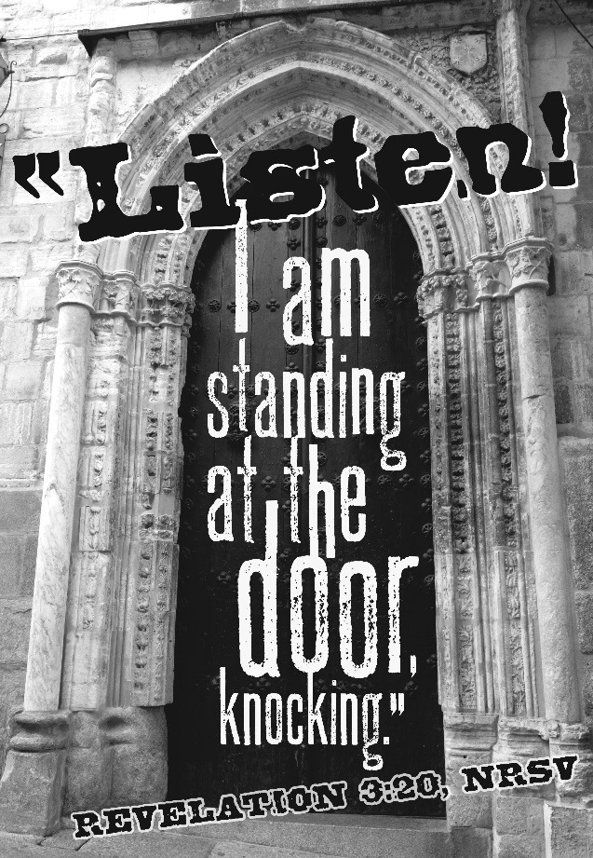

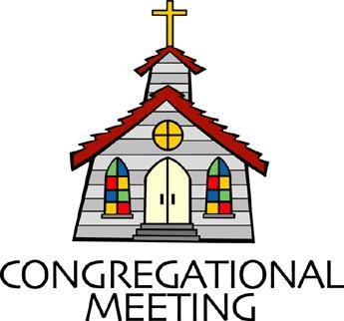
September 12, 2021 - 10:30 am

WELCOME VISITORS! We're glad you are here! Cards at the ends of each pew are for you to fill out and drop in the Offering Plate. Please let us know you are visiting, and join us for refreshments and fellowship following the service. The Sanctuary has an induction loop system to assist the hearing impaired. The system will also work on the telephone setting of hearing aids.

Springfield Presbyterian Church is rooted in the gospel of Jesus Christ, led by the Holy Spirit, and called to loving relationships through vibrant worship and service. Valuing all people, we are committed to developing disciples and fostering stewardship.
PREPARATION FOR THE WORD
(* those who are able are invited to stand)

PRELUDE

GATHERING OF THE PEOPLE

The Lord be with you! And also with you! (Greeting)

LIGHTING THE CHRIST CANDLE
Leader: Whenever we light this candle we proclaim:
People: Christ is the Light of the world and the center of our lives.

CALL TO WORSHIP [Psalm 19:7, 8, 11-13a, 14]
Leader: The law of the Lord is perfect and revives the soul; the testimony of the Lord is sure and gives wisdom to the innocent.,
People: The statutes of the Lord are just and rejoice the heart; the commandment of the Lord is clear and gives light to the eyes.
Leader: By them also is your servant enlightened, and in keeping them is great reward.
People: Can people tell how often they offend? Cleanse me from my secret faults.
Leader: Above all, keep your servant from presumptuous sins; let them not get dominion over me.
People: Let the words of my mouth and the meditation of my heart be acceptable in your sight, O Lord, my strength and my redeemer.
Leader: Praise the Lord.

* HYMN Seek Ye First #175

Seek ye first the kingdom of God and its righteousness,
And all these things shall be added unto you.
Allelu, alleluia.

Ask, and it shall be given unto you; seek, and you shall find;
Knock, and the door shall be opened unto you.
Allelu, alleluia.

You shall not live by bread alone, but by every word
That proceeds from the mouth of God.
Allelu, alleluia.

PRAYER OF CONFESSION (Unison)
Generous and Loving God, you speak to us through the words and deeds of Jesus, the prophets, and the apostles; through words and deeds of those who lessen suffering and work for justice; and through the voices of family, friends and church. Yet we turn away from you when you speak, distracted by false values, empty amusements, and the sounds of our own voices. We have no claim to your mercy, but you are merciful still. Forgive us for wandering from your ways, and for not seeking for you as eagerly as you seek for us. As our ancestors in the faith were bold to say: teach us Lord; lead us in the paths of righteousness. Help us now listen for your voice as we pray in silence.

SILENT PRAYERS OF CONFESSION

RESPONSE Lord Jesus, Think on Me Tune #417
Lord Jesus, think on me, and purge away my sin.
From earth-born passions set me free, and make me pure within.

WORDS OF ASSURANCE
Leader: Like a mother at a wedding reception asking her son to keep the party hopping; like a father who runs down the lane to welcome home a ne’er-do-well son; so our God always seeks us out with the word we need to hear, of forgiveness, challenge and hope.
People: Thanks be to God who in the love of Jesus calls us to be the people we are called to be in Christ. Amen.

* MUSICAL RESPONSE OF PRAISE Glory to God Tune #583
Glory to God, glory to God, glory in the highest!
Glory to God, glory to God, alleluia, alleluia!

* THE PEACE The peace of Christ be with you! And also with you!
(You may greet those around you.)

* RESPONSE Here I Am, Lord
Here I am, Lord, Is it I, Lord? I have heard you calling in the night.
I will go, Lord, if you lead me. I will hold your people in my heart.

THE PROCLAMATION OF THE WORD

PRAYER OF ILLUMINATION
Lord, open our hearts and minds by the power of your Holy Spirit, that as the Scriptures are read and your Word is proclaimed, we may hear with joy what you say to us today. Amen.

FIRST SCRIPTURE LESSON Proverbs 1:20-33
²⁰ Wisdom cries out in the street; in the squares she raises her voice.
²¹ At the busiest corner she cries out; at the entrance of the city gates she speaks: ²² ‘How long, O simple ones, will you love being simple?
How long will scoffers delight in their scoffing and fools hate knowledge? ²³ Give heed to my reproof; I will pour out my thoughts to you; I will make my words known to you. ²⁴ Because I have called and you refused, have stretched out my hand and no one heeded, ²⁵ and because you have ignored all my counsel and would have none of my reproof, ²⁶ I also will laugh at your calamity; I will mock when panic strikes you, ²⁷ when panic strikes you like a storm, and your calamity comes like a whirlwind, when distress and anguish come upon you.
²⁸ Then they will call upon me, but I will not answer; they will seek me diligently, but will not find me. ²⁹ Because they hated knowledge and did not choose the fear of the Lord, ³⁰ would have none of my counsel, and despised all my reproof, ³¹ therefore they shall eat the fruit of their way and be sated with their own devices. ³² For waywardness kills the simple, and the complacency of fools destroys them; ³³ but those who listen to me will be secure and will live at ease, without dread of disaster.’

SECOND SCRIPTURE LESSON Revelation 3:20-22
²⁰Listen! I am standing at the door, knocking; if you hear my voice and open the door, I will come in to you and eat with you, and you with me. ²¹To the one who conquers I will give a place with me on my throne, just as I myself conquered and sat down with my Father on his throne. ²²Let anyone who has an ear listen to what the Spirit is saying to the churches.’
Leader: Hear what the Spirit is saying to the Church.
All: Thanks be to God.

SERMON “Listen!” Rev. Stephen Price-Gibson

THE RESPONSE TO THE WORD

ANTHEM One Voice Ruth Moody
Paul O’Sullivan, guitar

* HYMN God Is Calling through the Whisper #410

God is calling through the whisper of the Spirit’s deepest sighs,
Through the thrill of sudden beauties that can catch us by surprise.
Flash of lightning, crash of thunder; hush the stillness, rush of wonder:
God is calling – can you hear? God is calling – can you hear?

God is calling through the voices of our neighbors’ urgent prayers,
Through their longing for redemption and for rescue from despair.
Place of hurt or face of needing; strident cry or silent pleading:
God is calling – can you hear? God is calling – can you hear?

God is calling through the music of sublime and human arts,
Through the hymns of earth and angels, and the carols of our hearts.
Lift of joy and gift of singing; days and nights our praises bringing:
God is calling – and we hear! God is calling – and we hear!

PASTORAL PRAYER AND THE LORD’S PRAYER

PRESENTATION OF TITHES AND OFFERINGS
* PRAYER OF DEDICATION

* HYMN I Heard the Voice of Jesus Say #182

I heard the voice of Jesus say, “Come unto me and rest;
Lay down, O weary one, lay down your head upon my breast.”
I came to Jesus as I was, so weary, worn, and sad;
I found in him a resting place, and he has made me glad.

I heard the voice of Jesus say, “Behold, I freely give
The living water, thirsty one; stoop down and drink and live.”
I came to Jesus, and I drank of that life-giving stream;
My thirst was quenched, my soul revived, and now I live in him.

I heard the voice of Jesus say, “I am this dark world’s light;
Look unto me, your morn shall rise, and all your day be bright.”
I looked to Jesus, and I found in him my star, my sun;
And in that light of life I’ll walk till traveling days are done.

* CHARGE AND BENEDICTION Ephesians 3:20; 2 Thessalonians 2:18
Leader: Glory to God whose power, working in us, can do infinitely more than we can ask or imagine: Glory to him from generation to generation in the Church, and in Christ Jesus for ever and ever. Amen.
The grace of our Lord Jesus Christ be with you all.
People: Amen.

* UNISON AMEN

POSTLUDE

Assisting in Worship: We appreciate those who serve:

Today 9/12 Next Week 9/19
Sunday Opener Barbara Cornell Beth Oates
Greeters & Ushers Sharon Pappas & Don Vasbinder &
Bob Rogers Charlie Sperling
Lay Leader Don Vasbinder Linda Black
Fellowship Need Volunteer Need Volunteer

Happy Birthday! September 13 – Mark Kearney
September 14 – Linda Caviglia
September 17 – Harrison Rachin

Sunday September 19, 2021 Lectionary
Jeremiah 11:18-20; Psalm 54; James 3:13-4:3, 7-8a; Mark 9:30-37

Announcements

Welcome Reverend Stephen Price-Gibson! Stephen Price-Gibson has recently retired from 40 years of service as a Presbyterian minister. After receiving a degree from Union Theological Seminary in New York, he served as the pastor of churches in New York, Iowa, Pennsylvania, Virginia and Nebraska. He and wife Caroline (also a Presbyterian minister and our guest preacher next Sunday) have two sons, live in Odenton, and are parish associates at Ark and Dove.

Congregational Care / Mission & Outreach: The Congregational Care/Mission & Outreach Committee would like your help. As we emerge from this pandemic, there is a greater than usual need to make every effort to connect with one another. Do you know of a member or friend of our church family who is ill, needs prayers, would like call, a visit or a card, or might benefit from meal train? If so, please contact the Church Office (410-795-6152), Cathy Marsh (410-549-6916) or Diana Steppling (862-266-2242).

Volunteer Opportunities
Looking for a Ride: We have a couple of folks in our Springfield family who need help getting to Church: Louise Clark who lives at Copper Ridge, and Angel Carbaugh who lives near Woodbine. Are you able to assist? Please contact Jennifer Wise at 443-745-7842.
Ruth Gosnell Education Fund (RGEF) Committee: A volunteer is needed to serve on the committee. Meetings are quarterly. If you are interested, please see Amy Vasbinder.
Fellowship Volunteers Needed: If you are interested, please see Barbara Cornell during Fellowship or email her at barbaracornell4@gmail.com.

Weekly Announcements: If you have an announcement to include with next week’s bulletin, please call the Office at 410-795-6152 or email to spc.office@verizon.net by Wednesday to make sure your information gets in.

Blessing Bags are in the Narthex. Please feel free to pick up a few. Handing one out to someone in need gives you a very real way to meet their immediate needs by providing them with some basic supplies.

Today:
Sunday September 12
10:30 am Worship
11:30 am Fellowship

This Week:
Tuesday September 14
7:00 pm Mission & Outreach Meeting (Manse)
Wednesday September 15
6:30 pm Bell Choir Practice
7:45 pm Adult Choir Practice

Looking Ahead:
Sunday September 19
10:30 am Worship
11:30 am Fellowship
Wednesday September 22
6:30 pm Bell Choir Practice
7:45 pm Adult Choir Practice

Office Hours: Tuesday, Wednesday & Friday
Springfield Presbyterian Church

10:30 am Worship
11:30 am Fellowship
Website: www.springfield-church.org Church Office: 410-795-6152
Like us on Facebook: www.facebook.com/SpringfieldPresbyterianChurch
Pastor: Rev. Becca Crate
Email: springfieldpastor@gmail.com
Clerk of Session: Sharon Pappas
Minister of Music: Linda Caviglia
Accompanist: Aaron Thacker Organist: Jennifer Wise
Youth Group Coordinators: Charles & Deb Sperling
Sunday School Coordinator: Connie Robinson
Administrative Assistant: Donna Mazer e-mail: spc.office@verizon.net

