(Large Print)

Springfield Presbyterian Church (USA)
7300 Spout Hill Road, Sykesville, MD 21784 410-795-6152

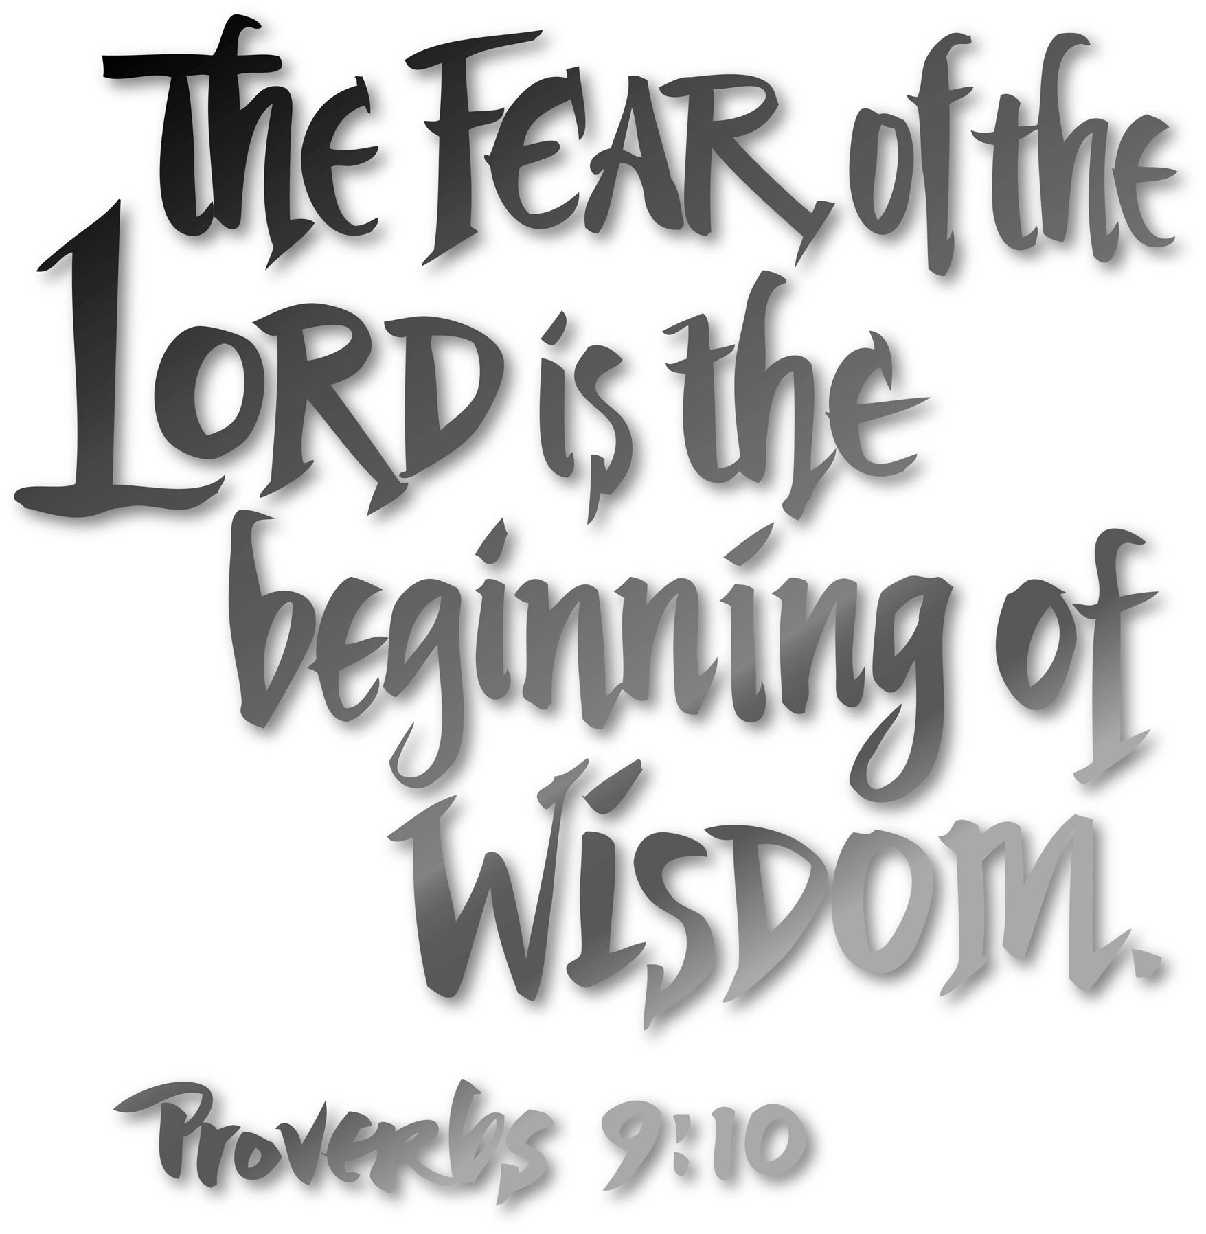

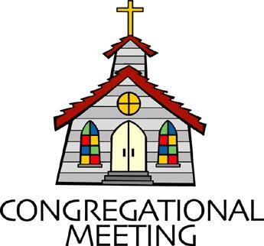
August 19, 2018 - 9:30 am

WELCOME VISITORS! We're glad you are here! Cards at the ends of each pew are for you to fill out and drop in the Offering Plate. Please let us know you are visiting, and join us for refreshments and fellowship following the service. The Sanctuary has an induction loop system to assist the hearing impaired. The system will also work on the telephone setting of hearing aids. A head set is available upon request.

Springfield Presbyterian Church is rooted in the gospel of Jesus Christ, led by the Holy Spirit, and called to loving relationships through vibrant worship and service. Valuing all people, we are committed to developing disciples and fostering stewardship.
PREPARATION FOR THE WORD
(* those who are able are invited to stand)

Please prepare for worship by listening to the music of the Prelude.

PRELUDE

GATHERING OF THE PEOPLE

The Lord be with you! And also with you! (Greeting)

LIGHTING THE CHRIST CANDLE
Leader: Whenever we light this candle we proclaim:
People: Christ is the Light of the world and the center of our lives.

CALL TO WORSHIP [Excerpts from Psalm 37 NRSV]
Leader: Do not fret because of the wicked.
People: Do not be envious of wrongdoers,
Leader: For they will soon fade like the grass,
People: They will wither like the green herb.
Leader: Trust in the Lord, and do good;
People: Live in the Lord’s land, and enjoy security.
Leader: Take delight in the Lord,
People: And He will give you the desires of your heart.
Leader: Commit your way to the Lord;
People: Trust in God, and God will act.
Leader: God will make your vindication shine like the light,
People: The justice of your cause like the noonday.
Leader: The mouths of the righteous utter wisdom,
People: Their tongues speak justice.
Leader: The law of their God is in their hearts;
People: Their steps do not slip.
ALL: Let us praise our faithful God!

* HYMN Guide Me, O Thou Great Jehovah

PRAYER OF CONFESSION
Generous God, you call us to embrace wisdom, to learn and grow, and be transformed by your Spirit. In our efforts to do that, we become distracted, more focused on worldly wisdom than Godly wisdom. We also recognize that you long for us to see you and your work in our everyday lives - when life is good and when life is bad. Yet, we are drawn to the negative, rather than reorienting ourselves to the positive ways you are present in our world. Help us, guide us, O God, to your transforming wisdom and redeem us so that we may see you in all times and all places. We ask for your forgiveness, O God, and seek to embody and embrace your Spirit more, day by day. Amen.

SILENT PRAYERS OF CONFESSION

RESPONSE Kyrie
Lord, have mercy upon us. Christ, have mercy upon us. Lord, have mercy upon us.

WORDS OF ASSURANCE
Leader: The mercy of the Lord is from everlasting to everlasting. In the name of God, we are forgiven.
People: Thanks be to God!

* MUSICAL RESPONSE OF PRAISE How Great Thou Art
Then sings my soul, my Savior God, to Thee, how great Thou art, how great Thou art. Then sings my soul, my Savior God, to Thee, how great Thou art, how great Thou art!

* THE PEACE The peace of Christ be with you! And also with you!
(you may greet those around you)

* RESPONSE Here I Am, Lord
Here I am, Lord, Is it I, Lord? I have heard you calling in the night.
I will go, Lord, if you lead me. I will hold your people in my heart.

THE PROCLAMATION OF THE WORD

FIRST SCRIPTURE LESSON Proverbs 9:1-6
Wisdom has built her house, she has hewn her seven pillars. ² She has slaughtered her animals, she has mixed her wine, she has also set her table. ³ She has sent out her servant-girls, she calls from the highest places in the town, ⁴ ‘You that are simple, turn in here!’ To those without sense she says, ⁵ ‘Come, eat of my bread and drink of the wine I have mixed. ⁶ Lay aside immaturity, and live, and walk in the way of insight.’

SECOND SCRIPTURE LESSON Ephesians 5:15-20
¹⁵Be careful then how you live, not as unwise people but as wise, ¹⁶making the most of the time, because the days are evil. ¹⁷So do not be foolish, but understand what the will of the Lord is. ¹⁸Do not get drunk with wine, for that is debauchery; but be filled with the Spirit, ¹⁹as you sing psalms and hymns and spiritual songs among yourselves, singing and making melody to the Lord in your hearts, ²⁰giving thanks to God the Father at all times and for everything in the name of our Lord Jesus Christ.

Leader: Hear what the Spirit is saying to the Church.
All: Thanks be to God.

TIME WITH YOUNG PEOPLE

SERMON Timely Wisdom Rev. Becca Crate
THE RESPONSE TO THE WORD

* HYMN Immortal, Invisible, God Only Wise

PASTORAL PRAYER AND THE LORD’S PRAYER
“For this I pray to God.” / “For this I give thanks to God.”
Congregational Response: “Hear our prayer, O God.”

PRESENTATION OF TITHES AND OFFERINGS
OFFERTORY
* SONG OF THANKS Doxology
Praise God from whom all blessings flow;
Praise Him, all creatures here below;
Praise Him above, ye heavenly host;
Praise Father, Son and Holy Ghost. Amen.
* PRAYER OF DEDICATION

* HYMN God, Be the Love to Search and Keep Me

* CHARGE AND BENEDICTION
Leader: Help us to grow in your wisdom,
People: So that our days are spent well,
Leader: In acts and deeds that bring your Kingdom closer,
People: And change the world.
Leader: We do all this through and by your Spirit,
People: Who leads us today and in whom we give thanks!

* UNISON AMEN

POSTLUDE

