PREPARATION FOR THE WORD

(* those who are able are invited to stand)

Please prepare for worship by listening to the music of the Prelude.

PRELUDE O Come, O Come, Emmanuel Arr. Sharon Wilson

GATHERING OF THE PEOPLE The Lord be with you! And also with you!
(Greeting)

ADVENT CANDLE LIGHTING
Advent Reading - Love
“Restore us, O God of hosts; let your face shine, that we may be saved. But let your hand be upon the one at your right hand, the one whom you made strong for yourself.
Then we will never turn back from you; give us life, and we will call on your name.
Restore us, O Lord God of hosts; let your face shine, that we may be saved.”
Psalm 80:7, 17-19
Today we light a candle for love. Help us to remember that the greatest gift of all is the gift God gives us in the birth of the baby Jesus. God’s gift of love never disappoints us. Love is the real meaning of Christmas and we can never have too much love! As we light this candle, may we open our lives to God’s great gift of love.

Sung Response (to the tune of Let All Mortal Flesh Keep Silence):
As we light the Advent candle with the light of Love so bright,
Faithfully we wait His coming; faithfully it shines through the night.
In our humble hearts, a fire burns as well;
Hear the prayer these flames would tell.

CALL TO WORSHIP
Leader: Christ was born,
People: So that hope could be seen in unexpected places.
Leader: Christ was born,
People: So peace would take on a whole new meaning.
Leader: Christ was born,
People: So our joy would be complete.

Leader: Christ was born,
People: So love would reign.
Leader: In Christ’s coming,
People: We abide in hope, peace, joy, and love.
ALL: Let us praise our God!

PRAYER OF CONFESSION (Unison)
Generous God, this season, as we await the newborn King, we are called to hope, joy, peace, and love. We recognize that we have not encouraged hope, but rather, we have fallen into cynicism. We see that we have not been joyful, especially on biting cold winter days. We know that we have not shown peace to all, because of the conflict that lies between us. We have not embraced love, when you call us to love our neighbor as ourselves. Forgive us, O God, for not embodying hope, joy, peace, and love. Renew us, restore us, and revive us into the people you call us to be. Amen.

SILENT PRAYERS OF CONFESSION

WORDS OF ASSURANCE
Leader: In this Advent season, we remember that Christ has come to offer us great hope, peace, joy, and love. In Christ’s coming and our repentance, we are made new again!
People: We rejoice in God’s forgiveness, offered as God’s holy gift to us. Praise be to God!

* HYMN Away in a Manger #115

PASTORAL PRAYER AND THE LORD’S PRAYER
“For this I pray to God” / “For this I give thanks to God.”
Congregational Response: “Hear our prayer, O God.”

CHRISTMAS PAGEANT
Springfield Congregation
Poems:

Before the Ice is in the Pools – Emily Dickinson
From Us to You – Anonymous
It’s Christmas Time – Julie Hebert
What Christmas Means – Edarly Edouard
The Ghost of Christmas Decorations Past – Fifi Colston
Christmas – Iris Lane Franklin
The Christmas Star – Julie Hebert
Are You Willing – Henry Van Dyke

MUSICAL RESPONSE Let Your Hearts Make Him Room Arr. Wagner

There’s More to Christmas – Anonymous
A Song Was Heard at Christmas – Timothy Dudley-Smith
The World Was Set Aglow – Kate Summers
What Can I Give Him? – Christina Rossetti
A Christmas Carol for Children – Martin Luther

MUSICAL RESPONSE Light of the Stable Arr. Rhyme

Christmas Carol – Sara Teasdale

OFFERING
Offering Plates can be found in the Narthex and we greatly appreciate any gift you may offer to show forth hope, peace, joy, and love in Christ to our community and to our world.

* HYMN The First Nowell #147
* BENEDICTION

* UNISON AMEN

POSTLUDE Christmas Eve/Sarajevo Arr. Neill/Kinkel
Springfield Presbyterian Church (USA)
7300 Spout Hill Road, Sykesville, MD 21784 410-795-6152
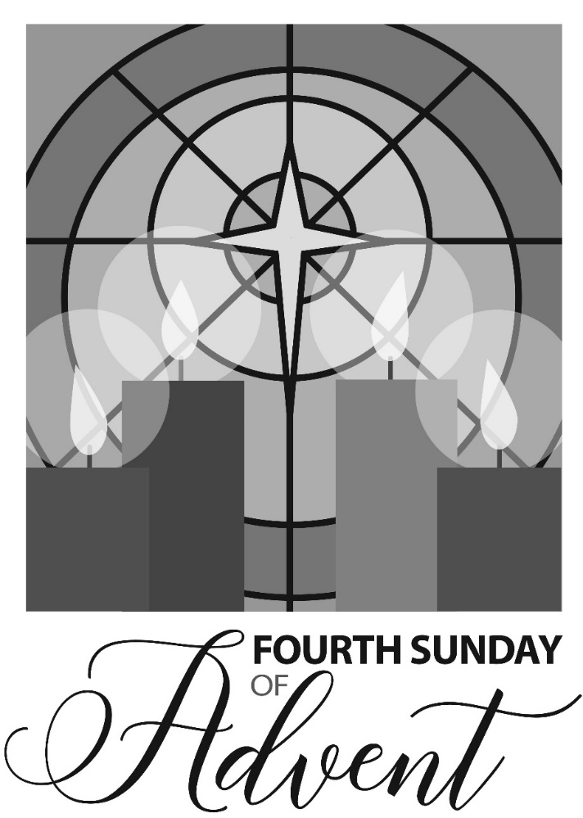

December 22, 2019 - 10:30 am Worship Service & Pageant

WELCOME VISITORS!
We're glad you are here! Cards at the ends of each pew are for you to fill out and drop in the Offering Plate. Please let us know you are visiting, and join us for refreshments and fellowship following the service. The Sanctuary has an induction loop system to assist the hearing impaired. The system will also work on the telephone setting of hearing aids.

Springfield Presbyterian Church is rooted in the gospel of Jesus Christ, led by the Holy Spirit, and called to loving relationships through vibrant worship and service. Valuing all people, we are committed to developing disciples and fostering stewardship.

