Springfield Presbyterian Church (USA)
7300 Spout Hill Road, Sykesville, MD 21784 410-795-6152
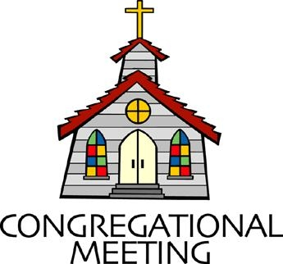

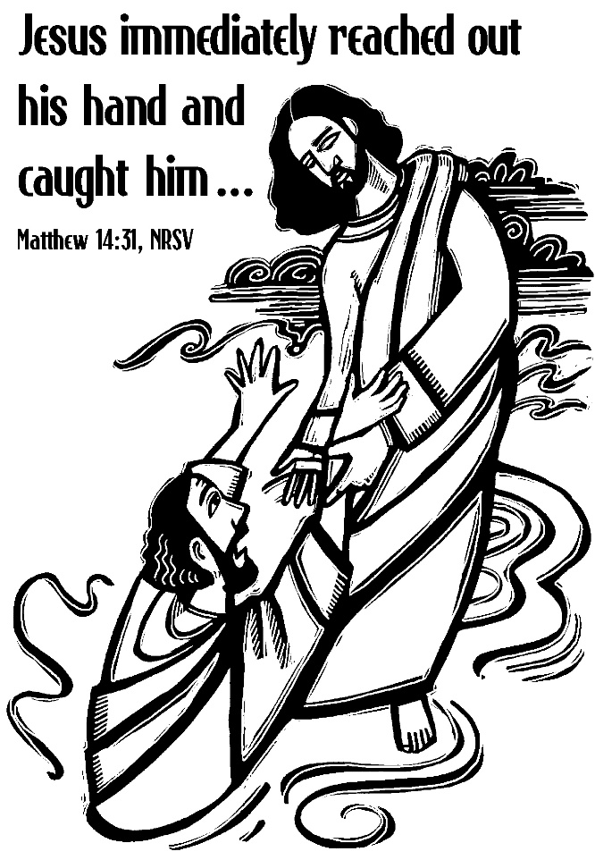

August 9, 2026 - 10:30 am

WELCOME VISITORS!

We're glad you are here! Cards at the ends of each pew are for you to fill out and drop in the Offering Plate. Please let us know you are visiting and join us for refreshments and fellowship following the service. The Sanctuary has an induction loop system to assist the hearing impaired. The system will also work on the telephone setting of hearing aids.

Springfield Presbyterian Church is rooted in the gospel of Jesus Christ, led by the Holy Spirit, and called to loving relationships through vibrant worship and service. Valuing all people, we are committed to developing disciples and fostering stewardship.
PREPARATION FOR THE WORD
(* those who are able are invited to stand)
PRELUDE

GATHERING OF THE PEOPLE

The Lord be with you! And also with you! (Greetings and Announcements)

LIGHTING THE CHRIST CANDLE
Leader: Whenever we light this candle we proclaim:
People: Christ is the Light of the world and the center of our lives.

CALL TO WORSHIP
Leader: We say it out loud together,
All: God is good!
Leader: We say it out loud together,
All: Jesus is Lord!
Leader: We say it out loud together,
All: The Holy Spirit meets us here!
Leader: Let us worship God!

* HYMN How Firm a Foundation GTG #463

How firm a foundation, ye saints of the Lord,
is laid for your faith in God's excellent Word!
What more can be said than to you God hath said,
to you who for refuge to Jesus have fled?

"Fear not, I am with thee, O be not dismayed,
for I am thy God, and will still give thee aid;
I'll strengthen thee, help thee, and cause thee to stand,
upheld by my righteous, omnipotent hand.

"When through the deep waters I call thee to go,
the rivers of sorrow shall not overflow;
for I will be near thee, thy troubles to bless,
and sanctify to thee thy deepest distress.

"When through fiery trials thy pathway shall lie,
my grace, all sufficient, shall be thy supply;
the flame shall not hurt thee; I only design
thy dross to consume, and thy gold to refine.

"The soul that on Jesus hath leaned for repose,
I will not, I will not desert to its foes;
that soul, though all hell should endeavor to shake,
I'll never, no, never, no, never forsake."

CALL TO CONFESSION
Leader: In God’s community, forgiveness and repair are holy works. As we confess together, I invite you to rest your hands with your palms facing up to orient yourself towards receiving God’s love. Let us pray together:

UNISON PRAYER FOR FORGIVENESS
Loving God, thank you for the gift of one another. Thank you for the people who work to make our days better. Forgive us when we do not help one another because people are not just like us, or when we disagree or have hurt feelings. This is when we need your help the most! Give us your grace so we can learn to see the pain we cause, listen, apologize, and love others with the care of Jesus.

SILENT PRAYERS OF CONFESSION

RESPONSE Lord, Jesus, Think on Me GTG #417 (v. 1)
Lord, Jesus, think on me, and purge away my sin.
From earth-born passions set me free, and make me pure within.

WORDS OF ASSURANCE
Heather: Hear the good news: God’s love and mercy heals us when we are hurt and when we have hurt others. In Jesus Christ, we are loved, forgiven, and strengthened to begin again. Thanks be to God, Amen!

* MUSICAL RESPONSE OF PRAISE Praise God, from Whom All Blessings Flow GTG #607
Praise God, from whom all blessings flow; praise Christ, all people here below; praise Holy Spirit evermore; praise Triune God, whom we adore. Amen.

* THE PEACE The peace of Christ be with you! And also with you!
(You may greet those around you.)

* RESPONSE Here I Am, Lord GTG #69
Here I am, Lord. Is it I, Lord? I have heard you calling in the night.
I will go, Lord, if you lead me. I will hold your people in my heart.

THE PROCLAMATION OF THE WORD

PRAYER OF ILLUMINATION
Leader: God our teacher, by your Holy Spirit, open our minds, that as the scriptures are read, and your word is proclaimed, the scales may fall from our eyes, and the light of understanding may shine on us, so that we might walk in your ways and glorify your holy name, for the sake of Jesus Christ our Savior. Amen.

FIRST SCRIPTURE LESSON Psalm 85:8-13 OT page 514
⁸Let me hear what God the Lord will speak, for he will speak peace to his people, to his faithful, to those who turn to him in their hearts. ⁹Surely his salvation is at hand for those who fear him, that his glory may dwell in our land. ¹⁰Steadfast love and faithfulness will meet; righteousness and peace will kiss each other.
¹¹Faithfulness will spring up from the ground, and righteousness will look down from the sky. ¹²The Lord will give what is good, and our land will yield its increase. ¹³Righteousness will go before him, and will make a path for his steps.

TIME FOR ALL GOD’S CHILDREN

GOSPEL LESSON Matthew 14:22-33 NT page 15
²²Immediately he made the disciples get into the boat and go on ahead to the other side, while he dismissed the crowds. ²³And after he had dismissed the crowds, he went up the mountain by himself to pray. When evening came, he was there alone, ²⁴but by this time the boat, battered by the waves, was far from the land, for the wind was against them. ²⁵And early in the morning he came walking toward them on the sea. ²⁶But when the disciples saw him walking on the sea, they were terrified, saying, "It is a ghost!" And they cried out in fear.
²⁷But immediately Jesus spoke to them and said, "Take heart, it is I; do not be afraid." ²⁸Peter answered him, "Lord, if it is you, command me to come to you on the water." ²⁹He said, "Come." So Peter got out of the boat, started walking on the water, and came toward Jesus. ³⁰But when he noticed the strong wind, he became frightened, and beginning to sink, he cried out, "Lord, save me!"
³¹Jesus immediately reached out his hand and caught him, saying to him, "You of little faith, why did you doubt?" ³²When they got into the boat, the wind ceased. ³³And those in the boat worshiped him, saying, "Truly you are the Son of God."

Leader: This is the Word of the Lord. All: Thanks be to God.

SERMON Little Faith By Heather Russell

THE RESPONSE TO THE WORD

* HYMN Come, Thou Font of Every Blessing GTG #475

Come, thou Fount of every blessing; tune my heart to sing thy grace;
Streams of mercy, never ceasing, call for songs of loudest praise.
Teach me some melodious sonnet, sung by flaming tongues above;
Praise the mount! I’m fixed upon it, mount of God’s unchanging love!

Here I raise my Ebenezer; hither by thy help I’m come;
And I hope, by thy good pleasure, safely to arrive at home.
Jesus sought me when a stranger, wandering from the fold of God;
He, to rescue me from danger, interposed his precious blood.

O to grace how great a debtor daily I’m constrained to be!
Let that grace now, like a fetter, bind my wandering heart to thee.
Prone to wander, Lord, I feel it, prone to leave the God I love;
Here’s my heart; O take and seal it; seal it for thy courts above.

PRAYERS OF THE PEOPLE AND THE LORD’S PRAYER
Our Father, who art in heaven, hallowed be thy name, thy kingdom come, thy will be done, on earth as it is in heaven. Give us this day our daily bread; and forgive us our debts, as we forgive our debtors; and lead us not into temptation, but deliver us from evil. For thine is the kingdom, and the power, and the glory, forever, Amen.

PRESENTATION OF TITHES AND OFFERINGS
OFFERTORY
* SONG OF THANKS As Those of Old Their Firstfruits Brought
GTG #712 (v. 3)
In gratitude and humble trust we bring our best today,
To serve your cause and share your love with all along life’s way.
O God who gave yourself to us in Jesus Christ your Son,
Help us to give ourselves each day until life’s work is done.
* PRAYER OF DEDICATION

* HYMN Immortal, Invisible, God Only Wise GTG #12

Immortal, invisible, God only wise, in light inaccessible hid from our eyes,
Most blessed, most glorious, the Ancient of Days,
Almighty, victorious, thy great name we praise.

Unresting, unhasting, and silent as light,
Nor wanting, nor wasting, thou rulest in might:
Thy justice, like mountains high soaring above;
Thy clouds, which are fountains of goodness and love.

To all, life thou givest, to both great and small.
In all life thou livest, the true life of all.
We blossom and flourish like leaves on the tree,
Then wither and perish; but naught changeth thee.

Thou reignest in glory; thou dwellest in light.
Thine angels adore thee, all veiling their sight.
All praise we would render; O help us to see
'Tis only the splendor of light hideth thee!

* CHARGE AND BENEDICTION
Heather: And now, may the peace of God, which passes all understanding, keep your hearts and minds in the knowledge and love of God, and of God’s Son, Jesus Christ our Lord; and the blessing of God almighty, the Father, the Son, and the Holy Spirit, remain with you always. Amen.

* UNISON AMEN GTG #601

POSTLUDE

Some liturgy adapted from Child of Blessing Lectionary Resource, Presbyterian Association of Musicians

Assisting in Worship: We appreciate those who serve:

Today 8/9 Next Week 8/16
Sunday Opener: Ron Holmes Ron Holmes
Ushers/Greeters: Barbara Nickell Steve & Donna Mazer
Ron Holmes
Lay Leader: Alex McClung Tim Oates
Offering Counters: Ron Holmes & Barb N. Beth Oates & Volunteer
Fellowship Hosts: Belle & Don Vasbinder Barbara Nickell

Happy Anniversary! August 10 – Rebekah & Will Schermer
August 16 – Connie & Craig Robinson

Happy Birthday! August 12 – Alaric Schermer
August 16 – Kari Anderson

Sunday, August 16 Lectionary:
Genesis 45:1-15; Psalm 133; Romans 11:1-2a, 29-32; Matthew 15: (10-20) 21-28
Announcements

Sykesville Middle School Supplies: It’s time! Watch out for school supply sales! SPC will once again be collecting items for Sykesville Middle School during the month of August. Year after year, it has been our honor to help these students. The staff and students are always so grateful. Please find the list of needed items on the table in the Narthex. Thank you in advance for your generous donations! ~ CoCaMO

Congregational Care: If you know of someone who would benefit from a card or a phone call, please text or call Diana Steppling at 862-266-2242.

Electronic Giving: Below is a QR code you can scan to make your contribution a new way! The page you get will ask for your name, email and phone

number. You can choose from a dropdown menu for selecting where the donation should go: General Fund, Capital Fund, Concert, Memorial. There is a fee for using a credit card, and you will be given the option to pay that fee along with your donation, but you don’t have to include it if you don’t want to.

Today:
Sunday August 9
10:30 am Worship
11:30 am Fellowship

Next Week:
Sunday August 16
10:30 am Worship
11:30 am Fellowship

Heather’s Summer Office Hours: Tuesday, Wednesday, Friday
8:30 am – 12:00 noon
Monday – Sabbath Day
springfieldpres.pastor@gmail.com
Cell 443-280-9712 (texts welcomed, please identify yourself)


Springfield Presbyterian Church
10:30 am Worship
11:30 am Fellowship
Website: www.springfield-church.org Church Office: 410-795-6152
Like us on Facebook: www.facebook.com/SpringfieldPresbyterianChurch
Ministry Associate: Heather Russell von Marko
Email: springfieldpres.pastor@gmail.com
Clerk of Session: Sharon Pappas
Music Director: Alexander Dudkin
Accompanist: Michael Hall
Bell Choir Director: Robin Kochanski
Administrative Assistant: Donna Mazer
Email: springfieldpres.office@gmail.com

