(Large Print)

Springfield Presbyterian Church (USA)
7300 Spout Hill Road, Sykesville, MD 21784 410-795-6152

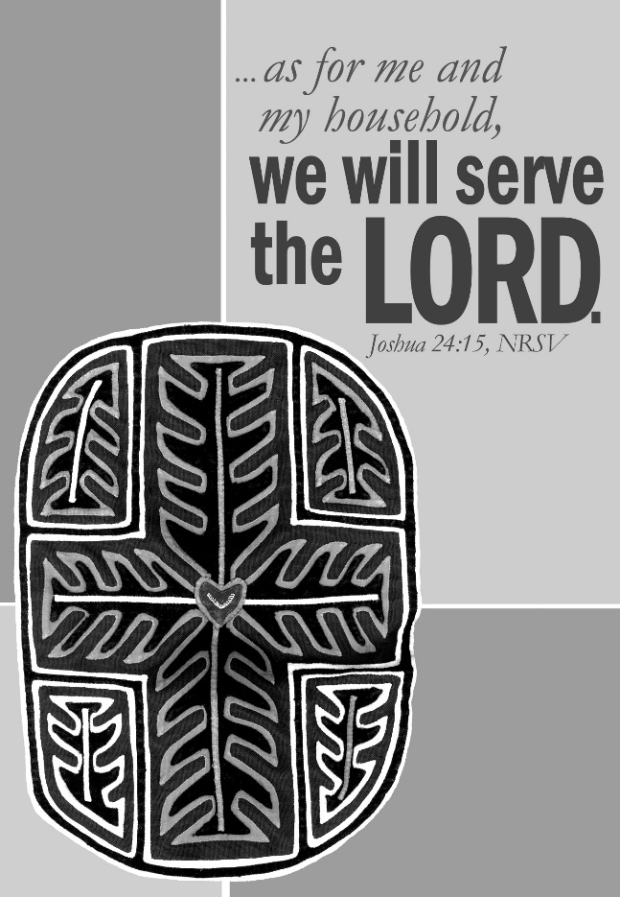

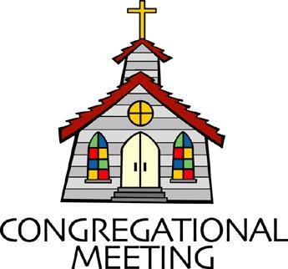
August 22, 2021 - 10:30 am

WELCOME VISITORS! We're glad you are here! Cards at the ends of each pew are for you to fill out and drop in the Offering Plate. Please let us know you are visiting, and join us for refreshments and fellowship following the service. The Sanctuary has an induction loop system to assist the hearing impaired. The system will also work on the telephone setting of hearing aids.

Springfield Presbyterian Church is rooted in the gospel of Jesus Christ, led by the Holy Spirit, and called to loving relationships through vibrant worship and service. Valuing all people, we are committed to developing disciples and fostering stewardship.
PREPARATION FOR THE WORD
(* those who are able are invited to stand)

PRELUDE

GATHERING OF THE PEOPLE

The Lord be with you! And also with you! (Greeting)

LIGHTING THE CHRIST CANDLE
Leader: Whenever we light this candle we proclaim:
People: Christ is the Light of the world and the center of our lives.

CALL TO WORSHIP [Psalm 84]
Leader: How lovely is your dwelling place, O Lord of hosts!
People: My soul longs, indeed it faints for the courts of the Lord; my heart and my flesh sing for joy to the living God.
Leader: Even the sparrow finds a home, and the swallow a nest for herself, where she may lay her young, at your altars, O Lord of hosts, my King and my God.
People: Happy are those who live in your house, ever singing your praise.
Leader: Happy are those whose strength is in you, in whose heart are the highways to Zion.
People: As they go through the valley they make it a place of springs; the early rain also covers it with pools.
Leader: They go from strength to strength; the God of gods will be seen in Zion.
People: O Lord God of hosts, hear my prayer; give ear, O God of Jacob!
Leader: Behold our shield, O God; look on the face of your anointed.

People: For a day in your courts is better than a thousand elsewhere. I would rather be a doorkeeper in the house of my God than live in the tents of wickedness.
Leader: For the Lord God is a sun and shield; He bestows favor and honor. No good thing does the Lord withhold from those who walk uprightly
People: O Lord of hosts, happy is everyone who trusts in you. Amen.

* HYMN This Is My Song #340

This is my song, O God of all nations,
A song of peace for lands afar and mine.
This is my home, the country where my heart is;
Here are my hopes, my dreams, my holy shrine;
But other hearts in other lands are beating
With hopes and dreams as true and high as mine.

My country’s skies are bluer than the ocean,
And sunlight beams on cloverleaf and pine.
But other lands have sunlight too, and clover,
And skies are everywhere as blue as mine.
So hear my song, O God of all the nations,
A song of peace for their land and for mine.

This is my prayer, O Lord of all earth’s kingdoms:
Thy kingdom come; on earth thy will be done.
Let Christ be lifted up till all shall serve him,
And hearts united learn to live as one.
So hear my prayer, O God of all the nations:
Myself I give thee; let thy will be done.

PRAYER OF CONFESSION [MBW]
Merciful God, we confess that we have not loved you with our whole heart. We have failed to be an obedient church. We have not done your will, we have broken your law, we have rebelled against your love. We have not loved our neighbors, and we have refused to hear the cry of the needy. Forgive us, we pray. Free us for joyful obedience; through Jesus Christ our Lord. Amen.

SILENT PRAYERS OF CONFESSION

RESPONSE Spirit of the Living God
Spirit of the living God, fall afresh on me. Spirit of the living God, fall afresh on me. Melt me; mold me; fill me; use me. Spirit of the living God, fall afresh on me.

WORDS OF ASSURANCE [Isaiah 43:1, 19]
Leader: Do not fear, says the Lord, for I have redeemed you. I have called you by name; you are mine.
People: God is doing a new thing; now it springs forth! By the grace of Jesus Christ, we are forgiven! Amen!

* MUSICAL RESPONSE OF PRAISE Great is Thy Faithfulness
Great is thy faithfulness! Great is thy faithfulness! Morning by morning, new mercies I see. All I have needed thy hand hath provided. Great is thy faithfulness, Lord unto me!

* THE PEACE The peace of Christ be with you! And also with you!
(You may greet those around you.)

* RESPONSE Here I Am, Lord
Here I am, Lord, Is it I, Lord? I have heard you calling in the night.
I will go, Lord, if you lead me. I will hold your people in my heart.

THE PROCLAMATION OF THE WORD

PRAYER OF ILLUMINATION
Generous God, you have declared that your kingdom is among us. Open our eyes to see it, our ears to hear it, our hearts to hold it, and our hands to serve it. This we pray in Jesus’ name. Amen.

FIRST SCRIPTURE LESSON Psalm 111
¹ Praise the Lord! I will give thanks to the Lord with my whole heart, in the company of the upright, in the congregation. ² Great are the works of the Lord, studied by all who delight in them. ³ Full of honor and majesty is his work, and his righteousness endures for ever. ⁴ He has gained renown by his wonderful deeds; the Lord is gracious and merciful. ⁵ He provides food for those who fear him; he is ever mindful of his covenant. ⁶ He has shown his people the power of his works, in giving them the heritage of the nations. ⁷ The works of his hands are faithful and just; all his precepts are trustworthy. ⁸ They are established for ever and ever, to be performed with faithfulness and uprightness.
⁹ He sent redemption to his people; he has commanded his covenant for ever. Holy and awesome is his name. ¹⁰ The fear of the Lord is the beginning of wisdom; all those who practice it have a good understanding. His praise endures for ever.

SECOND SCRIPTURE LESSON Joshua 24:1-25
Then Joshua gathered all the tribes of Israel to Shechem, and summoned the elders, the heads, the judges, and the officers of Israel; and they presented themselves before God. ²And Joshua said to all the people, ‘Thus says the Lord, the God of Israel: Long ago your ancestors—Terah and his sons Abraham and Nahor—lived beyond the Euphrates and served other gods. ³Then I took your father Abraham from beyond the River and led him through all the land of Canaan and made his offspring many. I gave him Isaac; ⁴and to Isaac I gave Jacob and Esau. I gave Esau the hill country of Seir to possess, but Jacob and his children went down to Egypt. ⁵Then I sent Moses and Aaron, and I plagued Egypt with what I did in its midst; and afterwards I brought you out. ⁶When I brought your ancestors out of Egypt, you came to the sea; and the Egyptians pursued your ancestors with chariots and horsemen to the Red Sea. ⁷When they cried out to the Lord, he put darkness between you and the Egyptians, and made the sea come upon them and cover them; and your eyes saw what I did to Egypt. Afterwards you lived in the wilderness for a long time. ⁸Then I brought you to the land of the Amorites, who lived on the other side of the Jordan; they fought with you, and I handed them over to you, and you took possession of their land, and I destroyed them before you. ⁹Then King Balak, son of Zippor of Moab, set out to fight against Israel. He sent and invited Balaam son of Beor to curse you, ¹⁰but I would not listen to Balaam; therefore he blessed you; so I rescued you out of his hand. ¹¹When you went over the Jordan and came to Jericho, the citizens of Jericho fought against you, and also the Amorites, the Perizzites, the Canaanites, the Hittites, the Girgashites, the Hivites, and the Jebusites; and I handed them over to you. ¹²I sent the hornet ahead of you, which drove out before you the two kings of the Amorites; it was not by your sword or by your bow. ¹³I gave you a land on which you had not labored, and towns that you had not built, and you live in them; you eat the fruit of vineyards and olive groves that you did not plant. ¹⁴‘Now therefore revere the Lord, and serve him in sincerity and in faithfulness; put away the gods that your ancestors served beyond the River and in Egypt, and serve the Lord. ¹⁵Now if you are unwilling to serve the Lord, choose this day whom you will serve, whether the gods your ancestors served in the region beyond the River or the gods of the Amorites in whose land you are living; but as for me and my household, we will serve the Lord.’
16 Then the people answered, ‘Far be it from us that we should forsake the Lord to serve other gods; ¹⁷for it is the Lord our God who brought us and our ancestors up from the land of Egypt, out of the house of slavery, and who did those great signs in our sight. He protected us along all the way that we went, and among all the peoples through whom we passed; ¹⁸and the Lord drove out before us all the peoples, the Amorites who lived in the land. Therefore we also will serve the Lord, for he is our God.’ ¹⁹But Joshua said to the people, ‘You cannot serve the Lord, for he is a holy God. He is a jealous God; he will not forgive your transgressions or your sins. ²⁰If you forsake the Lord and serve foreign gods, then he will turn and do you harm, and consume you, after having done you good.’ ²¹And the people said to Joshua, ‘No, we will serve the Lord!’ ²²Then Joshua said to the people, ‘You are witnesses against yourselves that you have chosen the Lord, to serve him.’ And they said, ‘We are witnesses.’ ²³He said, ‘Then put away the foreign gods that are among you, and incline your hearts to the Lord, the God of Israel.’ ²⁴The people said to Joshua, ‘The Lord our God we will serve, and him we will obey.’ ²⁵So Joshua made a covenant with the people that day, and made statutes and ordinances for them at Shechem.
Leader: Hear what the Spirit is saying to the Church.
All: Thanks be to God.

SERMON As For Our Households… Rev. Becca Crate

THE RESPONSE TO THE WORD

* HYMN Choose This Day The One You’ll Follow
(to the tune of Infant Holy, Infant Lowly #128)

"Choose this day the one you'll follow! Choose the one to guide your way!"
So a leader told his people as he spoke to them one day.
"Some see other gods and follow;
They put trust in what is hollow.
You must choose whom you'll obey!"

"As for me and those in my house, we'll serve God, and God alone!"
Lord, these words of challenge meet us in our families and our homes.
For the values all around us
Often trouble and confound us.
Can we live as you have shown?

In a world that finds its pleasure in the things that money buys,
We are called to different treasure as we hear your people's cries.
May our families find in serving
Those the world calls undeserving
Bread that truly satisfies.

In a world where recreation tempts our families from the pews,
May we ponder what the faith means as we help our families choose.
By example, are we leading —
Or are other things impeding
How we live your wondrous news?

In a world of war and violence, may we follow Christ each day.
Where oppression meets with silence, may our families act and pray.
May we find in faith and practice
How our homes can be a witness
As we follow Jesus' Way.

Biblical Reference: Joshua 24
Tune: Polish melody ("Infant Holy, Infant Lowly") (MIDI)
Text: Copyright © 2015 by Carolyn Winfrey Gillette. All rights reserved.

THE APOSTLES’ CREED
I believe in God, the Father almighty, maker of heaven and earth,
and in Jesus Christ, his only Son, our Lord; who was conceived by the Holy Ghost, born of the Virgin Mary, suffered under Pontius Pilate, was crucified, dead and buried; he descended into hell; the third day he rose again from the dead; he ascended into heaven, and sitteth on the right hand of God the Father Almighty; from thence he shall come to judge the quick and the dead. I believe in the Holy Ghost; the holy catholic church; the communion of saints; the forgiveness of sins; the resurrection of the body; and the life everlasting. Amen.

PASTORAL PRAYER AND THE LORD’S PRAYER

PRESENTATION OF TITHES AND OFFERINGS
OFFERTORY
* SONG OF THANKS For the Beauty of the Earth (refrain)
Lord of all, to thee we raise this our hymn of grateful praise.
* PRAYER OF DEDICATION

* HYMN Go, My Children, with My Blessing #547

Go, my children, with my blessing, never alone.
Waking, sleeping, I am with you, you are my own.
In my love’s baptismal river I have made you mine forever.
Go, my children, with my blessing, you are my own.

Go, my children, sins forgiven, at peace and pure.
Here you learned how much I love you, what I can cure.
Here you heard my dear Son’s story; here you touched him, saw his glory. Go, my children, sins forgiven, at peace and pure.

Go, my children, fed and nourished, closer to me.
Grow in love and love by serving, joyful and free.
Here my Spirit’s power filled you; here my tender comfort stilled you.
Go, my children, fed and nourished, joyful and free.

* CHARGE AND BENEDICTION
Leader: As for us and our households,
People: We will serve our God alone.
Leader: No longer will we be dismayed,
People: But live into the creed we have proclaimed.
Leader: With joy, as a gathered people,
People: Let us scatter the Word in every place. Amen.

* UNISON AMEN

POSTLUDE

Sunday August 29, 2021 Lectionary
Deut. 4:1-2, 6-9; Psalm 15; James 1:17-27; Mark 7:1-8, 14-15, 21-23
Assisting in Worship: We appreciate those who serve:

Today 8/22 Next Week 8/29
Sunday Opener Bob Rogers Ron Holmes
Greeters & Ushers Kathy Russ & Steve & Donna
Barbara Nickell Mazer
Lay Leader Dylan Vasbinder Sharon Pappas
Fellowship Need Volunteer Need Volunteer

Happy Birthday! August 23 – Robert Doyle
August 27 – Connie Gibbons
August 27 – Aaron Wise
August 28 – Bob Rogers

Announcements

Congregational Care / Mission & Outreach: The Congregational Care/Mission & Outreach Committee would like your help. As we emerge from this pandemic, there is a greater than usual need to make every effort to connect with one another. Do you know of a member or friend of our church family who is ill, needs prayers, would like call, a visit or a card, or might benefit from meal train? If so, please contact the Church Office (410-795-6152), Cathy Marsh (410-549-6916) or Diana Steppling (862-266-2242).

Volunteer Opportunities
Looking for a Ride: We have a couple of folks in our Springfield family who need help getting to Church: Louise Clark who lives at Copper Ridge, and Angel Carbaugh who lives near Woodbine. Are you able to assist? Please contact Jennifer Wise at 443-745-7842.
Ruth Gosnell Education Fund (RGEF) Committee: A volunteer is needed to serve on the committee. Meetings are quarterly. If you are interested, please see Amy Vasbinder.
Fellowship Volunteers Needed: If you are interested, please see Barbara Cornell during Fellowship or email her at barbaracornell4@gmail.com.

Weekly Announcements: If you have an announcement to include with next week’s bulletin, please call the Office at 410-795-6152 or email to spc.office@verizon.net by Wednesday to make sure your information gets in.

Blessing Bags are in the Narthex. Please feel free to pick up a few. Handing one out to someone in need gives you a very real way to meet their immediate needs by providing them with some basic supplies.

Office Hours: Tuesday, Wednesday & Friday
Springfield Presbyterian Church

10:30 am Worship
11:30 am Fellowship
Website: www.springfield-church.org Church Office: 410-795-6152
Like us on Facebook: www.facebook.com/SpringfieldPresbyterianChurch
Pastor: Rev. Becca Crate
Email: springfieldpastor@gmail.com
Clerk of Session: Sharon Pappas
Minister of Music: Linda Caviglia
Accompanist: Aaron Thacker Organist: Jennifer Wise
Youth Group Coordinators: Charles & Deb Sperling
Sunday School Coordinator: Connie Robinson
Administrative Assistant: Donna Mazer e-mail: spc.office@verizon.net

