(Large Print)

Springfield Presbyterian Church (USA)
7300 Spout Hill Road, Sykesville, MD 21784 410-795-6152

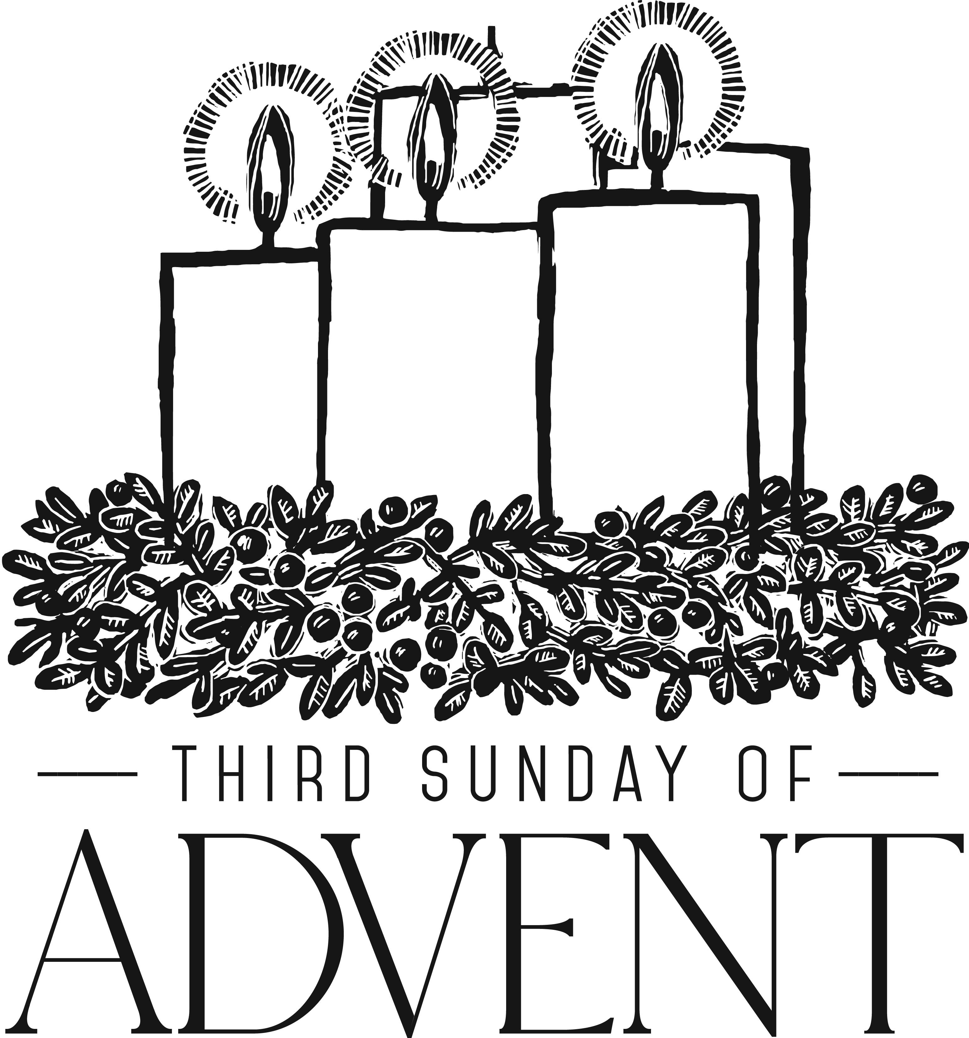

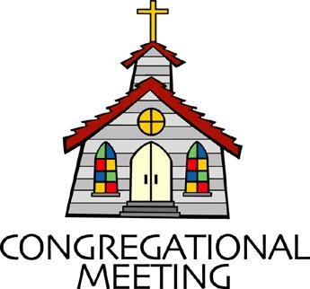
December 16, 2018 - 10:30 am

WELCOME VISITORS! We're glad you are here! Cards at the ends of each pew are for you to fill out and drop in the Offering Plate. Please let us know you are visiting, and join us for refreshments and fellowship following the service. The Sanctuary has an induction loop system to assist the hearing impaired. The system will also work on the telephone setting of hearing aids.

Springfield Presbyterian Church is rooted in the gospel of Jesus Christ, led by the Holy Spirit, and called to loving relationships through vibrant worship and service. Valuing all people, we are committed to developing disciples and fostering stewardship.
PREPARATION FOR THE WORD
(* those who are able are invited to stand)

Please prepare for worship by listening to the music of the Prelude.

PRELUDE

GATHERING OF THE PEOPLE

The Lord be with you! And also with you! (Greeting)

ADVENT CANDLE LIGHTING
Advent Reading - Week 3 Joy [Luke 2:9b-12]
The Messiah’s coming was punctuated by joy: “The angel said to the shepherds, ‘Do not be afraid; for see – I am bringing you good news of great joy for all the people; to you is born this day in the city of David a Savior, who is the Messiah, the Lord. This will be a sign for you; you will find a child wrapped in bands of cloth and lying in a manger.”

Lighting of the Candle
Joy to the world! The Lord is come; let earth receive her King!

Congregation joins choir in singing: Light the Candle
Light the candle of JOY today, the Giver of joy is here!
Welcome the joy we crave and pray for, but only Christ can give.
Flicker and flame and glow - with joy, light up the world around you.
Flicker and flame and glow - with joy, light up the world around you.

CALL TO WORSHIP [Based upon Isaiah 12:2-6]
Leader: Surely God is our salvation; we will trust, and we will not be afraid,
People: For the Lord God is our strength and our might; He has become our salvation.

Leader: With joy we draw waters from the wells of salvation, and we say:
People: Give thanks to the Lord,
Leader: Let us call on His name!
People: Let us make known His deeds among the nations;
Leader: Let us proclaim that His name is exalted.
People: Sing praises to the Lord, for He has done gloriously;
Leader: Let it be known to all the earth!
People: Shout aloud and sing for joy, for great in your midst is the Holy One!
ALL: Let us, with joy, worship our God!

* HYMN For You, O Lord, My Soul in Stillness Waits

Refrain:
For you, O Lord, my soul in stillness waits; truly my hope is in you.

O Lord of Light, our only hope of glory,
Your radiance shines in all who look to you;
Come, light the hearts of all in dark and shadow. (Refrain)

O Spring of Joy, rain down upon your spirits;
Our thirsty hearts are yearning for your word;
Come, make us whole, be comfort to our hearts. (Refrain)

O Root of Life, implant your seed within us,
And in your advent, draw us all to you,
Our hope reborn in dying and in rising. (Refrain)

O Key of Knowledge, guide us in our pilgrimage;
We ever seek, yet unfulfilled remain;
Open to us the pathway of your peace. (Refrain)

Come, let us bow before the God who made us;
Let every heart be opened to the Lord,
For we are all the people of God’s hand. (Refrain)

Here we shall meet the Maker of heavens,
Creator of the mountains and the seas,
Lord of the stars, and present to us now. (Refrain)

PRAYER OF CONFESSION
Generous God, joy can sound like a foreign concept, for we are a people who live in fear. The anxieties of the world trouble us. We are worried you will leave us and your presence won’t hold us. We are anxious about natural disasters and political ramifications. We fear that we are powerless, that our hands are weak and powerless. We have forgotten that you say to us, ‘do not be afraid’, so we stand idle in fear. Help us, O God, to gather our faithfulness, to learn to trust in you, and bring our uncertainties to you in prayer. Rather than live a life of fear, may you call us to joy, again and again. Forgive us, renew us, and refocus us on a life of abundance of hope, peace, joy, and love. Amen.

SILENT PRAYERS OF CONFESSION

RESPONSE O Little Town of Bethlehem (verse 3)
How silently, how silently, the wondrous gift is given!
So God imparts to human hearts the blessings of His heaven.
No ear may hear His coming, but in this world of sin,
Where meek souls will receive Him, still the dear Christ enters in.

WORDS OF ASSURANCE
Leader: In this Advent season, we remember that Christ has come to offer us great hope, peace, joy, and love. In Christ’s coming and our repentance, we are made new again!

People: We rejoice in God’s forgiveness, offered as God’s holy gift to us. Praise be to God!

* MUSICAL RESPONSE OF PRAISE Angels, from the Realms of Glory
All creation, join in praising God the Father, Spirit, Son,
Ever more your voices raising to the eternal Three in One:
Come and worship, come and worship, worship Christ the newborn King!

* THE PEACE The peace of Christ be with you! And also with you!
(You may greet those around you.)

* RESPONSE Here I Am, Lord
Here I am, Lord, Is it I, Lord? I have heard you calling in the night.
I will go, Lord, if you lead me. I will hold your people in my heart.

THE PROCLAMATION OF THE WORD

PRAYER OF ILLUMINATION
Lord, draw us close to hear your Word more clearly with a spirit of joy and curiosity, so that we may understand the words you have for your people today. Amen.

FIRST SCRIPTURE LESSON Zephaniah 3:14-20
¹⁴ Sing aloud, O daughter Zion; shout, O Israel! Rejoice and exult with all your heart, O daughter Jerusalem! ¹⁵ The Lord has taken away the judgements against you, he has turned away your enemies. The king of Israel, the Lord, is in your midst; you shall fear disaster no more. ¹⁶ On that day it shall be said to Jerusalem: Do not fear, O Zion; do not let your hands grow weak. ¹⁷ The Lord, your God, is in your midst, a warrior who gives victory; he will rejoice over you with gladness, he will renew you in his love; he will exult over you with loud singing ¹⁸ as on a day of festival. I will remove disaster from you, so that you will not bear reproach for it. ¹⁹ I will deal with all your oppressors at that time. And I will save the lame and gather the outcast, and I will change their shame into praise and renown in all the earth. ²⁰ At that time I will bring you home, at the time when I gather you; for I will make you renowned and praised among all the peoples of the earth, when I restore your fortunes before your eyes, says the Lord.

SECOND SCRIPTURE LESSON Philippians 4:4-7
⁴Rejoice in the Lord always; again I will say, Rejoice. ⁵Let your gentleness be known to everyone. The Lord is near. ⁶Do not worry about anything, but in everything by prayer and supplication with thanksgiving let your requests be made known to God. ⁷And the peace of God, which surpasses all understanding, will guard your hearts and your minds in Christ Jesus.

Leader: Hear what the Spirit is saying to the Church.
All: Thanks be to God.

TIME WITH YOUNG PEOPLE

SERMON Do Not Be Afraid Rev. Becca Crate

THE RESPONSE TO THE WORD

* HYMN O God of Every Nation

O God of every nation, of every race and land,
Redeem the whole creation, with your almighty hand.
Where hate and fear divide us, and bitter threats are hurled,
in love and mercy guide us, and heal our strife-torn world.

From search for wealth and power, and scorn of truth and right,
From trust in bombs that shower, destruction through the night,
From pride of race and station, and blindness to your way,
Deliver every nation, eternal God, we pray.

Lord, strengthen those who labor, that all may find release
From fear of rattling saber, from dread of war's increase;
When hope and courage falter, your still small voice be heard;
With faith that none can alter, your servants under-gird.

Keep bright in us the vision, of days when war shall cease,
When hatred and division, give way to love and peace,
Till dawns the morning glorious, when truth and justice reign
And Christ shall rule victorious, o'er all the world's domain.

PASTORAL PRAYER AND THE LORD’S PRAYER
“For this I pray to God.” / “For this I give thanks to God.”
Congregational Response: “Hear our prayer, O God.”

PRESENTATION OF TITHES AND OFFERINGS
OFFERTORY
* SONG OF THANKS As with Gladness Men of Old
As they offered gifts most rare, at the manger rude and bare;
So may we with holy joy, pure, and free from sin’s alloy.
All our costliest treasures bring, Christ, to Thee, our heavenly King.
* PRAYER OF DEDICATION

* HYMN O Lord, How Shall I Meet You
O Lord, how shall I meet you, how welcome you aright?
Your people long to greet you, my hope, my heart’s delight!
O kindle, Lord most holy, a lamp within my breast,
To do in spirit lowly, all that may please you best.

Love caused your incarnation; love brought you down to me;
Your thirst for my salvation, procured my liberty.
O love beyond all telling, that led you to embrace
In love, all loves excelling, our lost and fallen race.

You come, O Lord, with gladness, in mercy and goodwill,
To bring an end to sadness, and bid our fears be still.
In patient expectation, we live for that great day
When your renewed creation, your glory shall display.

* CHARGE AND BENEDICTION
Leader: Do not be afraid,
People: For the time is coming soon!
Leader: When shame turns to praise,
People: When our fear turns to joy,
Leader: Let our lives be a reflection,
People: Of the good work that God is doing in us this season!

* UNISON AMEN

POSTLUDE [All are invited to stay and listen, but feel free to leave after the Unison Amen if you prefer.]

Sunday December 23 Lectionary
Micah 5:2-5a; Luke 1:46b-55 or Psalm 80:1-7; Hebrews 10:5-10;
Luke 1:39-45 (46-55)
Assisting in Worship: We appreciate those who serve:

Today 12/16 Next Week 12/23
Sunday Opener Bob Rogers Sandy Newsome
Greeters & Ushers Sharon Pappas & Jim & Mary
Don Vasbinder Rhodes
Lay Leader Tim Oates Sharon Pappas
Sunday School Connie Robinson Connie Robinson
Fellowship Need Volunteer Need Volunteer

Church Attendance: December 2 - 58 December 9 - 51
Concert - 22

Church Cleaning: Dec. 28, 29 or 30 - Jim & Mary Rhodes

Happy Birthday! December 19 - Becky Spicer
December 20 - Stephanie Bunting
December 20 - Chad Stewart

Announcements

Christmas Joy Offering: Our Christmas Joy offering will be collected TODAY and on December 23. This offering goes to the Assistance Program of the Board of Pensions for clergy and church workers; Schools and Colleges Equipping Communities of Color; and Leadership Development for People of Color. Please help support our leaders around the globe - past, present, and future.

C.I.A. (Community In Action): C.I.A. is a group open to all religious and non-religious people as a means of providing the community with acts of kindness. We will be doing different activities throughout the school year to help people in our community who are in need. Our next meeting will be TOMORROW from 4:30 to 6:00 pm at the Manse. Pizza and drinks provided!

SERRV Sale: Our SERRV Sale will be on December 23 after Worship. Once again the Mission Committee has arranged for a consignment SERRV sale. Shop SERRV's unique, handcrafted, fair trade items from around the world. Fill your home and kitchen with authentic decor, handmade dishware and stunning handcrafted baskets. Adorn yourself with gorgeous fair trade jewelry, scarves and bags. Indulge in delicious chocolate and fair trade gourmet coffee. Give special fair trade gifts that will impact so many lives. Items sold through SERRV will help to fight poverty and build the communities of impoverished artisans and farmers. These artisans and farmers live in challenging circumstances and work diligently to provide for themselves and their families.

Newsletter Deadline: The deadline for submission of information for the January newsletter is December 23. Please submit your info to spc.office@verizon.net.

2019 Sunday School: New beginnings! Starting in January, 2019, Sunday School will begin after the sermon. Stay tuned for further information…

Weekly Announcements: If you have an announcement to include with next week’s bulletin, please call the Office at 410-795-6152 or email to spc.office@verizon.net by Wednesday each week.

Prayers & Thanksgivings

~ Prayers for Korean United Presbyterian from our Ministry Group.

The Congregational Care team wants to know what YOU or someone you know needs...a visit...a call...a meal. Please contact Diana Steppling or Connie Robinson.

Today:
Sunday December 16 - 3rd Sunday of Advent
9:00 am Red Sea Parting Practice
9:30 am Christmas Pageant Practice
10:30 am Worship & Sunday School
11:30 am Fellowship

This Week:
Monday December 17
9:30 am Feed My Sheep (Wesley Freedom)
4:30 pm C.I.A. Christmas Party (Manse)
Tuesday December 11
6:30 pm Bell Choir Practice
7:45 pm Adult Choir Practice
Friday December 21
7:00 pm Ecumenical Blue Christmas Service

Looking Ahead:
Sunday December 23 - 4th Sunday of Advent
10:30 am Christmas Pageant
Monday December 24 - Christmas Eve
5:30 pm Family Christmas Eve Service
8:00 pm Traditional Christmas Eve Service
11:00 pm Contemplative Christmas Eve Service

Office Hours: Tuesday, Wednesday, Friday 9:00 am - 3:00 pm
Springfield Presbyterian Church

10:30 am Worship & Sunday School
11:30 am Fellowship
Website: www.springfield-church.org Church Office: 410-795-6152
Like us on Facebook: www.facebook.com/SpringfieldPresbyterianChurch
Pastor: Rev. Becca Crate
Email: springfieldpastor@gmail.com
Clerk of Session: Sharon Pappas
Minister of Music: Linda Caviglia
Accompanist: Aaron Thacker Organist: Jennifer Wise
Youth Group Coordinators: Charles & Deb Sperling
Sunday School Coordinator: Connie Robinson
Administrative Assistant: Donna Mazer
e-mail: spc.office@verizon.net

