Springfield Presbyterian Church (USA)
7300 Spout Hill Road, Sykesville, MD 21784 410-795-6152

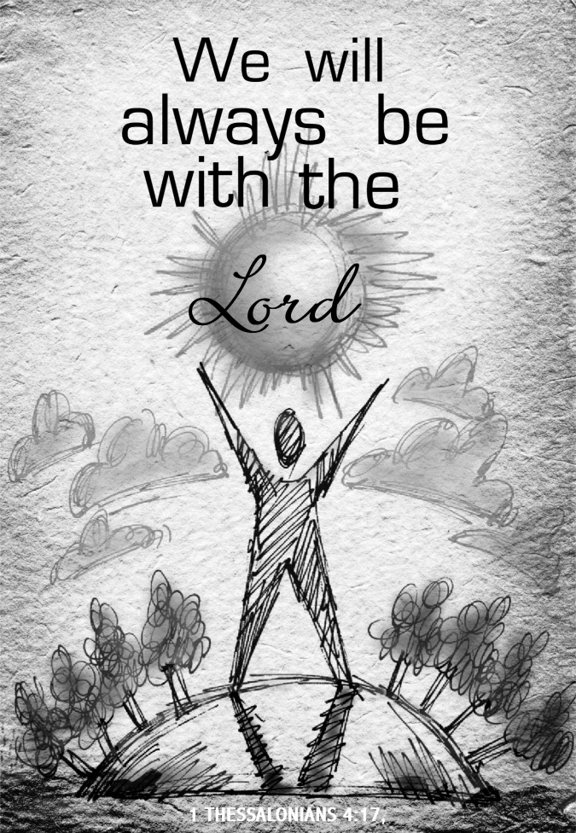

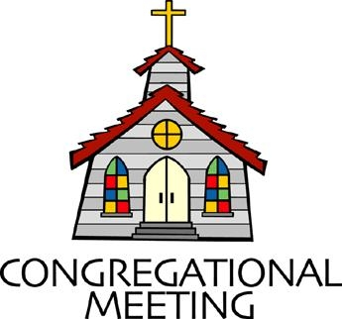
November 8, 2026 - 10:30 am

WELCOME VISITORS!

We're glad you are here! Cards at the ends of each pew are for you to fill out and drop in the Offering Plate. Please let us know you are visiting and join us for refreshments and fellowship following the service. The Sanctuary has an induction loop system to assist the hearing impaired. The system will also work on the telephone setting of hearing aids.

Springfield Presbyterian Church is rooted in the gospel of Jesus Christ, led by the Holy Spirit, and called to loving relationships through vibrant worship and service. Valuing all people, we are committed to developing disciples and fostering stewardship.
PREPARATION FOR THE WORD
(* those who are able are invited to stand)
PRELUDE

PASTOR’S WELCOME

ANNOUNCEMENTS

GATHERING OF THE PEOPLE

The Lord be with you! And also with you!

LIGHTING THE CHRIST CANDLE
Leader: Whenever we light this candle we proclaim:
People: Christ is the Light of the world and the center of our lives.

CALL TO WORSHIP
Leader: Are you awake? Are you alert?
All: Christ is coming into our lives in a new way.
Leader: Are you watching the signs? Are you interpreting what is happening today?
All: Christ is coming into our lives in a new way.
Leader: Do you see opportunities for ministry? Do you see the poor, the homeless, the hungry, the needy?
All: Christ is coming into our lives in a new way.
Leader: Come, let us worship and let us work in the reign of God.
All: Christ has extended the invitation: let us work together towards God’s vision of love on earth.

* HYMN For the Healing of the Nations GTG #346

For the healing of the nations, Lord, we pray with one accord;
For a just and equal sharing of the things that earth affords;
To a life of love in action help us rise and pledge our word.

Lead us forward into freedom; from despair your world release,
That, redeemed from war and hatred, all may come and go in peace.
Show us how through care and goodness fear will die and hope increase.

All that kills abundant living, let it from the earth be banned:
Pride of status, race, or schooling, dogmas that obscure your plan.
In our common quest for justice may we hallow life's brief span.

You, Creator God, have written your great name on humankind;
For our growing in your likeness, bring the life of Christ to mind,
That by our response and service earth its destiny may find.

CALL TO CONFESSION
Leader: God calls us to serve, but we want to do things our way. Let us confess before God and each other the ways we have failed to follow.

UNISON PRAYER FOR FORGIVENESS
Loving God, you call us to love, but our actions harm others. Too often, we do not serve you. Holy God, you call us to worship you, but we are overwhelmed by other demands for our attention. Too often, we do not serve you. Merciful God, you call us to follow your way. Too often, we do not choose to serve you. Forgive us.

SILENT PRAYERS OF CONFESSION

RESPONSE Remember Not, O God GTG #430 (v. 1)
Remember not, O God, the sins of long ago;
In tender mercy visit us, distressed and humbled low.

WORDS OF ASSURANCE
Heather: Friends, know this: the mercy of our God is forever. God does not abandon us when we make poor choices. We are forgiven and given the opportunity to try again. Thanks be to God. Amen.

* MUSICAL RESPONSE OF PRAISE How Great Thou Art (refrain only)
Then sings my soul, my Savior God, to thee: How great thou art!
How great thou art! Then sings my soul, my Savior God, to thee: How great thou art! How great thou art!

* THE PEACE The peace of Christ be with you! And also with you!
(You may greet those around you.)

* RESPONSE Here I Am, Lord GTG #69
Here I am, Lord. Is it I, Lord? I have heard you calling in the night.
I will go, Lord, if you lead me. I will hold your people in my heart.

THE PROCLAMATION OF THE WORD

PRAYER OF ILLUMINATION
Leader: Gracious God, teach us how to dance to the rhythm of your wisdom;
show us how to laugh with the insights of your truth, so that we can live for the praise of your glory in Jesus Christ our Lord. Amen.

FIRST SCRIPTURE LESSON 1 Thessalonians 4:13-18 NT page 193
¹³But we do not want you to be uninformed, brothers and sisters, about those who have died, so that you may not grieve as others do who have no hope.
¹⁴For since we believe that Jesus died and rose again, even so, through Jesus, God will bring with him those who have died. ¹⁵For this we declare to you by the word of the Lord, that we who are alive, who are left until the coming of the Lord, will by no means precede those who have died. ¹⁶For the Lord himself, with a cry of command, with the archangel's call and with the sound of God's trumpet, will descend from heaven, and the dead in Christ will rise first. ¹⁷Then we who are alive, who are left, will be caught up in the clouds together with them to meet the Lord in the air; and so we will be with the Lord forever.
¹⁸Therefore encourage one another with these words.

TIME FOR ALL GOD’S CHILDREN: Stone Soup (Barbara Cornell)

GOSPEL LESSON Matthew 25:1-13 NT page 26
¹"Then the kingdom of heaven will be like this. Ten bridesmaids took their lamps and went to meet the bridegroom. ²Five of them were foolish, and five were wise. ³When the foolish took their lamps, they took no oil with them; ⁴but the wise took flasks of oil with their lamps. ⁵As the bridegroom was delayed, all of them became drowsy and slept. ⁶But at midnight there was a shout, "Look! Here is the bridegroom! Come out to meet him.' ⁷Then all those bridesmaids got up and trimmed their lamps. ⁸The foolish said to the wise, "Give us some of your oil, for our lamps are going out.' ⁹But the wise replied, "No! there will not be enough for you and for us; you had better go to the dealers and buy some for yourselves.' ¹⁰And while they went to buy it, the bridegroom came, and those who were ready went with him into the wedding banquet; and the door was shut. ¹¹Later the other bridesmaids came also, saying, "Lord, lord, open to us.'
¹²But he replied, "Truly I tell you, I do not know you.' ¹³Keep awake therefore, for you know neither the day nor the hour.

Leader: This is the Word of the Lord. All: Thanks be to God.

SERMON

THE RESPONSE TO THE WORD

* HYMN Rejoice! Rejoice, Believers GTG #362

Rejoice! Rejoice, believers, and let your lights appear;
The evening is advancing and darker night is near.
The Bridegroom is arising and soon he will draw nigh.
Up, watch with expectation; at midnight comes the cry.

See that your lamps are burning; replenish them with oil;
Look now for your salvation, the end of sin and toil.
The marriage feast is waiting; the gates wide open stand;
Arise, O heirs of glory; the Bridegroom is at hand!

Our hope and expectation, O Jesus, now appear;
Arise, thou Sun so longed for, above this shadowed sphere!
With hearts and hands uplifted, we plead, O Lord, to see
The day of earth’s redemption, and ever be with thee!

PRAYERS OF THE PEOPLE

THE LORD’S PRAYER
Our Father, who art in heaven, hallowed be thy name, thy kingdom come, thy will be done, on earth as it is in heaven. Give us this day our daily bread; and forgive us our debts, as we forgive our debtors; and lead us not
into temptation, but deliver us from evil. For thine is the kingdom, and the power, and the glory, forever, Amen.

PRESENTATION OF TITHES AND OFFERINGS
OFFERTORY
* SONG OF THANKS We Give Thee but Thine Own GTG #708 (v. 1)
We give thee but thine own, what-e’er the gift may be;
All that we have is thine alone, a trust, O Lord, from thee.
* PRAYER OF DEDICATION

* HYMN Seek Ye First GTG #175

Seek ye first the kingdom of God and its righteousness,
And all these things shall be added unto you. Allelu, alleluia.

Ask, and it shall be given unto you; seek, and you shall find;
Knock, and the door shall be opened unto you. Allelu, alleluia.

You shall not live by bread alone, but by every word
That proceeds from the mouth of God. Allelu, alleluia.

* CHARGE AND BENEDICTION
Heather: As you go out from here, love one another with mutual affection; outdo one another in showing honor. Live in harmony with one another, rejoice in hope, be patient in affliction, persevere in prayer. Love and serve the Lord, in the name of the Father, and of the Son, and of the Holy Spirit, Amen.

* UNISON AMEN GTG #601

POSTLUDE

Some liturgy adapted from Child Of Blessing Lectionary Resource, Presbyterian Association of Musicians, Rev. Mindi, on her Rev-o-lution blog, Worship@North website. https://northchurchindy.wordpress.com/, The United Church of Canada/L’Église Unie du Canada Worship Service—Peace in Community, prepared by Miriam Spies.

Sunday, November 15 Lectionary:
Judges 4:1-7; Psalm 123; 1 Thessalonians 5:1-11; Matthew 25:14-30
Assisting in Worship: We appreciate those who serve:

Today 11/8 Next Week 11/15
Sunday Opener: Ron Holmes Mark Chaplik
Ushers/Greeters: Steve & Donna Mazer Sharon Pappas
Elizabeth Meirowitz
Lay Leader: Alex McClung Tim Oates
Offering Counters: Beth O. & Belle V. Ron H. & Volunteer
Fellowship Hosts: Belle & Don Vasbinder Stewardship Potluck

Happy Anniversary! November 9 – Steve & Donna Mazer

Happy Birthday! November 11 – Rebekah Schermer

Announcements

Happy-Thon: Happy-Thon funds collected in 2025 allowed the gifting of warm winter clothing and financial support for students at Sykesville Middle for some field trips. The Downtown Sykesville Connection is a 501(c)(3) charitable organization. Your ear-marked donations may be given until the end of November, leaving them time to plan their gift-giving this year.

Giving Thanks Luncheon: Next Sunday, November 15 is Stewardship Sunday! We'll be celebrating with a "Giving Thanks Luncheon." It will be pot-luck, but with a theme--Stone Soup! You may bring something for the table like bread, crackers, salad or dessert, but we'd love to have you help build our "stone soup" by bringing something for the pot. It can be cooked or raw, fresh, frozen, or canned. We want to keep it vegetarian and gluten-free. We'll put it all together to simmer during worship then enjoy it together! Please join us!

TV in Fellowship Room: You may have noticed the TV in the fellowship room- this has been installed in order to show the livestream of our worship service in an additional location. If you need a break from the sanctuary, or more room for wiggling kids, please know that you can still access the live service (with a 15 second delay) from there. We hope it will allow more people to access our worship service in ways that make sense for them.

Christmas Flowers: It’s time to order your Christmas flowers! Please see the order form on the last page of your bulletin.

Livestreaming: We are livestreaming our worship service on YouTube now. We will continue to have Zoom as an option, as well.

Congregational Care: If you know of someone who would benefit from a card or a phone call, please text or call Diana Steppling at 862-266-2242.

Electronic Giving: Below is a QR code you can scan to make your contribution a new way! The page you get will ask for your name, email and phone

number. You can choose from a dropdown menu for selecting where the donation should go: General Fund, Capital Fund, Concert, Memorial. There is a fee for using a credit card, and you will be given the option to pay that fee along with your donation, but you don’t have to include it if you don’t want to.

Today:
Sunday November 8
10:30 am Worship
11:30 am Fellowship

This Week:
Wednesday November 11
6:15 pm Bell Choir Practice
No Adult Choir Practice
Thursday November 12
7:00 pm Session Meeting (Manse)

Next Week:
Sunday November 15
10:30 am Worship
11:30 am Stewardship Potluck
Monday November 16
7:00 pm CoCaMO Meeting (Manse)
Tuesday November 17
6:15 pm Bell Choir Practice
7:30 pm Adult Choir Practice

Heather’s In Office Hours: Tuesday, Friday, Sunday
8:30 am – 2:00 pm
Heather’s Home Office Hours: Wednesday, Thursday
8:30 am – 2:00 pm
Heather’s Sabbath Day: Mondays

Reminder: In case of an emergency, please contact Heather directly: springfieldpres.pastor@gmail.com
cell 443-280-9712 (texts welcomed, please identify yourself)



Springfield Presbyterian Church
10:30 am Worship
11:30 am Fellowship
Website: www.springfield-church.org Church Office: 410-795-6152
Like us on Facebook: www.facebook.com/SpringfieldPresbyterianChurch
Pastor: Rev. Heather Russell von Marko
Email: springfieldpres.pastor@gmail.com
Clerk of Session: Sharon Pappas
Music Director: Robin Kochanski
Accompanist: Michael Hall
Office Manager: Donna Mazer
Email: springfieldpres.office@gmail.com

2026 Christmas Flowers
If you would like to place flowers in the Sanctuary for Christmas, complete the order form below and drop it off in the offering plate or at the Church Office, or mail this form and your payment on or before November 15 to the Church Office at 7314 Spout Hill Road, Sykesville, MD 21784.
Please make your check payable to Springfield Presbyterian Church. We will advise you about picking up your flowers as we get closer to Christmas.
All flowers will be in gold foil-wrapped pits. Circle the flower color you prefer!

Poinsettias: 6” pot (3-5 blooms) #_____ @ $11.00 = _______________
Red White Marble New! Red Glitter
(cream & pink) (red & white)

Cyclamen: 6” pot #_____ @ $15.00 = ________________
Red White Assorted Colors

In Memory of:_____________________________________________________________________________

In Honor of:________________________________________________________________________________

In Appreciation for:________________________________________________________________________

Name of Donor:____________________________________________________________________________
* I would like my flower to go to brighten someone else’s holiday: YES or No

In Memory of:_____________________________________________________________________________

In Honor of:________________________________________________________________________________

In Appreciation for:________________________________________________________________________

Name of Donor:____________________________________________________________________________
* I would like my flower to go to brighten someone else’s holiday: YES or No

