Springfield Presbyterian Church (USA)
7300 Spout Hill Road, Sykesville, Maryland 21784

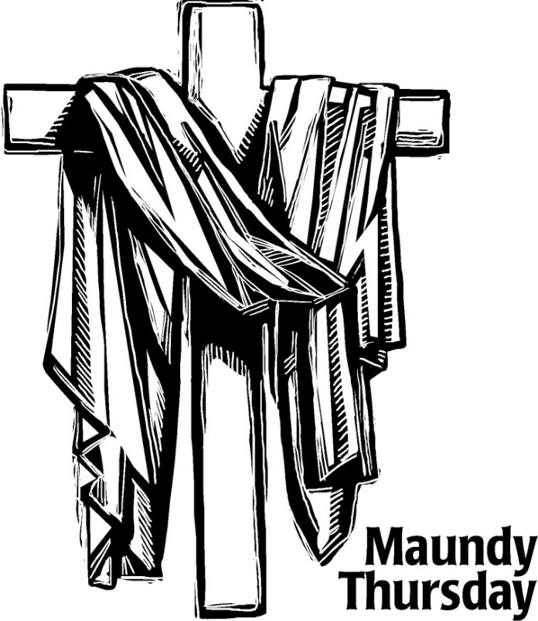

April 2, 2026 - 7:00 PM Worship Service

WELCOME VISITORS!
We're glad you are here! Cards at the ends of each pew are for you to fill out and drop in the Offering Plate. Please let us know you are visiting, and join us for refreshments and fellowship following the service. The Sanctuary has an induction loop system to assist the hearing impaired. The system will also work on the telephone setting of hearing aids. A head set is available upon request.

Springfield Presbyterian Church is rooted in the gospel of Jesus Christ, led by the Holy Spirit, and called to loving relationships through vibrant worship and service. Valuing all people, we are committed to developing disciples and fostering stewardship.
Call to Worship
Leader: The birds announce God’s glory!
All: They remind us of the love of God we often don’t pay attention to, but it is always there, singing for us.
Leader: Welcome! Welcome to this place and to this community. Here we are reminded again that the love of God awaits you and that we are the expression of God’s love to one another.
All: We come to church so that we do not forget this love. We are here to remind ourselves: God’s love is like birds singing every day. That is the good news we have: the love of God!
Leader: When we feel we have nothing else, we can lean on the love of God.

* Hymn Though I May Speak (The Gift of Love) GTG #693

Though I may speak with bravest fire, and have the gift to all inspire,
And have not love, my words are vain, as sounding brass, and hopeless gain.

Though I may give all I possess, and striving so my love profess,
But not be given by love within, the profit soon turns strangely thin.

Come, Spirit, come, our hearts control; our spirits long to be made whole.
Let inward love guide every deed; by this we worship, and are freed.

Call to Confession
Leader: God of love, we come to you feeling a thousand feelings. There is too much going on, and we don’t know how to handle it all. We don’t even know how to put words to all that we are going through.
All: Hear our prayers.
Leader: God of love, we come to you wanting total control over our lives, the stories we live, the people around us, and our own desires.
All: Hear our prayers.
Leader: God of love, we also come to you feeling numb.
All: Hear our prayers.
Leader: God of love, we come to you in silence.
All: Hear our prayers.
Leader: God of love, we come to you because you are the source of life.
All: Hear our prayers.

Time of Silence

Reading Luke 22:47-53
⁴⁷While he was still speaking, suddenly a crowd came, and the one called Judas, one of the twelve, was leading them. He approached Jesus to kiss him; ⁴⁸but Jesus said to him, "Judas, is it with a kiss that you are betraying the Son of Man?" ⁴⁹When those who were around him saw what was coming, they asked, "Lord, should we strike with the sword?" ⁵⁰Then one of them struck the slave of the high priest and cut off his right ear. ⁵¹But Jesus said, "No more of this!" And he touched his ear and healed him. ⁵²Then Jesus said to the chief priests, the officers of the temple police, and the elders who had come for him, "Have you come out with swords and clubs as if I were a bandit? ⁵³When I was with you day after day in the temple, you did not lay hands on me. But this is your hour, and the power of darkness!"

Reflection on the Scripture (adapted from Dr. Cláudio Carvalhaes)
By Heather Russell von Marko

Anthem O Lord, I Pray to Thee By: Patrick M. Liebergen

Reading John 13:1-35
¹Now before the festival of the Passover, Jesus knew that his hour had come to depart from this world and go to the Father. Having loved his own who were in the world, he loved them to the end. ²The devil had already put it into the heart of Judas son of Simon Iscariot to betray him. And during supper ³Jesus, knowing that the Father had given all things into his hands, and that he had come from God and was going to God, ⁴got up from the table, took off his outer robe, and tied a towel around himself. ⁵Then he poured water into a basin and began to wash the disciples' feet and to wipe them with the towel that was tied around him. ⁶He came to Simon Peter, who said to him, "Lord, are you going to wash my feet?" ⁷Jesus answered, "You do not know now what I am doing, but later you will understand."
⁸Peter said to him, "You will never wash my feet." Jesus answered, "Unless I wash you, you have no share with me." ⁹Simon Peter said to him, "Lord, not my feet only but also my hands and my head!" ¹⁰Jesus said to him, "One who has bathed does not need to wash, except for the feet, but is entirely clean. And you are clean, though not all of you." ¹¹For he knew who was to betray him; for this reason he said, "Not all of you are clean." ¹²After he had washed their feet, had put on his robe, and had returned to the table, he said to them, "Do you know what I have done to you? ¹³You call me Teacher and Lord—and you are right, for that is what I am. ¹⁴So if I, your Lord and Teacher, have washed your feet, you also ought to wash one another's feet.
¹⁵For I have set you an example, that you also should do as I have done to you. ¹⁶Very truly, I tell you, servants are not greater than their master, nor are messengers greater than the one who sent them. ¹⁷If you know these things, you are blessed if you do them. ¹⁸I am not speaking of all of you; I know whom I have chosen. But it is to fulfill the scripture, "The one who ate my bread has lifted his heel against me.' ¹⁹I tell you this now, before it occurs, so that when it does occur, you may believe that I am he. ²⁰Very truly, I tell you, whoever receives one whom I send receives me; and whoever receives me receives him who sent me." ²¹After saying this Jesus was troubled in spirit, and declared, "Very truly, I tell you, one of you will betray me." ²²The disciples looked at one another, uncertain of whom he was speaking. ²³One of his disciples—the one whom Jesus loved—was reclining next to him; ²⁴Simon Peter therefore motioned to him to ask Jesus of whom he was speaking. ²⁵So while reclining next to Jesus, he asked him, "Lord, who is it?" ²⁶Jesus answered, "It is the one to whom I give this piece of bread when I have dipped it in the dish." So when he had dipped the piece of bread, he gave it to Judas son of Simon Iscariot. ²⁷After he received the piece of bread, Satan entered into him. Jesus said to him, "Do quickly what you are going to do." ²⁸Now no one at the table knew why he said this to him. ²⁹Some thought that, because Judas had the common purse, Jesus was telling him, "Buy what we need for the festival"; or, that he should give something to the poor. ³⁰So, after receiving the piece of bread, he immediately went out. And it was night. ³¹When he had gone out, Jesus said, "Now the Son of Man has been glorified, and God has been glorified in him.
³²If God has been glorified in him, God will also glorify him in himself and will glorify him at once. ³³Little children, I am with you only a little longer. You will look for me; and as I said to the Jews so now I say to you, "Where I am going, you cannot come. ³⁴I give you a new commandment, that you love one another. Just as I have loved you, you also should love one another. ³⁵By this everyone will know that you are my disciples, if you have love for one another."

Reflection on the Scripture (adapted from Dr. Cláudio Carvalhaes)
By Heather Russell von Marko

Handwashing Ritual

Flute Trio Pavane By: Gabriel Faure

Communion
Heather: The Lord be with you.
All: And also with you.
Heather: Lift up your hearts.
All: We lift them up to the Lord.
Heather: Let us give thanks to the Lord our God.
All: It is right to give God thanks and praise.

Great Thanksgiving

Congregational Sung Prayer Jesus, Remember Me GTG#227 (sing 3 times)
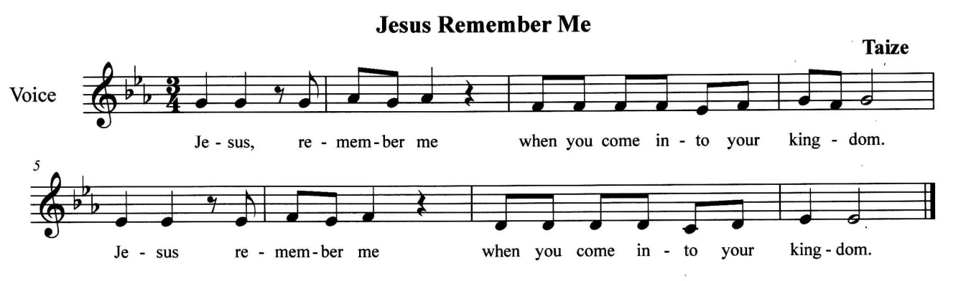

Invitation to the Table

Sharing of the Bread and Wine

* Closing Hymn Were You There GTG #228 (v. 1-5)

Were you there when they crucified my Lord? (Were you there?)
Were you there when they crucified my Lord?
O! Sometimes it causes me to tremble, tremble, tremble.
Were you there when they crucified my Lord? (Were you there?)

Were you there when they nailed him to the tree? (Were you there?)
Were you there when they nailed him to the tree?
O! Sometimes it causes me to tremble, tremble, tremble.
Were you there when they nailed him to the tree? (Were you there?)

Were you there when they pierced him in the side? (Were you there?)
Were you there when they pierced him in the side?
O! Sometimes it causes me to tremble, tremble, tremble.
Were you there when they pierced him in the side? (Were you there?)

Were you there when the sun refused to shine? (Were you there?)
Were you there when the sun refused to shine?
O! Sometimes it causes me to tremble, tremble, tremble.
Were you there when the sun refused to shine? (Were you there?)

Were you there when they laid him in the tomb? (Were you there?)
Were you there when they laid him in the tomb?
O! Sometimes it causes me to tremble, tremble, tremble.
Were you there when they laid him in the tomb? (Were you there?)

Charge and Blessing

Please exit in silence.

Liturgy adapted from Dr. Cláudio Carvalhaes / A Sanctified Art LLC / sanctifiedart.org

