(Large Print)

Springfield Presbyterian Church (USA)
7300 Spout Hill Road, Sykesville, MD 21784 410-795-6152
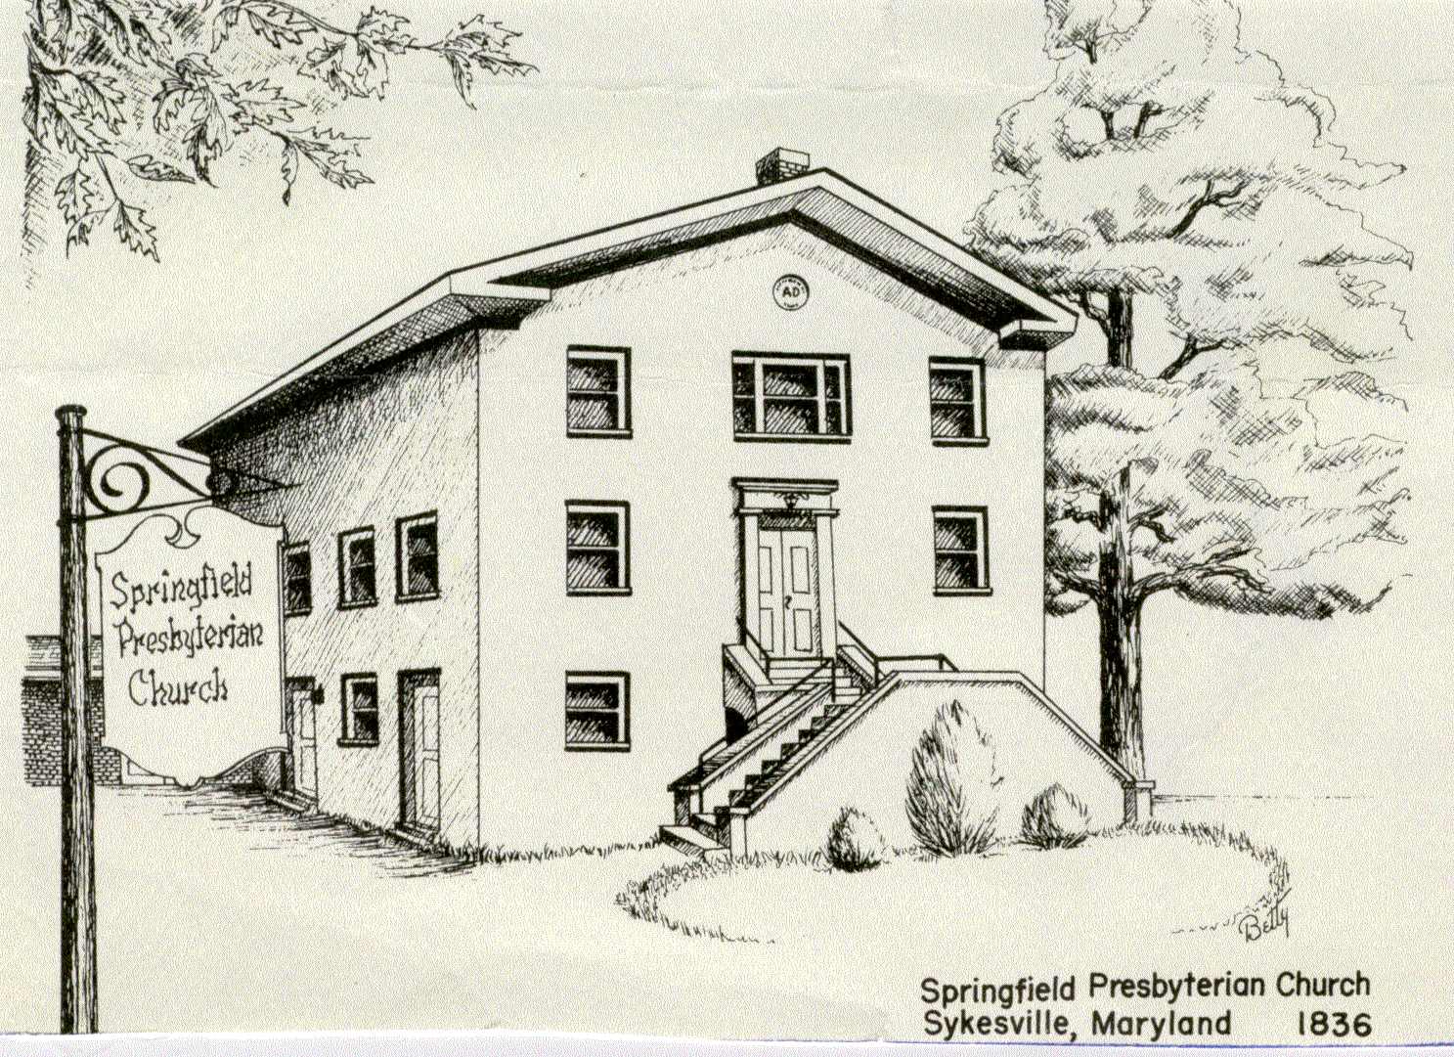

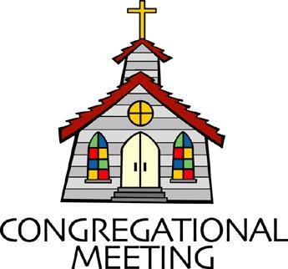
March 19, 2023 - 10:30 am

WELCOME VISITORS!
We're glad you are here! Cards at the ends of each pew are for you to fill out and drop in the Offering Plate. Please let us know you are visiting, and join us for refreshments and fellowship following the service. The Sanctuary has an induction loop system to assist the hearing impaired. The system will also work on the telephone setting of hearing aids.

Springfield Presbyterian Church is rooted in the gospel of Jesus Christ, led by the Holy Spirit, and called to loving relationships through vibrant worship and service. Valuing all people, we are committed to developing disciples and fostering stewardship.
PREPARATION FOR THE WORD
(* those who are able are invited to stand)

PRELUDE

GATHERING OF THE PEOPLE

The Lord be with you! And also with you!

(Greetings and Announcements)

LIGHTING THE CHRIST CANDLE
Leader: Whenever we light this candle we proclaim:
People: Christ is the Light of the world and the center of our lives.

CALL TO WORSHIP
Leader: Scripture is full of questions…..
People: Where are you?
Leader: Am I my brother’s keeper?
People: Whom shall I send?
Leader: Who do you say that I am?
People: Who Sinned?
Leader: How many times shall I forgive?
People: If God is for us, who can be against us?
Leader: Scripture is full of questions, so just like those in our scriptures, may we bring our full curiosity and wonder into this space.
People: Let us ask and seek after our merciful God.
*HYMN O My Soul, Bless Your Redeemer (1-4) #439
1. O my soul, bless your redeemer; all with-in me bless God’s name; Bless the Savior, and forget not all God’s mercies to proclaim.
2. God forgives all your transgressions, all diseases gently heals; God redeems you from destruction, and with you so kindly deals.
3. Far as east from west is distant, God has put away our sin; like the pity of a father has the Lord’s compassion been.
4. As it was without beginning, so it lasts without an end; to their children’s children ever shall God’s righteousness extend.

CALL TO CONFESSION
Leader: In today’s text, the disciples ask Jesus, “who sinned?” They want to know who around them could be blamed for suffering. The disciples want to identify who around them had done wrong. In the prayer of confession, we stop pointing fingers at others. In confession, we turn our attention toward ourselves and invite God into that honest and vulnerable space. So do this counter-cultural thing today by praying together.
PRAYER OF CONFESSION
Leader: Who here has sinned?
People: We have sinned. We put our heads in the sand. We ignored people in need. We make false assumptions and fail to be kind. We are in need of forgiveness. We bow our heads in silent repentance.

SILENT PRAYERS OF CONFESSION
RESPONSE O Lord, Hear My Prayer Tune #471 (sing twice)
O Lord, hear my prayer. O Lord, hear my prayer. When I call, answer me.
O Lord, hear my prayer. O Lord, hear my prayer. Come and listen to me.

WORDS OF ASSURANCE
Leader: Hear the Good News! Our God is a merciful God. God does not punish, hold grudges, or keep score. When we suffer, God weeps. When we sin, God forgives. When we lose our way, God comes running.
People: Thanks be to God for a love like that. Amen.

* MUSICAL RESPONSE OF PRAISE Come, Thou Almighty King
To thee, great One in Three, eternal praises be, hence evermore!
Thy sovereign majesty may we in glory see, and to eternity love and adore.

* THE PEACE The peace of Christ be with you! And also with you!
(You may greet those around you.)

* RESPONSE Here I Am, Lord
Here I am, Lord, Is it I, Lord? I have heard you calling in the night.
I will go, Lord, if you lead me. I will hold your people in my heart.

THE PROCLAMATION OF THE WORD

PRAYER OF ILLUMINATION
God of Good news,
There is reading your Word, there is hearing your Word, and then there is tunneling ourselves into your Word – harvesting your Word, building a home in your Word, laying your Word over us like a blanket, wrapping ourselves in your Word, knowing your Word like the back of our hand, singing your Word, planting ourselves like a garden in your Word. God, we could listen to scripture like we listen to the news, or we could cocoon ourselves in your Word and let us change us entirely. So, bundle us up, let us live into the Word in these diverse ways. We seek you with hopeful hearts. Amen.

FIRST SCRIPTURE LESSON John 9: 1-7 NT page 96
As he walked along, he saw a man blind from birth. His disciples asked him, “Rabbi, who sinned, this man or his parents, that he was born blind?” Jesus answered, “Neither this man nor his parents sinned; he was born blind so that God’s works might be revealed in him. We must work the works of him who sent me while it is day; night is coming when no one can work. As long as I am in the world, I am the light of the world.” When he had said this, he spat on the ground and made mud with the saliva and spread the mud on the man’s eyes, saying to him, “Go, wash in the pool of Siloam” (which means Sent). Then he went and washed and came back able to see.

SECOND SCRIPTURE LESSON John 9: 8-41 NT page 96
The neighbors and those who had seen him before as a beggar began to ask, “Is this not the man who used to sit and beg?” Some were saying, “It is he.” Others were saying “No, but it is someone like him.” He kept saying, “I am the man.” But they kept asking him, “Then how were your eyes opened?” He answered, “The man called Jesus made mud, spread it on my eyes, and said to me, “Go to Siloam and wash.” Then I went and washed and received my sight.” They said to him, “Where is he?” He said, “I do not know.”

They brought to the Pharisees the man who had formerly been blind. Now it was a sabbath day when Jesus made the mud and opened his eyes. Then the Pharisees also began to ask him how he had received his sight. He had said to them, “He put mud on my eyes. Then I washed, and now I see.” Some of the Pharisees said, “This man is not from God, for he does not observe the sabbath.” But others said, “How can a man who is a sinner perform such signs?” And they were divided. So they said again to the blind man, “What do you say about him? It was your eyes he opened.” He said, “He is a prophet.”

The Jews did not believe he had been blind and had received his sight until they called the parents of the man who had received his sight and asked them, “Is this your son, who you say was born blind? How then does he now see?” His parents answered, “We know that this is our son, and that he was born blind; but we do not know how it is that now he sees, nor do we know who opened his eyes. Ask him; he is of age. He will speak for himself.” His parents said this because they were afraid of the Jews; for the Jews had already agreed that anyone who confessed Jesus to be the Messiah, would be put out of the synagogue. Therefore his parents said, “He is of age; ask him.”

So for the second time they called the man who had been blind, and they said to him, “Give glory to God! We know that this man is a sinner.” He answered, “I do not know whether he is a sinner. One thing I do know, that though I was blind, now I see.” They said to him, “What did he do to you? How did he open your eyes?” He answered them, “I have told you already and you would not listen. Why do you want to hear it again? Do you also want to become his disciples?” Then they reviled him, saying, “You are his disciple, but we are disciples of Moses. We know that God has spoken to Moses, but as for this man, we do not know where he comes from.” The man answered, “Here is an astonishing thing! You do not know where he comes from, and yet he opened my eyes. We know that God does not listen to sinners, but he does listen to one who worships him and obeys his will. Never since the world began has it been heard that anyone opened the eyes of a person born blind. If this man were not from God, he could do nothing.” They answered him, “You were born entirely in sins, and are you trying to teach us?” And they drove him out.
Jesus had heard that they had driven him out, and when he found him, he said, “Do you believe in the Son of Man?” He answered, “And who is he, sir? Tell me, so that I may believe in him.” Jesus had said to him, “You have seen him, and the one speaking with you is he.” He said, “Lord, I believe.” And he worshiped him. Jesus said, “I came into this world for judgement so that those who do not see may see, and those who do see may become blind.” Some of the Pharisees near him heard this and said to him, “Surely we are not blind, are we?” Jesus said to them, “If you were blind, you would not have sin. But now that you say, ‘We see,’ your sin remains.

SERMON Who Sinned? Rev. Becca Price

THE RESPONSE TO THE WORD

*HYMN We Come with Questions (To the tune of Praise to the Lord, the Almighty) #35
1. We come with questions assuming that there will be answers. Setting the world in an order that obeys our grammar. We want to know where Spirit’s river will flow. Frustrated by her meanders.
2. Here is the mystery we claim as the followers of Jesus. Christ has died, Christ is raised, Christ daily comes to redeem us. Grace free, not earned whether or not we deserve. God works beyond rules and boundaries.
3. God help us live into mystery beyond comprehension. Quite our minds always clamoring for some direction. Give us your peace with all that we can’t perceive. Holding us within the tension.

PASTORAL PRAYER AND OUR LORD’S PRAYER

OFFERTORY Walk With Me Lord by Wagner
* SONG OF THANKS Lord of All Good Tune #711
Lord of all good, our gifts we bring to you; use them your holy purpose to fulfill,
Tokens of love and pledges brought anew, that our whole life is offered to your will.
* PRAYER OF DEDICATION

* HYMN Live into Hope #772

1. Live into hope of captives freed, of sight regained, the end of greed. The oppressed shall be the first to see the year of God’s own jubilee!
2. Live into hope! The blind shall see with insight and with clarity, removing shades of pride and fear, a vision of our God brought near.
3. Live into hope of liberty, the right to speak, the right to be, the right to have one’s daily bread, to hear God’s word and thus be fed.
4. Live into hope of captives freed from chains or fear or want or greet. God now proclaims our full release to faith and hope and joy and peace.

* CHARGE AND BENEDICTION
Leader: As you leave this place, may God bless you with seeking.
People: We will seek out the hungry, the weary, the good in every person we pass.
Leader: Go to seek out the hopeful, the faithful, the God in each of us.
People: We shall seek and wonder.
Leader: And so, may we find what we are looking for. In the name of our loving God, who is always seeking us, let us go in peace. Amen.

* UNISON AMEN
POSTLUDE
Assisting in Worship: We appreciate those who serve:

Today 3/19 Next Week 3/26
Ushers/Greeters: Don Vasbinder Connie Gibbons
Volunteer Needed Volunteer Needed
Lay Leader: Ron Holmes Diana Steppling

Happy Birthday! March 16 – Heather Caviglia
Happy Anniversary! March 14 – Hubert and Barbara Hoehn

Sunday March 26, 2023 Lectionary
Ezek. 37:1-14 and Ps.130; Rom. 8:6-11; John 11: 1-45

Announcements

One Great Hour of Sharing: Our church is a Four for Four church, meaning it receives all four of the special offerings of PC(USA). The first, One Great Hour of Sharing, is received during Lent. With this offering we support rebuilding hope through Presbyterian Disaster Assistance; the growing food insecurity with the Presbyterian Hunger Program; and we partner in progress through the Self-Development of People. Donations go equally to all three programs. As we watch the news, we know the importance of all three of these needs. You may use the separate envelope included in your bulletin, or include a donation with your pledge with a note for OGHS. Or, if you have strong preferences for one of the three programs, you may note on your check how you want it divided. Your gifts will help so many. Thank you.

Comfort Bags: Do you know of anyone who is in need of a little comfort? New comfort bags are now available in the Narthex. Feel free to scoop one up and pass it along to someone in need. “No act of kindness, no matter how small, is ever wasted.” ~ Aesop

Springfield Membership: Are you interested in finding out more about our faith community and becoming a member? We would love to answer any questions you have. Please contact Pastor Becca at springfieldpastor@gmail.com for more information.

Congregational Care / Mission & Outreach (CoCaMO): Do you know of a member or friend of our church family who is ill, needs prayers, would like call, a visit or a card, or might benefit from meal train? If so, please contact the Church Office (410-795-6152), Cathy Marsh (410-549-6916) or Diana Steppling (862-266-2242).

Today:
Sunday March 19
10:30 am Worship
11:30 am Fellowship
This Week:
Wednesday March 22
6:16 – 7:15 pm Bell Choir Practice
7:30 – 8:45 pm Adult Choir Practice
Friday, March 24
Game Night
Looking Ahead:
Sunday April 2
10:30 am Worship
11:30 am Fellowship

Office Hours: Tuesday, Wednesday and Friday, 10:00 am - 3:00 pm
Springfield Presbyterian Church

10:30 am Worship
11:30 am Fellowship
Website: www.springfield-church.org Church Office: 410-795-6152
Like us on Facebook: www.facebook.com/SpringfieldPresbyterianChurch
Pastor: Rev. Becca Price
Email: springfieldpastor@gmail.com
Clerk of Session: Sharon Pappas
Minister of Music: Linda Caviglia
Accompanist/Organist: Aaron Thacker
Youth Group Coordinator: Dylan Vasbinder
Administrative Assistant: Donna Mazer e-mail: spc.office@verizon.net

