,Springfield Presbyterian Church (USA)
7300 Spout Hill Road, Sykesville, MD 21784 410-795-6152
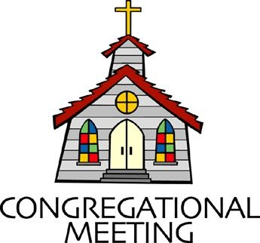

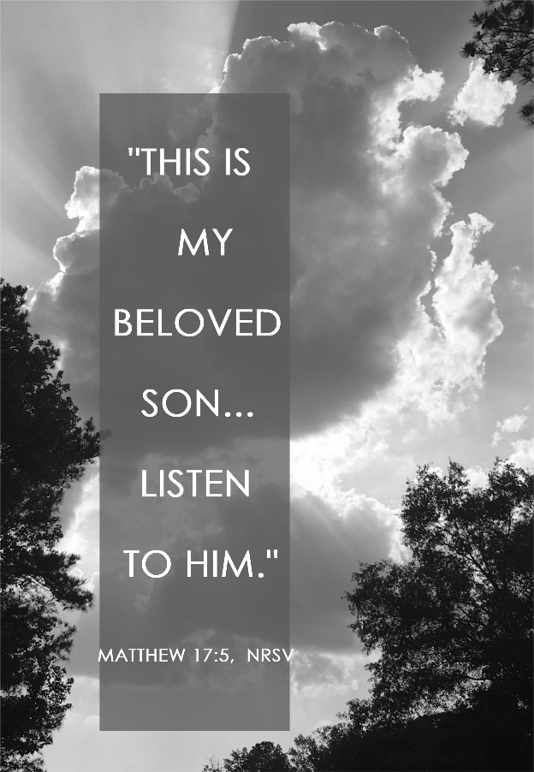

March 1, 2026 - 10:30 am

WELCOME VISITORS!

We're glad you are here! Cards at the ends of each pew are for you to fill out and drop in the Offering Plate. Please let us know you are visiting and join us for refreshments and fellowship following the service. The Sanctuary has an induction loop system to assist the hearing impaired. The system will also work on the telephone setting of hearing aids.

Springfield Presbyterian Church is rooted in the gospel of Jesus Christ, led by the Holy Spirit, and called to loving relationships through vibrant worship and service. Valuing all people, we are committed to developing disciples and fostering stewardship.

PREPARATION FOR THE WORD
(* those who are able are invited to stand)

PRELUDE

GATHERING OF THE PEOPLE

The Lord be with you! And also with you! (Greetings and Announcements)

LIGHTING THE CHRIST CANDLE
Leader: Whenever we light this candle we proclaim:
People: Christ is the Light of the world and the center of our lives.

CALL TO WORSHIP
Leader: I lift up my eyes to the hills—
People: From where will my help come?
Leader: My help comes from the Lord,
People: Who made heaven and earth.

* HYMN Open Now Thy Gates of Beauty GTG #403

Open now thy gates of beauty, Zion, let me enter there,
Where my soul in joyful duty waits for God who answers prayer;
O how blessed is this place, filled with solace, light, and grace.

Gracious God, I come before thee; come thou also unto me;
Where we find thee and adore thee, there a heaven on earth must be;
To my heart O enter thou; let it be thy temple now.

Speak, O Lord, and I will hear thee; let thy will be done indeed;
May I undisturbed draw near thee, while thou dost thy people feed.
Here of life the fountain flows; here is balm for all our woes.

CALL TO CONFESSION
Leader: Jesus leads us to that mountain place of stronger light and sure sound
where we may see God’s glory. But first, we must lift the veil and clear the fog by confessing our sins against God and one another.

PRAYER OF CONFESSION
God of Mercy and Grace, you come to us in Jesus of Nazareth to break down the dividing walls of hostility between us: Yet we maintain walls that separate and isolate. You give us the ministry of reconciliation: Yet we nurse our wounds and withhold mercy and forgiveness. You invite us to join with Peter, James, and John on the mountain of Transfiguration: Yet we deny the wonders you have worked in our own lives. You ask us to acknowledge and share our wealth: Yet we refuse to recognize and relieve the poverty around us. You bless our lives with boundless love: Yet we fail to witness to that love, and so keep others from knowing you. Forgive our selfishness, we pray. Transform us by your Spirit and your Word into that which pleases you, the image of Christ. Amen.

SILENT PRAYERS OF CONFESSION

RESPONSE O Lord, Hear My Prayer GTG #471 (sing 3 times)
O Lord, hear my prayer. O Lord, hear my prayer. When I call, answer me.
O Lord, hear my prayer. O Lord, hear my prayer. Come and listen to me.

WORDS OF ASSURANCE
Leader: Jesus admonished Peter, James, and John not to tell of what they witnessed on the mountain until he was resurrected. But we can tell what we have seen and heard of God’s glory!
People: Through Jesus Christ we are forgiven, thanks be to God.

* MUSICAL RESPONSE OF PRAISE Praise Ye the Lord, the Almighty
GTG #35 (v. 3)
Praise ye the Lord! O let all that is in me adore him!
All that hath life and breath, come now with praises before him!
Let the amen sound from his people again; gladly for aye we adore him.

* THE PEACE The peace of Christ be with you! And also with you!
(You may greet those around you.)

* RESPONSE Here I Am, Lord GTG #69
Here I am, Lord. Is it I, Lord? I have heard you calling in the night.
I will go, Lord, if you lead me. I will hold your people in my heart.

THE PROCLAMATION OF THE WORD

PRAYER OF ILLUMINATION
O Lord, as we gather here to worship in this place, assure us of your presence through the Holy Spirit, that we may be led to follow you this day and always. In the name of Christ we pray. Amen.

FIRST SCRIPTURE LESSON Psalm 121 OT page 539
¹ I lift up my eyes to the hills— from where will my help come? ² My help comes from the Lord, who made heaven and earth. ³ He will not let your foot be moved; he who keeps you will not slumber. ⁴ He who keeps Israel will neither slumber nor sleep. ⁵ The Lord is your keeper; the Lord is your shade at your right hand.
⁶ The sun shall not strike you by day, nor the moon by night. ⁷ The Lord will keep you from all evil; he will keep your life. ⁸ The Lord will keep your going out and your coming in from this time on and forevermore.

SECOND SCRIPTURE LESSON Matthew 17:1-9 NT page 17
¹ Six days later, Jesus took with him Peter and James and his brother John and led them up a high mountain, by themselves. ² And he was transfigured before them, and his face shone like the sun, and his clothes became dazzling white.
³ Suddenly there appeared to them Moses and Elijah, talking with him.
⁴ Then Peter said to Jesus, "Lord, it is good for us to be here; if you wish, I will make three dwellings here, one for you, one for Moses, and one for Elijah."
⁵ While he was still speaking, suddenly a bright cloud overshadowed them, and from the cloud a voice said, "This is my Son, the Beloved; with him I am well pleased; listen to him!" ⁶ When the disciples heard this, they fell to the ground and were overcome by fear. ⁷ But Jesus came and touched them, saying, "Get up and do not be afraid." ⁸ And when they looked up, they saw no one except Jesus himself alone. ⁹ As they were coming down the mountain, Jesus ordered them, "Tell no one about the vision until after the Son of Man has been raised from the dead."

Leader: Hear what the Spirit is saying to the Church.
All: Thanks be to God.

SERMON Could it be me? By Rev. Shannon Weston

THE RESPONSE TO THE WORD

* HYMN My Faith Looks Up to Thee GTG #829

My faith looks up to thee, thou Lamb of Calvary, Savior divine!
Now hear me while I pray; take all my guilt away;
O let me from this day be wholly thine!

May thy rich grace impart strength to my fainting heart, my zeal inspire;
As thou hast died for me, O may my love to thee
Pure, warm, and changeless be, a living fire!

While life's dark maze I tread and griefs around me spread, be thou my guide;
Bid darkness turn to day; wipe sorrow's tears away;
Nor let me ever stray from thee aside.

When ends life's transient dream, when death's cold, sullen stream shall o'er me roll;
Blest Savior, then, in love, fear and distrust remove;
O bear me safe above, a ransomed soul!

COMMUNION OF THE PEOPLE

INVITATION

THE GREAT PRAYER OF THANKSGIVING
Leader: The Lord be with you.
People: And also with you.
Leader: Lift up your hearts.
People: We lift them up to the Lord.
Leader: Let us give thanks to the Lord our God.
People: It is right to give our thanks and praise.
[The Pastor continues… “Therefore with all creation we sing your praise.”]

IN PRAISE OF GOD Tune #552
Holy, holy, holy, Lord, God of Power and might.
Heaven and earth are full of your glory, Hosanna in the highest!
Blessed is He who comes in the name of the Lord.
Hosanna in the highest, hosanna in the highest.
[The Pastor continues… “Great is the mystery of faith.”]

IN PRAISE OF CHRIST Tune #553
Christ has died; Christ is risen; Christ will come again.
Christ has died; Christ is risen; Christ will come again.
[The Pastor continues… “almighty God, now and forever.”]

PASTORAL PRAYER AND THE LORD’S PRAYER

WORDS OF INSTITUTION

SHARING OF THE MEAL

PRAYER OF DEDICATION
Leader: Gracious God, may we who have received this sacrament live in the unity of your Holy Spirit, that we may show forth your gifts to all the world. We ask this in the name of Jesus Christ.
All: Amen.

PRESENTATION OF TITHES AND OFFERINGS
OFFERTORY
* SONG OF THANKS Lord of All Good GTG #711 (v. 1)
Lord of all good, our gifts we bring to you;
Use them your holy purpose to fulfill,
Tokens of love and pledges brought anew,
That our whole life is offered to your will.
* PRAYER OF DEDICATION

* HYMN O Love that Wilt Not Let Me Go GTG #833

O Love that wilt not let me go, I rest my weary soul in thee;
I give thee back the life I owe,
That in thine ocean depths its flow may richer, fuller be.

O Light that followest all my way, I yield my flickering torch to thee;
My heart restores its borrowed ray,
That in thy sunshine’s blaze its day may brighter, fairer be.

O Joy that seekest me through pain, I cannot close my heart to thee;
I trace the rainbow through the rain,
And feel the promise is not vain that morn shall tearless be.

O Cross that liftest up my head, I dare not ask to fly from thee;
I lay in dust life’s glory dead,
And from the ground there blossoms red life that shall endless be.

* CHARGE AND BENEDICTION

* UNISON AMEN GTG #601

POSTLUDE

Assisting in Worship: We appreciate those who serve:

Today 3/1 Next Week 3/8
Sunday Opener: Linda Caviglia Beth Oates
Ushers/Greeters: Steve & Donna Mazer Alex & Brenda McClung
Lay Leader: Bob Steppling Don Vasbinder
Pulpit Supply: Rev. Shannon Weston Kathy Welsh Smith
Communion Servers: 1. Mark Kearney
2. Beth Oates
3. Barbara Cornell
4. Sue Holmes
5. Ron Holmes
Offering Count: Ron H. & Andrea Kwako Andrea Kwako & Volunteer
Fellowship Hosts: Linda Caviglia Christy Yeager
Sunday March 8, 2026 Lectionary
Exodus 17:1-7; Psalm 95; Romans 5:1-11; John 4:5-42

Happy Birthday! March 2 – Linda Black
March 5 – Andrea Lane
March 6 – Sue Holmes

Announcements

Welcome! We welcome Rev. Shannon Weston to our pulpit again today!
Shannon (she/her) is a Leadership Coach, Conflict Mediator, and Coach Trainer. Her work with pastors, church leaders, and nonprofits has been recognized as a valid ministry by the Presbytery of Baltimore. Before Coaching, Shannon served two decades as a pastor in the PCUSA, serving churches in Kentucky, New York, and Maryland. She lives in Lutherville with her husband Derrick and their four children.

Welcome also to Joann Benson, our substitute accompanist!

Concert: The next concert featuring The Eric Byrd Trio is TODAY at 3:00 pm. The Eric Byrd Trio has been a part of our concert series several times in the past years and has always been a joy to host. If you have enjoyed a concert by them before, you know you don’t want to miss it and if you haven’t, be sure you come to enjoy the Trio’s amazing music and talent, followed by excellent food afterwards.

Search Team: At the January Session meeting, a new Search Team was elected to move forward to find us a new pastor. Committee on Ministry member, Guy Moody, met with Session to explain our options. Session chose to follow a new path, Transitional Pastor, designed to move quicker and offer more creative possibilities for the way things might work now. The purpose is to ensure that we have essential pastoral leadership and to guide us in determining our mission and style of leadership to achieve that goal.

The Search Team met twice and learned in more detail how this Transitional Pastor position will work for us. It will allow us to call a Bridge Pastor for up to six months while we design interview questions and advertise. The Search Team will review applications and interview candidates for the Transitional Pastor position. Once a candidate is identified, Session will contract with the selected pastor for 1-2 years with options to renew.

At the last meeting, the Search Team finalized a job description that is now being sent to Committee on Ministry (COM). With their continued guidance, the team will move forward with each step. The pool of candidates is not large and if you know anyone who might be interested, let us know. They need to be an ordained minister PC(USA) or from a denomination with whom PC(USA) is in full communion.

If you have any questions, please contact Bob Steppling at bobsteppling@gmail.com

Search Team: Chair Bob Steppling, Tony Caviglia, Sue Holmes, Steve Mazer, Belle Vasbinder, with Sharon Pappas

Zoom Link for Worship Services: The Zoom link for church services is on the SPC website, not on the Facebook page. The Bulletin is also available on the website as well.

Congregational Care: If you know of someone who would benefit from a card or a phone call, please text or call Connie Gibbons at 410-935-3467.

Electronic Giving: Below is a QR code you can scan to make your contribution a new way! The page you get will ask for your name, email and phone

number. You can choose from a dropdown menu for selecting where the donation should go: General Fund, Capital Fund, Concert, Memorial. There is a fee for using a credit card, and you will be given the option to pay that fee along with your donation, but you don’t have to include it if you don’t want to.

Today:
Sunday March 1
10:30 am Worship
11:30 am Fellowship
3:00 pm Concert (Sanctuary)

This Week:
Monday March 2
7:00 pm HeadHuggers (Manse)
Tuesday March 3
7:00 pm ESCAPE Lunch Packing (Manse)
Wednesday March 4
6:15 – 7:15 pm Bell Choir Practice

Next Week:
Sunday March 8
10:30 am Worship
11:30 am Fellowship
Wednesday March 11
6:15 – 7:15 pm Bell Choir Practice
7:30 – 8:45 pm Adult Choir Practice
Thursday March 12
7:00 pm Session Meeting (Manse)

Office Hours: Tuesday, Wednesday, Friday, 10 am – 3 pm

Springfield Presbyterian Church
10:30 am Worship (and Sunday School 1st & 3rd Sundays)
11:30 am Fellowship
Website: www.springfield-church.org Church Office: 410-795-6152
Like us on Facebook: www.facebook.com/SpringfieldPresbyterianChurch
Pastor: Vacant
Email: spc.office@verizon.net
Clerk of Session: Sharon Pappas
Minister of Music/Accompanist: Vacant
Bell Choir Director: Vacant
Youth Group Coordinator: Dylan Vasbinder
Administrative Assistant: Donna Mazer Email: spc.office@verizon.net

