(Large Print)

Springfield Presbyterian Church (USA)
7300 Spout Hill Road, Sykesville, MD 21784 410-795-6152

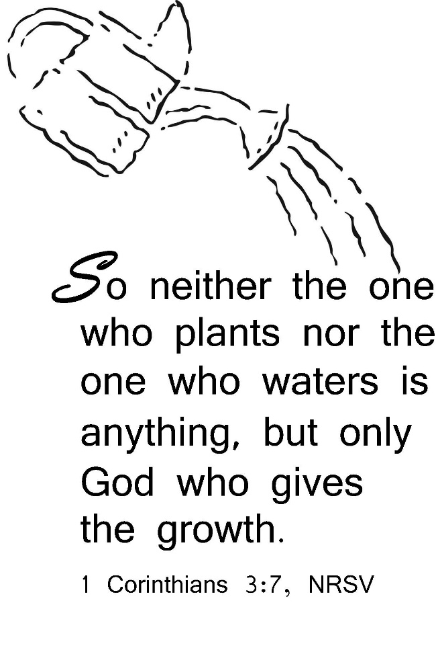

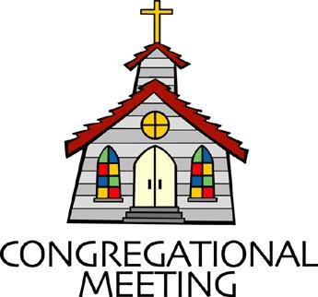
February 16, 2020 - 10:30 am

WELCOME VISITORS! We're glad you are here! Cards at the ends of each pew are for you to fill out and drop in the Offering Plate. Please let us know you are visiting, and join us for refreshments and fellowship following the service. The Sanctuary has an induction loop system to assist the hearing impaired. The system will also work on the telephone setting of hearing aids.

Springfield Presbyterian Church is rooted in the gospel of Jesus Christ, led by the Holy Spirit, and called to loving relationships through vibrant worship and service. Valuing all people, we are committed to developing disciples and fostering stewardship.

PREPARATION FOR THE WORD
(* those who are able are invited to stand)

PRELUDE

GATHERING OF THE PEOPLE

The Lord be with you! And also with you! (Greeting)

LIGHTING THE CHRIST CANDLE
Leader: Whenever we light this candle we proclaim:
People: Christ is the Light of the world and the center of our lives.

CALL TO WORSHIP [Iona Community Opening Responses]
Leader: The world belongs to God,
People: The earth and all its people.
Leader: How good it is, how wonderful,
People: To live together in unity.
Leader: Love and faith come together;
People: Justice and peace join hands.
Leader: If Christ’s disciples keep silent,
People: These stones would shout aloud.
Leader: Open our lips, O God,
People: And our mouths shall proclaim your praise.

* HYMN We All Are One in Mission

We all are one in mission; we all are one in call,
Our varied gifts united by Christ, the Lord of all.
A single, great commission compels us from above
To plan and work together that all may know Christ's love.

We all are called for service to witness in God's name.
Our ministries are different; our purpose is the same:
To touch the lives of others by God's surprising grace,
So every folk and nation may feel God's warm embrace.

Now let us be united and let our song be heard.
Now let us be a vessel for God's redeeming word.
We all are one in mission; we all are one in call,
Our varied gifts united by Christ, the Lord of all.

PRAYER OF CONFESSION
Gracious God, we live in a world of human leadership, where we are constantly being asked whom we follow and who we will serve. In this debate and election year, we are constantly seeking unity and finding division. Help us to rise above this – to maintain and acknowledge that you are one true guide. Turn us from the worries of the day, and help us to focus on your Kingdom on this earth. Forgive us when we have put more trust in human leaders than we have in you. Restore us, renew us, and call us back in faithfulness, led by the power of your Holy Spirit daily. Amen.

SILENT PRAYERS OF CONFESSION

RESPONSE Restore in Us, O God
Restore in us, O God, the splendor of your love;
Renew your image in our hearts, and all our sins remove.

WORDS OF ASSURANCE
Leader: Hear the good news!
People: Hope does not disappoint us, for God’s love has been poured in our hearts through the Holy Spirit.
Leader: Believe in hope – believe this good news!
People: In Jesus Christ, we are forgiven! Alleluia, amen!
* MUSICAL RESPONSE OF PRAISE O for a Thousand Tongues
To God all glory, praise, and love be now and ever given
By saints below and saints above, the church in earth and heaven.

* THE PEACE The peace of Christ be with you! And also with you!
(You may greet those around you.)

* RESPONSE Here I Am, Lord
Here I am, Lord, Is it I, Lord? I have heard you calling in the night.
I will go, Lord, if you lead me. I will hold your people in my heart.

THE PROCLAMATION OF THE WORD

PRAYER OF ILLUMINATION
Leader: God of mercy, you promised never to break your covenant with us. Amid all the changing words of our generation, speak your eternal Word that does not change. Enable us to respond to your gracious promises with faithful and obedient lives, through our Lord Jesus Christ. Amen.

FIRST SCRIPTURE LESSON Psalm 112:1-9
¹ Praise the Lord! Happy are those who fear the Lord, who greatly delight in his commandments. ² Their descendants will be mighty in the land; the generation of the upright will be blessed. ³ Wealth and riches are in their houses, and their righteousness endures for ever. ⁴ They rise in the darkness as a light for the upright; they are gracious, merciful, and righteous. ⁵ It is well with those who deal generously and lend, who conduct their affairs with justice. ⁶ For the righteous will never be moved; they will be remembered for ever. ⁷ They are not afraid of evil tidings; their hearts are firm, secure in the Lord. ⁸ Their hearts are steady, they will not be afraid; in the end they will look in triumph on their foes. ⁹ They have distributed freely, they have given to the poor; their righteousness endures for ever; their horn is exalted in honor.

SECOND SCRIPTURE LESSON 1 Corinthians 3:1-9
And so, brothers and sisters, I could not speak to you as spiritual people, but rather as people of the flesh, as infants in Christ. ²I fed you with milk, not solid food, for you were not ready for solid food. Even now you are still not ready, ³for you are still of the flesh. For as long as there is jealousy and quarrelling among you, are you not of the flesh, and behaving according to human inclinations? ⁴For when one says, ‘I belong to Paul’, and another, ‘I belong to Apollos’, are you not merely human? ⁵What then is Apollos? What is Paul? Servants through whom you came to believe, as the Lord assigned to each. ⁶I planted, Apollos watered, but God gave the growth. ⁷So neither the one who plants nor the one who waters is anything, but only God who gives the growth. ⁸The one who plants and the one who waters have a common purpose, and each will receive wages according to the labor of each. ⁹For we are God’s servants, working together; you are God’s field, God’s building.

Leader: Hear what the Spirit is saying to the Church.
All: Thanks be to God.

TIME WITH YOUNG PEOPLE

SERMON Who’s the Leader? Rev. Becca Crate

THE RESPONSE TO THE WORD

* HYMN Come Sing, O Church, in Joy!

Come sing, O church, in joy! Come join, O church, in song!
For Christ the Lord has led us through the ages long!
In bold accord, come celebrate the journey now and praise the Lord!

Long years have come and gone, and still God reigns supreme,
Empowering us to catch the vision, dream the dream!
In bold accord, come celebrate the journey now and praise the Lord!

Let courage be our friend; let wisdom be our guide,
As we in mission magnify the Crucified!
In bold accord, come celebrate the journey now and praise the Lord!

Come sing, O church, in joy! Come join O church, in song!
For Christ the Lord has triumphed o’er the ages long!
In bold accord, come celebrate the journey now and praise the Lord!

PASTORAL PRAYER AND THE LORD’S PRAYER
“For this I pray to God.” / “For this I give thanks to God.”
Congregational Response: “Hear our prayer, O God.”

PRESENTATION OF TITHES AND OFFERINGS
OFFERTORY
* SONG OF THANKS God of the Fertile Fields
We would be stewards true, holding in trust from you all that you give;
Help us in love to share, teach us like you to care for people everywhere, that all may live.
* PRAYER OF DEDICATION

* HYMN O Christ, the Great Foundation
O Christ, the great foundation on which your people stand
To preach your true salvation in every age and land:
Pour out your Holy Spirit to make us strong and pure,
To keep the faith unbroken as long as worlds endure.

Baptized in one confession, one church in all the earth,
We bear our Lord’s impression, the sign of second birth:
One holy people gathered in love beyond our own,
By grace we were invited; by grace we make you known.

Where tyrants’ hold is tightened, where strong devour the weak,
Where innocents are frightened, the righteous fear to speak,
There let your church awaking attack the powers of sin
And, all their ramparts breaking, with you the victory win.

This is the moment glorious when he who once was dead
Shall lead his church victorious, their champion and their head.
The Lord of all creation his heavenly kingdom brings:
The final consummation, the glory of all things.

* CHARGE AND BENEDICTION
Leader: We will follow our one true guide,
People: The creator of the universe.
Leader: We will trust in His son, Jesus Christ,
People: Living a life worthy of the cross.
Leader: We will be led by the Holy Spirit,
People: Who teaches us how to live, every moment and every day.

* UNISON AMEN

POSTLUDE

Sunday February 23 Lectionary
Exodus 24:12-18; Psalm 2 or Psalm 99; 2 Peter 1:16-21; Matthew 17:1-9
Assisting in Worship: We appreciate those who serve:

Today 2/16 Next Week 2/23
Sunday Opener Barbara Cornell Bob Rogers
Greeters & Ushers Don Vasbinder & Steve & Donna
Charlie Sperling Mazer
Lay Leader Linda Black Kathy Russ
Sunday School Connie Robinson Connie Robinson
Fellowship Belle & Don Vasbinder Diana Steppling

Church Attendance: February 2 – 42 February 9 - 34

Church Cleaning: Feb. 21, 22 or 23 – Sandy & Ed Newsome

Happy Birthday! February 18 – Dorothy Schafer

Announcements

Shrove Sunday Pancakes!!! No, you’re reading that right - Shrove Sunday, not Tuesday! On Sunday, February 23, we will celebrate Shrove Sunday with a pancake lunch/brunch in the Fellowship Room. We need volunteers to bring in griddles, pancake mix, syrup, etc., so please indicate what you’ll bring on the sign-up sheet downstairs.

Easter Flowers: Believe it or not, it’s time to place your Easter flower orders! Order forms and payment are due no later than February 23. Extra order forms are available in the Narthex.

For the Love of Music Concert: St. Andrew’s Episcopal Church is hosting the “For the Love of Music” concert on Saturday, February 22 at 7 pm. Tickets are $10 per person, and proceeds go to benefit GUMC Food Pantry, Episcopal Refugee & Immigrant Center Alliance in Baltimore, Grassroots Howard County, Appalachian Construction Week, and the Claggett Center’s camp for children whose lives are affected by the opioid epidemic.
Inclement Weather: If we feel the need to cancel Worship and Sunday School, there will be a message on the Church answering machine, as well as on Facebook. You may also receive an email with that information.

Coat Drive: Shepherd’s Staff is collecting new or gently used coats, hats, mittens, gloves and socks. Bring them (clean) to church and Julie Ballard will deliver them to Shepherd’s Staff throughout the winter.

Blessing Bags are in the Narthex. Please feel free to pick up a few. Handing one out to someone in need gives you a very real way to meet their immediate needs by providing them with some basic supplies.

Prayers & Thanksgivings

~ Prayers of strength and healing for Elaine Cleland for health concerns.
~ Prayers for Christ Memorial Presbyterian Church from our Ministry Group.

The Congregational Care team wants to know what YOU or someone you know needs...a visit...a call...a meal. Please contact Diana Steppling or Connie Robinson. If you are in need of pastoral care, please contact Pastor Becca at 410-795-6152 or springfieldpastor@gmail.com.

Today:
Sunday February 16
9:00 am Red Sea Parting Practice
10:30 am Worship
11:30 am Fellowship
12:00 noon Social Justice Book Club Meeting (Library)

This Week:
Monday February 17
9:30 am Feed My Sheep (Wesley Freedom)
4:30 pm C.I.A. Meeting (Manse)
Tuesday February 18
7:00 pm Mission/Outreach Committee Meeting (Manse)
Wednesday February 19
6:30 pm Bell Choir Practice
7:45 pm Adult Choir Practice
Thursday February 20
7:00 pm Session Meeting (Manse)
Friday February 21
7:00 pm Family Game Night (Fellowship Room)

Looking Ahead:
Sunday February 23 – Shrove Sunday
10:30 am Worship
11:30 am Fellowship – Pancakes!
Tuesday February 25
10:30 am Prayer Group (Manse)
Wednesday February 26 – Ash Wednesday
7:00 pm Worship

Office Hours: Tuesday, Wednesday, Friday 9:00 am - 3:00 pm

Springfield Presbyterian Church

10:30 am Worship & Sunday School
11:30 am Fellowship
Website: www.springfield-church.org Church Office: 410-795-6152
Like us on Facebook: www.facebook.com/SpringfieldPresbyterianChurch
Pastor: Rev. Becca Crate
Email: springfieldpastor@gmail.com
Clerk of Session: Sharon Pappas
Minister of Music: Linda Caviglia
Accompanist: Aaron Thacker Organist: Jennifer Wise
Youth Group Coordinators: Charles & Deb Sperling
Sunday School Coordinator: Connie Robinson
Administrative Assistant: Donna Mazer
e-mail: spc.office@verizon.net

