(Large Print)

Springfield Presbyterian Church (USA)
7300 Spout Hill Road, Sykesville, MD 21784 410-795-6152

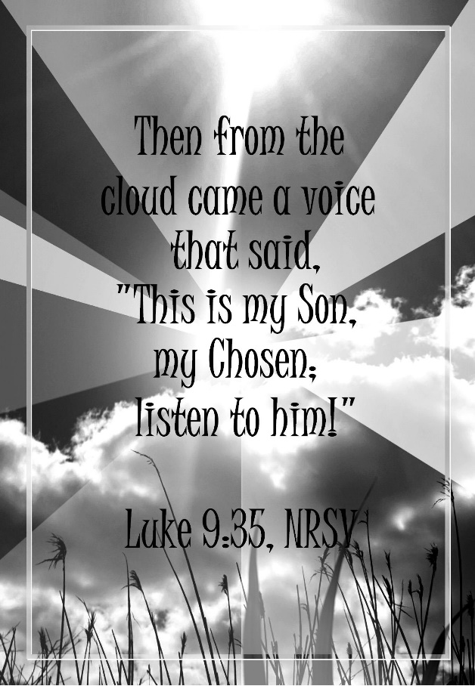

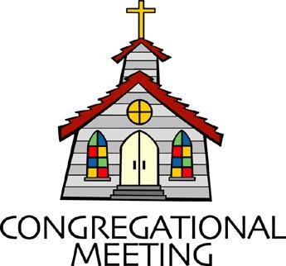
February 27, 2022 - 10:30 am

WELCOME VISITORS! We're glad you are here! Cards at the ends of each pew are for you to fill out and drop in the Offering Plate. Please let us know you are visiting, and join us for refreshments and fellowship following the service. The Sanctuary has an induction loop system to assist the hearing impaired. The system will also work on the telephone setting of hearing aids.

Springfield Presbyterian Church is rooted in the gospel of Jesus Christ, led by the Holy Spirit, and called to loving relationships through vibrant worship and service. Valuing all people, we are committed to developing disciples and fostering stewardship.

PREPARATION FOR THE WORD
(* those who are able are invited to stand)
PRELUDE

GATHERING OF THE PEOPLE

The Lord be with you! And also with you! (Greeting)

LIGHTING THE CHRIST CANDLE
Leader: Whenever we light this candle we proclaim:
People: Christ is the Light of the world and the center of our lives.

CALL TO WORSHIP [Psalm 99]
Leader: The Lord is king; let the peoples tremble!
People: He sits enthroned upon the cherubim; let the earth quake!
Leader: Let them praise your great and awesome name. Holy is He!
People: Mighty King, lover of justice, you have established equity.
Leader: You have executed justice and righteousness in Jacob
People: Extol the Lord our God; worship at His footstool. Holy is He!
Leader: Moses and Aaron were among His priests, Samuel also was among those who called on His name.
People: They cried to the Lord and the Lord answered them.
Leader: He spoke to them in the pillar of cloud;
People: They kept His decrees, and the statutes that He gave them.
Leader: O Lord our God, you answered them; you were a forgiving God to them, but an avenger of their wrongdoings.
People: Extol the Lord our God, and worship at His holy mountain; for the Lord our God is holy.
ALL: Let us praise our faithful and loving God! Amen!

* HYMN God of Grace and God of Glory #307

God of grace and God of glory, on thy people pour thy power;
Crown thine ancient church's story; bring its bud to glorious flower.
Grant us wisdom, grant us courage, for the facing of this hour,
For the facing of this hour.

Lo! the hosts of evil round us scorn thy Christ, assail his ways!
From the fears that long have bound us free our hearts to faith and praise.
Grant us wisdom, grant us courage, for the living of these days,
For the living of these days.

Cure thy children's warring madness; bend our pride to thy control;
Shame our wanton, selfish gladness, rich in things and poor in soul.
Grant us wisdom, grant us courage, lest we miss thy kingdom's goal,
Lest we miss thy kingdom's goal.

Save us from weak resignation to the evils we deplore.
Let the gift of thy salvation be our glory evermore.
Grant us wisdom, grant us courage, serving thee whom we adore,
Serving thee whom we adore.

CALL TO CONFESSION
Leader: We are a people of imagination and intelligence, yet when we hear the words of the Transfiguration, it can seem too brilliant to be real. It’s hard for us to imagine the scene, outside the movies, happening in our world. Let us come admit our unbelief and seek your forgiveness as we learn to live anew.

PRAYER OF CONFESSION
The sights of the great mountaintop, the overwhelming cloud, and a radical healing are things we want to interpret and believe. Yet,

we must be honest and admit our human disbelief. We ask that you remove the cynicisms from our eyes and our hearts and restore us to believe in what may seem impossible. Help us to remember again and again that by your power, all is able, so we ask that you forgive us and encourage us by that good news.

SILENT PRAYERS OF CONFESSION

RESPONSE Come and Fill Our Hearts Tune #466
Come and fill our hearts with your peace. You alone, O Lord, are holy.
Come and fill our hearts with your peace. Alleluia!

WORDS OF ASSURANCE
Leader: When we come before God and admit our sin, our God is ready and willing to meet us where we are and forgive our sin.
People: Thanks be to our forgiving and loving God! We are a grateful people! Amen!

* MUSICAL RESPONSE OF PRAISE Now Thank We All Our God
All praise and thanks to God, who reigns in highest heaven,
To Father and to Son and Spirit now be given.
The one eternal God, whom heaven and earth adore,
The God who was, and is, and shall be ever more.

* THE PEACE The peace of Christ be with you! And also with you!
(You may greet those around you.)

* RESPONSE Here I Am, Lord
Here I am, Lord, Is it I, Lord? I have heard you calling in the night.
I will go, Lord, if you lead me. I will hold your people in my heart.

THE PROCLAMATION OF THE WORD

PRAYER OF ILLUMINATION
Generous God, we long to be faithful disciples, so help us to hear your Word with intentionality today. Remove all distractions from our minds and hearts and set our ears to clearly hear the Word you have for us today. As we listen, may we continue to be changed by this Word and renewed for the work of your Kingdom. Amen.

FIRST SCRIPTURE LESSON Psalm 92:1-5; 12-15
¹ It is good to give thanks to the Lord, to sing praises to your name, O Most High; ² to declare your steadfast love in the morning, and your faithfulness by night, ³ to the music of the lute and the harp, to the melody of the lyre. ⁴ For you, O Lord, have made me glad by your work; at the works of your hands I sing for joy. ⁵ How great are your works, O Lord! Your thoughts are very deep! ¹² The righteous flourish like the palm tree, and grow like a cedar in Lebanon. ¹³ They are planted in the house of the Lord; they flourish in the courts of our God. ¹⁴ In old age they still produce fruit; they are always green and full of sap, ¹⁵ showing that the Lord is upright; he is my rock, and there is no unrighteousness in him.

SECOND SCRIPTURE LESSON Luke 9:28-43[a]
²⁸Now about eight days after these sayings Jesus took with him Peter and John and James, and went up on the mountain to pray. ²⁹And while he was praying, the appearance of his face changed, and his clothes became dazzling white. ³⁰Suddenly they saw two men, Moses and Elijah, talking to him. ³¹They appeared in glory and were speaking of his departure, which he was about to accomplish at Jerusalem. ³²Now Peter and his companions were weighed down with sleep; but since they had stayed awake, they saw his glory and the two men who stood with him. ³³Just as they were leaving him, Peter said to Jesus, ‘Master, it is good for us to be here; let us make three dwellings, one for you, one for Moses, and one for Elijah’—not knowing what he said. ³⁴While he was saying this, a cloud came and overshadowed them; and they were terrified as they entered the cloud. ³⁵Then from the cloud came a voice that said, ‘This is my Son, my Chosen; listen to him!’ ³⁶When the voice had spoken, Jesus was found alone. And they kept silent and in those days told no one any of the things they had seen. ³⁷On the next day, when they had come down from the mountain, a great crowd met him. ³⁸Just then a man from the crowd shouted, ‘Teacher, I beg you to look at my son; he is my only child. ³⁹Suddenly a spirit seizes him, and all at once he shrieks. It throws him into convulsions until he foams at the mouth; it mauls him and will scarcely leave him. ⁴⁰I begged your disciples to cast it out, but they could not.’ ⁴¹Jesus answered, ‘You faithless and perverse generation, how much longer must I be with you and bear with you? Bring your son here.’ ⁴²While he was coming, the demon dashed him to the ground in convulsions. But Jesus rebuked the unclean spirit, healed the boy, and gave him back to his father. ⁴³And all were astounded at the greatness of God.

Leader: Hear what the Spirit is saying to the Church.
All: Thanks be to God.

SERMON A Transformative Transfiguration Rev. Becca Crate-Price

THE RESPONSE TO THE WORD

* HYMN Swiftly Pass the Clouds of Glory #190
Swiftly pass the clouds of glory, heaven’s voice, the dazzling light;
Moses and Elijah vanish; Christ alone commands the height!
Peter, James, and John fall silent, turning from the summit’s rise downward toward the shadowed valley where their Lord has fixed his eyes.
Glimpsed and gone the revelation, they shall gain and keep its truth, not be building on the mountain any shrine or sacred booth,
But by following the Savior through the valley to the cross and by testing faith’s resilience through betrayal, pain, and loss.

Lord, transfigure our perception with the purest light that shines, and recast our life’s intentions to the shape of your designs,
Till we seek no other glory than what lies past Calvary’s hill and our living and our dying and our rising by your will.

PASTORAL PRAYER AND THE LORD’S PRAYER

ANTHEM I Heard the Voice of Jesus Say

* HYMN Lord, the Light of Your Love Is Shining #192
Lord, the light of your love is shining, in the midst of the darkness, shining; Jesus, Light of the World, shine upon us; set us free by the truth you now bring us. Shine on me; shine on me.

Refrain:
Shine, Jesus, shine; fill this land with the Father’s glory.
Blaze, Spirit, blaze; set our hearts on fire.
Flow, river, flow; flood the nations with grace and mercy.
Send forth your word, Lord, and let there be light.

Lord, I come to your awesome presence, from the shadows into your radiance; by the blood I may enter your brightness.
Search me; try me; consume all my darkness. Shine on me; shine on me. [Refrain]

As we gaze on your kingly brightness, so our faces display your likeness; ever changing from glory to glory, mirrored here may our lives tell your story. Shine on me; shine on me. [Refrain]

* CHARGE AND BENEDICTION
Leader: Changed and transformed,
People: We go out into this world as different people.
Leader: Changed and transformed,
People: We remember the glory of God around every corner.
Leader: Changed and transformed,
People: We anticipate the God who makes all things possible.

* UNISON AMEN

POSTLUDE

Sunday March 6, 2022 Lectionary
Deuteronomy 26:1-11; Psalm 91:1-2, 9-16; Romans 10:8b-13; Luke 4:1-13

Assisting in Worship: We appreciate those who serve:

Today 2/27 Next Week 3/6
Sunday Opener Barbara Cornell Ron Holmes
Greeter Donna Mazer Beth Oates
Lay Leader Elizabeth Meirowitz Don Vasbinder

Announcements

Easter Flowers: LAST CHANCE to order your Easter flowers! Please send your order to the Office!

Springfield Membership: Are you interested in finding out more about our faith community and becoming a member? We would love to answer any questions you have. Please contact Pastor Becca at springfieldpastor@gmail.com for more information.

Per Capita: Per Capita is how we Presbyterian congregations care for each other and stay connected. It funds mission work, support and training for pastors and congregations, and administration expenses. Our portion this year is $38.13; $28 remains at Presbytery, $1.15 to Synod, and $8.98 to General Assembly. You will find this expense in our budget but you can help offset that and show your support by contributing that portion as faithful members. There is a wonderful article by J. Herbert Nelson, Stated Clerk for PC(USA) that can be found by going to baltimorepresbytery.org/percapita and then scroll to the bottom of the page to click on Stated Clerk: What per capita pays for, why it matters.

Fellowship Reminder: Following the Worship service, we will gather downstairs for fellowship, but will not have food and will continue to wear our masks. We, as a Session, have made this decision out of an abundance of caution and the desire to keep our family of Christ safe and healthy.

Congregational Care / Mission & Outreach: Do you know of a member or friend of our church family who is ill, needs prayers, would like call, a visit or a card, or might benefit from meal train? If so, please contact the Church Office (410-795-6152), Cathy Marsh (410-549-6916) or Diana Steppling (862-266-2242).

Inclement Weather: If we feel the need to cancel Worship, there will be a message on the Church answering machine, as well as on Facebook. You may also receive an email with that information.

Today:
Sunday February 27
10:30 am Worship
11:30 am Fellowship

This Week:
Wednesday March 2 – Ash Wednesday
7:00 pm Worship

Looking Ahead:
Sunday March 6
9:30 am Adult Choir Practice
10:30 am Worship
11:30 am Fellowship
Wednesday March 9
6:15 – 7:15 pm Bell Choir Practice
No Adult Choir Practice
Thursday March 10
7:00 pm Session Meeting

Office Hours: Tuesday, Wednesday & Friday
Springfield Presbyterian Church

10:30 am Worship
11:30 am Fellowship
Website: www.springfield-church.org Church Office: 410-795-6152
Like us on Facebook: www.facebook.com/SpringfieldPresbyterianChurch
Pastor: Rev. Becca Crate-Price
Email: springfieldpastor@gmail.com
Clerk of Session: Sharon Pappas
Minister of Music: Linda Caviglia
Accompanist/Organist: Aaron Thacker
Youth Group Coordinator: Dylan Vasbinder
Administrative Assistant: Donna Mazer e-mail: spc.office@verizon.net

