(Large Print)

Springfield Presbyterian Church (USA)
7300 Spout Hill Road, Sykesville, MD 21784 410-795-6152

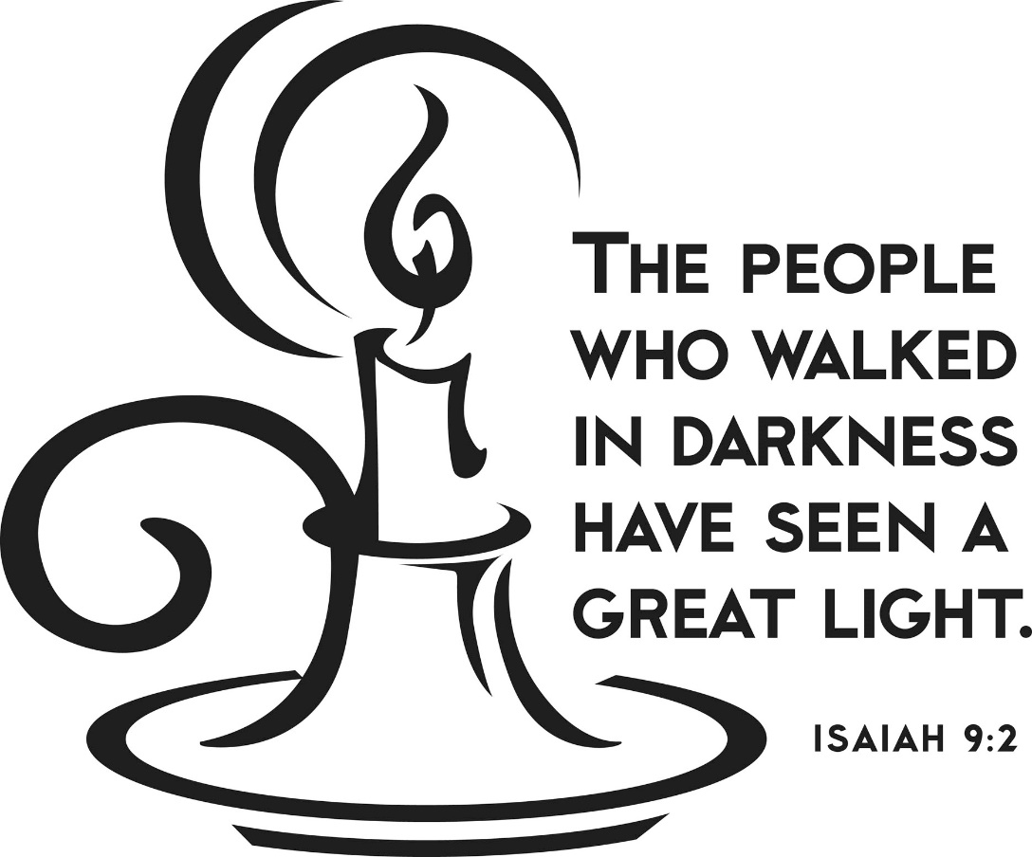

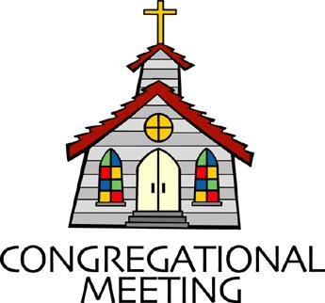
January 22, 2023 - 10:30 am

WELCOME VISITORS!
We're glad you are here! Cards at the ends of each pew are for you to fill out and drop in the Offering Plate. Please let us know you are visiting, and join us for refreshments and fellowship following the service. The Sanctuary has an induction loop system to assist the hearing impaired. The system will also work on the telephone setting of hearing aids.

Springfield Presbyterian Church is rooted in the gospel of Jesus Christ, led by the Holy Spirit, and called to loving relationships through vibrant worship and service. Valuing all people, we are committed to developing disciples and fostering stewardship.

PREPARATION FOR THE WORD
(* those who are able are invited to stand)

PRELUDE

GATHERING OF THE PEOPLE

The Lord be with you! And also with you! (Greeting)

LIGHTING THE CHRIST CANDLE
Leader: Whenever we light this candle we proclaim:
People: Christ is the Light of the world and the center of our lives.

CALL TO WORSHIP Psalm 27:1, 4-6
Leader: The Lord is our light and our salvation; whom shall we fear?
People: The Lord is the stronghold of our lives; of whom shall we be afraid?
Leader: One thing we asked of the Lord, that we will seek after;
People: To live in the house of the Lord all the days of our lives.
Leader: And to behold the beauty of the Lord and to inquire in His temple.
People: For He will hide us in His shelter in the day of trouble.
Leader: He will conceal us under the cover of His tent; He will set us high on a rock.
People: Now our heads are lifted up, above our enemies all around us.
Leader: We will offer in His tent sacrifices with shouts of joy.
People: We will sing and make melody to the Lord.
ALL: Let us come and worship the light of the world, our Living Lord!

* HYMN Christ, Be Our Light GTG #314

Longing for light, we wait in darkness.
Longing for truth, we turn to you. Make us your own,
Your holy people, light for the world to see.

Refrain:
Christ, be our light! Shine in our hearts.
Shine through the darkness.
Christ, be our light! Shine in your church gathered today.

Longing for peace, our world is troubled.
Longing for hope, many despair. Your word alone has power to save us.
Make us your living voice. [Refrain]

Longing for food, many are hungry.
Longing for water, many still thirst. Make us your bread,
Broken for others, shared until all are fed. [Refrain]

Longing for shelter, many are homeless.
Longing for warmth, many are cold. Make us your building,
Sheltering others, walls made of living stone. [Refrain]

Many the gifts, many the people, many the hearts that yearn to belong.
Let us be servants to one another, making your kingdom come. [Refrain]

CALL TO CONFESSION
Leader: In these last few weeks, we have heard the proclamation that the light will always overcome the darkness. Yet, as we look around, as the winter chills our bones, we can find it difficult to see your light. We can easily become skeptical, forgetting the awe and wonder of our Savior’s birth as we move farther from the stable that Christmas morning. Let us come together, remembering that God can change and transform us, renew our Spirits, and remind us of who we are once again. In confidence, we pray together:

PRAYER OF CONFESSION
Gracious God, our sins are too heavy to carry, too real to hide, and too deep to undo. Forgive what our lips tremble to name, what our hearts can no longer bear, and what has become for us a consuming fire of judgment. Set us free from a past that we cannot change; open to us a future in which we can be changed; and grant us grace to grow more and more in your likeness and image; through Jesus Christ, the light of the world. Amen.

SILENT PRAYERS OF CONFESSION

RESPONSE Just as I Am, without One Plea Tune #442
Just as I am, thou wilt receive, wilt welcome, pardon, cleanse, relieve;
Because thy promise I believe, O Lamb of God, I come; I come!

WORDS OF ASSURANCE [1 Tim. 1:15; 1 Peter 2:24]
Leader: The saying is sure and worthy of full acceptance, that Jesus Christ came into the world to save sinners. He himself bore our sins in His body on the cross, that we might be dead to sin, and alive to all that is good.
People: We declare in the name of Jesus Christ, we are forgiven! Thanks be to God. Alleluia and Amen.

* MUSICAL RESPONSE OF PRAISE We Praise You, O God Tune #612
We praise you, O God, our Redeemer, Creator;
In grateful devotion our tribute we bring.
We lay it before you; we kneel and adore you;
We bless your holy name; glad praises we sing.

* THE PEACE The peace of Christ be with you! And also with you!
(You may greet those around you.)

* RESPONSE Here I Am, Lord
Here I am, Lord, Is it I, Lord? I have heard you calling in the night.
I will go, Lord, if you lead me. I will hold your people in my heart.

THE PROCLAMATION OF THE WORD

PRAYER OF ILLUMINATION
Living God, speak to us, as you have spoken to our ancestors: through the voices of your prophets, the breath of your spirit, and the life of your Son, so that we may live according to your word; through Jesus Christ our Savior. Amen.

FIRST SCRIPTURE LESSON Isaiah 9:1-4
But there will be no gloom for those who were in anguish. In the former time he brought into contempt the land of Zebulun and the land of Naphtali, but in the latter time he will make glorious the way of the sea, the land beyond the Jordan, Galilee of the nations. ² The people who walked in darkness have seen a great light; those who lived in a land of deep darkness—on them light has shined. ³ You have multiplied the nation, you have increased its joy; they rejoice before you as with joy at the harvest, as people exult when dividing plunder. ⁴ For the yoke of their burden, and the bar across their shoulders, the rod of their oppressor, you have broken as on the day of Midian.

SECOND SCRIPTURE LESSON Matthew 4:12-23
¹²Now when Jesus heard that John had been arrested, he withdrew to Galilee. ¹³He left Nazareth and made his home in Capernaum by the lake, in the territory of Zebulun and Naphtali, ¹⁴so that what had been spoken through the prophet Isaiah might be fulfilled: ¹⁵ ‘Land of Zebulun, land of Naphtali, on the road by the sea, across the Jordan,

Galilee of the Gentiles— ¹⁶ the people who sat in darkness have seen a great light, and for those who sat in the region and shadow of death light has dawned.’ ¹⁷From that time Jesus began to proclaim, ‘Repent, for the kingdom of heaven has come near.’ ¹⁸As he walked by the Sea of Galilee, he saw two brothers, Simon, who is called Peter, and Andrew his brother, casting a net into the lake—for they were fishermen. ¹⁹And he said to them, ‘Follow me, and I will make you fish for people.’ ²⁰Immediately they left their nets and followed him. ²¹As he went from there, he saw two other brothers, James son of Zebedee and his brother John, in the boat with their father Zebedee, mending their nets, and he called them. ²²Immediately they left the boat and their father, and followed him. ²³Jesus went throughout Galilee, teaching in their synagogues and proclaiming the good news of the kingdom and curing every disease and every sickness among the people.

SERMON In Darkness, A New Light Shines Rev. Becca Price

THE RESPONSE TO THE WORD

* HYMN Arise, Your Light Is Come! GTG #744

Arise, your light is come! The Spirit’s call obey;
Show forth the glory of your God, which shines on you today.

Arise, your light is come! Fling wide the prison door;
Proclaim the captives’ liberty, good tidings to the poor.

Arise, your light is come! All you in sorrow born,
Bind up the broken-hearted ones and comfort those who mourn.

Arise, your light is come! The mountains burst in song!
Rise up like eagles on the wing; God’s power will make us strong.

PASTORAL PRAYER AND THE LORD’S PRAYER

OFFERTORY Who at My Door is Standing? By K. Lee Scott
* SONG OF THANKS Take My Life Tune #697
Take my silver and my gold; not a mite would I withhold;
Take my intellect and use every power as thou shalt choose,
Every power as thou shalt choose.
* PRAYER OF DEDICATION

* HYMN Lord, You Give the Great Commission GTG #298

Lord, you give the great commission: “Heal the sick and preach the word.”
Lest the church neglect its mission, and the gospel go unheard,
Help us witness to your purpose with renewed integrity:
With the Spirit’s gifts empower us for the work of ministry.

Lord, you call us to your service: “In my name baptize and teach.”
That the world may trust your promise, life abundant meant for each,
Give us all new fervor, draw us closer in community:
With the Spirit’s gifts empower us for the work of ministry.

Lord, you make the common holy: “This, my body; this, my blood.”
Let us all, for earth’s true glory, daily lift life heavenward,
Asking that the world around us share your children’s liberty:
With the Spirit’s gifts empower us for the work of ministry.

Lord, you show us love’s true measure: “Father, what they do, forgive.”
Yet we hoard as private treasure all that you so freely give.
May your care and mercy lead us to a just society:
With the Spirit’s gifts empower us for the work of ministry.

Lord, you bless with words assuring: “I am with you to the end.”
Faith and hope and love restoring, may we serve as you intend,
And, amid the cares that claim us, hold in mind eternity:
With the Spirit’s gifts empower us for the work of ministry.

* CHARGE AND BENEDICTION
Leader: In a world that dwells in darkness,
People: Let us be a people of light.
Leader: Let us speak words of love.
People: Let us offer love to all who we encounter,
Leader: So that we may be the disciples of God,
People: Here in the present and every day to come.

* UNISON AMEN

POSTLUDE

Assisting in Worship: We appreciate those who serve:

Today 1/22 Next Week 1/29
Sunday Opener: Bob Rogers Barbara Cornell
Ushers/Greeters: Sharon Pappas Alex & Brenda
Cynthia Smith McClung
Lay Leader: Mark Kearney Tim Oates

Happy Birthday! January 23 – Natalie Halvorson

Happy Anniversary! January 23 – Carl & Kari Anderson
Sunday January 29, 2023 Lectionary
Micah 6:1-8; Psalm 15; 1 Corinthians 1:18-31; Matthew 5:1-12

Announcements

Upcoming Concert: Mark your calendars for Sunday, February 5 at 3:00 pm when we welcome the Eric Byrd Trio, enthusiastic ambassadors of jazz, for a concert in our Sanctuary!

Fellowship: There's something fun and exciting coming up in February! The Souper Bowl!! No, I didn't mean the Super Bowl but the "Souper Bowl of Caring"! Sunday February 12 we will gather for our annual soup lunch -- right after our Congregational Meeting. We already have 5 soups coming, including chili and a vegetarian option. If you would like to bring something, like rolls or sandwiches, there will be a sign-up sheet at church or you can contact me, barbaracornell4@gmail.com, to see what else is needed. Maybe you'd like to help set up tables on Saturday afternoon!

The "Souper Bowl of Caring" is an opportunity for fellowship and sharing, but it is also a chance to give to people who are food-insecure. Our youth are spearheading this collection, so give generously.
Thank you, Barbara Cornell

Thank you! Thank you so much to the congregation for your generous Christmas gifts again this year! It is truly our pleasure to know you all and work with you all! Grace and Peace in the New Year ~ Pastor Becca, Linda Caviglia, Aaron Thacker and Donna Mazer

Springfield Membership: Are you interested in finding out more about our faith community and becoming a member? We would love to answer any questions you have. Please contact Pastor Becca at springfieldpastor@gmail.com for more information.

Winter Fellowship Time: A new year has started--time to make our plans for Fellowship in the new year! We'd love to have your help providing and serving the goodies we share as we visit after worship. If you have not hosted Fellowship yet, we can pair you with someone who knows the routine, and how to make the coffee.
If you don't want to host, we would be happy to have you sign up to bring something in. We always have a supply of crackers and cookies in the kitchen, but our table often includes fruit, cheese and baked goods. Let us know on the sign-up sheet in the kitchen or email me what you'd like to bring. Thanks so much!
Barbaracornell@gmail.com or 240-308-0035

Congregational Care / Mission & Outreach (CoCaMO): Do you know of a member or friend of our church family who is ill, needs prayers, would like call, a visit or a card, or might benefit from meal train? If so, please contact the Church Office (410-795-6152), Cathy Marsh (410-549-6916) or Diana Steppling (862-266-2242).

Prayers & Thanksgivings

~ Prayers of healing for Jeanie Nicholas (Julie Ballard’s niece) who is struggling with cancer.
~ Continued prayers for Diana Steppling who was recently diagnosed with Parkinson’s.

Today:
Sunday January 22
10:30 am Worship
11:30 am Fellowship
12:00 noon RGEF Meeting (Library)

This Week:
Wednesday January 25
7:30 – 8:45 pm Adult Choir Practice

Looking Ahead:
Sunday January 29 – Noisy Offering
10:30 am Worship
11:30 am Fellowship
12:00 noon Nominating Committee Meeting
Wednesday February 1
7:30 – 8:45 pm Adult Choir Practice

Office Hours: Tuesday, Wednesday and Friday, 10:00 am - 3:00 pm
Springfield Presbyterian Church

10:30 am Worship
11:30 am Fellowship
Website: www.springfield-church.org Church Office: 410-795-6152
Like us on Facebook: www.facebook.com/SpringfieldPresbyterianChurch
Pastor: Rev. Becca Price
Email: springfieldpastor@gmail.com
Clerk of Session: Sharon Pappas
Minister of Music: Linda Caviglia
Accompanist/Organist: Aaron Thacker
Youth Group Coordinator: Dylan Vasbinder
Administrative Assistant: Donna Mazer e-mail: spc.office@verizon.net

