(Large Print)

Springfield Presbyterian Church (USA)
7300 Spout Hill Road, Sykesville, MD 21784 410-795-6152

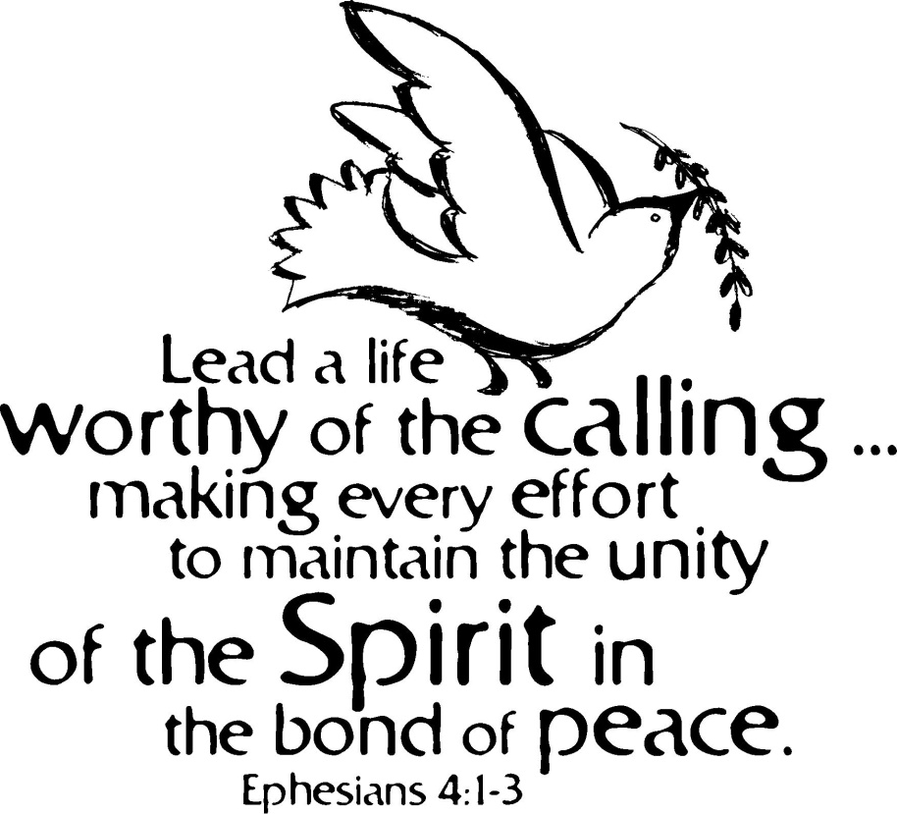

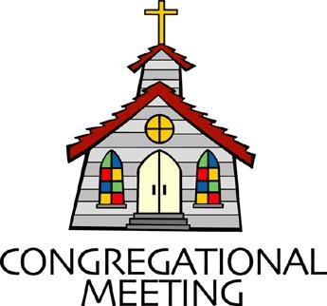
August 5, 2018 - 9:30 am

WELCOME VISITORS! We're glad you are here! Cards at the ends of each pew are for you to fill out and drop in the Offering Plate. Please let us know you are visiting, and join us for refreshments and fellowship following the service. The Sanctuary has an induction loop system to assist the hearing impaired. The system will also work on the telephone setting of hearing aids. A head set is available upon request.

Springfield Presbyterian Church is rooted in the gospel of Jesus Christ, led by the Holy Spirit, and called to loving relationships through vibrant worship and service. Valuing all people, we are committed to developing disciples and fostering stewardship.

PREPARATION FOR THE WORD
(* those who are able are invited to stand)

Please prepare for worship by listening to the music of the Prelude.

PRELUDE

GATHERING OF THE PEOPLE

The Lord be with you! And also with you! (Greeting)

LIGHTING THE CHRIST CANDLE
Leader: Whenever we light this candle we proclaim:
People: Christ is the Light of the world and the center of our lives.

CALL TO WORSHIP [Psalm 136:1-9]
Leader: O give thanks to the Lord, for He is good,
People: For His steadfast love endures forever.
Leader: O give thanks to the God of gods,
People: For His steadfast love endures forever.
Leader: O give thanks to the Lord of lords,
People: For His steadfast love endures forever.
Leader: Who alone does great wonders,
People: For His steadfast love endures forever.
Leader: Who by understanding made the heavens,
People: For His steadfast love endures forever.
Leader: Who spread out the earth on the waters,
People: For His steadfast love endures forever.
Leader: Who made the great lights,
People: For His steadfast love endures forever.
Leader: The sun to rule over the day,
People: For His steadfast love endures forever.
Leader: The moon and stars to rule over the night,
People: Let us praise our God, for His steadfast love endures forever!

* HYMN For The Beauty of the Earth

PRAYER OF CONFESSION
Generous God, we are one in you, the body of Christ, each called to different ministries and purposes. Yet, we ignore the calling that you’ve placed on our hearts and our lives. When you ask us to be brave, we avert our eyes. When you ask us to share an unpopular message, we hope someone else will do it. When you ask us to be the community together in diverse and rich ways, we seek solitude alone. We have sinned and fallen short of the call, and so we ask you anew to revive that purpose within us and show us how to live a life worthy of your calling. Gracious God, forgive us, restore us, and redeem us back to your purposes. Amen.

SILENT PRAYERS OF CONFESSION

RESPONSE Kyrie
Lord, have mercy upon us. Christ, have mercy upon us. Lord, have mercy upon us.

WORDS OF ASSURANCE
Leader: Who is in a position to condemn? Only Christ – and Christ lived for us, died for us, and rose to glorious resurrection for us. In Him, we are forgiven.
People: Praise be to our God!

* MUSICAL RESPONSE OF PRAISE How Great Thou Art
Then sings my soul, my Savior God, to Thee, how great Thou art, how great Thou art. Then sings my soul, my Savior God, to Thee, how great Thou art, how great Thou art!
* THE PEACE The peace of Christ be with you! And also with you!
(you may greet those around you)

* RESPONSE Here I Am, Lord
Here I am, Lord, Is it I, Lord? I have heard you calling in the night.
I will go, Lord, if you lead me. I will hold your people in my heart.

THE PROCLAMATION OF THE WORD

FIRST SCRIPTURE LESSON Psalm 135:1-14
¹ Praise the Lord! Praise the name of the Lord; give praise, O servants of the Lord, ² you that stand in the house of the Lord, in the courts of the house of our God. ³ Praise the Lord, for the Lord is good; sing to his name, for he is gracious. ⁴ For the Lord has chosen Jacob for himself, Israel as his own possession. ⁵ For I know that the Lord is great; our Lord is above all gods. ⁶ Whatever the Lord pleases he does, in heaven and on earth, in the seas and all deeps. ⁷ He it is who makes the clouds rise at the end of the earth; he makes lightnings for the rain and brings out the wind from his storehouses. ⁸ He it was who struck down the firstborn of Egypt, both human beings and animals; ⁹ he sent signs and wonders into your midst, O Egypt, against Pharaoh and all his servants.
¹⁰ He struck down many nations and killed mighty kings— ¹¹ Sihon, king of the Amorites, and Og, king of Bashan, and all the kingdoms of Canaan— ¹² and gave their land as a heritage, a heritage to his people Israel. ¹³ Your name, O Lord, endures for ever, your renown, O Lord, throughout all ages. ¹⁴ For the Lord will vindicate his people, and have compassion on his servants.

SECOND SCRIPTURE LESSON Ephesians 4:1-16
I therefore, the prisoner in the Lord, beg you to lead a life worthy of the calling to which you have been called, ²with all humility and gentleness, with patience, bearing with one another in love, ³making every effort to maintain the unity of the Spirit in the bond of peace. ⁴There is one body and one Spirit, just as you were called to the one hope of your calling, ⁵one Lord, one faith, one baptism, ⁶one God and Father of all, who is above all and through all and in all. ⁷But each of us was given grace according to the measure of Christ’s gift. ⁸Therefore it is said,
‘When he ascended on high he made captivity itself a captive; he gave gifts to his people.’ ⁹(When it says, ‘He ascended’, what does it mean but that he had also descended into the lower parts of the earth? ¹⁰He who descended is the same one who ascended far above all the heavens, so that he might fill all things.) ¹¹The gifts he gave were that some would be apostles, some prophets, some evangelists, some pastors and teachers, ¹²to equip the saints for the work of ministry, for building up the body of Christ, ¹³until all of us come to the unity of the faith and of the knowledge of the Son of God, to maturity, to the measure of the full stature of Christ. ¹⁴We must no longer be children, tossed to and fro and blown about by every wind of doctrine, by people’s trickery, by their craftiness in deceitful scheming. ¹⁵But speaking the truth in love, we must grow up in every way into him who is the head, into Christ, ¹⁶from whom the whole body, joined and knitted together by every ligament with which it is equipped, as each part is working properly, promotes the body’s growth in building itself up in love.

Leader: Hear what the Spirit is saying to the Church.
All: Thanks be to God.

TIME WITH YOUNG PEOPLE

SERMON A Life Worthy of the Calling Rev. Becca Crate

THE RESPONSE TO THE WORD

* HYMN I Come With Joy

THE SACRAMENT OF HOLY COMMUNION

INVITATION

THE GREAT PRAYER OF THANKSGIVING
Leader: The Lord be with you.
People: And also with you.
Leader: Lift up your hearts.
People: We lift them up to the Lord.
Leader: Let us give thanks to the Lord our God.
People: It is right to give our thanks and praise.

[The Pastor continues… “…who forever sing to the glory of your name.”]

IN PRAISE OF GOD Tune #581
Holy, holy, holy, Lord, God of Power and might.
Heaven and earth are full of your glory, Hosanna in the highest!
Blessed is He who comes in the name of the Lord.
Hosanna in the highest, hosanna in the highest.

[The Pastor continues… “dedicated to your service.”]

IN PRAISE OF CHRIST Tune #582
Dying, you destroyed our death; rising, you restored our life.
Lord Jesus, come in glory.

PASTORAL PRAYER AND THE LORD’S PRAYER
“For this I pray to God.” / “For this I give thanks to God.”
Congregational Response: “Hear our prayer, O God.”

WORDS OF INSTITUTION

SHARING OF THE MEAL
PRAYER OF DEDICATION (Unison)
Dear God, take us out to live as changed people because we have shared the living bread and cannot remain the same. Ask much of us, expect much from us, enable much by us, encourage many through us. So, Lord, may we live to your glory, both as inhabitants of the earth, and citizens of the commonwealth of Heaven. Through Christ, with Christ, in Christ, in the unity of the Holy Spirit, all glory and honor are yours, almighty God, now and forever. Amen.

PRESENTATION OF TITHES AND OFFERINGS
OFFERTORY
* SONG OF THANKS Doxology
Praise God from whom all blessings flow;
Praise Him, all creatures here below;
Praise Him above, ye heavenly host;
Praise Father, Son and Holy Ghost. Amen.
* PRAYER OF DEDICATION

* HYMN Blessed Be the Tie That Binds

* CHARGE AND BENEDICTION
Leader: We are one body, the body of Christ.
People: And so together we will serve.
Leader: Each of us called to different purposes,
People: So we will use our gifts in this world.
Leader: That all may be united,
People: To live a life worthy of the calling.

* UNISON AMEN

POSTLUDE

