SPRINGFIELD PRESBYTERIAN CHURCH (USA)

7300 Spout Hill Road Sykesville, Maryland 21784

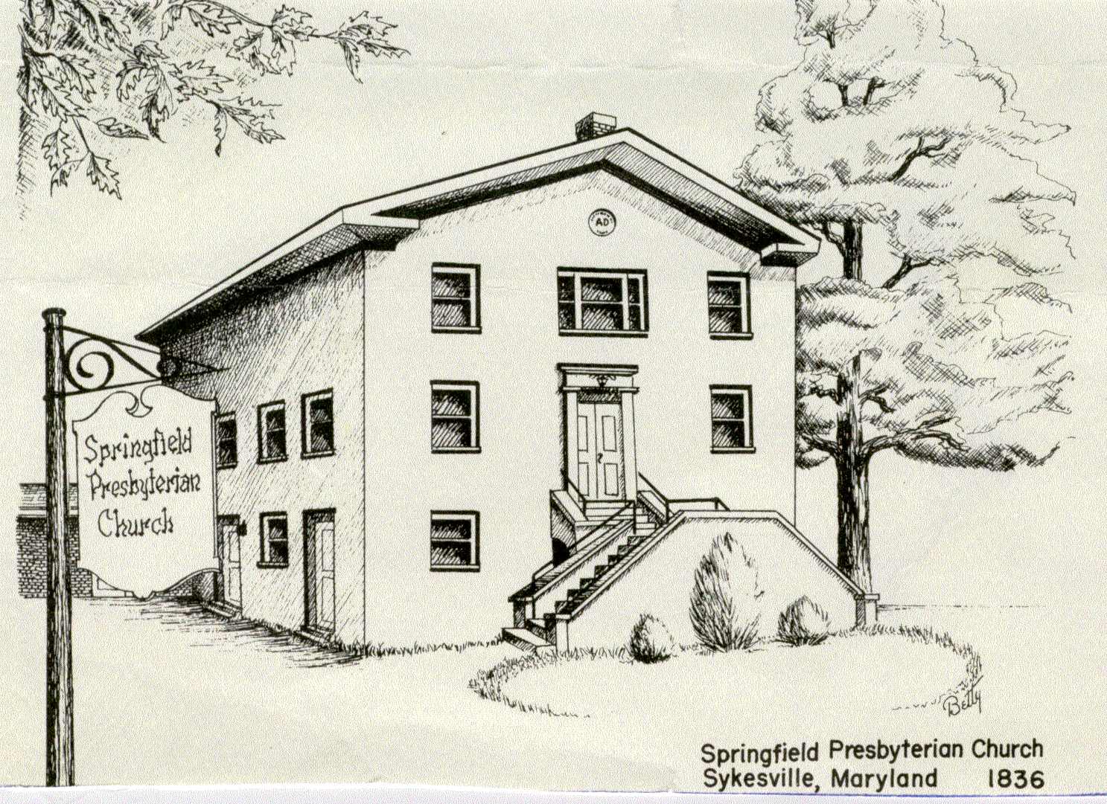

April 3, 2022
Native American Service

WELCOME VISITORS!
We're glad you are here! Cards at the ends of each pew are for you to fill out and drop in the Offering Plate. Please let us know if you are visiting and join us for refreshments and fellowship following the service. The Sanctuary has an induction loop system to assist the hearing impaired. The system will also work on the telephone setting of hearing aids. A headset is available upon request.

Springfield Presbyterian Church is rooted in the gospel of Jesus Christ, led by the Holy Spirit, and called to loving relationships through vibrant worship and service. Valuing all people, we are committed to developing disciples and fostering stewardship.

Prelude
Announcements
Lighting the Christ Candle
Leader: Whenever we light this candle we proclaim:
People: Christ is the Light of the world and center of our lives.
Gathering of the People
Leader: The Lord be with you!
People: And also with you! [Greetings and Announcements]
Call to Worship
Leader: We call God the Creator
People: We call God the Divine Spirit
Leader: We call God the Three in One
People: We call God the Great I Am
Leader: We call God our Savior
People: We call God our Redeemer
Leader: This morning we call God Wakantanka, which means Great Spirit.
People: For our Dakota and Nakota and Lakota siblings of faith
Leader: Let us hear their stories
People: And grow in our faith because of words
ALL: Let us come to worship!
.
*Hymn Hear the Good News of Salvation 411

Call to Confession
When we read out of our textbooks, we often miss the stories of real people. We become blinded by a majority viewpoint. We choose to not know the stories of many, for they are painful.

Yet the stories are important, and God calls us not to be complacent in our own unknowing. Let us ask God to help us to grow and learn as we confess our sin together.

Prayer of Confession

Creator God, as we reflect this Lent, we touch upon the many ways you call us to live more abundantly and listen more attentively. This morning, we have the opportunity to tune our hearts to the ways you are working in the lives of our Dakota friends. Help us not to turn a blind eye, help us to open our ears, and help us to soften our hearts. Forgive us for our complacency and lead us to your service. Amen.

Silent Prayers of Confession

Response: O Lord, Hear My Prayer
O Lord, hear my prayer, O Lord, hear my prayer
When I call, answer me. O Lord, hear my prayer, O Lord, hear my prayer. Come and listen to me.

Words of Assurance
Leader: When we turn to Wakan Tanka, we are forgiven. Let us resonate in that good news.
People: We are a grateful people, forgiven, and ready to begin again. Amen.

Response: Come, Thou Almighty King - #2 v. 4

To thee, great One in Three, eternal praises be, hence evermore!
Thy sovereign majesty may we in glory see, and to eternity love and adore.
The Peace
Leader: The peace of Christ be with you!
People: And also with you! (You may greet those around you)
The Proclamation of the Word

Prayer of Illumination
Creator God, illuminate our hearts and minds by the power of your Holy Spirit to hear the words of your Scripture anew. Guide us in being mindful of what it calls us to do in our time and in our world today. Amen.

First Scripture Lesson [from Many and Great]
Jeremiah 10:12-13

It is he who made the earth by his power, who established the world by his wisdom, and by his understanding stretched out the heavens.

When he utters his voice, there is a tumult of waters in the heavens, and he makes the mist rise from the ends of the earth.

He makes lightnings for the rain, and he brings out the wind from his storehouses.

Second Scripture Lesson [from Hear the Good News of Salvation]

Ephesians 1:13
In him you also, when you had heard the word of truth, the gospel of your salvation, and had believed in him, were marked with the seal of the promised Holy Spirit.
Sermon Baltimore Dakota Partnership Elder Bob Steppling, Chair of the Baltimore Dakota Learning Camp Steering Committee

The Response to the Word
Anthem Many and Great, O God, Are Thy Works
Dakota Melody (see insert)
The Sacrament Of The Lord’s Supper

THE SACRAMENT OF THE LORD’S SUPPER

INVITATION

PRAYERS OF THANKSGIVING
Leader: The Lord be with you.
People: And also with you.
Leader: Lift up your hearts.
People: We lift them up to the Lord.
Leader: Let us give thanks to the Lord God.
People: It is right to give our thanks and praise.

…who forever sing to the glory of your name”

In Praise of God

“…Accept this our sacrifice of praise and thanksgiving as a living and holy offering of ourselves, that our lives may proclaim the one crucified and risen.”

In Praise of Christ

PASTORAL PRAYER & THE LORD’S PRAYER

THE COMMUNION OF THE PEOPLE

CLOSING PRAYER (in Unison)
God of compassion, through your Son Jesus Christ you reconciled your people to yourself. Following His example of prayer and fasting, may we obey you with willing hearts and serve one another in holy love; through Jesus Christ our Lord. Amen.

Offertory
Doxology – Traditional Melody

Wakantanka yatan miye
(Wacantanka yatan meyeah)
Cinhintku kin makata hi,
(Chinhikoo kin macata hee)
Wicaceji yatanpi kte,
(Wichachajee yatanpee tay)
Qa wonyia Wakan kici
(Ka woneeya Wakan keechee)

Charge and Benediction
Leader: As you leave this place, may we be awestruck by the beauty of this world.
People: May we laugh and may it be contagious
Leader: May we overflow with love for those around us.
People: May we be filled with hope and quick to point out joy.
Leader: In all of our living, and breathing, and being,
People: May we find ourselves full to the brim with the God’s Holy Spirit.
Leader: And may it change our lives,
People: In the name of the Beloved and Love itself – let us go in peace, full to the brim. Amen.

Postlude

Sunday April 10, 2022 Lectionary
Luke 19:28-40; Psalms 118:1-2, 19-29; Isa. 50:4-9a & Ps. 31:9-16; Phil. 2:5-11; Luke 22:14-23:56 or Luke 23:1-49
- - - - - - - - - - - - - - - - - -cut here- - - - - - - - - - - - - - - - - - - - - - - - - - - - - - - - -

Assisting in Worship: We appreciate those who serve:

Today 4/3 Next Week 4/10
Sunday Opener
Greeter Bobby Barrett Beth Oates
Bob Rogers
Lay Leader Diana Steppling Max Carroll

Communion Assistance if Needed: Sharon Pappas
Linda Caviglia

Happy Birthday! April 3: Barbara Cornell
3: India Oates
7: Wes McClung
10: Michelle Newsome
12: Lisa Rogers
13: Kelsey Robinson
15: Belle Vasbinder
19: Debbie Sperling
23: Morgan Mazer

Announcements

Springfield Membership: Are you interested in finding out more about our faith community and becoming a member? We would love to answer any questions you have. Please contact Pastor Becca at springfieldpastor@gmail.com for more information.
Mask Update: By the agreement of Session, we are now making masks optional. We do want to encourage you, if you feel compelled or have any underlying conditions, to keep your mask on. If you do wish to take off your mask though, we are also happy to see your faces. More information about fellowship and other practices will be coming as we make our way back to normalcy.

Called Congregational Meeting: Sunday, April 10, 2022. The meeting will be held virtually and in the sanctuary. We will gather immediately after worship for an election of officers. The proposed slate of officers for election includes Ron Holmes, Leah Halvorson and Alex McClung. We are so grateful for the dedication of Elizabeth Meirowitz, Beth Oats and Dianna Steppling who have already served two terms.

Special Thank you: to the Nominating Committee: Beth Oates and Steve Mazer (co-chairs), Carl Anderson, Linda Caviglia, Elizabeth Meirowitz and Belle Vasbinder.

Congregational Care / Mission & Outreach: Do you know of a member or friend of our church family who is ill, needs prayers, would like call, a visit or a card, or might benefit from meal train? If so, please contact the Church Office (410-795-6152), Cathy Marsh (410-549-6916) or Diana Steppling (862-266-2242).

Weekly Announcements: If you have an announcement to include with next week’s bulletin, please call the Office at 410-795-6152 or email to spc.office@verizon.net by Wednesday to make sure your information gets in.

Blessing Bags are in the Narthex. Please feel free to pick up a few. Handing one out to someone in need gives you a very real way to meet their immediate needs by providing them with some basic supplies.

Ruth Gosnell Foundation (RGF) The RGF meeting is rescheduled for April 24, 2022.

Got Candy? The Youth Group will gather before Easter and create a King Cake with lots of candy as we also take an opportunity to teach about the Easter promise. If you have any candy you can donate, please bring it to church.

Next Concert Series: We will welcome Haskill Smith as part of our concert series on April 10, 2022 at 3 p.m. Please see our website for more information.

Fellowship Help Needed: If you are interested in helping with Fellowship, please contact Barbara Cornell (410-549-9397). A sign-up sheet will also be available.

Today:
Sunday April 3, 2022 – 5th Sunday in Lent
10:30 am Worship
11:30 am Fellowship

This Week:
Tuesday April 5, 2022
7:00 p.m. CoCaMo Meeting
Wednesday April 6, 2022
6:15 – 7:15 pm Bell Choir Practice
7:30 – 8:45 pm Adult Choir Practice
Thursday April 7, 2022
7:00 p.m. Session Meeting

Looking Ahead:
Sunday April 10 – Palm/Passion Sunday
10:30 am Worship
11:30 am Fellowship
Wednesday April 13, 2022
6:15 – 7:15 pm Bell Choir Practice
7:30 – 8:45 pm Adult Choir Practice

