Springfield Presbyterian Church (USA)
7300 Spout Hill Road, Sykesville, MD 21784 410-795-6152
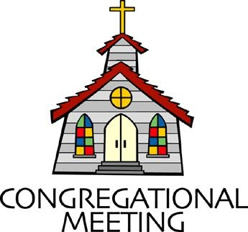

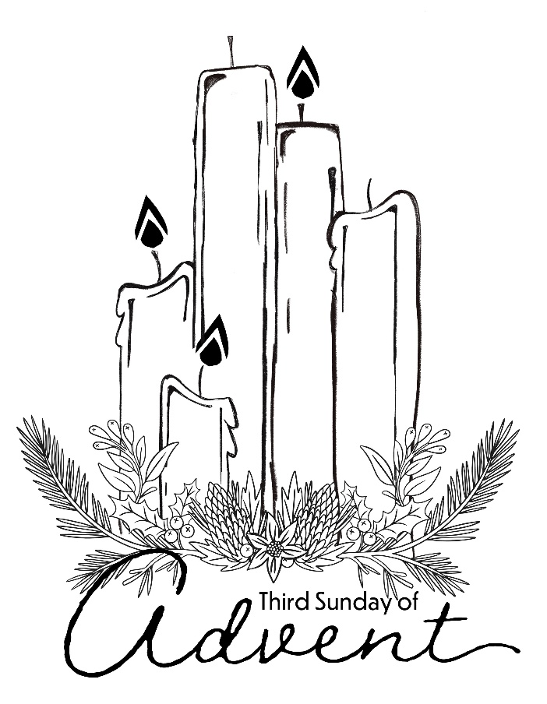

December 14, 2025 - 10:30 am

WELCOME VISITORS!

We're glad you are here! Cards at the ends of each pew are for you to fill out and drop in the Offering Plate. Please let us know you are visiting and join us for refreshments and fellowship following the service. The Sanctuary has an induction loop system to assist the hearing impaired. The system will also work on the telephone setting of hearing aids.

Springfield Presbyterian Church is rooted in the gospel of Jesus Christ, led by the Holy Spirit, and called to loving relationships through vibrant worship and service. Valuing all people, we are committed to developing disciples and fostering stewardship.
PREPARATION FOR THE WORD
(* those who are able are invited to stand)

PRELUDE What Child is This & Ring Christmas Bells both arr. Conley
Flute Trio – Beth Ream, Paula Grapes & Linda Caviglia

GATHERING OF THE PEOPLE

The Lord be with you! And also with you! (Greetings and Announcements)

LIGHTING THE CHRIST CANDLE
Leader: Whenever we light this candle we proclaim:
People: Christ is the Light of the world and the center of our lives.

ADVENT CANDLE LIGHTING – HOPE FOR THOSE WHO ARE WATCHING
Reader: Advent is a time to awaken our spiritual senses.
Congregation: We stand in awe of your deeds, O Lord, repeat them in our day!
Reader: Grant us vision to behold your glory.
Congregation: We stand in awe of your deeds, O Lord, repeat them in our day!
Reader: Quiet us so we may hear your still, soft voice.
Congregation: We stand in awe of your deeds, O Lord, repeat them in our day!
Reader: Make us vessels of your mercy, compassion, and grace.
Congregation: We stand in awe of your deeds, O Lord, repeat them in our day!
Reader: For all of us eagerly watching for your glory in our midst:
Congregation: Grant that we might have the peace of Christ as we wait, the love of Christ as we act, and the grace of Christ as we speak.
Reader: This morning, we light three candles. The first candle reminds us of those who find themselves in a season of waiting, resting in hopeful anticipation for God to act. The second candle is for anyone feeling weakened and wearied by the circumstances of life. We echo the cry of scripture to renew their strength and increase their power. The third candle (the candle of Joy) awakens our spiritual senses, challenging us to embrace the glory of God, as we await our Savior’s promised coming.
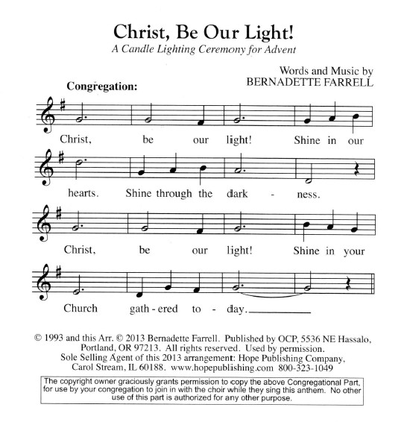

Congregation: God of eternity, you called faithful people throughout the ages to behold your glory. We acknowledge you call us to the same awareness today. We confess at times our spiritual senses are stifled. Rekindle a new awareness of your everlasting glory. We stand in awe of your deeds and ask you to repeat them in our day. In Jesus’s name we pray. Amen.

CALL TO WORSHIP
Leader: This is the season of holy waiting.
People: We wait for the time when the desert will bloom, and all God’s people will come together singing!
Leader: We wait in the shadows for the Light of the World to appear.
People: We yearn for peace. We long for hope. We seek God’s realm of joy.
Leader: Jesus says: I am coming soon.
People: Amen! Come Lord Jesus!

* HYMN Prepare the Way, O Zion GTG #106

Prepare the way, O Zion, your Christ is drawing near!
Let every hill and valley a level way appear.
Greet One who comes in glory, foretold in sacred story.

Refrain:
O blest is Christ who came in God’s most holy name.

He brings God’s rule, O Zion; he comes from heaven above.
His rule is peace and freedom, and justice, truth, and love.
Lift high your praise resounding, for grace and joy abounding. [Refrain]

Fling wide your gates, O Zion; your Savior’s rule embrace,
And tidings of salvation proclaim in every place.
All lands will bow rejoicing, their adoration voicing. [Refrain]

CALL TO CONFESSION
Leader: The life of faith is not only about being faithful to God, it is also about knowing that God is faithful to us. God will never turn away from us. No matter what we carry, there’s room for us in God’s heart. With that confidence, we turn to God speaking the truth of our lives.

PRAYER OF CONFESSION
Holy God, we confess that we do not welcome your light or hope for your future. We could choose a better way, but we don’t. We prepare for war instead of peace. We dishonor one another and lay waste to your creation.
We let our insecurities and assumptions lead the way. Forgive us, O God. Renew us. Transform us. Broaden our imagination and expand our hearts.
Grant us wisdom to choose the better way, courage to walk in your path
and love enough to seek things that will endure, until Christ comes.

SILENT PRAYERS OF CONFESSION

RESPONSE On Jordan’s Bank the Baptist’s Cry GTG #96 (v. 2)
Then cleansed be every life from sin; make straight the way for God within,
And let us all our hearts prepare for Christ to come and enter there.

WORDS OF ASSURANCE
Leader: Hear the good news – for it is all around us: a new song passed from generation to generation. In a dry and dusty land comes a blossom, a crocus,
a spring, a highway, a dance… By water and Spirit we are joined to this wonder.
In Jesus Christ God finds us, forgives us, holds us, embraces us, empowers us.
All: The gift is coming to us. The gift is already here. Thanks be to God!

* MUSICAL RESPONSE OF PRAISE Glory to God GTG #583
Gloria, gloria, in excelsis Deo! Gloria, gloria, alleluia, alleluia!

* THE PEACE The peace of Christ be with you! And also with you!
(You may greet those around you.)

* RESPONSE Here I Am, Lord GTG #69
Here I am, Lord. Is it I, Lord? I have heard you calling in the night.
I will go, Lord, if you lead me. I will hold your people in my heart.

THE PROCLAMATION OF THE WORD

PRAYER FOR ILLUMINATION
Living God, in our dry and dusty lives we long to hear your voice loud and clear,
to have courage to listen and to follow your way. So pour out the power of your Spirit and plant your Word down deep in us, that your Word may blossom in our lives, through Jesus Christ, our way in the wilderness. Amen.

FIRST SCRIPTURE LESSON Isaiah 35:1-10 OT page 623
¹The wilderness and the dry land shall be glad, the desert shall rejoice and blossom; like the crocus ²it shall blossom abundantly, and rejoice with joy and singing. The glory of Lebanon shall be given to it, the majesty of Carmel and Sharon. They shall see the glory of the Lord, the majesty of our God.
³Strengthen the weak hands, and make firm the feeble knees. ⁴Say to those who are of a fearful heart, "Be strong, do not fear! Here is your God. He will come with vengeance, with terrible recompense. He will come and save you." ⁵Then the eyes of the blind shall be opened, and the ears of the deaf unstopped;

⁶then the lame shall leap like a deer, and the tongue of the speechless sing for joy. For waters shall break forth in the wilderness, and streams in the desert;
⁷the burning sand shall become a pool, and the thirsty ground springs of water; the haunt of jackals shall become a swamp, the grass shall become reeds and rushes. ⁸A highway shall be there, and it shall be called the Holy Way; the unclean shall not travel on it, but it shall be for God's people; no traveler, not even fools, shall go astray. ⁹No lion shall be there, nor shall any ravenous beast come up on it; they shall not be found there, but the redeemed shall walk there.
¹⁰And the ransomed of the Lord shall return, and come to Zion with singing; everlasting joy shall be upon their heads; they shall obtain joy and gladness, and sorrow and sighing shall flee away.

SECOND SCRIPTURE LESSON Matthew 11:2-11 NT page 10
²When John heard in prison what the Messiah was doing, he sent word by his disciples ³and said to him, "Are you the one who is to come, or are we to wait for another?" ⁴Jesus answered them, "Go and tell John what you hear and see:
⁵the blind receive their sight, the lame walk, the lepers are cleansed, the deaf hear, the dead are raised, and the poor have good news brought to them. ⁶And blessed is anyone who takes no offense at me." ⁷As they went away, Jesus began to speak to the crowds about John: "What did you go out into the wilderness to look at? A reed shaken by the wind? ⁸What then did you go out to see? Someone dressed in soft robes? Look, those who wear soft robes are in royal palaces. ⁹What then did you go out to see? A prophet? Yes, I tell you, and more than a prophet. ¹⁰This is the one about whom it is written, "See, I am sending my messenger ahead of you, who will prepare your way before you.' ¹¹Truly I tell you, among those born of women no one has arisen greater than John the Baptist; yet the least in the kingdom of heaven is greater than he.

Leader: Hear what the Spirit is saying to the Church.
All: Thanks be to God.

SERMON Or Shall We Wait for Another? By Rev. Sue Lowcock Harris

THE RESPONSE TO THE WORD

* HYMN Once in Royal David’s City GTG #140

Once in royal David’s city stood a lowly cattle shed,
Where a mother laid her baby in a manger for his bed:
Mary was that mother mild; Jesus Christ, her little child.

He came down to earth from heaven who is God and Lord of all,
And his shelter was a stable, and his cradle was a stall;
With the poor and meek and lowly, lived on earth our Savior holy.

Jesus is our childhood’s pattern; day by day like us he grew;
He was little, weak and helpless; tears and smiles like us he knew;
And he feels for all our sadness, and he shares in all our gladness.

And our eyes at last shall see him, through his own redeeming love;
For that child so dear and gentle is our Lord in heaven above;
And he leads his children on to the place where he is gone.

PASTORAL PRAYER AND THE LORD’S PRAYER

PRESENTATION OF TITHES AND OFFERINGS
OFFERTORY A Celtic Advent Carol Barrett/Angerman
(Paula Grapes, flute)
* SONG OF THANKS As with Gladness Men of Old GTG #150 (v. 3)
As they offered gifts most rare at thy manger, rude and bare,
So may we with holy joy, pure and free from sin’s alloy,
All our costliest treasures bring, Christ, to thee, our heavenly king.
* PRAYER OF DEDICATION

* HYMN How Our Hearts with Joy Abound GTG #333

How our hearts with joy abound, with your beauty all around;
Words are feeble to express your great love and righteousness.

Fairer still than human frame, ever to our eyes the same,
Steadfast love shines from your face; from your lips flow words of grace.

Yours the scepter, yours the throne; you to us are God alone.
Vast the mercies to us given: wealth of earth, and joy in heaven.

* CHARGE AND BENEDICTION
Leader: The good news of Advent is this: Christ is coming. Christ is always coming!
All: Amen! Come Lord Jesus!

* UNISON AMEN GTG #601

POSTLUDE Deck the Halls & Joy to the World both arr. Bowen

Assisting in Worship: We appreciate those who serve:

Today 12/14 Next Week 12/21
Sunday Opener: Beth Oates Linda Caviglia
Ushers/Greeters: Elizabeth Meirowitz Alex & Brenda McClung
Cynthia Smith
Lay Leader: Linda Caviglia Mark Chaplik
Pulpit Supply: Rev. Sue Lowcock Harris Rev. Shannon Weston
Fellowship Hosts: Mark & Diane Chaplik Christy Yeager
Offering Count: Andrea Kwako & Beth O. Andrea Kwako & Linda C.

Happy Anniversary! December 14 – Tony and Linda Caviglia

Happy Birthday! December 14 – Dylan Vasbinder
December 19 – Becky Spicer
December 20 – Stephanie Bunting

Sunday December 21, 2025 Lectionary
Isaiah 7:10-16; Psalm 80:1-7, 17-19; Romans 1:1-7; Matthew 1:18-25
Announcements

Welcome! We welcome Rev. Sue Lowcock Harris to our pulpit today! Sue is a retired member of Baltimore Presbytery, currently serving as the Moderator of the Presbytery. She was ordained in 1983 and has served congregations, middle governing bodies, and university campuses in diverse roles as co-pastor, interim pastor, chaplain, project coordinator, and faculty, in urban, rural and suburban settings. From 2005 – 2023 she served as one of the Co-Pastors of the First Presbyterian Church of Howard County, with her husband, Morton Harris. Since retirement, she has served as a Bridge Pastor at Second Presbyterian Church and at Hunting Ridge Presbyterian Church where she continues to support the Session as their Moderator.

Welcome also to Michael Hall, our substitute accompanist! Michael is a Peabody University of Cincinnati graduate with degrees in French horn performance. The bulk of his work is as a freelance horn player. He serves as principal horn with National Philharmonic and Mid Atlantic Symphony, and he subs with many other groups, including the BSO. As a pianist, Michael has worked as an accompanist at both Catholic U and the Duke Ellington School for the Arts, and fills in for worship from time to time at several churches and synagogues in the Baltimore/DC region. He also maintains a small private studio for horn and piano students at his home in Violetville, Baltimore.

Christmas Joy Offering: God has called and trained countless leaders, now in so many places. Let us remember them and their teachers with our Christmas Joy Offering received TODAY and December 21.

Christmas Caroling: We are planning a Christmas Caroling event at 4:00 pm on Sunday afternoon, December 21st. We have a health/rehabilitation center as a very close neighbor – Autumn Lake is just across Spout Hill Road and could really use some outside cheer! We have caroled over there many times, and have always been greeted enthusiastically. Often, residents who are not generally responsive or vocal will join in singing familiar Christmas carols, and you can see in their faces that it means a lot to them. There are several choir members who plan to go, but we would love to have many people from the congregation as well. It’s a busy time of year, but if you can spare an hour or so that afternoon, it will be well worth it for spreading the good news of Christmas to people who may be lonely and missing being at home during the Christmas season. If you are interested, please let Linda Caviglia know, just so she has an idea of how many will be there. (cavig5@comcast.net or
410-746-1221 – call or text)

Zoom Link for Worship Services: The Zoom link for church services is on the SPC website, not on the Facebook page. The Bulletin is also available on the website as well.

Congregational Care: If you know of someone who would benefit from a card or a phone call, please text or call Connie Gibbons at 410-935-3467.

Electronic Giving: Below is a QR code you can scan to make your contribution a new way! The page you get will ask for your name, email and phone

number. You can choose from a dropdown menu for selecting where the donation should go: General Fund, Capital Fund, Concert, Memorial. There is a fee for using a credit card, and you will be given the option to pay that fee along with your donation, but you don’t have to include it if you don’t want to.

Today:
Sunday December 14 – 3rd Sunday of Advent
10:30 am Worship
11:30 am Fellowship
Tuesday December 16
7:00 pm CoCaMO Meeting (Manse)

This Week:
Wednesday December 17
6:15 – 7:15 pm Bell Choir Practice
7:30 – 8:45 pm Adult Choir Practice

Next Week:
Sunday December 21 – 4th Sunday of Advent
10:30 am Worship
11:30 am Fellowship
4:00 pm Caroling at Autumn Lake

Thursday December 24 – Christmas Eve
7:00 pm Worship

Office Hours: Tuesday, Wednesday, Friday, 10 am – 3 pm

Springfield Presbyterian Church
10:30 am Worship (and Sunday School 1st & 3rd Sundays)
11:30 am Fellowship
Website: www.springfield-church.org Church Office: 410-795-6152
Like us on Facebook: www.facebook.com/SpringfieldPresbyterianChurch
Pastor: Vacant
Email: spc.office@verizon.net
Clerk of Session: Sharon Pappas
Minister of Music/Accompanist: Aaron Thacker
Bell Choir Director: Vacant
Youth Group Coordinator: Dylan Vasbinder
Administrative Assistant: Donna Mazer Email: spc.office@verizon.net

