(Large Print)

Springfield Presbyterian Church (USA)
7300 Spout Hill Road, Sykesville, MD 21784 410-795-6152

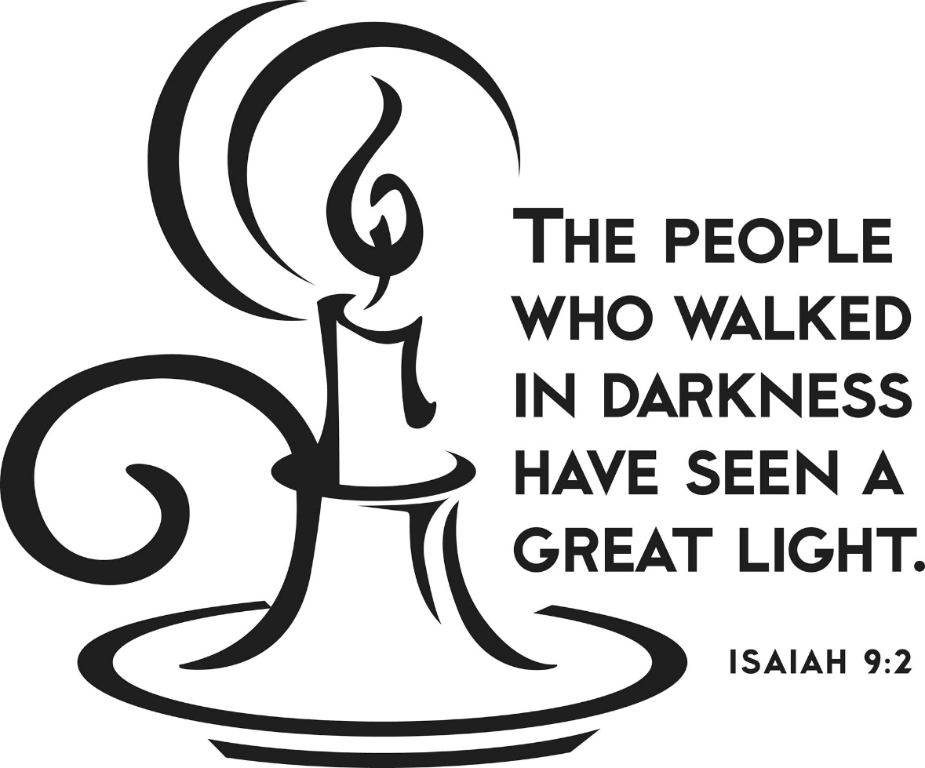

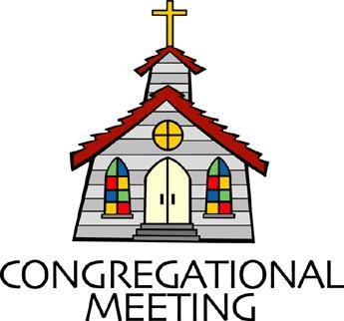
February 2, 2020 - 10:30 am

WELCOME VISITORS! We're glad you are here! Cards at the ends of each pew are for you to fill out and drop in the Offering Plate. Please let us know you are visiting, and join us for refreshments and fellowship following the service. The Sanctuary has an induction loop system to assist the hearing impaired. The system will also work on the telephone setting of hearing aids.

Springfield Presbyterian Church is rooted in the gospel of Jesus Christ, led by the Holy Spirit, and called to loving relationships through vibrant worship and service. Valuing all people, we are committed to developing disciples and fostering stewardship.
PREPARATION FOR THE WORD
(* those who are able are invited to stand)

PRELUDE

GATHERING OF THE PEOPLE

The Lord be with you! And also with you! (Greeting)

LIGHTING THE CHRIST CANDLE
Leader: Whenever we light this candle we proclaim:
People: Christ is the Light of the world and the center of our lives.

CALL TO WORSHIP [Psalm 27:1, 4-9]
Leader: The Lord is our light and our salvation; whom shall we fear?
People: The Lord is the stronghold of our lives; of whom shall we be afraid?
Leader: One thing we asked of the Lord, that will we seek after: to live in the house of the Lord all the days of our lives.
People: To behold the beauty of the Lord, and to inquire in His temple.
Leader: He will hide us in His shelter in the day of trouble.
People: He will conceal us under the cover of His tent, He will set us high on a rock.
Leader: Now our heads are lifted up above all of our enemies,
People: We offer in His tent sacrifices with shouts of joy; we will sing and make melody to the Lord.
Leader: Hear, O Lord, when we cry aloud, be gracious to us and answer us.
People: Come, our hearts say, seek His face! And so, your face, Lord, do we seek. Do not hide your face from us.
Leader: Do not turn your servants away in anger, you who have been our help.
People: Do not cast us off, do not forsake us, O God of our salvation.
ALL: Let us praise and worship our saving and grace-filled God!

* HYMN I Danced in the Morning
I danced in the morning when the world was begun,
And I danced in the moon and the stars and the sun,
And I came down from heaven and I danced on the earth.
At Bethlehem I had my birth.

Refrain:
Dance, then, wherever you may be; I am the Lord of the Dance, said he,
And I'll lead you all, wherever you may be,
And I'll lead you all in the dance, said he.

I danced for the scribe and the Pharisee,
But they would not dance and they would not follow me.
I danced for the fishermen, for James and John.
They came with me and the dance went on. [Refrain]

I danced on the Sabbath and I cured the lame.
The holy people said it was a shame.
They whipped and they stripped and they hung me high,
And left me there on a cross to die. [Refrain]

I danced on a Friday when the sky turned black.
It's hard to dance with the devil on your back.
They buried my body and they thought I'd gone,
But I am the dance and I still go on. [Refrain]

They cut me down and I leapt up high.
I am the life that will never, never die.
I'll live in you if you'll live in me,
I am the Lord of the Dance, said he. [Refrain]

PRAYER OF CONFESSION
Gracious God, we are a people who walk in great light, for you have vanquished the threat of the darkness. Yet, we are a people who can still be consumed by the dark; by the darkness of our own greed and our desire to get ahead. You have multiplied the nation and increased its joy, yet we have not danced in the joy you offer. You have taken away the burden, the bar across our shoulders, yet because of our own want for control, we keep the bar on our own backs secured. Forgive us for the darkness, for the joy we do not seek, and the burden we put upon ourselves when we do not fully trust in you. Forgive us, restore us, and renew us, your beloved people, to who we are called to be, alive and moving in your world. Amen.

SILENT PRAYERS OF CONFESSION

RESPONSE Restore in Us, O God
Restore in us, O God, the splendor of your love;
Renew your image in our hearts, and all our sins remove.

WORDS OF ASSURANCE
Leader: Jesus is the light of the world, and despite our own wrongdoings, He continues to call us back into the light because of His great love and grace for His people.
People: Praise be to God for God’s abundant love and forgiveness!

* MUSICAL RESPONSE OF PRAISE O for a Thousand Tongues
To God all glory, praise, and love be now and ever given
By saints below and saints above, the church in earth and heaven.

* THE PEACE The peace of Christ be with you! And also with you!
(You may greet those around you.)

* RESPONSE Here I Am, Lord
Here I am, Lord, Is it I, Lord? I have heard you calling in the night.
I will go, Lord, if you lead me. I will hold your people in my heart.

THE PROCLAMATION OF THE WORD

PRAYER OF ILLUMINATION
Leader: Gracious God, we do not live by bread alone, but by every word that comes from your mouth. Make us hunger for this your word, that it may nourish us today in the ways of eternal life, through Jesus Christ, the bread of heaven. Amen.

FIRST SCRIPTURE LESSON Isaiah 9:1-4
But there will be no gloom for those who were in anguish. In the former time he brought into contempt the land of Zebulun and the land of Naphtali, but in the latter time he will make glorious the way of the sea, the land beyond the Jordan, Galilee of the nations. ² The people who walked in darkness have seen a great light; those who lived in a land of deep darkness—on them light has shined. ³ You have multiplied the nation, you have increased its joy; they rejoice before you as with joy at the harvest, as people exult when dividing plunder. ⁴ For the yoke of their burden, and the bar across their shoulders, the rod of their oppressor, you have broken as on the day of Midian.

SECOND SCRIPTURE LESSON Matthew 4:12-23
¹²Now when Jesus heard that John had been arrested, he withdrew to Galilee. ¹³He left Nazareth and made his home in Capernaum by the lake, in the territory of Zebulun and Naphtali, ¹⁴so that what had been spoken through the prophet Isaiah might be fulfilled: ¹⁵ ‘Land of Zebulun, land of Naphtali, on the road by the sea, across the Jordan, Galilee of the Gentiles— ¹⁶ the people who sat in darkness have seen a great light, and for those who sat in the region and shadow of death light has dawned.’ ¹⁷From that time Jesus began to proclaim, ‘Repent, for the kingdom of heaven has come near.’ ¹⁸As he walked by the Sea of Galilee, he saw two brothers, Simon, who is called Peter, and Andrew his brother, casting a net into the lake—for they were fishermen. ¹⁹And he said to them, ‘Follow me, and I will make you fish for people.’ ²⁰Immediately they left their nets and followed him. ²¹As he went from there, he saw two other brothers, James son of Zebedee and his brother John, in the boat with their father Zebedee, mending their nets, and he called them. ²²Immediately they left the boat and their father, and followed him. ²³Jesus went throughout Galilee, teaching in their synagogues and proclaiming the good news of the kingdom and curing every disease and every sickness among the people.

Leader: Hear what the Spirit is saying to the Church.
All: Thanks be to God.

TIME WITH YOUNG PEOPLE

SERMON The Back Breaking Bar Rev. Becca Crate

THE RESPONSE TO THE WORD

* HYMN I Will Come to You (You Are Mine)

I will come to you in the silence, I will lift you from all your fear.
You will hear my voice, I claim you as my choice.
Be still and know I am here.

Refrain:
Do not be afraid, I am with you. I have called you each by name.
Come and follow me, I will bring you home;
I love you and you are mine.

I am hope for all who are hopeless, I am eyes for all who long to see.
In the shadows of the night, I will be your light.
Come and rest in me. [Refrain]

I am strength for all the despairing,
Healing for the ones who dwell in shame.
All the blind will see, the lame will all run free,
And all will know my name. [Refrain]

I am the word that leads all to freedom,
I am the peace the world cannot give.
I will call your name, embracing all your pain.
Stand up, now walk and live! [Refrain]

COMMUNION OF THE PEOPLE

INVITATION

THE GREAT PRAYER OF THANKSGIVING
Leader: The Lord be with you.
People: And also with you.
Leader: Lift up your hearts.
People: We lift them up to the Lord.
Leader: Let us give thanks to the Lord our God.
People: It is right to give our thanks and praise.
[The Pastor continues… “…who forever sing to the glory of your name.”]

IN PRAISE OF GOD Tune #552
Holy, holy, holy, Lord, God of Power and might.
Heaven and earth are full of your glory, Hosanna in the highest!
Blessed is He who comes in the name of the Lord.
Hosanna in the highest, hosanna in the highest.
[The Pastor continues… “…dedicated to your service.”]

IN PRAISE OF CHRIST Tune #553
Christ has died; Christ is risen; Christ will come again.
Christ has died; Christ is risen; Christ will come again.

PASTORAL PRAYER AND THE LORD’S PRAYER
“For this I pray to God.” / “For this I give thanks to God.”
Congregational Response: “Hear our prayer, O God.”

WORDS OF INSTITUTION

SHARING OF THE MEAL

PRAYER OF DEDICATION (Unison)
God of grace and peace, as you have shared your life with us through the child in the manger and this simple meal together, let us share your life with others. Amen.

PRESENTATION OF TITHES AND OFFERINGS
OFFERTORY Come to the Banquet By Joseph M. Martin
* SONG OF THANKS God of the Fertile Fields
We would be stewards true, holding in trust from you all that you give;
Help us in love to share, teach us like you to care for people everywhere, that all may live.
* PRAYER OF DEDICATION

* HYMN Take My Life

Take my life and let it be consecrated, Lord, to thee;
Take my moments and my days; let them flow in ceaseless praise;
Let them flow in ceaseless praise.

Take my hands and let them move at the impulse of thy love;
Take my feet and let them be swift and beautiful for thee,
Swift and beautiful for thee.

Take my voice and let me sing always, only, for my King;
Take my lips and let them be filled with messages from thee,
Filled with messages from thee.

Take my silver and my gold; not a mite would I withhold;
Take my intellect and use every power as thou shalt choose,
Every power as thou shalt choose.

Take my will and make it thine; it shall be no longer mine.
Take my heart, it is thine own; it shall be thy royal throne,
It shall be thy royal throne.

Take my love; my Lord, I pour at thy feet its treasure store;
Take myself and I will be ever, only, all for thee,
Ever, only, all for thee.

* CHARGE AND BENEDICTION
Leader: We have been given a great light,
People: A light to shine in this world.
Leader: We have been given joy,
People: And we will increase it in abundance.
Leader: We have been given freedom, no longer oppressed.
People: So we will live as the free people of God, free to love, serve, and celebrate God’s Kingdom here and now.

* UNISON AMEN

POSTLUDE

Sunday February 9 Lectionary
Isaiah 58:1-9a (9b-12); Psalm 112:1-9 (10); 1 Corinthians 2:1-12 (13-16);
Matthew 5:13-20

Assisting in Worship: We appreciate those who serve:

Today 2/2 Next Week 2/9
Sunday Opener Jennifer Wise Beth Oates
Greeters & Ushers Amy Vasbinder & Connie Gibbons &
Jim Wise Cathy Marsh
Lay Leader Tim Oates Dylan Vasbinder
Sunday School Connie Robinson Connie Robinson
Fellowship Connie Gibbons & Sandy Newsome
Cathy Marsh

Church Attendance: January 19 – 30 January 26 - 31

Church Cleaning: Feb. 7, 8 or 9 – Belle Vasbinder & Barbara Nickell

Happy Birthday! February 5 – Wesley Stinson

Announcements

Souper Bowl: Souper Bowl Sunday lunch is TODAY! There are four kinds of soups, homemade rolls and desserts waiting for you during our fellowship time after our service. Envelopes are in the pews if you would like to make a donation to the Youth Group event at the end of the month when these donations are used to shop and restock the food pantry at Sykesville Middle School.

Blood Drive: Wesley Freedom United Methodist Church is hosting the American Red Cross Blood Drive on Saturday, February 8 from 7:30 am to 1:00 pm. Please contact Phil Salmon at 410-236-6882 or visit redcrossblood.org and enter Sponsor Code:
WesleyFreedomUMCEldersburg to schedule your appointment.

Congregational Meeting: There will be a Congregational Meeting on Sunday, February 9 immediately following Worship, where Session will present the 2020 budget and committees share their work done in 2019. We meet again in April to elect officers to be installed in June, and in November to approve Terms of Call for Pastor Becca.

Inclement Weather: If we feel the need to cancel Worship and Sunday School, there will be a message on the Church answering machine, as well as on Facebook. You may also receive an email with that information.

Coat Drive: Shepherd’s Staff is collecting new or gently used coats, hats, mittens, gloves and socks. Bring them (clean) to church and Julie Ballard will deliver them to Shepherd’s Staff throughout the winter.

Blessing Bags are in the Narthex. Please feel free to pick up a few. Handing one out to someone in need gives you a very real way to meet their immediate needs by providing them with some basic supplies.

Prayers & Thanksgivings

~ Prayers for St. Andrew’s of Mt. Airy from our Ministry Group.

The Congregational Care team wants to know what YOU or someone you know needs...a visit...a call...a meal. Please contact Diana Steppling or Connie Robinson. If you are in need of pastoral care, please contact Pastor Becca at 410-795-6152 or springfieldpastor@gmail.com.

Today:
Sunday February 2
9:00 am Red Sea Parting Practice
10:30 am Worship
11:30 am Fellowship – Souper Bowl

This Week:
Monday February 3
4:30 pm C.I.A. Meeting (Manse)
Wednesday February 5
6:30 pm Bell Choir Practice
7:45 pm Adult Choir Practice
Saturday February 8
7:30 am – 1:00 pm Wesley Freedom Blood Drive

Looking Ahead:
Sunday February 9
10:30 am Worship
11:30 am Congregational Meeting (Sanctuary)
12:00 noon Fellowship
3:00 pm Concert – Eric Byrd Trio (Jazz)
Monday February 10
7:00 pm Head Huggers (Manse)
Tuesday February 11
10:30 am Prayer Group (Manse)
Wednesday February 12
6:30 pm Bell Choir Practice
7:45 pm Adult Choir Practice

Office Hours: Tuesday, Wednesday, Friday 9:00 am - 3:00 pm

Springfield Presbyterian Church

10:30 am Worship & Sunday School
11:30 am Fellowship
Website: www.springfield-church.org Church Office: 410-795-6152
Like us on Facebook: www.facebook.com/SpringfieldPresbyterianChurch
Pastor: Rev. Becca Crate
Email: springfieldpastor@gmail.com
Clerk of Session: Sharon Pappas
Minister of Music: Linda Caviglia
Accompanist: Aaron Thacker Organist: Jennifer Wise
Youth Group Coordinators: Charles & Deb Sperling
Sunday School Coordinator: Connie Robinson
Administrative Assistant: Donna Mazer
e-mail: spc.office@verizon.net

