(Large Print)

Springfield Presbyterian Church (USA)
7300 Spout Hill Road, Sykesville, MD 21784 410-795-6152

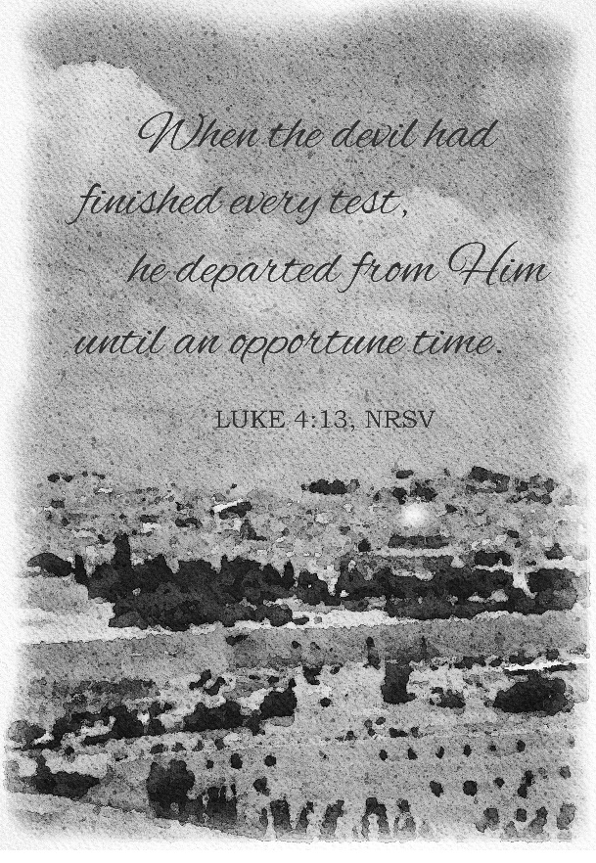

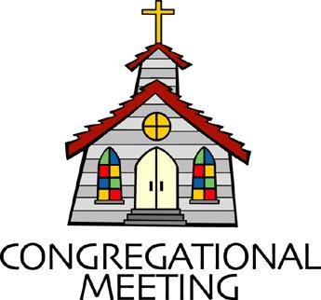
March 6, 2022 - 10:30 am

WELCOME VISITORS! We're glad you are here! Cards at the ends of each pew are for you to fill out and drop in the Offering Plate. Please let us know you are visiting, and join us for refreshments and fellowship following the service. The Sanctuary has an induction loop system to assist the hearing impaired. The system will also work on the telephone setting of hearing aids.

Springfield Presbyterian Church is rooted in the gospel of Jesus Christ, led by the Holy Spirit, and called to loving relationships through vibrant worship and service. Valuing all people, we are committed to developing disciples and fostering stewardship.
PREPARATION FOR THE WORD
(* those who are able are invited to stand)
PRELUDE

GATHERING OF THE PEOPLE

The Lord be with you! And also with you! (Greeting)

LIGHTING THE CHRIST CANDLE
Leader: Whenever we light this candle we proclaim:
People: Christ is the Light of the world and the center of our lives.

CALL TO WORSHIP
Leader: Jesus went to the mountaintop to pray.
People: Jesus went into the city to heal.
Leader: Jesus walked to Samaria to extend love.
People: Jesus went to the water’s edge to teach.
Leader: Jesus went to places of peace and connection,
People: But Jesus also went to the wilderness.
Leader: There is nowhere we can go that God does not walk with us.
People: We are in God’s house. Let us worship our Holy God.

* HYMN Lord, Who Throughout These Forty Days #166

Lord, who throughout these forty days for us did fast and pray,
Teach us with you to mourn our sins and close by you to stay.

As you with Satan did contend and did the victory win,
O give us strength to persevere, in you to conquer sin.

And through these days of penitence, and through this Passiontide,
Yes, evermore, in life and death, O Lord, with us abide.

Abide with us, till when this life of suffering shall be past,
An Easter of unending joy we may attain at last.

CALL TO CONFESSION
Leader: Friends, we worship a God who doesn’t keep score and doesn’t hold grudges. We worship a God who invites us into a richer faith, a deeper love, a more compassionate existence with a million chances to try again. So let us speak truth into our lives, asking for God’s help where we need it. Let us pray the prayer of confession together.

PRAYER OF CONFESSION
Generous God, when we think that expansive life is about power, teach us a new way. When we think that the expansive life is about material wealth, teach us a new way. When we think that expansive life is about control, teach us a new way. Teach us to live as you live and to love as you love. Forgive us when we do not. In gratitude we pray, amen.

SILENT PRAYERS OF CONFESSION

RESPONSE O Lord, Hear My Prayer (sing two times) Tune #471
O Lord, hear my prayer. O Lord, hear my prayer. When I call, answer me.
O Lord, hear my prayer. O Lord, hear my prayer. Come and listen to me.

WORDS OF ASSURANCE
Leader: Siblings in Christ, no matter how many times we mess up, no matter how far we wander, no matter how lost we feel, God’s grace is full to the brim. It overflows in desert places. It finds us where we are and it covers us in mercy. Hear and believe this good news we say together:
People: God’s love is overflowing, we are covered in mercy and forgiven once again. Thanks be to God. Amen.

* MUSICAL RESPONSE OF PRAISE Come, Thou Almighty King (v. 4)
To thee, great One in Three, eternal praises be, hence evermore!
Thy sovereign majesty may we in glory see, and to eternity love and adore.

* THE PEACE The peace of Christ be with you! And also with you!
(You may greet those around you.)

* RESPONSE Here I Am, Lord
Here I am, Lord, Is it I, Lord? I have heard you calling in the night.
I will go, Lord, if you lead me. I will hold your people in my heart.

THE PROCLAMATION OF THE WORD

PRAYER OF ILLUMINATION
God of the wilderness places in our lives, it can be hard to hear you in the desert, or in the city, or in the midst of our calendar reminders. We lose sight of you in rush hour traffic and notification alerts. It can be hard to hear you, so we ask: make everything quiet. Pause the chaos, still the rushing, ease our racing thoughts, give us ears to hear your word for us today which promises that even in the desert you are full to the brim. We are listening, we ache for your good news. Grateful we pray, amen.

FIRST SCRIPTURE LESSON Psalm 91
¹ You who live in the shelter of the Most High, who abide in the shadow of the Almighty, ² will say to the Lord, ‘My refuge and my fortress; my God, in whom I trust.’ ³ For he will deliver you from the snare of the fowler and from the deadly pestilence; ⁴ he will cover you with his pinions, and under his wings you will find refuge; his faithfulness is a shield and buckler. ⁵ You will not fear the terror of the night, or the arrow that flies by day, ⁶ or the pestilence that stalks in darkness, or the destruction that wastes at noonday. ⁷ A thousand may fall at your side, ten thousand at your right hand, but it will not come near you. ⁸ You will only look with your eyes and see the punishment of the wicked.
⁹ Because you have made the Lord your refuge, the Most High your dwelling-place, ¹⁰ no evil shall befall you, no scourge come near your tent. ¹¹ For he will command his angels concerning you to guard you in all your ways. ¹² On their hands they will bear you up, so that you will not dash your foot against a stone. ¹³ You will tread on the lion and the adder, the young lion and the serpent you will trample under foot.
¹⁴ Those who love me, I will deliver; I will protect those who know my name. ¹⁵ When they call to me, I will answer them; I will be with them in trouble, I will rescue them and honor them. ¹⁶ With long life I will satisfy them, and show them my salvation.

SECOND SCRIPTURE LESSON Luke 4:1-13
Jesus, full of the Holy Spirit, returned from the Jordan and was led by the Spirit in the wilderness, ²where for forty days he was tempted by the devil. He ate nothing at all during those days, and when they were over, he was famished. ³The devil said to him, ‘If you are the Son of God, command this stone to become a loaf of bread.’ ⁴Jesus answered him, ‘It is written, “One does not live by bread alone.” ’ ⁵Then the devil led him up and showed him in an instant all the kingdoms of the world. ⁶And the devil said to him, ‘To you I will give their glory and all this authority; for it has been given over to me, and I give it to anyone I please. ⁷If you, then, will worship me, it will all be yours.’ ⁸Jesus answered him, ‘It is written, “Worship the Lord your God, and serve only him.” ’ ⁹Then the devil took him to Jerusalem, and placed him on the pinnacle of the temple, saying to him, ‘If you are the Son of God, throw yourself down from here, ¹⁰for it is written, “He will command his angels concerning you, to protect you”, ¹¹and “On their hands they will bear you up, so that you will not dash your foot against a stone.” ’ ¹²Jesus answered him, ‘It is said, “Do not put the Lord your God to the test.” ’ ¹³When the devil had finished every test, he departed from him until an opportune time.

Leader: Hear what the Spirit is saying to the Church.
All: Thanks be to God.

SERMON An Oasis in the Wilderness Rev. Becca Crate-Price

THE RESPONSE TO THE WORD

* HYMN I Need Thee Every Hour #735

I need thee every hour, most gracious Lord;
No tender voice like thine can peace afford.

Refrain:
I need thee, O I need thee, every hour I need thee!
O bless me now, my Savior--I come to thee!

I need thee every hour; stay thou near by;
Temptations lose their power when thou art nigh. [Refrain]

I need thee every hour; teach me thy will,
And thy rich promises in me fulfill. [Refrain]

I need thee every hour, Most Holy One;
O make me thine indeed, thou blessed Son. [Refrain]

THE SACRAMENT OF THE LORD’S SUPPER

INVITATION

THE GREAT PRAYER OF THANKSGIVING
Leader: The Lord be with you.
People: And also with you.
Leader: Lift up your hearts.
People: We lift them up to the Lord.
Leader: Let us give thanks to the Lord our God.
People: It is right to give our thanks and praise.
[The Pastor continues… “…who forever sing to the glory of your name...”]

IN PRAISE OF GOD Tune #552
Holy, holy, holy, Lord, God of Power and might.
Heaven and earth are full of your glory, Hosanna in the highest!
Blessed is He who comes in the name of the Lord.
Hosanna in the highest, hosanna in the highest.
[The Pastor continues… “…proclaim the one crucified and risen.”]

IN PRAISE OF CHRIST Tune #553
Christ has died; Christ is risen; Christ will come again.
Christ has died; Christ is risen; Christ will come again.

PASTORAL PRAYER AND THE LORD’S PRAYER

WORDS OF INSTITUTION

SHARING OF THE MEAL

PRAYER OF DEDICATION (Unison)
God of compassion, through your Son Jesus Christ you reconciled your people to yourself. Following His example of prayer and fasting, may we obey you with willing hearts and serve one another in holy love; through Jesus Christ our Lord. Amen.

ANTHEM On Eagles Wings

* HYMN Arise, Your Light Is Come! #744
Arise, your light is come! The Spirit’s call obey;
Show forth the glory of your God, which shines on you today.
Arise, your light is come! Fling wide the prison door;
Proclaim the captives’ liberty, good tidings to the poor.

Arise, your light is come! All you in sorrow born,
Bind up the broken-hearted ones and comfort those who mourn.

Arise, your light is come! The mountains burst in song!
Rise up like eagles on the wing; God’s power will make us strong.

* CHARGE AND BENEDICTION
Leader: As you leave this place, may we be awestruck by the beauty of this world.
People: May we laugh and may it be contagious.
Leader: May we overflow with love for those around us.
People: May we be filled with hope and quick to point out joy.
Leader: In all of our living, and breathing, and being,
People: May we find ourselves full to the brim with God’s Holy Spirit,
Leader: And may it change our lives.
People: In the name of the Beloved and Love itself – let us go in peace, full to the brim. Amen.

* UNISON AMEN

POSTLUDE

Sunday March 13, 2022 Lectionary
Genesis 15:1-12, 17-18; Psalm 27; Philippians 3:17-4:1; Luke 13:31-35

Assisting in Worship: We appreciate those who serve:

Today 3/6 Next Week 3/13
Sunday Opener Ron Holmes Bob Rogers
Greeter Beth Oates Elizabeth Meirowitz
Lay Leader Don Vasbinder Tony Caviglia
Communion Helpers (if necessary): Tony Caviglia
Mark Kearney

Happy Birthday! March 6 – Sue Holmes

Announcements

Springfield Membership: Are you interested in finding out more about our faith community and becoming a member? We would love to answer any questions you have. Please contact Pastor Becca at springfieldpastor@gmail.com for more information.

New Mask Update: As of this Sunday, March 6, by the agreement of Session, we are now making masks optional. We do want to encourage you, if you feel compelled or have any underlying conditions, to keep your mask on. If you do wish to take off your mask though, we are also happy to see your faces. More information about fellowship and other practices will be coming as we make our way back to normalcy.

Daylight Saving Time: Don’t forget to set your clocks forward one hour on Saturday night, 3/12, or you’ll be late to church!

Per Capita: Per Capita is how we Presbyterian congregations care for each other and stay connected. It funds mission work, support and training for pastors and congregations, and administration expenses. Our portion this year is $38.13; $28 remains at Presbytery, $1.15 to Synod, and $8.98 to General Assembly. You will find this expense in our budget but you can help offset that and show your support by contributing that portion as faithful members. There is a wonderful article by J. Herbert Nelson, Stated Clerk for PC(USA) that can be found by going to baltimorepresbytery.org/percapita and then scroll to the bottom of the page to click on Stated Clerk: What per capita pays for, why it matters.

Congregational Care / Mission & Outreach: Do you know of a member or friend of our church family who is ill, needs prayers, would like call, a visit or a card, or might benefit from meal train? If so, please contact the Church Office (410-795-6152), Cathy Marsh (410-549-6916) or Diana Steppling (862-266-2242).

Today:
Sunday March 6 – 1st Sunday in Lent
9:30 am Adult Choir Practice
10:30 am Worship
11:30 am Fellowship

This Week:
Wednesday March 9
6:15 – 7:15 pm Bell Choir Practice
No Adult Choir Practice
Thursday March 10
7:00 pm Session Meeting

Looking Ahead:
Sunday March 13 – 2nd Sunday in Lent
10:30 am Worship
11:30 am Fellowship

Office Hours: Tuesday, Wednesday & Friday
Springfield Presbyterian Church

10:30 am Worship
11:30 am Fellowship
Website: www.springfield-church.org Church Office: 410-795-6152
Like us on Facebook: www.facebook.com/SpringfieldPresbyterianChurch
Pastor: Rev. Becca Crate-Price
Email: springfieldpastor@gmail.com
Clerk of Session: Sharon Pappas
Minister of Music: Linda Caviglia
Accompanist/Organist: Aaron Thacker
Youth Group Coordinator: Dylan Vasbinder
Administrative Assistant: Donna Mazer e-mail: spc.office@verizon.net

