(Large Print)

Springfield Presbyterian Church (USA)
7300 Spout Hill Road, Sykesville, MD 21784 410-795-6152

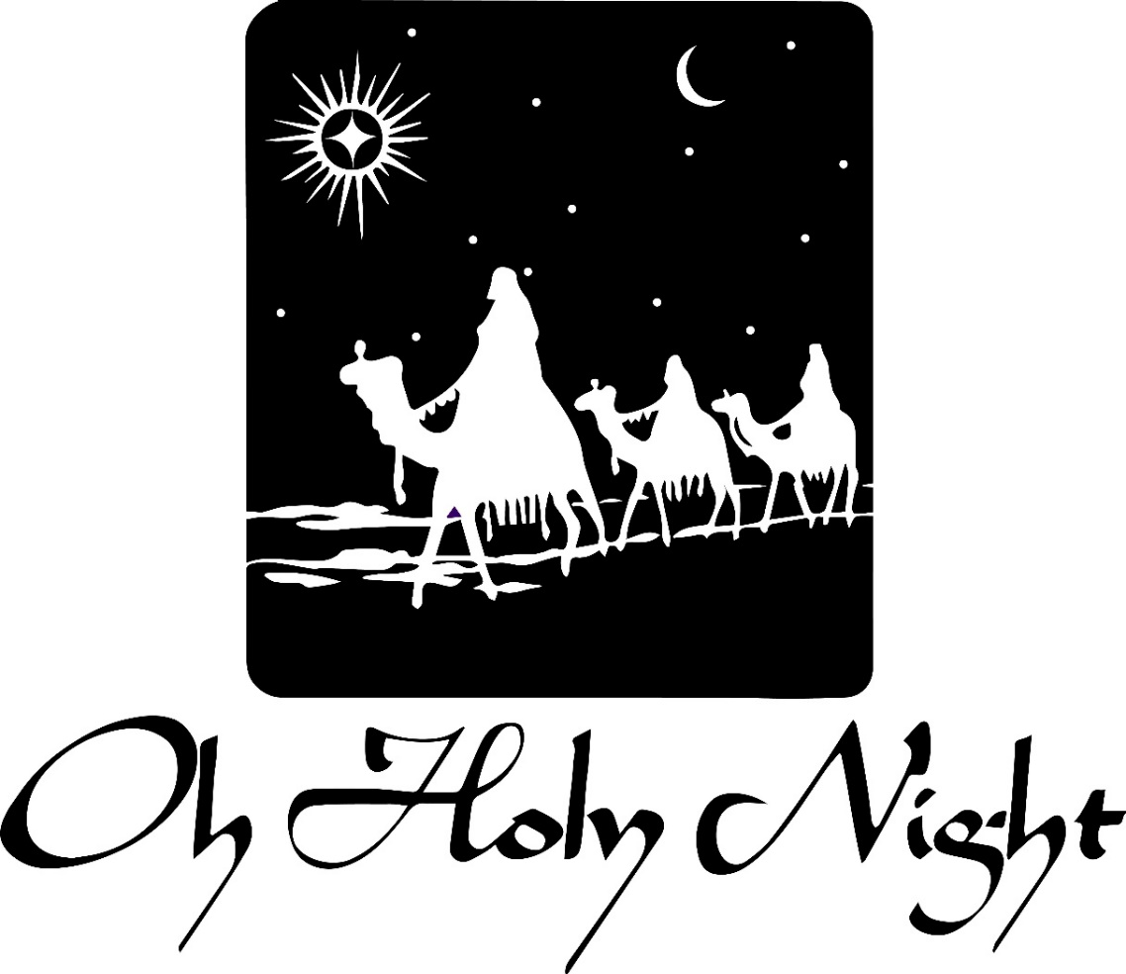

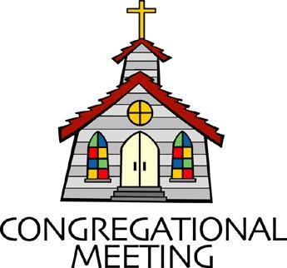
December 24, 2022 - 7:00 pm

WELCOME VISITORS! We're glad you are here! Cards at the ends of each pew are for you to fill out and drop in the Offering Plate. Please let us know you are visiting, and join us for refreshments and fellowship following the service. The Sanctuary has an induction loop system to assist the hearing impaired. The system will also work on the telephone setting of hearing aids.

Springfield Presbyterian Church is rooted in the gospel of Jesus Christ, led by the Holy Spirit, and called to loving relationships through vibrant worship and service. Valuing all people, we are committed to developing disciples and fostering stewardship.
PREPARATION FOR THE WORD
(* those who are able are invited to stand)

PRELUDE Infant Holy, Infant Lowly arr. Cathy Moklebust

O Come, O Come, Emmanuel arr. Kevin Bryant
Presbytones Handbell Choir

CALL TO WORSHIP

Leader: An unmarried teenage girl was invited— to carry Christ into this world.
People: An ordinary carpenter was invited— to be a father to a child unlike any other.

Leader: The shepherds were invited— outcast and isolated, included at the manger. People: The Magi were invited— foreigners and seekers, included at the manger.

Leader: And if she was invited, and he was invited, and they were invited— then we can trust that we too are invited.
People: This story is for us. This love is for us.
Leader: Family of faith, this is our invitation. Welcome home. Amen.

LIGHTING OF THE ADVENT CANDLES AND CHRIST CANDLE
Worship Leader/Lay Leader: Over a hundred people, from the ages of two to eighty years old, were asked to fill in the blank for this statement: “My story is…” From the voices of different generations, hear their answers:

Teenager: Amazing!
Child: Just beginning.
Adult: A wee bit messy with lots of love.
Older Adult: Privileged.
Teenager: Hopeful.
Child: Full of silliness.
Adult: Still unfolding.
Older Adult: Long, but good.
Teenager: One of resilience.
Child: Incomplete, thank goodness.
Adult: Multilingual.
Older Adult: A work in progress.
Teenager: My story is not just mine, it’s tied to yours.
Older Adult: Tonight we tell the story that we tell every year – the story of Christ’s birth, the story of love made flesh. It’s a story that weaves through every generation. It’s a story that picks up the bits and pieces of our narrative and braids us together.

Older Adult: So tonight we light the Christ candle, because from generation to generation, our story belongs to God. Thanks be to God for a love like that. Amen.

Sung Response: Accompanied by Bells
O little town of Bethlehem, how still we see thee lie!
Above thy deep and dreamless sleep the silent stars go by.
Yet in thy dark streets shineth the everlasting light;
The hopes and fears of all the years are met in thee tonight.

* HYMN O Come, All Ye Faithful GTG #133 (verses 1 & 4)

O come, all ye faithful, joyful and triumphant;
O come ye; O come ye to Bethlehem!
Come, and behold him, born the King of angels!

Refrain:
O come, let us adore him; O come, let us adore him;
O come, let us adore him, Christ, the Lord!

Yea, Lord, we greet thee, born this happy morning;
Jesus, to thee be all glory given;
Word of the Father, now in flesh appearing! [Refrain]

THE SERVICE OF LESSONS AND CAROLS

FIRST READINGS
Psalm 62:1-2
For God alone my soul waits in silence; from God comes my salvation. God alone is my rock and my salvation, my fortress; I shall never be shaken.

Isaiah 9:2-7 OT page 600
² The people who walked in darkness have seen a great light; those who lived in a land of deep darkness— on them light has shined.
³ You have multiplied the nation, you have increased its joy; they rejoice before you as with joy at the harvest, as people exult when dividing plunder. ⁴ For the yoke of their burden, and the bar across their shoulders, the rod of their oppressor, you have broken as on the day of Midian. ⁵ For all the boots of the tramping warriors and all the garments rolled in blood shall be burned as fuel for the fire. ⁶ For a child has been born for us, a son given to us; authority rests upon his shoulders; and he is named Wonderful Counsellor, Mighty God, Everlasting Father, Prince of Peace. ⁷ His authority shall grow continually, and there shall be endless peace for the throne of David and his kingdom. He will establish and uphold it with justice and with righteousness from this time onwards and for evermore. The zeal of the Lord of hosts will do this.

* HYMN It Came Upon the Midnight Clear GTG #123 (verses 1& 5)

It came upon the midnight clear, that glorious song of old,
From angels bending near the earth, to touch their harps of gold:
“Peace on the earth, good will to all, from heaven’s all-gracious King”:
The world in solemn stillness lay, to hear the angels sing.

For lo, the days are hastening on, by prophets seen of old,
When with the ever-circling years shall come the time foretold,
When peace shall over all the earth its ancient splendors fling,
And the whole world give back the song which now the angels sing.

SECOND READINGS
Isaiah 12:2
Surely God is my salvation; I will trust, and will not be afraid.
For the Lord God is my strength and my might; and has become my salvation.

Luke 1:26-35, 38
²⁶In the sixth month the angel Gabriel was sent by God to a town in Galilee called Nazareth, ²⁷to a virgin engaged to a man whose name was Joseph, of the house of David. The virgin’s name was Mary. ²⁸And he came to her and said, ‘Greetings, favored one! The Lord is with you.’ ²⁹But she was much perplexed by his words and pondered what sort of greeting this might be. ³⁰The angel said to her, ‘Do not be afraid, Mary, for you have found favor with God. ³¹And now, you will conceive in your womb and bear a son, and you will name him Jesus. ³²He will be great, and will be called the Son of the Most High, and the Lord God will give to him the throne of his ancestor David. ³³He will reign over the house of Jacob for ever, and of his kingdom there will be no end.’ ³⁴Mary said to the angel, ‘How can this be, since I am a virgin?’ ³⁵The angel said to her, ‘The Holy Spirit will come upon you, and the power of the Most High will overshadow you; therefore the child to be born will be holy; he will be called Son of God. ³⁸Then Mary said, ‘Here am I, the servant of the Lord; let it be with me according to your word.’ Then the angel departed from her.

ANTHEM Gloria! By Antonio Vivaldi

THIRD READINGS
Salvae Regina: Hail Mary, full of grace, the Lord is with Thee.
Blessed are thou among women and blessed is the fruit of Thy womb, Jesus.

Luke 1:39-55
³⁹In those days Mary set out and went with haste to a Judean town in the hill country, ⁴⁰where she entered the house of Zechariah and greeted Elizabeth. ⁴¹When Elizabeth heard Mary’s greeting, the child leapt in her womb. And Elizabeth was filled with the Holy Spirit ⁴²and exclaimed with a loud cry, ‘Blessed are you among women, and blessed is the fruit of your womb. ⁴³And why has this happened to me, that the mother of my Lord comes to me? ⁴⁴For as soon as I heard the sound of your greeting, the child in my womb leapt for joy. ⁴⁵And blessed is she who believed that there would be a fulfilment of what was spoken to her by the Lord.’ ⁴⁶And Mary said, ‘My soul magnifies the Lord, ⁴⁷and my spirit rejoices in God my Savior, ⁴⁸ for he has looked with favor on the lowliness of his servant. Surely, from now on all generations will call me blessed; ⁴⁹ for the Mighty One has done great things for me, and holy is his name. ⁵⁰ His mercy is for those who fear him from generation to generation. ⁵¹ He has shown strength with his arm; he has scattered the proud in the thoughts of their hearts. ⁵² He has brought down the powerful from their thrones, and lifted up the lowly; ⁵³ he has filled the hungry with good things, and sent the rich away empty. ⁵⁴ He has helped his servant Israel, in remembrance of his mercy, ⁵⁵ according to the promise he made to our ancestors, to Abraham and to his descendants for ever.’

* HYMN Canticle of the Turning (verses 1 & 2)

My soul cries out with a joyful shout that the God of my heart is great, and my spirit sings of the wondrous things that you bring to the ones who wait. You fixed your sight on your servant’s plight, and my weakness you did not spurn, so from east to west shall my name be blest. Could the world be about to turn?

Refrain:
My heart shall sing of the day you bring. Let the fires of your justice burn. Wipe away all tears, for the dawns draws near, and the world is about to turn.

Though I am small, my God, my all, you work great things in me, and your mercy will last from the depths of the past to the end of the age to be. Your very name puts the proud to shame, and to those who would for you yearn, you will show your might, put the strong to flight, for the world is about to turn. [Refrain]

FOURTH READINGS
J. B. Ebling
All my heart today rejoices, as I hear, far and near, sweetest angel voices;
‘Christ is born,’ their choirs are singing, till the air, everywhere, now with joy is ringing.

Luke 2:1-14 NT page 54
In those days a decree went out from Emperor Augustus that all the world should be registered. ²This was the first registration and was taken while Quirinius was governor of Syria. ³All went to their own towns to be registered. ⁴Joseph also went from the town of Nazareth in Galilee to Judea, to the city of David called Bethlehem, because he was descended from the house and family of David. ⁵He went to be

registered with Mary, to whom he was engaged and who was expecting a child. ⁶While they were there, the time came for her to deliver her child. ⁷And she gave birth to her firstborn son and wrapped him in bands of cloth, and laid him in a manger, because there was no place for them in the inn. ⁸In that region there were shepherds living in the fields, keeping watch over their flock by night. ⁹Then an angel of the Lord stood before them, and the glory of the Lord shone around them, and they were terrified. ¹⁰But the angel said to them, ‘Do not be afraid; for see—I am bringing you good news of great joy for all the people: ¹¹to you is born this day in the city of David a Savior, who is the Messiah, the Lord. ¹²This will be a sign for you: you will find a child wrapped in bands of cloth and lying in a manger.’ ¹³And suddenly there was with the angel a multitude of the heavenly host, praising God and saying, ¹⁴ ‘Glory to God in the highest heaven, and on earth peace among those whom he favors!’

* HYMN Angels We Have Heard on High GTG #113

Angels we have heard on high, sweetly singing o’er the plains,
And the mountains in reply echoing their joyous strains.
Gloria in excelsis Deo!
Gloria in excelsis Deo!

Shepherds, why this jubilee? Why your joyous strains prolong?
What the gladsome tidings be which inspire your heavenly song?
Gloria in excelsis Deo!
Gloria in excelsis Deo!

Come to Bethlehem and see him whose birth the angels sing;
Come, adore on bended knee Christ, the Lord, the newborn King.
Gloria in excelsis Deo!
Gloria in excelsis Deo!
FIFTH READINGS
Traditional This, this is Christ the King,
English Whom shepherds guard and angels sing;
Ballad Haste, haste, to bring Him laud, the Babe, the Son of Mary!

Luke 2:15-20 NT page 55
¹⁵When the angels had left them and gone into heaven, the shepherds said to one another, ‘Let us go now to Bethlehem and see this thing that has taken place, which the Lord has made known to us.’ ¹⁶So they went with haste and found Mary and Joseph, and the child lying in the manger. ¹⁷When they saw this, they made known what had been told them about this child; ¹⁸and all who heard it were amazed at what the shepherds told them. ¹⁹But Mary treasured all these words and pondered them in her heart. ²⁰The shepherds returned, glorifying and praising God for all they had heard and seen, as it had been told them.

ANTHEM Christmas Light by Kris Crunk

SIXTH READINGS
Colossians 1:15-16
He is the image of the invisible God, the firstborn of all creation;
for in Him all things in heaven and on earth were created,
things visible and invisible, whether thrones or dominions or rulers or powers; all things have been created through and for Him.

John 1:1-14, 16
In the beginning was the Word, and the Word was with God, and the Word was God. ²He was in the beginning with God. ³All things came into being through him, and without him not one thing came into being. What has come into being ⁴in him was life, and the life was the light of all people. ⁵The light shines in the darkness, and the darkness

did not overcome it. ⁶There was a man sent from God, whose name was John. ⁷He came as a witness to testify to the light, so that all might believe through him. ⁸He himself was not the light, but he came to testify to the light. ⁹The true light, which enlightens everyone, was coming into the world. ¹⁰He was in the world, and the world came into being through him; yet the world did not know him. ¹¹He came to what was his own, and his own people did not accept him. ¹²But to all who received him, who believed in his name, he gave power to become children of God, ¹³who were born, not of blood or of the will of the flesh or of the will of man, but of God. ¹⁴And the Word became flesh and lived among us, and we have seen his glory, the glory as of a father’s only son, full of grace and truth. ¹⁶From his fullness we have all received, grace upon grace.

* HYMN Joy to the World GTG #134

Joy to the world, the Lord is come! Let earth receive her king;
Let every heart prepare him room,
And heaven and nature sing, and heaven and nature sing,
And heaven, and heaven and nature sing.

Joy to the earth, the Savior reigns! Let all their songs employ,
While fields and floods, rocks, hills, and plains
Repeat the sounding joy, repeat the sounding joy,
Repeat, repeat the sounding joy.

No more let sins and sorrows grow, nor thorns infest the ground;
He comes to make his blessings flow far as the curse is found,
Far as the curse is found,
Far as, far as the curse is found.

He rules the world with truth and grace,
And makes the nations prove
The glories of his righteousness and wonders of his love,
And wonders of his love, and wonders, wonders of his love.

RESPONDING TO THE WORD

Meditation: Generation to Generation Rev. Becca Price

THE OFFERING

OFFERTORY Love Came Down At Christmas arr. Cynthia Dobrinski
PRAYER OF DEDICATION

THE COMMUNION OF CHRIST’S PEOPLE

INVITATION [Luke 2:12; Micah 5:4]
Leader: A child is born for us in Bethlehem, wrapped in bands of cloth and lying in a manger.
People: He will be our Shepherd, feeding his flock in the strength of the Lord.

THE GREAT PRAYER OF THANKSGIVING
Leader: The Lord be with you.
People: And also with you.
Leader: Lift up your hearts.
People: We lift them up to the Lord.
Leader: Let us give thanks to the Lord our God.
People: It is right to give our thanks and praise.
[The Pastor continues… “…who forever sing to the glory of your name.”]

IN PRAISE OF GOD Tune #552
Holy, holy, holy, Lord, God of Power and might.
Heaven and earth are full of your glory, Hosanna in the highest!
Blessed is He who comes in the name of the Lord.
Hosanna in the highest, hosanna in the highest.
[The Pastor continues… “…dedicated to your service.”]

IN PRAISE OF CHRIST Tune #553
Christ has died; Christ is risen; Christ will come again.
Christ has died; Christ is risen; Christ will come again.

PASTORAL PRAYER AND THE LORD’S PRAYER

WORDS OF INSTITUTION

SHARING OF THE MEAL

PRAYER OF DEDICATION (Unison)
Dear God, take us out to live as changed people because we have shared the living bread and cannot remain the same. Ask much of us, expect much from us, enable much by us, encourage many through us. So, Lord, may we live to your glory, both as inhabitants of the earth, and citizens of the commonwealth of Heaven. Through Christ, with Christ, in Christ, in the unity of the Holy Spirit, all glory and honor are yours, almighty God, now and forever. Amen.
SHARING OF THE LIGHT OF CHRIST

* LIGHTING THE CANDLES
The candle lighting will take place during the singing of Silent Night.

* HYMN Silent Night, Holy Night! GTG #122

Silent night, holy night! All is calm, all is bright
’Round yon virgin mother and child! Holy Infant, so tender and mild,
Sleep in heavenly peace, sleep in heavenly peace.

Silent night, holy night! Shepherds quake at the sight;
Glories stream from heaven afar, Heavenly hosts sing “Alleluia:
Christ the Savior is born; Christ the Savior is born!”

Silent night, holy night! Son of God, love’s pure light
Radiant beams from thy holy face, With the dawn of redeeming grace,
Jesus, Lord, at thy birth, Jesus, Lord, at thy birth.

Silent night, holy night! Wondrous star, lend thy light;
With the angels let us sing Alleluia to our King:
Christ the Savior is born; Christ the Savior is born.

(Extinguishing the lights)

* BENEDICTION

POSTLUDE Hallelujah Chorus G.F. Handel
Congregational Sing-Along (music available)

The Christmas Flowers in the Sanctuary were given by:

Julie Ballard – In Memory of Mom & Dad Becker, Sisters & Bil, Welma & Roy, Shirley & Joe, Philip Ballard
The Black Family - In Memory of Barbara & Charles Dockendorf; In Appreciation for Our Wonderful Music Program

Tony & Linda Caviglia - In Memory of Charles & Elaine Cleland

Barbara Cornell - In Memory of My Parents

Ron & Sue Holmes – With Grateful Thanks for Our Grandchildren Carter, Hudson, Violet and Felix; In Honor of Sue’s Mom Betty and the Love She So Freely Gives

Barbara Nickell – In Memory of James F. Nickell, Sr., James F. Nickell, Jr., Parents and Grandparents Paul & Anna Angell, Harvey & Sara Noyes, Hobart & Lingle Nickell, Joseph & Goldie Gonterman

Sharon Pappas - In Appreciation for Sandy, Jeff, Greg, Stephanie and Their Children

Judy Rhoades – In Appreciation for Springfield Worker Bees

Scott & Stephanie Schroeder – In Memory of Brother-In-Law George Farmer, Jr.

Bob & Diana Steppling - In Memory of Jack & Betty Steppling, Ira P. and
Philip Evans

Belle & Don Vasbinder - In Memory of Janet & Bob, William & Isabelle, Jeannette & George, Kurt, Nettie Studley, Brian Schlecht

