(Large Print)

Springfield Presbyterian Church (USA)
7300 Spout Hill Road, Sykesville, MD 21784 410-795-6152

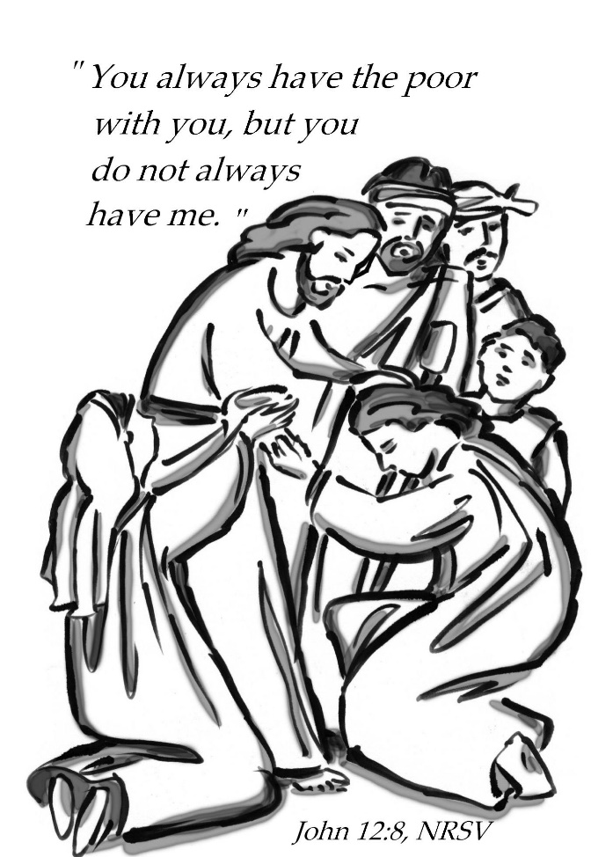

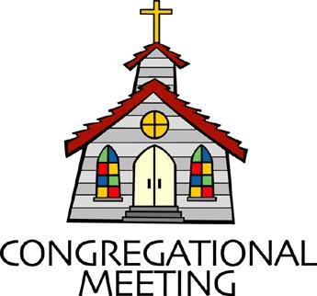
April 24, 2022 - 10:30 am

WELCOME VISITORS! We're glad you are here! Cards at the ends of each pew are for you to fill out and drop in the Offering Plate. Please let us know you are visiting, and join us for refreshments and fellowship following the service. The Sanctuary has an induction loop system to assist the hearing impaired. The system will also work on the telephone setting of hearing aids.

Springfield Presbyterian Church is rooted in the gospel of Jesus Christ, led by the Holy Spirit, and called to loving relationships through vibrant worship and service. Valuing all people, we are committed to developing disciples and fostering stewardship.
PREPARATION FOR THE WORD
(* those who are able are invited to stand)
PRELUDE

GATHERING OF THE PEOPLE

The Lord be with you! And also with you! (Greeting)

LIGHTING THE CHRIST CANDLE
Leader: Whenever we light this candle we proclaim:
People: Christ is the Light of the world and the center of our lives.

CALL TO WORSHIP
Leader: May we find courage here –
People: Courage to follow our call, courage to live out our faith.
Leader: May we find hope here –
People: Hope for a better world, hope that refuses to let us go.
Leader: May we find truth here –
People: Truth that lives in sacred community, truth that lives in ancient stories.
Leader: May we find all that we seek,
People: And in our seeking, may we know God. Amen.

* HYMN Sing Praise to God Who Reigns Above #645

Sing praise to God who reigns above, the God of all creation,
The God of power, the God of love, the God of our salvation.
With healing balm my soul is filled, and every faithless murmur stilled: to God all praise and glory!

What God’s almighty power has made God's gracious mercy keepeth;
By morning glow or evening shade God's watchful eye ne'er sleepeth.
Within the kingdom of God's might, lo! all is just and all is right:
To God all praise and glory!

The Lord is never far away, but, through all grief distressing,
An ever-present help and stay, our peace and joy and blessing,
As with a mother's tender hand God gently leads the chosen band:
To God all praise and glory!

Thus all my toilsome way along I sing aloud thy praises,
That all may hear the grateful song my voice unwearied raises.
Be joyful in the Lord, my heart; both soul and body, take your part:
To God all praise and glory!

CALL TO CONFESSION
Leader: There are very few things as powerful as a group of people that admits they are not perfect and asks for grace as they grow. Imagine what our world might be like if every institution had such a weekly rhythm? Friends, we can light the way. Let us be brave in our truth-telling and honest in our confession. For we will always be met by grace. Let us pray together…

PRAYER OF CONFESSION
Jesus of Nazareth, we admit that often we tuck our faith into our pockets, hiding in a place of comfort rather than proudly declaring: yes we are Christians, yes we believe, yes this faith has changed me. We are so afraid of offending others or embarrassing ourselves that we have established rules: no faith at the dinner table, no faith in politics, no faith with strangers. Forgive us for whispering when we could be singing. Forgive us for staying quiet when we could be part of rewriting the narrative. We want to be brave. We want to pour out perfume over your feet. These things we pray, amen.

SILENT PRAYERS OF CONFESSION

RESPONSE Restore in Us, O God Tune #434
Restore in us, O God, the splendor of your love;
Renew your image in our hearts, and all our sins remove.

WORDS OF ASSURANCE
Leader: Family of faith, hear this good news: Even in our silence,
People: God loves us.
Leader: Even in our fear or shame,
People: God chooses us.
Leader: Even when we sin,
People: God wraps us in grace.
Leader: You are free – to be bold, to be brazen, to be exactly who God called you to be.
ALL: Thanks be to God, amen.

* MUSICAL RESPONSE OF PRAISE Alleluia, Alleluia! Give Thanks
Alleluia, alleluia! Give thanks to the risen Lord.
Alleluia, alleluia! Give praise to his name.

* THE PEACE The peace of Christ be with you! And also with you!
(You may greet those around you.)

* RESPONSE Here I Am, Lord
Here I am, Lord, Is it I, Lord? I have heard you calling in the night.
I will go, Lord, if you lead me. I will hold your people in my heart.

THE PROCLAMATION OF THE WORD

PRAYER OF ILLUMINATION
Holy God, sometimes my waking is a prayer. Sometimes the song I have stuck in my head, rumbling around on repeat is a prayer. Sometimes the way I talk to the children and the way I hug the dog is a prayer. Sometimes the way I take my phone out to get a picture of the sunset or of the people I love – that is a prayer. Other times, prayer is moments like this – heads bowed, eyes closed, hearts quiet for just a moment. And in all of it, I trust you to hear me. Help me to hear you in return. Gratefully we pray, amen.

FIRST SCRIPTURE LESSON Isaiah 43:16-21
¹⁶ Thus says the Lord, who makes a way in the sea, a path in the mighty waters, ¹⁷ who brings out chariot and horse, army and warrior; they lie down, they cannot rise, they are extinguished, quenched like a wick:
¹⁸ Do not remember the former things, or consider the things of old.
¹⁹ I am about to do a new thing; now it springs forth, do you not perceive it? I will make a way in the wilderness and rivers in the desert.
²⁰ The wild animals will honor me, the jackals and the ostriches; for I give water in the wilderness, rivers in the desert, to give drink to my chosen people, ²¹ the people whom I formed for myself so that they might declare my praise.

SECOND SCRIPTURE LESSON John 12:1-8
Six days before the Passover Jesus came to Bethany, the home of Lazarus, whom he had raised from the dead. ²There they gave a dinner for him. Martha served, and Lazarus was one of those at the table with him. ³Mary took a pound of costly perfume made of pure nard, anointed Jesus’ feet, and wiped them with her hair. The house was filled with the fragrance of the perfume. ⁴But Judas Iscariot, one of his disciples (the one who was about to betray him), said, ⁵‘Why was this perfume not sold for three hundred denarii and the money given to the poor?’ ⁶(He said this not because he cared about the poor, but because he was a thief; he kept the common purse and used to steal what was put into it.) ⁷Jesus said, ‘Leave her alone. She bought it so that she might keep it for the day of my burial. ⁸You always have the poor with you, but you do not always have me.’

Leader: Hear what the Spirit is saying to the Church.
All: Thanks be to God.

SERMON Brazen Acts of Beauty Rev. Becca Crate-Price

THE RESPONSE TO THE WORD

* HYMN When Mary Poured a Rich Perfume (to the tune of #712)

When Mary poured a rich perfume on Jesus' weary feet,
Her caring filled that humble room; the fragrance there was sweet.
But full of anger, Judas said, "We could have used this more!
Why was her gift not sold instead and given to the poor?"

The Lord replied, "Leave her alone! She bought it for this day.
This caring love that she has shown is faithful to God's way.
The poor will always be with you, but you will not have me."
He blessed her and he thanked her, too, for giving lavishly.

O Christ, what can your people bring to show you thanks and love?
You need no fragrant offering; for now you reign above.
Since there will never cease to be the poor throughout the land,
May we, your church, serve faithfully by offering them our hand.

Alternate tune: FOREST GREEN, Traditional English melody; English Hymnal, 1906 ("All Beautiful the March of Days") (MIDI) Text: Copyright © 2001 by Carolyn Winfrey Gillette. All rights reserved.

PASTORAL PRAYER AND THE LORD’S PRAYER

OFFERTORY
SONG OF THANKS We Give Thee but Thine Own #708
We give thee but thine own, what e’er the gift may be;
All that we have is thine alone, a trust, O Lord, from thee.
PRAYER OF DEDICATION

* HYMN Fairest Lord Jesus #630

Fairest Lord Jesus, Ruler of all nature,
O thou of God to earth come down,
Thee will I cherish, thee will I honor,
Thou, my soul's glory, joy, and crown.

Fair are the meadows, fairer still the woodlands,
robed in the blooming garb of spring.
Jesus is fairer; Jesus is purer,
Who makes the woeful heart to sing.

Fair is the sunshine, fairer still the moonlight,
And all the twinkling, starry host.
Jesus shines brighter; Jesus shines purer,
Than all the angels heaven can boast.

Beautiful Savior, Ruler of the nations,
Son of God and Son of Man!
Glory and honor, praise, adoration,
Now and forevermore be thine!

* CHARGE AND BENEDICTION
Leader: As you leave this place, may we be awestruck by the beauty of this world.
People: May we laugh and may it be contagious.
Leader: May we overflow with love for those around us.
People: May we be filled with hope and quick to point out joy.
Leader: In all of our living, and breathing, and being,
People: May we find ourselves full to the brim with the God’s Holy Spirit,
Leader: And may it change our lives.
People: In the name of the Beloved and Love itself – let us go in peace, full to the brim. Amen.

* UNISON AMEN

POSTLUDE

Assisting in Worship: We appreciate those who serve:

Today 4/24 Next Week 5/1
Sunday Opener Ron Holmes Bob Rogers
Ushers/Greeters Cynthia Smith Steve & Donna
Need Volunteer Mazer
Lay Leader Barbara Cornell Christy Yeager

Sunday May 1, 2022 Lectionary
Acts 9:1-6 (7-20); Psalm 30; Revelation 5:11-14; John 21:1-19
Announcements

Sunday School is back! On the 1st and 3rd Sundays of the month, we will be offering Sunday School! See Pastor Becca for details…

Ruth Gosnell Foundation (RGEF): The RGEF meeting is rescheduled for TODAY after worship.

Spring Plant Sale: Between May 1 and May 31, buy your spring plants at Buppert’s Farm and they will donate 10% of your purchase price back to Springfield’s ongoing projects and mission! Pick up a flyer in the Narthex and share it with your family and friends!

Springfield Membership: Are you interested in finding out more about our faith community and becoming a member? We would love to answer any questions you have. Please contact Pastor Becca at springfieldpastor@gmail.com for more information.

Mask Update: By the agreement of Session, we are now making masks optional. We do want to encourage you, if you feel compelled or have any underlying conditions, to keep your mask on. If you do wish to take off your mask though, we are also happy to see your faces. More information about fellowship and other practices will be coming as we make our way back to normalcy.

Congregational Care / Mission & Outreach: Do you know of a member or friend of our church family who is ill, needs prayers, would like call, a visit or a card, or might benefit from meal train? If so, please contact the Church Office (410-795-6152), Cathy Marsh (410-549-6916) or Diana Steppling (862-266-2242).

Fellowship Help Needed: If you are interested in helping with Fellowship, please contact Barbara Cornell (401-549-9397). A sign-up sheet will also be available.

Today:
Sunday April 24
10:30 am Worship
11:30 am Fellowship
12:00 noon RGEF Meeting (Library)

This Week:
Wednesday April 27
No Bell Choir Practice
No Adult Choir Practice

Looking Ahead:
Sunday May 1
10:30 am Worship
11:30 am Fellowship
Wednesday May 4
6:15 – 7:15 pm Bell Choir Practice
7:30 – 8:45 pm Adult Choir Practice

Office Hours: Tuesday, Wednesday & Friday
Springfield Presbyterian Church

10:30 am Worship
11:30 am Fellowship
Website: www.springfield-church.org Church Office: 410-795-6152
Like us on Facebook: www.facebook.com/SpringfieldPresbyterianChurch
Pastor: Rev. Becca Crate-Price
Email: springfieldpastor@gmail.com
Clerk of Session: Sharon Pappas
Minister of Music: Linda Caviglia
Accompanist/Organist: Aaron Thacker
Youth Group Coordinator: Dylan Vasbinder
Administrative Assistant: Donna Mazer e-mail: spc.office@verizon.net

