(Large Print)

Springfield Presbyterian Church (USA)
7300 Spout Hill Road, Sykesville, MD 21784 410-795-6152

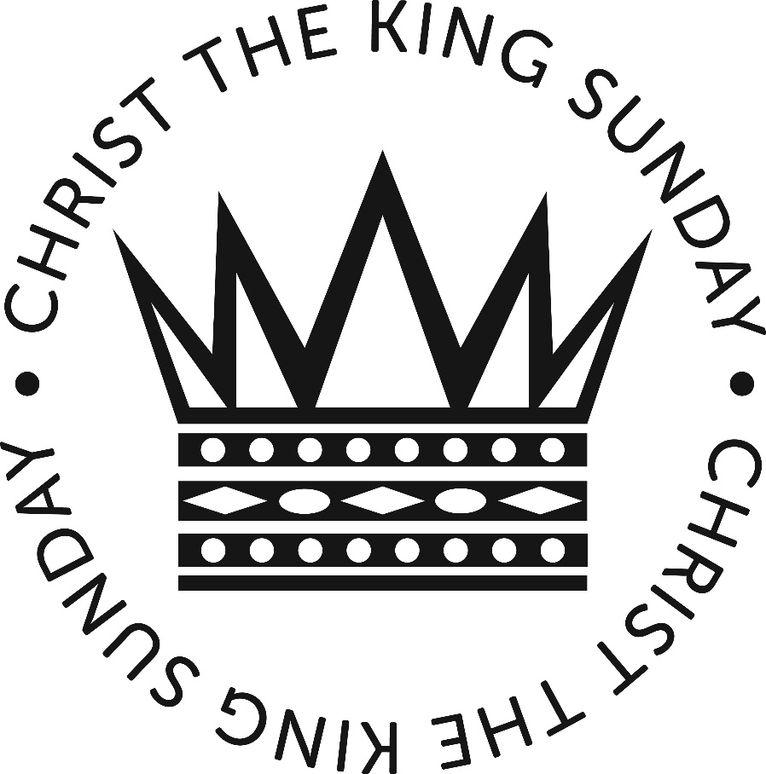

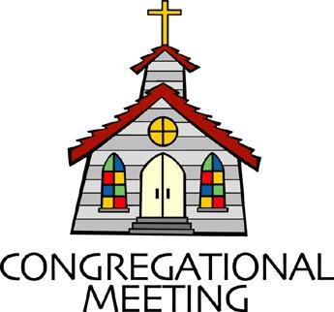
November 21, 2021 - 10:30 am

WELCOME VISITORS! We're glad you are here! Cards at the ends of each pew are for you to fill out and drop in the Offering Plate. Please let us know you are visiting, and join us for refreshments and fellowship following the service. The Sanctuary has an induction loop system to assist the hearing impaired. The system will also work on the telephone setting of hearing aids.

Springfield Presbyterian Church is rooted in the gospel of Jesus Christ, led by the Holy Spirit, and called to loving relationships through vibrant worship and service. Valuing all people, we are committed to developing disciples and fostering stewardship.

PREPARATION FOR THE WORD
(* those who are able are invited to stand)

PRELUDE

GATHERING OF THE PEOPLE

The Lord be with you! And also with you! (Greeting)

LIGHTING THE CHRIST CANDLE
Leader: Whenever we light this candle we proclaim:
People: Christ is the Light of the world and the center of our lives.

CALL TO WORSHIP
Leader: Sovereign God, ruler of all creation, you sent Jesus to testify to the truth.
People: You alone are the Lord of life.
Leader: Help us to listen always to His voice,
People: So that we may proclaim His realm of justice, peace, and endless love;
Leader: For your Kingdom is not of this earth,
People: But your Kingdom reigns within us.
Leader: For you are King, your dominion is over all.
People: And thus we praise you, Christ the King.
Leader: May your Kingdom reign forever and ever.
All: Let us worship God!

* HYMN Come, Christians, Join to Sing #267

Come, Christians, join to sing: Alleluia! Amen!
Loud praise to Christ our King: Alleluia! Amen!
Let all, with heart and voice, before his throne rejoice;
Praise is his gracious choice: Alleluia! Amen!
Come, lift your hearts on high: Alleluia! Amen!
Let praises fill the sky: Alleluia! Amen!
He is our guide and friend; to us he'll condescend;
His love shall never end: Alleluia! Amen!

Praise yet our Christ again: Alleluia! Amen!
Life shall not end the strain: Alleluia! Amen!
On heaven's blissful shore his goodness we'll adore,
Singing forevermore: Alleluia! Amen!

PRAYER OF CONFESSION
Generous God, you ask us to claim you as King, but other powers rule in our lives. The power of earthly kingdoms, nations, and leaders push against what you have taught us. We remain silent, we feel defeated, and we forget that you are King. When a world of violence reigns, forgive us for not seeing clearly, that you are the God of love. Retune and refocus our hearts that we see your kingship, for you are Christ our King, and let us claim you as our ruler over all the earth. God, we plea, let your kingdom of love reign and let it begin with us. Amen.

SILENT PRAYERS OF CONFESSION

RESPONSE Remember Not O God (verse 2) Tune #430
O Lord, our Savior, help, and glorify your name;
Deliver us from all our sins and take away our shame.

WORDS OF ASSURANCE [From Psalm 103]
Leader: The Lord is compassionate and gracious, slow to anger, abounding in love. He will not harbor His anger forever; He does not treat us as our sins deserve or repay us according to our iniquities. For as high as the heavens are above the earth, so great is His love!
People: Thanks be to our compassionate, forgiving, and loving God! Amen!

* MUSICAL RESPONSE OF PRAISE We Are Forgiven Tune #447
We are forgiven. We are forgiven. Thanks be to God. Thanks be to God.
We are forgiven. We are forgiven. Thanks be to God. Thanks be to God.

* THE PEACE The peace of Christ be with you! And also with you!
(You may greet those around you.)

* RESPONSE Here I Am, Lord
Here I am, Lord, Is it I, Lord? I have heard you calling in the night.
I will go, Lord, if you lead me. I will hold your people in my heart.

THE PROCLAMATION OF THE WORD

PRAYER OF ILLUMINATION
Dear God, prepare our hearts, O God, to accept your Word. Silence in us any voices but your own, so that we may hear your Word and also do it, through Christ our Lord. Amen.

FIRST SCRIPTURE LESSON Jeremiah 23:1-6
Woe to the shepherds who destroy and scatter the sheep of my pasture! says the Lord. ²Therefore, thus says the Lord, the God of Israel, concerning the shepherds who shepherd my people: It is you who have scattered my flock, and have driven them away, and you have not attended to them. So I will attend to you for your evil doings, says the Lord. ³Then I myself will gather the remnant of my flock out of all the lands where I have driven them, and I will bring them back to their fold, and they shall be fruitful and multiply. ⁴I will raise up shepherds over them who will shepherd them, and they shall not fear any longer, or be dismayed, nor shall any be missing, says the Lord. ⁵The days are surely coming, says the Lord, when I will raise up for David a righteous Branch,

and he shall reign as king and deal wisely, and shall execute justice and righteousness in the land. ⁶In his days Judah will be saved and Israel will live in safety. And this is the name by which he will be called: ‘The Lord is our righteousness.’

SECOND SCRIPTURE LESSON Luke 23:33-43
³³When they came to the place that is called The Skull, they crucified Jesus there with the criminals, one on his right and one on his left. [[ ³⁴Then Jesus said, ‘Father, forgive them; for they do not know what they are doing.’]] And they cast lots to divide his clothing. ³⁵And the people stood by, watching; but the leaders scoffed at him, saying, ‘He saved others; let him save himself if he is the Messiah of God, his chosen one!’ ³⁶The soldiers also mocked him, coming up and offering him sour wine, ³⁷and saying, ‘If you are the King of the Jews, save yourself!’ ³⁸There was also an inscription over him, ‘This is the King of the Jews.’
³⁹One of the criminals who were hanged there kept deriding him and saying, ‘Are you not the Messiah? Save yourself and us!’ ⁴⁰But the other rebuked him, saying, ‘Do you not fear God, since you are under the same sentence of condemnation? ⁴¹And we indeed have been condemned justly, for we are getting what we deserve for our deeds, but this man has done nothing wrong.’ ⁴²Then he said, ‘Jesus, remember me when you come into your kingdom.’ ⁴³He replied, ‘Truly I tell you, today you will be with me in Paradise.’

Leader: Hear what the Spirit is saying to the Church.
All: Thanks be to God.

SERMON Rev. Kate Foster

THE RESPONSE TO THE WORD

* HYMN You, Lord, Are Both Lamb and Shepherd #274

You, Lord, are both Lamb and Shepherd.
You, Lord, are both prince and slave.
You, peacemaker and sword-bringer of the way you took and gave.
You, the everlasting instant; you, whom we both scorn and crave.

Clothed in light upon the mountain,
Stripped of might upon the cross,
Shining in eternal glory, beggared by the soldier’s toss,
You, the everlasting instant; you who are both gift and cost.

You, who walked each day beside us,
Sit in power at God’s side.
You, who preach away that’s narrow, have a love that reaches wide.
You, the everlasting instant; you, who are our pilgrim guide.

Worthy is our earthly Jesus!
Worthy is our cosmic Christ!
Worthy your defeat and victory; worthy still your peace and strife.
You, the everlasting instant; you, who are our death and life.

PASTORAL PRAYER AND THE LORD’S PRAYER

ANTHEM Rejoice, the Lord Is King! Joel Raney

PRESENTATION OF TITHES AND OFFERINGS
* PRAYER OF DEDICATION

* HYMN All Hail the Power of Jesus’ Name! #263

All hail the power of Jesus' name!
Let angels prostrate fall;
Bring forth the royal diadem, and crown him Lord of all!
Bring forth the royal diadem, and crown him Lord of all!

Ye chosen seed of Israel's race,
Ye ransomed from the fall,
Hail him who saves you by his grace, and crown him Lord of all!
Hail him who saves you by his grace, and crown him Lord of all!

Let every kindred, every tribe
On this terrestrial ball
To him all majesty ascribe, and crown him Lord of all!
To him all majesty ascribe, and crown him Lord of all!

O that with yonder sacred throng
We at his feet may fall!
We'll join the everlasting song, and crown him Lord of all!
We'll join the everlasting song, and crown him Lord of all!

* CHARGE AND BENEDICTION
Leader: Christ is King!
People: Let Him reign!
Leader: Christ is King!
People: Let us praise God as a thankful people for His rule!
Leader: Christ is King!
People: Let us bring His kingdom of love and justice into this world!

* UNISON AMEN POSTLUDE

Sunday November 28, 2021 Lectionary – 1st Sunday of Advent
Jeremiah 33:14-16; Psalm 25:1-10; 1 Thessalonians 3:9-13;
Luke 21:25-36
Assisting in Worship: We appreciate those who serve:

Today 11/21 Next Week 11/28
Sunday Opener Bob Rogers Barbara Cornell
Greeters & Ushers Bob Rogers & Amy Vasbinder &
Volunteer Bob Rogers
Lay Leader Don Vasbinder Mark Kearney

Happy Birthday! November 25 – Barbara Nickell
November 26 – Jim Rhodes

Announcements

We welcome Rev. Kate Foster to our pulpit today!

Congregational Meeting: There will be a Called Congregational Meeting TODAY immediately following Worship, for the purpose of electing the 2022 Nominating Committee to present our slate of officers next spring, and to approve the 2022 Terms of Call for Pastor Becca. The proposed names for election to the Nominating Committee are Carl Anderson, Linda Caviglia, Steve Mazer, Elizabeth Meirowitz, Belle Vasbinder and Beth Oates.

Annual SERRV Sale: Check your inbox for an email from SPC about the annual holiday SERRV sale! Orders can be placed online through the provided link, with 20% of total sales for SPC to send to the charitable cause of our choice. Happy shopping!

Fellowship Reminder: Following the Worship service, we will gather downstairs for fellowship, but will not have food and will continue to wear our masks. We, as a Session, have made this decision out of an abundance of caution and the desire to keep our family of Christ safe and healthy.

Congregational Care / Mission & Outreach: The Congregational Care/Mission & Outreach Committee would like your help. As we emerge from this pandemic, there is a greater than usual need to make every effort to connect with one another. Do you know of a member or friend of our church family who is ill, needs prayers, would like call, a visit or a card, or might benefit from meal train? If so, please contact the Church Office (410-795-6152), Cathy Marsh (410-549-6916) or Diana Steppling (862-266-2242).

Today:
Sunday November 21 – Christ the King Sunday
10:30 am Worship
11:30 am Called Congregational Meeting (Sanctuary)
12:00 noon Fellowship

This Week:
Wednesday November 24
No Choir Practice
Thursday November 25
HAPPY THANKSGIVING!

Looking Ahead:
Sunday November 28 – 1st Sunday of Advent
10:30 am Worship
11:30 am Fellowship

Office Hours: Tuesday, Wednesday & Friday
Springfield Presbyterian Church

10:30 am Worship
11:30 am Fellowship
Website: www.springfield-church.org Church Office: 410-795-6152
Like us on Facebook: www.facebook.com/SpringfieldPresbyterianChurch
Pastor: Rev. Becca Crate
Email: springfieldpastor@gmail.com
Clerk of Session: Sharon Pappas
Minister of Music: Linda Caviglia
Accompanist: Aaron Thacker Organist: Jennifer Wise
Youth Group Coordinators: Charles & Deb Sperling
Sunday School Coordinator: Connie Robinson
Administrative Assistant: Donna Mazer e-mail: spc.office@verizon.net

