(Large Print)

Springfield Presbyterian Church (USA)
7300 Spout Hill Road, Sykesville, MD 21784 410-795-6152

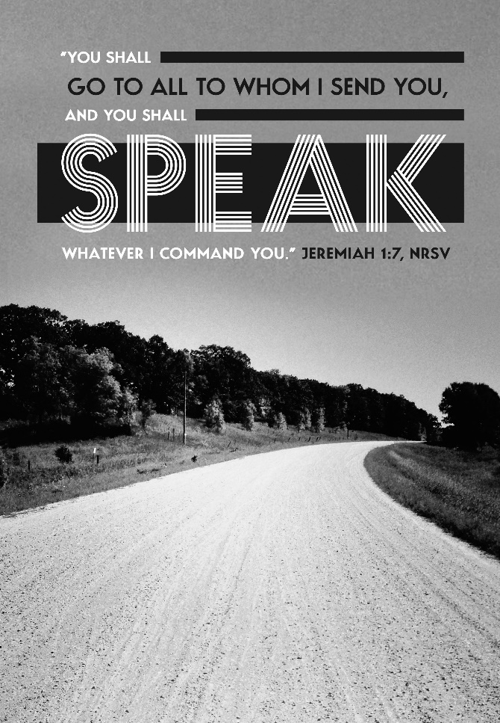

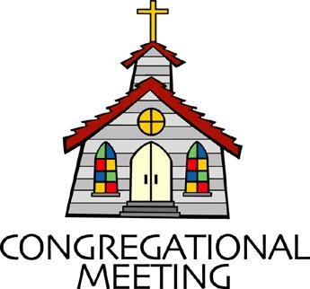
May 22, 2022 - 10:30 am

WELCOME VISITORS! We're glad you are here! Cards at the ends of each pew are for you to fill out and drop in the Offering Plate. Please let us know you are visiting, and join us for refreshments and fellowship following the service. The Sanctuary has an induction loop system to assist the hearing impaired. The system will also work on the telephone setting of hearing aids.

Springfield Presbyterian Church is rooted in the gospel of Jesus Christ, led by the Holy Spirit, and called to loving relationships through vibrant worship and service. Valuing all people, we are committed to developing disciples and fostering stewardship.
PREPARATION FOR THE WORD
(* those who are able are invited to stand)
PRELUDE Aria by Michael Helman
How Beautiful arr. Lloyd Larson

GATHERING OF THE PEOPLE

The Lord be with you! And also with you! (Greeting)

LIGHTING THE CHRIST CANDLE
Leader: Whenever we light this candle we proclaim:
People: Christ is the Light of the world and the center of our lives.

CALL TO WORSHIP
Leader: Today we celebrate transitions,
People: We celebrate the ways the Spirit moves within us, calls us to change, and embraces every new step.
Leader: Today we recognize that we are not alone,
People: We joyfully praise our God who is with us and a community whose love pushes us forward.
Leader: Today we remember the God who calls us all to action, no matter our age, our experience, or our knowledge.
People: We remember that we all hold a piece of truth, a piece of the greater puzzle of God’s mosaic.
Leader: On this celebration Sunday,
People: We celebrate God and our graduates, giving thanks for God’s faithfulness as they step into new hopes, goals, and dreams. Amen.

* HYMN I Was There to Hear Your Borning Cry #488
I was there to hear your borning cry; I’ll be there when you are old.
I rejoiced the day you were baptized to see your life unfold.
I was there when you were but a child with a faith to suit you well;
In a blaze of light you wandered off to find where demons dwell.
When you heard the wonder of the Word, I was there to cheer you on. You were raised to praise the living Lord to whom you now belong.
If you find someone to share your time and you join your hearts as one,
I’ll be there to make your verses rhyme from dusk till rising sun.

In the middle ages of your life, not too old, no longer young,
I’ll be there to guide you through the night, complete what I’ve begun.
When the evening gently closes in and you shut your weary eyes,
I’ll be there as I have always been with just one more surprise.

I was there to hear your borning cry, I’ll be there when you are old.
I rejoiced the day you were baptized to see your life unfold.

CALL TO CONFESSION
Leader: Sometimes we forget the wisdom of children and the knowledge of our youth. We claim that to be older is to be wiser and we close our ears to hearing the younger voices that might be pushing us in a new and beautiful direction. We have lost sight of those in our Scripture who did dynamic things in their youth, like David or Jeremiah. We forget the youth of today, like Greta Thurnberg or Amanda Gorman, have spoken truth for a world in need of their ideas and vision. So we come together to admit our sin and seek to reengage and re-envision where God is calling us to listen to our youth.

PRAYER OF CONFESSION
Generous God, we have forgotten the call to have the faith of a child, to look at life with awe and to encounter situations with creativity and innovation. We have become complicit in our ways, we have not listened to the voice of our youth, and to the prophetic words they have to offer. In a busy world, we forget to listen. So today we commit to lean in, to hear their words, and to follow through. Forgive us, O God, and let us be witnesses to the joy and transformation happening among us today. Amen.
SILENT PRAYERS OF CONFESSION

RESPONSE Restore in Us, O God Tune #434
Restore in us, O God, the splendor of your love;
Renew your image in our hearts, and all our sins remove.

WORDS OF ASSURANCE
Leader: When we acknowledge our sin, God is quick to forgive.
People: We rejoice at God’s grace and are indeed a forgiven people. Thanks be to God! Alleluia and Amen!

* MUSICAL RESPONSE OF PRAISE Alleluia, Alleluia! Give Thanks
Alleluia, alleluia! Give thanks to the risen Lord.
Alleluia, alleluia! Give praise to his name.

* THE PEACE The peace of Christ be with you! And also with you!
(You may greet those around you.)

* RESPONSE Here I Am, Lord
Here I am, Lord, Is it I, Lord? I have heard you calling in the night.
I will go, Lord, if you lead me. I will hold your people in my heart.

THE PROCLAMATION OF THE WORD

PRAYER OF ILLUMINATION
Generous God, your Word is a light to guide us and when we listen closely, we find that your Words speak wisdom to our lives today. Help us to hear the Word, to clear our minds of distraction, and to look toward where God calls each of our hearts. Amen.

FIRST SCRIPTURE LESSON Jeremiah 1:4-10
⁴Now the word of the Lord came to me saying, ⁵ ‘Before I formed you in the womb I knew you, and before you were born I consecrated you;
I appointed you a prophet to the nations.’ ⁶Then I said, ‘Ah, Lord God! Truly I do not know how to speak, for I am only a boy.’ ⁷But the Lord said to me, ‘Do not say, “I am only a boy”; for you shall go to all to whom I send you, and you shall speak whatever I command you.
⁸ Do not be afraid of them, for I am with you to deliver you, says the Lord.’ ⁹Then the Lord put out his hand and touched my mouth; and the Lord said to me, ‘Now I have put my words in your mouth. ¹⁰ See, today I appoint you over nations and over kingdoms, to pluck up and to pull down, to destroy and to overthrow, to build and to plant.’

SECOND SCRIPTURE LESSON 1 Timothy 4:11-16
¹¹These are the things you must insist on and teach. ¹²Let no one despise your youth, but set the believers an example in speech and conduct, in love, in faith, in purity. ¹³Until I arrive, give attention to the public reading of scripture, to exhorting, to teaching. ¹⁴Do not neglect the gift that is in you, which was given to you through prophecy with the laying on of hands by the council of elders. ¹⁵Put these things into practice, devote yourself to them, so that all may see your progress. ¹⁶Pay close attention to yourself and to your teaching; continue in these things, for in doing this you will save both yourself and your hearers.
Leader: Hear what the Spirit is saying to the Church.
All: Thanks be to God.

SERMON The God of Transformation and Transitions Rev. Becca Crate-Price

THE RESPONSE TO THE WORD

* HYMN God of Generations (to the tune of Holy, Holy, Holy!)

God of generations, we are all your children;
To your church we bring our gifts, our worship and our song.
Young and old we follow, hand in hand together:
In your great love, together we are strong.

Christ, you welcomed children, called us to be like them,
And received a boy's small gift to feed a hungry crowd.
In our church's children, may we see you working:
More than "our future"! They are faithful now.

Spirit, freely moving, giving youth a vision,
By your grace young Jeremiah heard your loving call;
Mary was a young one when she learned her mission:
Through faithful youth, you offer truth to all.

God of men and women, Helper on our journey,
You have called us in our faith to grow and to mature.
May we keep on learning, worshiping and praying,
That each new day, we'll serve you all the more.

Abraham and Sarah trusted in your promise:
Age was no condition when you gave them work to do.
Old and young we follow, hand in hand together;
At every age, Lord, we belong to you.

Biblical References: Mark 10:14; Matthew 18:3; John 6:9; Acts 2:17; Jeremiah 1:6; Luke 1:27; Genesis 17:17
Tune: John Bacchus Dykes, 1861 ("Holy, Holy, Holy! Lord God Almighty!") (MIDI)
Text: Copyright © 1998 by Carolyn Winfrey Gillette. All rights reserved.

A RECOGNITION OF OUR GRADUATES Remember Who You Are
By Mark Burrows
PASTORAL PRAYER AND THE LORD’S PRAYER

OFFERTORY Joy and Elation by Cynthia Dobrinski
SONG OF THANKS We Give Thee but Thine Own #708
We give thee but thine own, what e’er the gift may be;
All that we have is thine alone, a trust, O Lord, from thee.
PRAYER OF DEDICATION

* HYMN Lord, When I Came into This Life #691

Within the circle of the faith, as member of your cast,
I take my place with all the saints of future, present, past.

In all the tensions of my life, between my faith and doubt,
Let your great Spirit give me hope, sustain me, lead me out.

So help me in my unbelief and let my life be true:
Feet firmly planted on the earth, my sights set high on you.

* CHARGE AND BENEDICTION
Leader: We celebrate our youth,
People: And commend their journey onwards.
Leader: We remain a safe space,
People: For them to come home and know our love.
Leader: And we trust God,
People: To transform their lives in this time of transition.

* UNISON AMEN

POSTLUDE Festive Celebration by Kevin McChesney

Assisting in Worship: We appreciate those who serve:

Today 5/22 Next Week 5/29
Sunday Opener Ron Holmes Bob Rogers
Ushers/Greeters Elizabeth Meirowitz Sharon Pappas
Cynthia Smith Alex McClung
Lay Leader Linda Black Diana Steppling
Sunday May 29, 2022 Lectionary
Acts 16:16-34; Psalm 97; Revelation 22:12-14, 16-17, 20-21; John 17:20-26

Happy Birthday! May 26 – Davis Streaker
May 29 – Shona Klein

Announcements

Mask Update: Due to the uptick in COVID-19 cases, the Session has decided to strongly encourage masking and social distancing. Though it is not a mandate, we seek to love one another by keeping each other as safe as possible. Thank you for your help in this endeavor.

Pastor-Parish Committee: The Pastor-Parish Committee invites you to share your concerns, suggestions, and gratitude. We have a form in the Narthex and a lock-box that we will open weekly and we ask that you share your name and be specific. We look forward to reading your comments so that we can continue to grow into the body of Christ.

Sunday School is back! On the 1st and 3rd Sundays of the month, we will be offering Sunday School! See Pastor Becca for details…

Spring Plant Sale: Between May 1 and May 31, buy your spring plants at Buppert’s Farm and they will donate 10% of your purchase price back to Springfield’s ongoing projects and mission! Pick up a flyer in the Narthex and share it with your family and friends!

Springfield Membership: Are you interested in finding out more about our faith community and becoming a member? We would love to answer any questions you have. Please contact Pastor Becca at springfieldpastor@gmail.com for more information.

Congregational Care / Mission & Outreach: Do you know of a member or friend of our church family who is ill, needs prayers, would like call, a visit or a card, or might benefit from meal train? If so, please contact the Church Office (410-795-6152), Cathy Marsh (410-549-6916) or Diana Steppling (862-266-2242).

Fellowship Help Needed: If you are interested in helping with Fellowship, please contact Barbara Cornell (401-549-9397). A sign-up sheet will also be available.

Today:
Sunday May 22 – Celebration of Graduates
10:30 am Worship
11:30 am Fellowship

This Week:
Wednesday May 25
7:00 – 8:00 pm Adult Choir Practice
No Bell Choir Practice

Looking Ahead:
Sunday May 29
10:30 am Worship
11:30 am Fellowship

Office Hours: Tuesday, Wednesday & Friday
Springfield Presbyterian Church

10:30 am Worship
11:30 am Fellowship
Website: www.springfield-church.org Church Office: 410-795-6152
Like us on Facebook: www.facebook.com/SpringfieldPresbyterianChurch
Pastor: Rev. Becca Crate-Price
Email: springfieldpastor@gmail.com
Clerk of Session: Sharon Pappas
Minister of Music: Linda Caviglia
Accompanist/Organist: Aaron Thacker
Youth Group Coordinator: Dylan Vasbinder
Administrative Assistant: Donna Mazer e-mail: spc.office@verizon.net

