Springfield Presbyterian Church (USA)
7300 Spout Hill Road, Sykesville, MD 21784 410-795-6152
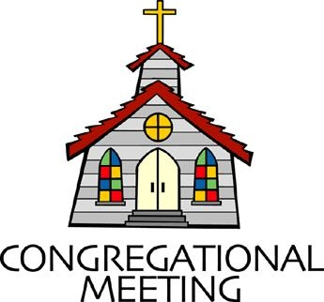

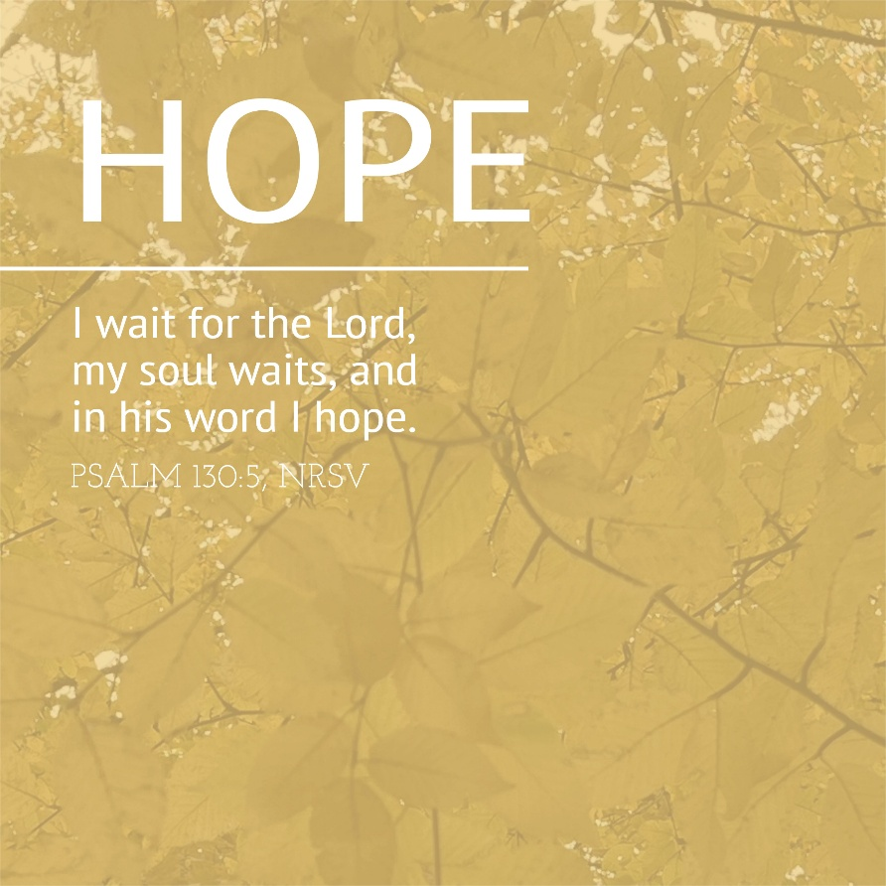

November 30, 2025 - 10:30 am

WELCOME VISITORS!

We're glad you are here! Cards at the ends of each pew are for you to fill out and drop in the Offering Plate. Please let us know you are visiting and join us for refreshments and fellowship following the service. The Sanctuary has an induction loop system to assist the hearing impaired. The system will also work on the telephone setting of hearing aids.

Springfield Presbyterian Church is rooted in the gospel of Jesus Christ, led by the Holy Spirit, and called to loving relationships through vibrant worship and service. Valuing all people, we are committed to developing disciples and fostering stewardship.
PREPARATION FOR THE WORD
(* those who are able are invited to stand)
PRELUDE

GATHERING OF THE PEOPLE

The Lord be with you! And also with you! (Greetings and Announcements)

LIGHTING THE CHRIST CANDLE
Leader: Whenever we light this candle we proclaim:
People: Christ is the Light of the world and the center of our lives.

ADVENT CANDLE LIGHTING – HOPE FOR THOSE WHO WAIT
Choir sings: (…..Christ, be our light! Shine in your Church gathered today.)
Reader: Advent is a time for the human heart to wait, while trusting God’s eternal time.

Congregation: How long, O Lord, how long?

Reader: For those waiting for answered prayer:

Congregation: Grant your steadfast patience.

Reader: For those waiting in the face of uncertainty:

Congregation: Grant unshakable confidence in your sovereign provision.

Reader: For those waiting for justice and mercy to reign:
Congregation: Grant a glimpse of your glory in our wounded world.

Reader: For all of us waiting for God’s kingdom to come:

Congregation: Grant that we might have the peace of Christ as we wait, the love of Christ as we act, and the grace of Christ as we speak.

Reader: This morning, we light the first candle (the candle of Hope) which reminds us that throughout history, God’s people have spent time waiting, wandering and wondering about the timing of God’s eternal plan. Like the people of old, we long for God’s presence to illuminate the areas of life where we are called to wait. This morning, we echo the words of the Psalmist, “Wait for the Lord; be strong, and let your heart take courage: wait for the Lord!” (Psalm 27:14)

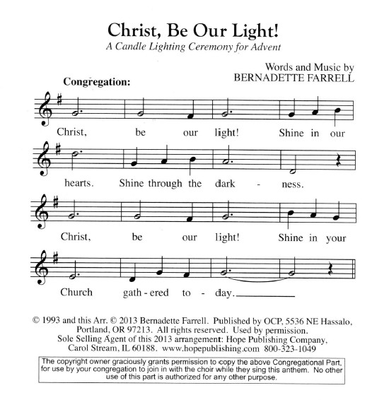
Congregation: God of all creation, we declare that you are the Eternal One. We confess to you, O Lord, that we easily grow impatient, when your word to us is to wait. Ignite within us a new and everlasting hope. We pray this in the name of Christ, our Lord. Amen.

CALL TO WORSHIP —from Psalm 22:22; 97:12; 145:1, 3, NRSV
Leader: In the midst of the congregation I will praise you. Rejoice in the Lord, and give thanks to God’s holy name!
People: I will extol you, my God, and bless your name forever and ever.
Leader: Great is the Lord, and greatly to be praised; God’s greatness is unsearchable.
* HYMN Lift Up Your Heads, Ye Mighty Gates GTG #93

Lift up your heads, ye mighty gates; behold the King of glory waits;
The King of kings is drawing near; the Savior of the world is here.

Fling wide the portals of your heart; make it a temple, set apart
From earthly use for heaven’s employ, adorned with prayer and love and joy.

Redeemer, come! I open wide my heart to thee; here, Lord, abide.
Let me thy inner presence feel; thy grace and love in me reveal.

CALL TO CONFESSION —based on Romans 8:39
Leader: We know that nothing is able to separate us from the love of God in Jesus Christ. Let us in freedom confess the wrong we have done.
PRAYER OF CONFESSION
Holy and merciful God, in your presence we confess our sinfulness, our shortcomings, and our offenses against you. You alone know how often we have sinned in wandering from your ways, in wasting your gifts, in forgetting your love. Have mercy on us, O Lord, for we are ashamed and sorry for all we have done to displease you. Forgive our sins, and help us to live in your light and walk in your ways, for the sake of Jesus Christ, our Savior. Amen.
SILENT PRAYERS OF CONFESSION

RESPONSE Remember Not, O God GTG #430 (v. 1)
Remember not, O God, the sins of long ago;
In tender mercy visit us, distressed and humbled low.

WORDS OF ASSURANCE
Leader: Relentlessly God seeks us out. With abundant grace and boundless mercy, across time and space and through the generations, God seeks us out. This is good news!
People: In Jesus Christ, we are forgiven!

* MUSICAL RESPONSE OF PRAISE How Great Thou Art (refrain only) #625
Then sings my soul, my Savior God, to thee:
How great thou art! How great thou art!
Then sings my soul, my Savior God, to thee:
How great thou art! How great thou art!

* THE PEACE The peace of Christ be with you! And also with you!
(You may greet those around you.)

* RESPONSE Here I Am, Lord GTG #69
Here I am, Lord. Is it I, Lord? I have heard you calling in the night.
I will go, Lord, if you lead me. I will hold your people in my heart.

THE PROCLAMATION OF THE WORD

PRAYER FOR ILLUMINATION
Gracious God, illumine these words by your Spirit that we might hear what you would have us hear and be who you would have us be, for the sake of Jesus Christ, the Word made flesh. Amen.

FIRST SCRIPTURE LESSON Isaiah 2:1-5 OT page 594
¹The word that Isaiah son of Amoz saw concerning Judah and Jerusalem. ²In days to come the mountain of the Lord's house shall be established as the highest of the mountains, and shall be raised above the hills; all the nations shall stream to it. ³Many peoples shall come and say, "Come, let us go up to the mountain of the Lord, to the house of the God of Jacob; that he may teach us his ways and that we may walk in his paths." For out of Zion shall go forth instruction, and the word of the Lord from Jerusalem. ⁴He shall judge between the nations, and shall arbitrate for many peoples; they shall beat their swords into plowshares, and their spears into pruning hooks; nation shall not lift up sword against nation, neither shall they learn war any more. ⁵O house of Jacob, come, let us walk in the light of the Lord!

SECOND SCRIPTURE LESSON Matthew 24:36-44 NT page 26
³⁶"But about that day and hour no one knows, neither the angels of heaven, nor the Son, but only the Father. ³⁷For as the days of Noah were, so will be the coming of the Son of Man. ³⁸For as in those days before the flood they were eating and drinking, marrying and giving in marriage, until the day Noah entered the ark, ³⁹and they knew nothing until the flood came and swept them all away, so too will be the coming of the Son of Man. ⁴⁰Then two will be in the field; one will be taken and one will be left. ⁴¹Two women will be grinding meal together; one will be taken and one will be left. ⁴²Keep awake therefore, for you do not know on what day your Lord is coming. ⁴³But understand this: if the owner of the house had known in what part of the night the thief was coming, he would have stayed awake and would not have let his house be broken into.
⁴⁴Therefore you also must be ready, for the Son of Man is coming at an unexpected hour.

Leader: Hear what the Spirit is saying to the Church.
All: Thanks be to God.

SERMON The Best of Times, the Worst of Times By Debbie Schmidt

THE RESPONSE TO THE WORD

* HYMN Come, Thou Long-Expected Jesus GTG #82

Come, thou long-expected Jesus, born to set thy people free;
From our fears and sins release us; let us find our rest in thee.
Israel’s strength and consolation, hope of all the earth thou art;
Dear desire of every nation, joy of every longing heart.

Born thy people to deliver, born a child and yet a king,
Born to reign in us forever, now thy gracious kingdom bring.
By thine own eternal Spirit rule in all our hearts alone;
By thine all-sufficient merit raise us to thy glorious throne.

PASTORAL PRAYER AND THE LORD’S PRAYER

PRESENTATION OF TITHES AND OFFERINGS
OFFERTORY Hope Will Come
* SONG OF THANKS We Give Thee but Thine Own GTG #708 (v. 1)
We give thee but thine own, what-e’er the gift may be;
All that we have is thine alone, a trust, O Lord, from thee.
* PRAYER OF DEDICATION

* HYMN People, Look East GTG #105

People, look east. The time is near of the crowning of the year.
Make your house fair as you are able; trim the hearth and set the table.
People, look east: Love, the Guest, is on the way.

Furrows, be glad. Though earth is bare, one more seed is planted there.
Give up your strength the seed to nourish, that in course the flower may flourish.
People, look east: Love, the Rose, is on the way.

Birds, though you long have ceased to build, guard the nest that must be filled. Even the hour when wings are frozen, God for fledging time has chosen.
People, look east: Love, the Bird, is on the way.

Stars, keep the watch. When night is dim, one more light the bowl shall brim, shining beyond the frosty weather, bright as sun and moon together.
People, look east: Love, the Star, is on the way.

Angels, announce with shouts of mirth, Christ who brings new life to earth. Set every peak and valley humming with the word, the Lord is coming.
People, look east: Love, the Lord, is on the way.

* CHARGE AND BENEDICTION

* UNISON AMEN

POSTLUDE

Assisting in Worship: We appreciate those who serve:

Today 11/30 Next Week 12/7
Sunday Opener: Beth Oates Barbara Cornell
Ushers/Greeters: Don Vasbinder Connie Gibbons
Bob Rogers Leah Halvorson
Lay Leader: Christy Yeager Elizabeth Meirowitz
Pulpit Supply: Debbie Schmidt Rev. Shannon Weston
Fellowship Hosts: Linda Caviglia Beth Oates
Offering Count: Andrea Kwako & Beth O. Andrea Kwako & Ron H.

Sunday December 7, 2025 Lectionary
Isaiah 11:1-10; Psalm 72:1-7, 18-19; Romans 15:4-13; Matthew 3:1-12

Happy Birthday! December 3 – Angel Carbaugh
December 4 – Ryley Brown
December 6 – Shane Yeager

Announcements

Welcome! We welcome Debbie Schmidt to our pulpit today! Debbie is the retired Associate for Spiritual Leader Development for Baltimore Presbytery and currently the elder for Congregational Spiritual Growth at Chestnut Grove Presbyterian. She has spent much of her adult life leading small group Bible studies and retreats in churches and in her home. She is also trained as a Spiritual Director. Her husband, John, is the retired senior pastor of Central Presbyterian Church. They have two adult children and four grandchildren.

Welcome also to Michael Hall, our substitute accompanist! Michael is a Peabody University of Cincinnati graduate with degrees in French horn performance. The bulk of his work is as a freelance horn player. He serves as principal horn with National Philharmonic and Mid Atlantic Symphony, and he subs with many other groups, including the BSO. As a pianist, Michael has worked as an accompanist at both Catholic U and the Duke Ellington School for the Arts, and fills in for worship from time to time at several churches and synagogues in the Baltimore/DC region. He also maintains a small private studio for horn and piano students at his home in Violetville, Baltimore.

Noisy Offering: TODAY we welcome those noisy coins and they will go toward a selection from the Presbyterian Giving catalog reaching beyond our local community. Your coins have supported the local Community Table hot meals program, The Baltimore-Dakota partnership, and Downtown Sykesville's Happy-Thon Christmas event for families in our area.

ESCAPE Lunch Packing: IT'S OUR TURN AGAIN to make bag lunches for ESCAPE. Join us in the manse Tuesday, December 2 at 7 pm to assemble them. Sign up at Fellowship if you can help bring some of the food.

Upcoming Concert: Mark your calendars for our upcoming concert with Flute Cocktail on Sunday, December 7, 2025 at 3:00 pm. Flute Cocktail is a flute choir composed of 24 flutists playing all sizes of flutes; Piccolo, C-flute, Alto, Bass and Contrabass. So, if you’ve never experienced all these different flutes, now is your chance to see them and hear their different and beautiful tones. Flute Cocktail has been playing for public and private functions in the greater Baltimore, Annapolis and Washington areas since 2002. In 2012, the group officially became a part of the Columbia Bands, Inc. organization. Dr. Linda Kirkpatrick is the director for Flute Cocktail. She has a deep background with flutes as performer, director and author. We are looking forward to seeing this wonderful group perform in our sanctuary. Please join us for music and good food and fellowship following the performance.

Christmas Caroling: We are planning a Christmas Caroling event at 4:00 pm on Sunday afternoon, December 21st. We have a health/rehabilitation center as a very close neighbor – Autumn Lake is just across Spout Hill Road and could really use some outside cheer! We have caroled over there many times, and have always been greeted enthusiastically. Often, residents who are not generally responsive or vocal will join in singing familiar Christmas carols, and you can see in their faces that it means a lot to them. There are several choir members who plan to go, but we would love to have many people from the congregation as well. It’s a busy time of year, but if you can spare an hour or so that afternoon, it will be well worth it for spreading the good news of Christmas to people who may be lonely and missing being at home during the Christmas season. If you are interested, please let Linda Caviglia know, just so she has an idea of how many will be there. (cavig5@comcast.net or
410-746-1221 – call or text)

Zoom Link for Worship Services: The Zoom link for church services is on the SPC website, not on the Facebook page. The Bulletin is also available on the website as well.

Bible Study - "Together on Tuesday": Rev. Amy Carlson, Mt. Hebron, has offered the zoom link to her Tuesday, 7:30 pm study The Word Became Flesh, a study of John's Gospel. You can email her to be added to the mailing, which she usually emails out on Monday or Tuesday, at amycarlson@mthebronpc.org.

Congregational Care: If you know of someone who would benefit from a card or a phone call, please text or call Connie Gibbons at 410-935-3467.

Electronic Giving: Below is a QR code you can scan to make your contribution a new way! The page you get will ask for your name, email and phone

number. You can choose from a dropdown menu for selecting where the donation should go: General Fund, Capital Fund, Concert, Memorial. There is a fee for using a credit card, and you will be given the option to pay that fee along with your donation, but you don’t have to include it if you don’t want to.

Today:
Sunday November 30 – 1st Sunday of Advent
10:30 am Worship
11:30 am Fellowship

This Week:
Monday December 1
7:00 pm Headhuggers (Manse)
Tuesday December 2
7:00 pm ESCAPE Lunch Packing (Manse)
Wednesday December 3
6:15 – 7:15 pm Bell Choir Practice
7:30 – 8:45 pm Adult Choir Practice
Thursday December 4
7:00 pm Session Meeting (Manse)
Saturday December 6
9:00 am Greening of the Church

Next Week:
Sunday December 7 – 2nd Sunday of Advent
10:30 am Worship
11:30 am Fellowship
12:00 noon RGEF Meeting (Library)
3:00 pm Concert (Sanctuary)
Wednesday December 10
6:15 – 7:15 pm Bell Choir Practice
7:30 – 8:45 pm Adult Choir Practice
Thursday December 11
7:00 pm Freedom Area Ringers Concert (Sanctuary)

Office Hours: Tuesday, Wednesday, Friday, 10 am – 3 pm

Springfield Presbyterian Church
10:30 am Worship (and Sunday School 1st & 3rd Sundays)
11:30 am Fellowship
Website: www.springfield-church.org Church Office: 410-795-6152
Like us on Facebook: www.facebook.com/SpringfieldPresbyterianChurch
Pastor: Vacant
Email: spc.office@verizon.net
Clerk of Session: Sharon Pappas
Minister of Music/Accompanist: Aaron Thacker
Bell Choir Director: Vacant
Youth Group Coordinator: Dylan Vasbinder
Administrative Assistant: Donna Mazer Email: spc.office@verizon.net

