(Large Print)

Springfield Presbyterian Church (USA)
7300 Spout Hill Road, Sykesville, MD 21784 410-795-6152

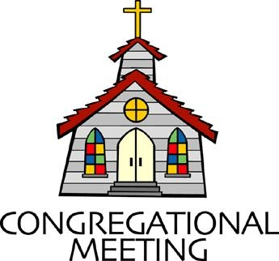
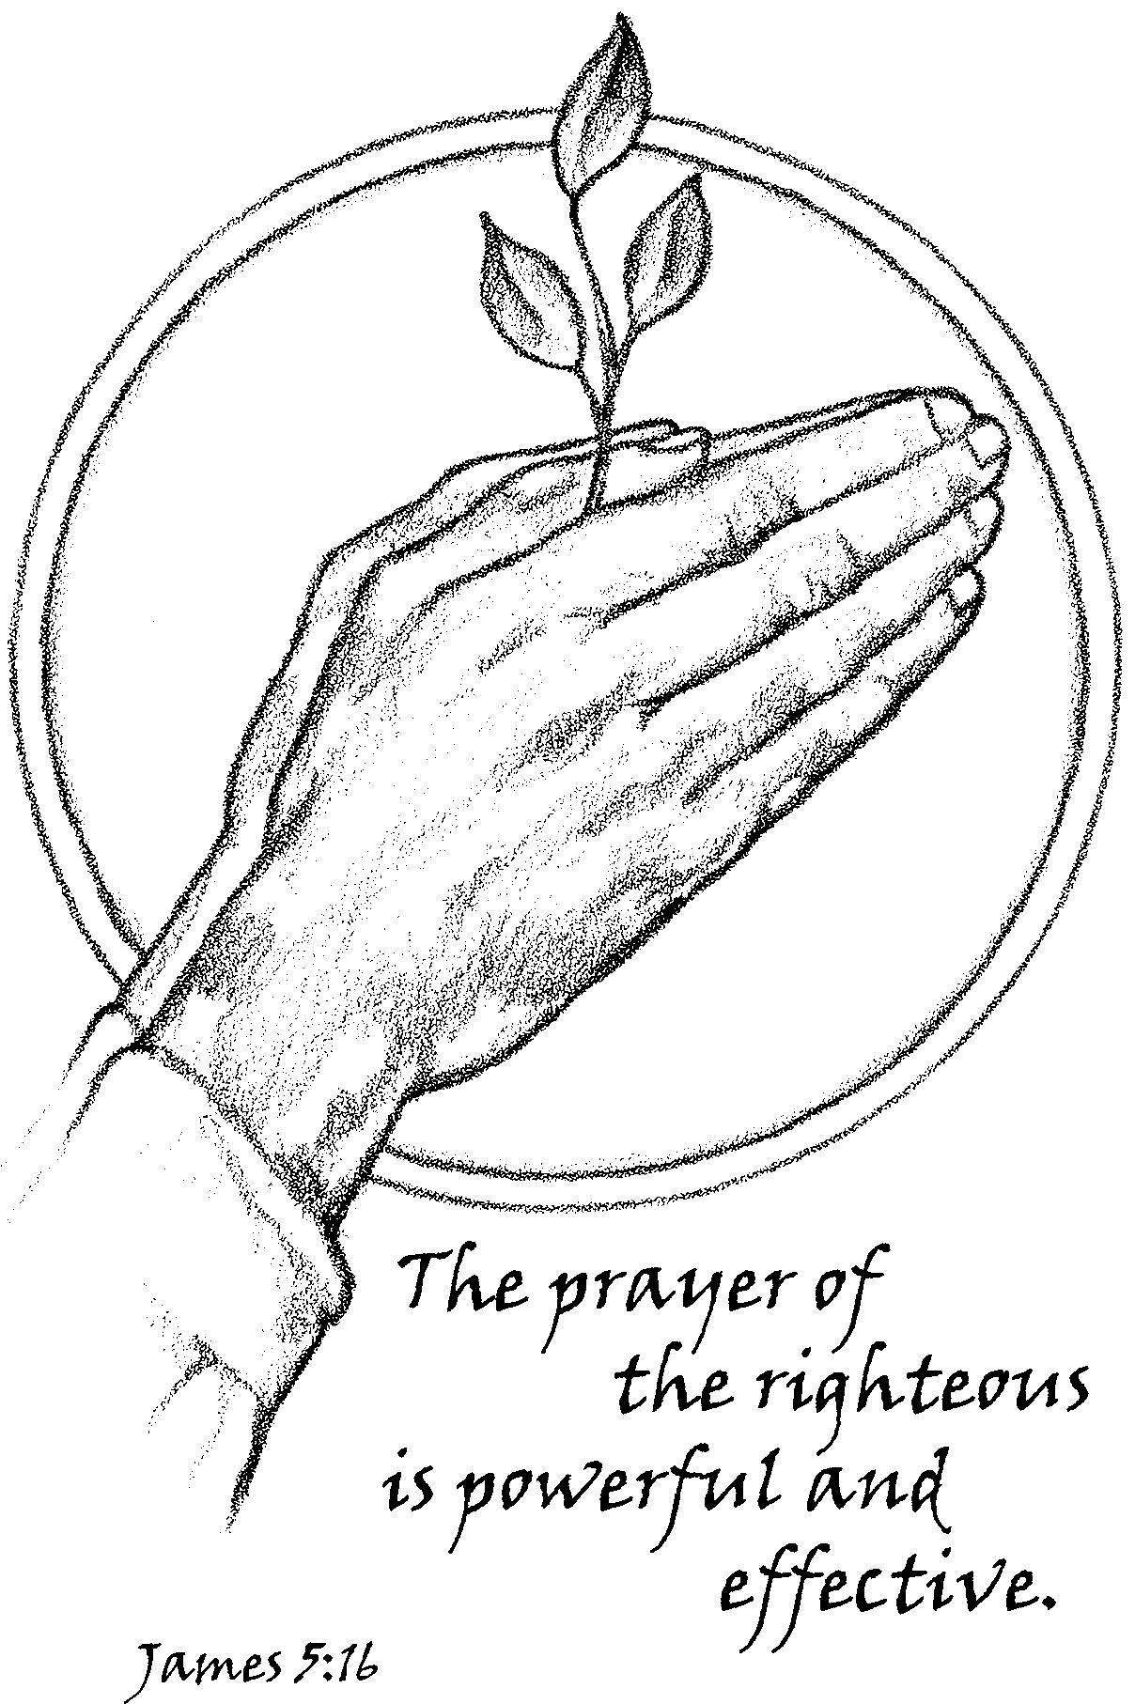

September 17, 2023 - 10:30 am

WELCOME VISITORS!

We're glad you are here! Cards at the ends of each pew are for you to fill out and drop in the Offering Plate. Please let us know you are visiting and join us for refreshments and fellowship following the service. The Sanctuary has an induction loop system to assist the hearing impaired. The system will also work on the telephone setting of hearing aids.

Springfield Presbyterian Church is rooted in the gospel of Jesus Christ, led by the Holy Spirit, and called to loving relationships through vibrant worship and service. Valuing all people, we are committed to developing disciples and fostering stewardship.
PREPARATION FOR THE WORD
(* those who are able are invited to stand)

PRELUDE

GATHERING OF THE PEOPLE

The Lord be with you! And also with you!

(Greetings and Announcements)

LIGHTING THE CHRIST CANDLE
Leader: Whenever we light this candle we proclaim:
People: Christ is the Light of the world and the center of our lives.

CALL TO WORSHIP
Leader: Our names for God vary,
People: Father, Son, and Holy Ghost,
Leader: Creator, Prince of Peace, Spirit,
People: Alpha and Omega, the Great Divine,
Leader: Great Spirit, Wanataka,
People: Our names are many,
Leader: With the beautiful diversity of language,
People: We come before the God beyond our understanding.
ALL: Let us come and worship!

*HYMN Lift Every Voice and Sing GTG #339
Lift every voice and sing till earth and heaven ring,
ring with the harmonies of liberty.
Let our rejoicing rise high as the listening skies;
let it resound loud as the rolling sea.
Sing a song full of the faith that the dark past has taught us;
sing a song full of the hope that the present has brought us.
Facing the rising sun of our new day begun,
let us march on, till victory is won.

Stony the road we trod, bitter the chastening rod,
felt in the days when hope unborn had died.
Yet, with a steady beat, have not our weary feet
come to the place for which our parents sighed?
We have come over a way that with tears has been watered;
we have come, treading our path through the blood of the slaughtered,
out from the gloomy past, till now we stand at last
where the white gleam of our bright star is cast.

God of our weary years, God of our silent tears,
thou who hast brought us thus far on the way;
thou who hast by thy might led us into the light,
keep us forever in the path, we pray.
Lest our feet stray from the places, our God, where we met thee;
lest, our hearts drunk with the wine of the world, we forget thee;
shadowed beneath thy hand may we forever stand,
true to our God, true to our native land.

CALL TO CONFESSION
Leader: As we learn about the Baltimore-Dakota camps this morning, we also come in recognition that we have much to learn from one another. We, for many reasons, often find solace in our own ways, and learning can be difficult because it requires us to be open, to be vulnerable, and to be willing to grow. So, let us come before God, recognizing the need for growth within us, let us confess our faults, and ask God to restore us to right relationship once again. Let us pray:

PRAYER OF CONFESSION
Generous and Loving God, we confess that we have sought to mark off boundaries and claim things as our own when everything is inherently yours. We seek to take, to feel stability, but in doing so, we have forfeited the stability of our neighbor. We ask that you

change our hearts and minds, so that our words and actions better reflect a Kingdom in which diversity is celebrated and all are welcomed and called beloved. Amen.

SILENT PRAYERS OF CONFESSION

RESPONSE Hear My Prayer, O God Tune #782
Hear my prayer, O God, and listen to my plea;
Faithful, righteous One, give ear and answer me.
Judge me not, I pray; no merit dare I claim;
Knowing my own faults, I trust in your just Name.

WORDS OF ASSURANCE
Leader: With great awe, we humbly accept the grace of the Great Spirit’s love for us.
People: Thanks be to God, whose forgiveness washes over us again and again. Alleluia and amen.

* MUSICAL RESPONSE OF PRAISE My Shepherd Will Supply My Need
Tune #803
The sure provisions of my God attend me all my days,
O may your house be my abode, and all my work be praise.
There would I find a settled rest, while others go and come;
No more a stranger, or a guest, but like a child at home.

* THE PEACE The peace of Christ be with you! And also with you!
(You may greet those around you.)

* RESPONSE Here I Am, Lord
Here I am, Lord, Is it I, Lord? I have heard you calling in the night.
I will go, Lord, if you lead me. I will hold your people in my heart.

THE PROCLAMATION OF THE WORD

PRAYER OF ILLUMINATION
Spirit of the Living God, reading and hearing are one of the many ways in which we can learn about you and the ways you are moving in our world and lives. Help us to take this time to tune into those senses, to remove any obstacles, and to embrace these words spoken. Help them to shape, take, and remake us to resemble your love for all. Amen.

FIRST SCRIPTURE LESSON John 1:1-18
In the beginning was the Word, and the Word was with God, and the Word was God. ²He was in the beginning with God. ³All things came into being through him, and without him not one thing came into being. What has come into being ⁴in him was life, and the life was the light of all people. ⁵The light shines in the darkness, and the darkness did not overcome it. ⁶There was a man sent from God, whose name was John. ⁷He came as a witness to testify to the light, so that all might believe through him. ⁸He himself was not the light, but he came to testify to the light. ⁹The true light, which enlightens everyone, was coming into the world. ¹⁰He was in the world, and the world came into being through him; yet the world did not know him. ¹¹He came to what was his own, and his own people did not accept him. ¹²But to all who received him, who believed in his name, he gave power to become children of God, ¹³who were born, not of blood or of the will of the flesh or of the will of man, but of God. ¹⁴And the Word became flesh and lived among us, and we have seen his glory, the glory as of a father’s only son, full of grace and truth. ¹⁵(John testified to him and cried out, ‘This was he of whom I said, “He who comes after me ranks ahead of me because he was before me.” ’) ¹⁶From his fullness we have all received, grace upon grace. ¹⁷The law indeed was given through Moses; grace and truth came through Jesus Christ. ¹⁸No one has ever seen God. It is God the only Son, who is close to the Father’s heart, who has made him known.

SECOND SCRIPTURE LESSON James 5:13-18
¹³Are any among you suffering? They should pray. Are any cheerful? They should sing songs of praise. ¹⁴Are any among you sick? They should call for the elders of the church and have them pray over them, anointing them with oil in the name of the Lord. ¹⁵The prayer of faith will save the sick, and the Lord will raise them up; and anyone who has committed sins will be forgiven. ¹⁶Therefore confess your sins to one another, and pray for one another, so that you may be healed. The prayer of the righteous is powerful and effective. ¹⁷Elijah was a human being like us, and he prayed fervently that it might not rain, and for three years and six months it did not rain on the earth. ¹⁸Then he prayed again, and the heaven gave rain and the earth yielded its harvest.

Leader: Hear what the Spirit is saying to the Church.
All: Thanks be to God.

SERMON The Baltimore-Dakota Learning Partnership
Rev. Fern Cloud

THE RESPONSE TO THE WORD

*HYMN Many and Great, O God, Are Thy Works GTG #21

Many and great, O God, are thy works, Maker of earth and sky.
Thy hands have set the heavens with stars;
thy fingers spread the mountains and plains.
Lo, at thy word the waters were formed.
Deep seas obey thy voice.

Grant unto us communion with thee, thou star-abiding One.
Come unto us and dwell with us.
With thee are found the gifts of life.
Bless us with life that has no end, eternal life with thee.

PASTORAL PRAYER AND THE LORD’S PRAYER

PRESENTATION OF TITHES AND OFFERINGS
OFFERTORY
* SONG OF THANKS Now Thank We All Our God Tune #643
O may this bounteous God through all our life be near us,
With ever joyful hearts and blessed peace to cheer us;
And keep us in God’s grace, and guide us when perplexed,
And free us from all ills in this world and the next.
* PRAYER OF DEDICATION

* HYMN Heleluyan (Alleluia)
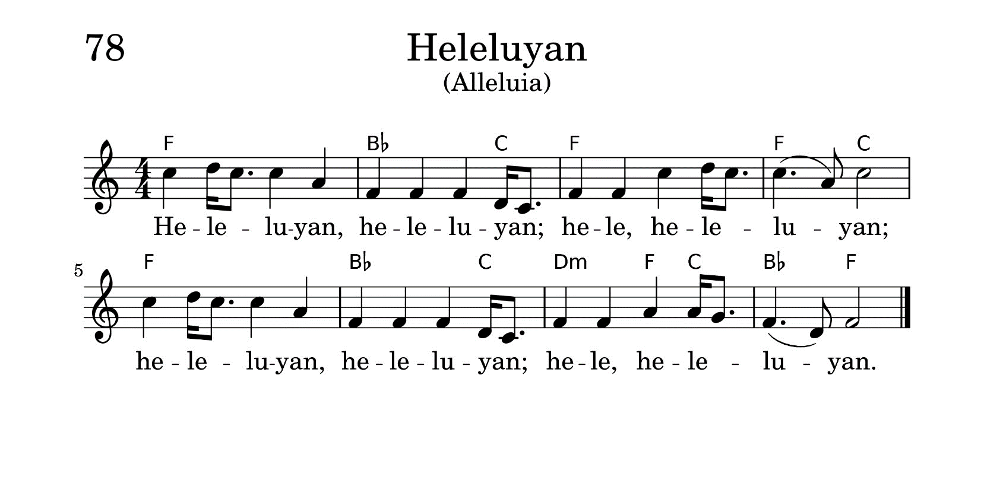
* CHARGE AND BENEDICTION
Leader: We go from this place in awe,
People: We humbly see God’s diversity among us,
Leader: And with our new learning,
People: We shall go with hearts wide open,
Leader: To be the people you call us to be,
People: Loving, open, and ready to see God’s goodness before us every day.

* UNISON AMEN

POSTLUDE

Sunday September 24, 2023 Lectionary
Exodus 16:2-15; Psalm 105:1-6, 37-45; Philippians 1:21-30;
Matthew 20:1-16

Assisting in Worship: We appreciate those who serve:

Today 9/17 Next Week 9/24
Sunday Opener: Bob Rogers Linda Caviglia
Ushers/Greeters: Don Vasbinder Steve & Donna
Elizabeth Meirowitz Mazer
Lay Leader: Diana Steppling Barbara Cornell

Announcements

COME HOME TO OUR HOMECOMING PICNIC! Old friends, new friends, bring a friend, make a friend! We're having a picnic, rain or shine, TODAY, right after worship. Grilled hotdogs and hamburgers will be supplied, but we'll need some help setting up and cleaning up. Contact Barbara Cornell or Diana Steppling if you have any questions.

Choir and Bells: Choir practice began on September 6 and the choir will sing for the first time today! Bell choir practice will begin on Wednesday, September 20 from 6:15 to 7:15 pm. Linda Caviglia will be playing/leading while we continue to search for a new music director.

Fall Fellowship: It's fall, the start of a new season. It almost feels like a new year! A new schedule is posted on the refrigerator, ready for you to sign up. Why don't you take a look and see if there is a date with a special meaning for you, something you'd like to celebrate with us all. You don't have to host all of Fellowship—you could just sign up to bring something! Let Barbara Cornell know if you have any questions or suggestions. barbaracornell4@gmail.com, 240-308-0035

Congregational Care / Mission & Outreach (CoCaMO): Do you know of a member or friend of our church family who is ill, needs prayers, would like call, a visit or a card, or might benefit from meal train? If so, please contact the Church Office (410-795-6152), Cathy Marsh (410-549-6916) or Diana Steppling (862-266-2242).

Today:
Sunday September 17
10:30 am Worship
11:30 am Picnic

This Week:
Wednesday September 20
6:15 – 7:15 pm Bell Choir Practice
7:30 – 8:45 pm Adult Choir Practice

Next Week:
Sunday September 24
10:30 am Worship
11:30 am Fellowship
12:00 noon RGEF Meeting (Manse)

Office Hours: Tuesday, Wednesday and Friday, 10:00 am - 3:00 pm

Springfield Presbyterian Church

10:30 am Worship
11:30 am Fellowship
Website: www.springfield-church.org Church Office: 410-795-6152
Like us on Facebook: www.facebook.com/SpringfieldPresbyterianChurch
Pastor: Rev. Becca Price
Email: springfieldpastor@gmail.com
Clerk of Session: Sharon Pappas
Minister of Music: Vacant
Accompanist/Organist: Aaron Thacker
Youth Group Coordinator: Dylan Vasbinder
Administrative Assistant: Donna Mazer e-mail: spc.office@verizon.net

