(Large Print)

Springfield Presbyterian Church (USA)
7300 Spout Hill Road, Sykesville, MD 21784 410-795-6152

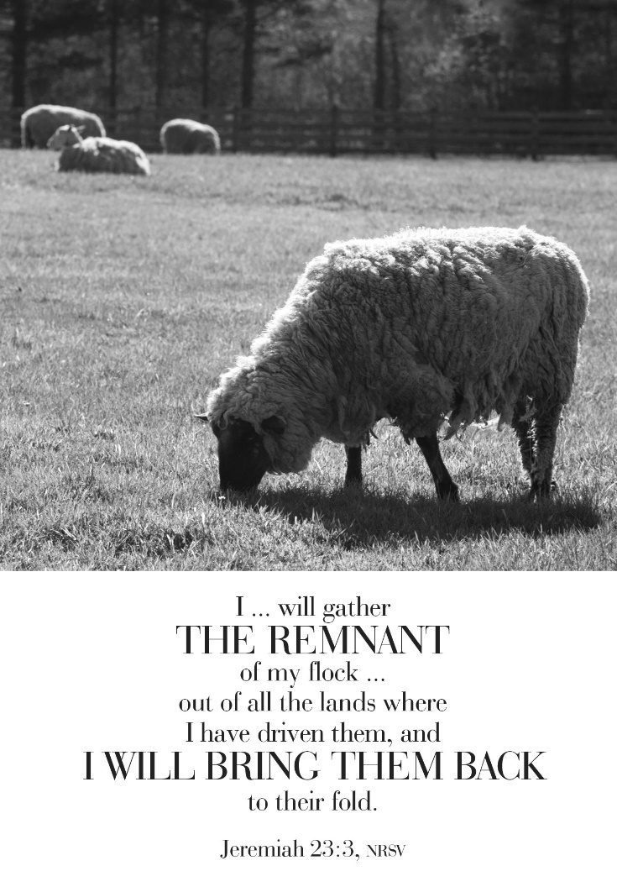

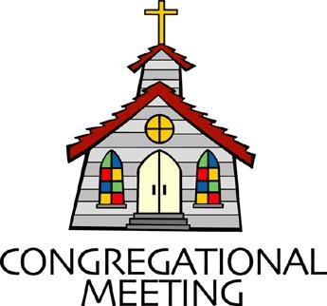
November 24, 2019 - 10:30 am

WELCOME VISITORS! We're glad you are here! Cards at the ends of each pew are for you to fill out and drop in the Offering Plate. Please let us know you are visiting, and join us for refreshments and fellowship following the service. The Sanctuary has an induction loop system to assist the hearing impaired. The system will also work on the telephone setting of hearing aids.

Springfield Presbyterian Church is rooted in the gospel of Jesus Christ, led by the Holy Spirit, and called to loving relationships through vibrant worship and service. Valuing all people, we are committed to developing disciples and fostering stewardship.
PREPARATION FOR THE WORD
(* those who are able are invited to stand)

PRELUDE

GATHERING OF THE PEOPLE

The Lord be with you! And also with you! (Greeting)

LIGHTING THE CHRIST CANDLE
Leader: Whenever we light this candle we proclaim:
People: Christ is the Light of the world and the center of our lives.

CALL TO WORSHIP
Leader: Let the heavens be glad and let the earth rejoice!
People: Christ will reign forever and ever!
Leader: The Lord is robed in majesty and girded in strength.
People: Christ will reign forever and ever!
Leader: God has established the world, and God’s realm will never be shaken.
People: Christ will reign forever and ever!
Leader: God will judge the world with righteousness and the peoples with equity.
People: Christ will reign forever and ever!
Leader: The kingdom of this world has become the kingdom of our Lord.
People: Christ will reign forever and ever!
ALL: Let us praise Christ the King!

* HYMN Crown Him with Many Crowns
Crown him with many crowns, the Lamb upon his throne;
Hark, how the heavenly anthem drowns all music but its own!
Awake, my soul, and sing of him who died for thee,
And hail him as thy matchless King through all eternity.
Crown him the Lord of love; behold his hands and side,
Rich wounds, yet visible above, in beauty glorified:
No angel in the sky can fully bear that sight,
But downward bends his burning eye at mysteries so bright.

Crown him the Lord of peace, whose power a scepter sways
From pole to pole, that wars may cease, absorbed in prayer and praise.
His reign shall know no end; and round his pierced feet
Fair flowers of paradise extend their fragrance ever sweet.

Crown him the Lord of years, the potentate of time;
Creator of the rolling spheres, ineffably sublime.
All hail, Redeemer, hail! For thou hast died for me;
Thy praise shall never, never fail throughout eternity.

PRAYER OF CONFESSION
Righteous and Loving God, you have crowned Jesus Christ as Lord of all. We confess that we have not bowed before Him, and are slow to acknowledge His rule. We give allegiance to the powers of this world, and fail to be governed by justice and love. In your mercy, forgive us. Raise us to acclaim Him as ruler of all, that we may be loyal ambassadors, obeying the commands of our Lord Jesus Christ. Amen.

SILENT PRAYERS OF CONFESSION

RESPONSE Breathe on Me, Breath of God
Breathe on me, breath of God, until my heart is pure,
Until with thee I will one will, to do and to endure.

WORDS OF ASSURANCE [Col. 1:13-14]
Leader: God has rescued us from the power of evil and claimed us for the realm of Jesus Christ, in whom we have redemption.

People: In the name of Jesus Christ, we are forgiven! Thanks be to God! Amen!

* MUSICAL RESPONSE OF PRAISE O My Soul, Bless Your Redeemer
O my soul, bless your Redeemer; all within me bless God’s name;
Bless the Savior, and forget not all God’s mercies to proclaim.

* THE PEACE The peace of Christ be with you! And also with you!
(You may greet those around you.)

* RESPONSE Here I Am, Lord
Here I am, Lord, Is it I, Lord? I have heard you calling in the night.
I will go, Lord, if you lead me. I will hold your people in my heart.

THE PROCLAMATION OF THE WORD

PRAYER OF ILLUMINATION
Leader: Sovereign God, let your word rule in our hearts and your Spirit govern our lives until at last we see the fulfillment of your realm of justice and peace; through Jesus Christ our Lord. Amen.

FIRST SCRIPTURE LESSON Psalm 46
¹ God is our refuge and strength, a very present help in trouble.
² Therefore we will not fear, though the earth should change, though the mountains shake in the heart of the sea; ³ though its waters roar and foam, though the mountains tremble with its tumult. ⁴ There is a river whose streams make glad the city of God, the holy habitation of the Most High. ⁵ God is in the midst of the city; it shall not be moved; God will help it when the morning dawns. ⁶ The nations are in an uproar, the kingdoms totter; he utters his voice, the earth melts. ⁷ The Lord of hosts is with us; the God of Jacob is our refuge. ⁸ Come, behold

the works of the Lord; see what desolations he has brought on the earth. ⁹ He makes wars cease to the end of the earth; he breaks the bow, and shatters the spear; he burns the shields with fire. ¹⁰ ‘Be still, and know that I am God! I am exalted among the nations, I am exalted in the earth.’ ¹¹ The Lord of hosts is with us; the God of Jacob is our refuge.

SECOND SCRIPTURE LESSON Jeremiah 23:1-6
Woe to the shepherds who destroy and scatter the sheep of my pasture! says the Lord. ²Therefore, thus says the Lord, the God of Israel, concerning the shepherds who shepherd my people: It is you who have scattered my flock, and have driven them away, and you have not attended to them. So I will attend to you for your evil doings, says the Lord. ³Then I myself will gather the remnant of my flock out of all the lands where I have driven them, and I will bring them back to their fold, and they shall be fruitful and multiply. ⁴I will raise up shepherds over them who will shepherd them, and they shall not fear any longer, or be dismayed, nor shall any be missing, says the Lord. ⁵The days are surely coming, says the Lord, when I will raise up for David a righteous Branch, and he shall reign as king and deal wisely, and shall execute justice and righteousness in the land. ⁶In his days Judah will be saved and Israel will live in safety. And this is the name by which he will be called: ‘The Lord is our righteousness.’

Leader: Hear what the Spirit is saying to the Church.
All: Thanks be to God.

TIME WITH YOUNG PEOPLE

SERMON Into the Fold Rev. Becca Crate

THE RESPONSE TO THE WORD

* HYMN Come, Christians, Join to Sing
Come, Christians, join to sing: Alleluia! Amen!
Loud praise to Christ our King: Alleluia! Amen!
Let all, with heart and voice, before his throne rejoice;
Praise is his gracious choice: Alleluia! Amen!

Come, lift your hearts on high: Alleluia! Amen!
Let praises fill the sky: Alleluia! Amen!
He is our guide and friend; to us he'll condescend;
His love shall never end: Alleluia! Amen!

Praise yet our Christ again: Alleluia! Amen!
Life shall not end the strain: Alleluia! Amen!
On heaven's blissful shore his goodness we'll adore,
Singing forevermore: Alleluia! Amen!

PASTORAL PRAYER AND THE LORD’S PRAYER
“For this I pray to God.” / “For this I give thanks to God.”
Congregational Response: “Hear our prayer, O God.”

PRESENTATION OF TITHES AND OFFERINGS
OFFERTORY The Perfect Wisdom of Our God Arr. Milly Ijames
* SONG OF THANKS We Give Thee but Thine Own
May we thy bounties thus as stewards true receive,
And gladly, as thou blessest us, to thee our first-fruits give.
* PRAYER OF DEDICATION

* HYMN A Mighty Fortress Is Our God
A mighty fortress is our God, a bulwark never failing.
Our helper he, amid the flood of mortal ills prevailing.
For still our ancient foe doth seek to work us woe.
His craft and power are great, and armed with cruel hate,
On earth is not his equal.

Did we in our own strength confide, our striving would be losing,
Were not the right man on our side, the man of God's own choosing.
Dost ask who that may be? Christ Jesus, it is he.
Lord Sabaoth his name, from age to age the same,
And he must win the battle.

And though this world, with devils filled, should threaten to undo us,
We will not fear, for God hath willed his truth to triumph through us.
The Prince of Darkness grim, we tremble not for him.
His rage we can endure, for lo, his doom is sure.
One little word shall fell him.

That word above all earthly powers, no thanks to them, abideth.
The Spirit and the gifts are ours through him who with us sideth.
Let goods and kindred go, this mortal life also.
The body they may kill; God's truth abideth still.
His kingdom is forever.

* CHARGE AND BENEDICTION
Leader: We praise our God, Christ the King!
People: Whose reign triumphs forevermore!
Leader: In faithfulness, by the leading of the Spirit,
People: We faithfully remember we are a part of the Shepherd’s flock, the King’s own children.
Leader: And so we leave this place,
People: Acknowledging all people, in all places, in all times, as the beloved children of the King.

* UNISON AMEN

POSTLUDE
Sunday December 1 Lectionary
Isaiah 2:1-5; Psalm 122; Romans 13:11-14; Matthew 24:36-44

Assisting in Worship: We appreciate those who serve:

Today 11/24 Next Week 12/1
Sunday Opener Jennifer Wise Barbara Cornell
Greeters & Ushers Bob Rogers & Amy Vasbinder &
Volunteer Bob Rogers
Lay Leader Don Vasbinder Mark Kearney
Sunday School Connie Robinson Connie Robinson
Fellowship Barbara Cornell

Church Attendance: November 11 - 42

Church Cleaning: November 29, 30 or December 1 – Lisa & Bob
Rogers

Happy Birthday! November 25 – Barbara Nickell
November 26 – Jim Rhodes

Happy Anniversary! November 29 – Amy & Omar Izaguirre

Announcements

Stewardship: Many of you have turned in your pledge card for 2020, and we thank you! If you haven’t submitted yours yet, you may put it in the offering plate or send it to the Church Office at your earliest convenience. This will help us to prepare our budget for 2020.

Christmas Flowers: LAST CHANCE! If you haven’t ordered your Christmas flowers to place in the Sanctuary for Christmas, you have a few more days to place your order. There are order forms in the Narthex or contact the Church Office no later than Tuesday, November 26.

Shepherd’s Staff Festival of Trees (November 29 – December 1): Come join the fun! The Shepherd's Staff's Annual Festival of Trees will include a Silent Auction featuring over 30 decorated trees, an Ugly Sweater Contest, fun raffles, live music, baked goods, fun photo booth, children's craft table, and cash & carry gift baskets. For sponsorship opportunities, call 410-857-5944, email info@shepstaff.org, or online at http://www.shepstaff.org/events/festival-of-trees/
HOURS:
Fri, Nov. 29 : 10 a.m. - 5 p.m.
Sat. Nov. 30: 10 a.m. - 8 p.m.
Sun. Dec. 1: 10 a.m. - 2 p.m. Silent Auction ends at 2 p.m., with tree
pick-up from 4-6 p.m.

Our Next Concert: We welcome our very own Aaron Thacker and his colleague, Ben Shaver to our stage on Sunday, December 8 at 3:00 pm. We hope your family and friends can join us for this concert, and some fellowship and good food following the music!

Blessing Bags are in the Narthex. Please feel free to pick up a few. Handing one out to someone in need gives you a very real way to meet their immediate needs by providing them with some basic supplies.

Weekly Announcements: If you have an announcement to include with next week’s bulletin, please call the Office at 410-795-6152 or email to spc.office@verizon.net by Wednesday each week.

Prayers & Thanksgivings

~ Prayers for First of Howard County from our Ministry Group.

The Congregational Care team wants to know what YOU or someone you know needs...a visit...a call...a meal. Please contact Diana Steppling or Connie Robinson. If you are in need of pastoral care, please contact Pastor Becca at 410-795-6152 or springfieldpastor@gmail.com.

Today:
Sunday November 24
10:30 am Worship
11:30 am Fellowship
12:00 noon RGEF Meeting (Library)

This Week:
Tuesday November 26
10:30 am Prayer Group (Manse)
Wednesday November 27
No Choir Practice

Looking Ahead:
Sunday December 1
9:00 am Red Sea Parting Practice
10:30 am Worship
11:30 am Fellowship
12:00 noon Greening of the Church
Monday December 2
4:30 pm C.I.A. Meeting (Manse)
Wednesday December 4
6:30 pm Bell Choir Practice
7:45 pm Adult Choir Practice
Thursday December 5
7:00 pm Mission & Outreach Committee Meeting (Manse)

Office Hours: Tuesday, Wednesday, Friday 9:00 am - 3:00 pm

Springfield Presbyterian Church

10:30 am Worship & Sunday School
11:30 am Fellowship
Website: www.springfield-church.org Church Office: 410-795-6152
Like us on Facebook: www.facebook.com/SpringfieldPresbyterianChurch
Pastor: Rev. Becca Crate
Email: springfieldpastor@gmail.com
Clerk of Session: Sharon Pappas
Minister of Music: Linda Caviglia
Accompanist: Aaron Thacker Organist: Jennifer Wise
Youth Group Coordinators: Charles & Deb Sperling
Sunday School Coordinator: Connie Robinson
Administrative Assistant: Donna Mazer
e-mail: spc.office@verizon.net

