Springfield Presbyterian Church (USA)
7300 Spout Hill Road, Sykesville, MD 21784 410-795-6152

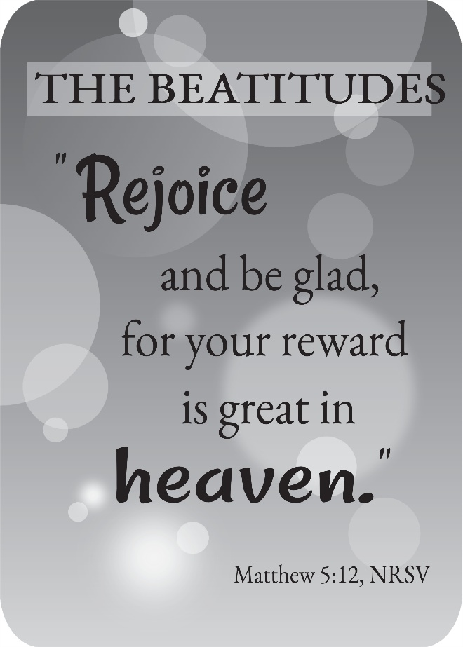

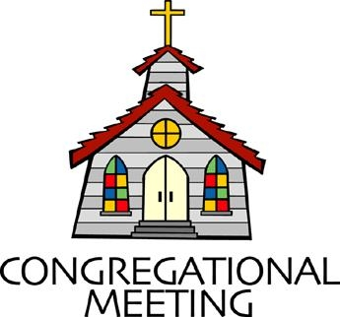
November 1, 2026 - 10:30 am

WELCOME VISITORS!

We're glad you are here! Cards at the ends of each pew are for you to fill out and drop in the Offering Plate. Please let us know you are visiting and join us for refreshments and fellowship following the service. The Sanctuary has an induction loop system to assist the hearing impaired. The system will also work on the telephone setting of hearing aids.

Springfield Presbyterian Church is rooted in the gospel of Jesus Christ, led by the Holy Spirit, and called to loving relationships through vibrant worship and service. Valuing all people, we are committed to developing disciples and fostering stewardship.

PREPARATION FOR THE WORD
(* those who are able are invited to stand)

PRELUDE

PASTOR’S WELCOME

ANNOUNCEMENTS

GATHERING OF THE PEOPLE

The Lord be with you! And also with you!

LIGHTING THE CHRIST CANDLE
Leader: Whenever we light this candle we proclaim:
People: Christ is the Light of the world and the center of our lives.

CALL TO WORSHIP
Leader: We are gathered
All: to tell stories.
Leader: We are gathered
All: to remember.
Leader: We are gathered
All: surrounded by so great a cloud of witnesses.
Leader: We are gathered
All: to celebrate the saints.
Leader: Let us worship God.

* HYMN For All the Saints GTG #326

For all the saints who from their labors rest,
Who thee by faith before the world confessed,
Thy name, O Jesus, be forever blest. Alleluia! Alleluia!

Thou wast their rock, their fortress, and their might;
Thou, Lord, their captain in the well-fought fight;
Thou, in the darkness drear, their one true light. Alleluia! Alleluia!

O blest communion, fellowship divine!
We feebly struggle; they in glory shine;
Yet all are one in thee, for all are thine. Alleluia! Alleluia!

And when the strife is fierce, the warfare long,
Steals on the ear the distant triumph song,
And hearts are brave again, and arms are strong. Alleluia! Alleluia!

From earth’s wide bounds, from ocean’s farthest coast,
Through gates of pearl streams in the countless host,
Singing to Father, Son, and Holy Ghost, Alleluia! Alleluia!

CALL TO CONFESSION
Leader: All of us are saints, because all of us are God’s children. Even so, we make mistakes. We sin whether we intend to or not. In the confidence that God loves us no matter what, let us confess our sins.

UNISON PRAYER FOR FORGIVENESS
God, you always listen. We are sorry for the times we have not shown mercy to our neighbors, our family and even sometimes ourselves. Forgive us for raising our voices about things that do not matter and staying quiet about things that do. Help us to live the example of love that Jesus taught us and the saints showed us.

SILENT PRAYERS OF CONFESSION

RESPONSE Remember Not, O God GTG #430 (v. 1)
Remember not, O God, the sins of long ago;
In tender mercy visit us, distressed and humbled low.

WORDS OF ASSURANCE
Heather: God’s mercy and love never ends. Hear the Good News: In Jesus Christ we are forgiven. Amen.

* MUSICAL RESPONSE OF PRAISE How Great Thou Art (refrain only)
Then sings my soul, my Savior God, to thee: How great thou art!
How great thou art! Then sings my soul, my Savior God, to thee: How great thou art! How great thou art!

* THE PEACE The peace of Christ be with you! And also with you!
(You may greet those around you.)

* RESPONSE Here I Am, Lord GTG #69
Here I am, Lord. Is it I, Lord? I have heard you calling in the night.
I will go, Lord, if you lead me. I will hold your people in my heart.

THE PROCLAMATION OF THE WORD

PRAYER OF ILLUMINATION
Leader: Lord, in your mercy, give us understanding as your word is read today. May the meditations of our hearts and minds together be pleasing in your sight, our rock and our redeemer. Amen.

FIRST SCRIPTURE LESSON 1 John 3:1-3 NT page 225
¹See what love the Father has given us, that we should be called children of God; and that is what we are. The reason the world does not know us is that it did not know him. ²Beloved, we are God's children now; what we will be has not yet been revealed. What we do know is this: when he is revealed, we will be like him, for we will see him as he is. ³And all who have this hope in him purify themselves, just as he is pure.

GOSPEL LESSON Matthew 5:1-12 NT page 4
¹When Jesus saw the crowds, he went up the mountain; and after he sat down, his disciples came to him. ²Then he began to speak, and taught them, saying:
³"Blessed are the poor in spirit, for theirs is the kingdom of heaven. ⁴"Blessed are those who mourn, for they will be comforted. ⁵"Blessed are the meek, for they will inherit the earth. ⁶"Blessed are those who hunger and thirst for righteousness, for they will be filled. ⁷"Blessed are the merciful, for they will receive mercy. ⁸"Blessed are the pure in heart, for they will see God. ⁹"Blessed are the peacemakers, for they will be called children of God. ¹⁰"Blessed are those who are persecuted for righteousness' sake, for theirs is the kingdom of heaven.
¹¹"Blessed are you when people revile you and persecute you and utter all kinds of evil against you falsely on my account. ¹²Rejoice and be glad, for your reward is great in heaven, for in the same way they persecuted the prophets who were before you.

Leader: This is the Word of the Lord. All: Thanks be to God.

VIDEO REFLECTION

THE RESPONSE TO THE WORD

* HYMN Guide Me, O Thou Great Jehovah GTG #65

Guide me, O thou great Jehovah, pilgrim through this barren land.
I am weak, but thou art mighty. Hold me with thy powerful hand.
Bread of heaven, bread of heaven, feed me till I want no more;
Feed me till I want no more.

Open now the crystal fountain, whence the healing stream doth flow.
Let the fire and cloudy pillar lead me all my journey through.
Strong deliverer, strong deliverer, be thou still my strength and shield;
Be thou still my strength and shield.

When I tread the verge of Jordan, bid my anxious fears subside.
Death of death, and hell's destruction, land me safe on Canaan's side.
Songs of praises, songs of praises I will ever give to thee; I will ever give to thee.

PRAYERS OF THE PEOPLE

TIME OF REMEMBRANCE
Leader: We remember the great ancestors of our faith, from Abraham and Sarah, to Paul and Phoebe:
All: Ancestors of the faith, we remember you.
Leader: We remember the prophets and priests, the ministers and teachers who have taught us the way of God:
All: Teachers of the faith, we remember you.

Leader: We remember our grandparents and parents, aunts and uncles, those who have gone before us in our lifetime:
All: Family of our faith, we remember you.
Leader: We lift up the memories of children and grandchildren, brothers and sisters, spouses, partners and parents whose lives ended too soon:
All: Those close in our heart, we remember you.
Leader: We lift up to You, O God, the names of those we have lost in this past year from our lives, knowing that they are with Your heart forever. As we come forward, we will pause after each flower is moved to remember, pray, and give thanks for their life.

(Remembrance with flowers and bell tolling)

We celebrate the lives of those we have named, O God, and lift up many more names in our hearts.
All: Family of God, we remember you, and we honor you. We know you are with us in the spirit of worship, and you will not be forgotten.
Leader: We give thanks, O God, for all who have gone on to join with You beyond this life. We trust in the hope of resurrection and the promise of new life in Christ, and know that in our grief and celebration, O God, You are with us through it all, and we are not left alone. In the name of Christ, in whom love lives forever, we pray.
All: Amen.
THE COMMUNION OF THE PEOPLE

INVITATION

THE GREAT PRAYER OF THANKSGIVING
Tucker: The Lord be with you.
All: And also with you.
Tucker: Lift up your hearts.
All: We lift them up to the Lord.
Tucker: Let us give thanks to the Lord our God.
All: It is right to give our thanks and praise.

[the Pastor continues… “who forever sing your praise:”]
All: Holy, holy, holy Lord, God of power and might, heaven and earth are full of your glory. Hosanna in the highest. Blessed is he who comes in the name of the Lord. Hosanna in the highest!

[the Pastor continues… “… we will feast with you at your table in glory.”]
Tucker: Great is the mystery of faith:
All: Christ has died, Christ is risen, Christ will come again.

THE LORD’S PRAYER
Our Father, who art in heaven, hallowed be thy name, thy kingdom come, thy will be done, on earth as it is in heaven. Give us this day our daily bread; and forgive us our debts, as we forgive our debtors; and lead us not
into temptation, but deliver us from evil. For thine is the kingdom, and the power, and the glory, forever, Amen.

PRAYER AFTER COMMUNION
Heather: God of glory, in this holy feast you have made us one with Christ and with that great multitude of the faithful - those who hunger and thirst no more and worship day and night in your temple. Lead us in the paths of righteousness and guide us to the springs of the water of life, until we join the choir of the redeemed, singing: Salvation belongs to our God who is seated on the throne, and to the Lamb: Jesus Christ our Lord. Amen.

PRESENTATION OF TITHES AND OFFERINGS
OFFERTORY Find Us Faithful
* SONG OF THANKS We Give Thee but Thine Own GTG #708 (v. 1)
We give thee but thine own, what-e’er the gift may be;
All that we have is thine alone, a trust, O Lord, from thee.
* PRAYER OF DEDICATION

* HYMN Love Divine, All Loves Excelling GTG #366

Love divine, all loves excelling, Joy of heaven, to earth come down,
Fix in us thy humble dwelling; all thy faithful mercies crown.
Jesus, thou art all compassion; pure, unbounded love thou art;
Visit us with thy salvation; enter every trembling heart.

Breathe, O breathe thy loving Spirit into every troubled breast;
Let us all in thee inherit; let us find the promised rest.
Take away the love of sinning; Alpha and Omega be;
End of faith, as its beginning, set our hearts at liberty.

Come, Almighty, to deliver; let us all thy life receive;
Suddenly return, and never, nevermore thy temples leave.
Thee we would be always blessing, serve thee as thy hosts above,
Pray, and praise thee without ceasing, glory in thy perfect love.

Finish then thy new creation; pure and spotless let us be;
Let us see thy great salvation perfectly restored in thee:
Changed from glory into glory, till in heaven we take our place,
Till we cast our crowns before thee, lost in wonder, love, and praise.

* CHARGE AND BENEDICTION
Heather: As you go out from here, love one another with mutual affection; outdo one another in showing honor. Live in harmony with one another, rejoice in hope, be patient in affliction, persevere in prayer. Love and serve the Lord, in the name of the Father, and of the Son, and of the Holy Spirit, Amen.

* UNISON AMEN GTG #601

POSTLUDE

Some liturgy adapted from Child Of Blessing Lectionary Resource, Presbyterian Association of Musicians and Rev. Mindi: https://www.rev-o-lution.org/.

Happy Anniversary! November 4 – Alex & Brenda McClung

Happy Birthday! November 1 – Olivia Oates
November 3 – Brenda McClung

Sunday, November 8 Lectionary:
Joshua 3:7-17; Psalm 107:1-7, 33-37; 1 Thessalonians 2:9-13; Matthew 23:1-12
Assisting in Worship: We appreciate those who serve:

Today 11/1 Next Week 11/8
Sunday Opener: Linda Caviglia Ron Holmes
Ushers/Greeters: Cynthia Smith Steve & Donna Mazer
Leah Halvorson
Lay Leader: Mark Kearney Alex McClung
Offering Counters: Barbara N. & Volunteer Beth O. & Belle V.
Fellowship Hosts: Bob & Diana Steppling Andrea Kwako &
Heidi McRoy

Announcements

We welcome Tucker Ball who is joining us today as an elder of Dickey Memorial Presbyterian Church. He will co-preside at the communion table as a part of his training to be commissioned to serve communion at his home church.

Happy-Thon: Happy-Thon is more than holiday presents. It strengthens the social fabric connecting neighbors across schools, businesses, local government, nonprofit partners, and our generations. The goal of Happy-Thon is to cultivate a vibrant downtown Sykesville area and a community where everyone feels welcomed, supported, and able to participate. Your ear-marked donations may be given until the end of November, leaving them time to plan their gift-giving.

TV in Fellowship Room: You may have noticed the TV in the fellowship room- this has been installed in order to show the livestream of our worship service in an additional location. If you need a break from the sanctuary, or more room for wiggling kids, please know that you can still access the live service (with a 15 second delay) from there. We hope it will allow more people to access our worship service in ways that make sense for them.

Christmas Flowers: It’s time to order your Christmas flowers! Please see the order form on the last page of your bulletin.

Livestreaming: We are livestreaming our worship service on YouTube now. We will continue to have Zoom as an option, as well.

Congregational Care: If you know of someone who would benefit from a card or a phone call, please text or call Diana Steppling at 862-266-2242.

Electronic Giving: Below is a QR code you can scan to make your contribution a new way! The page you get will ask for your name, email and phone

number. You can choose from a dropdown menu for selecting where the donation should go: General Fund, Capital Fund, Concert, Memorial. There is a fee for using a credit card, and you will be given the option to pay that fee along with your donation, but you don’t have to include it if you don’t want to.

Today:
Sunday November 1
10:30 am Worship
11:30 am Fellowship

This Week:
Monday November 2
7:00 pm Headhuggers (Manse)
Tuesday November 3
1:15 pm Worship Committee (Zoom)
7:30 pm Adult Choir Practice
Wednesday November 4
6:15 pm Bell Choir Practice

Next Week:
Sunday November 8
10:30 am Worship
11:30 am Fellowship
Wednesday November 11
6:15 pm Bell Choir Practice
No Adult Choir Practice
Thursday November 12
7:00 pm Session Meeting (Manse)

Heather’s In Office Hours: Tuesday, Friday, Sunday
8:30 am – 2:00 pm
Heather’s Home Office Hours: Wednesday, Thursday
8:30 am – 2:00 pm
Heather’s Sabbath Day: Mondays

Reminder: In case of an emergency, please contact Heather directly: springfieldpres.pastor@gmail.com
cell 443-280-9712 (texts welcomed, please identify yourself)


Springfield Presbyterian Church
10:30 am Worship
11:30 am Fellowship
Website: www.springfield-church.org Church Office: 410-795-6152
Like us on Facebook: www.facebook.com/SpringfieldPresbyterianChurch
Pastor: Rev. Heather Russell von Marko
Email: springfieldpres.pastor@gmail.com
Clerk of Session: Sharon Pappas
Music Director: Robin Kochanski
Accompanist: Michael Hall
Office Manager: Donna Mazer
Email: springfieldpres.office@gmail.com

2026 Christmas Flowers
If you would like to place flowers in the Sanctuary for Christmas, complete the order form below and drop it off in the offering plate or at the Church Office, or mail this form and your payment on or before November 15 to the Church Office at 7314 Spout Hill Road, Sykesville, MD 21784.
Please make your check payable to Springfield Presbyterian Church. We will advise you about picking up your flowers as we get closer to Christmas.
All flowers will be in gold foil-wrapped pits. Circle the flower color you prefer!

Poinsettias: 6” pot (3-5 blooms) #_____ @ $11.00 = _______________
Red White Marble New! Red Glitter
(cream & pink) (red & white)

Cyclamen: 6” pot #_____ @ $15.00 = ________________
Red White Assorted Colors

In Memory of:_____________________________________________________________________________

In Honor of:________________________________________________________________________________

In Appreciation for:________________________________________________________________________

Name of Donor:____________________________________________________________________________
* I would like my flower to go to brighten someone else’s holiday: YES or No

In Memory of:_____________________________________________________________________________

In Honor of:________________________________________________________________________________

In Appreciation for:________________________________________________________________________

Name of Donor:____________________________________________________________________________
* I would like my flower to go to brighten someone else’s holiday: YES or No

