Springfield Presbyterian Church (USA)
7300 Spout Hill Road, Sykesville, MD 21784 410-795-6152
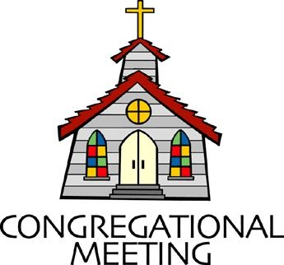

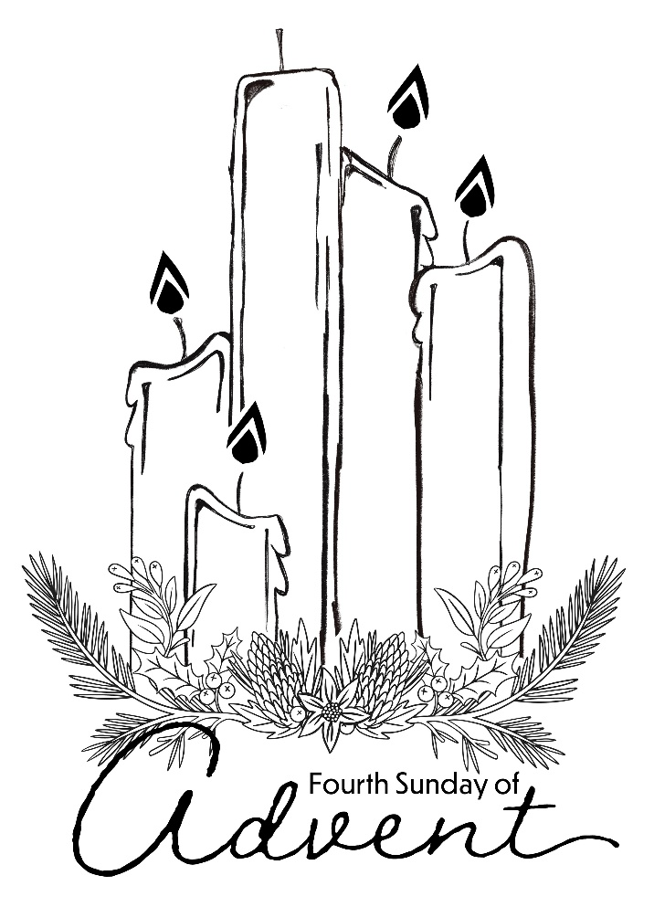

December 21, 2025 - 10:30 am

WELCOME VISITORS!

We're glad you are here! Cards at the ends of each pew are for you to fill out and drop in the Offering Plate. Please let us know you are visiting and join us for refreshments and fellowship following the service. The Sanctuary has an induction loop system to assist the hearing impaired. The system will also work on the telephone setting of hearing aids.

Springfield Presbyterian Church is rooted in the gospel of Jesus Christ, led by the Holy Spirit, and called to loving relationships through vibrant worship and service. Valuing all people, we are committed to developing disciples and fostering stewardship.

PREPARATION FOR THE WORD
(* those who are able are invited to stand)

PRELUDE Once in Royal David’s City arr. Kevin McChesney

GATHERING OF THE PEOPLE

The Lord be with you! And also with you! (Greetings and Announcements)

LIGHTING THE CHRIST CANDLE
Leader: Whenever we light this candle we proclaim:
People: Christ is the Light of the world and the center of our lives.

ADVENT CANDLE LIGHTING – HOPE FOR THOSE WHO ARE WOUNDED
Reader: Advent is a time to bind up the broken hearted.
Congregation: Come, Lord, and make all things new.
Reader: For past wrongs that prevent us from moving forward:
Congregation: Come, Lord, and make all things new.
Reader: For any bitterness that scratches our soul:
Congregation: Come, Lord, and make all things new.
Reader: For relationships left in decay and neglect:
Congregation: Come, Lord, and make all things new.
Reader: For any action that has wounded us or by which we have wounded others:
Congregation: Grant that we might have the peace of Christ as we wait, the love of Christ as we act, and the grace of Christ as we speak.
Reader: This morning, we light four candles. The first candle is the light of hope for those in times of waiting. The second candle is the light of hope for those who are wearied by the circumstances of life. The third candle is the light of hope for those eagerly watching for God’s promised glory. The fourth candle (the candle of Joy) is the light of hope for those who carry the wounds of life. Today, we acknowledge our pain and the pain we have caused others. As the light shines, we turn to the Savior who came to rescue the lost, to help the hurting, and to bind up the broken.

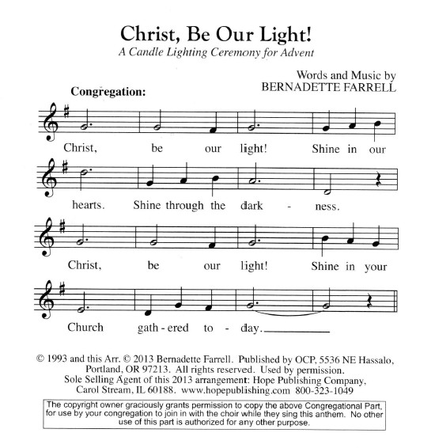
Congregation: Merciful God, Advent reminds us that you left heaven’s majesty to walk among wounded people in a broken world. We thank you that your love knows no boundaries or limitations. No wound of this earth is greater than the wounds you came to heal. For all who suffer this day, light the way, O Lord, towards the promise of healing and wholeness made known in you. Amen.

CALL TO WORSHIP
Leader: Across the universe, creation waits for the prophets to speak their words of expectation and their vision of renewal.
People: May we gather round them today once more and let their longing grip us and lead us into birth and blessing.
Leader: So come now, my friends, this is the meeting place of promise and prophecy.
People: Let us listen to the ancient words that we might be ready to hear a baby’s cry.

* HYMN My Soul Cries Out with a Joyful Shout GTG #100

My soul cries out with a joyful shout that the God of my heart is great, and my spirit sings of the wondrous things that you bring to the ones who wait. You fixed your sight on your servant’s plight, and my weakness you did not spurn, so from east to west shall my name be blest. Could the world be about to turn?

Refrain:
My heart shall sing of the day you bring. Let the fires of your justice burn. Wipe away all tears, for the dawns draws near, and the world is about to turn.

Though I am small, my God, my all, you work great things in me, and your mercy will last from the depths of the past to the end of the age to be. Your very name puts the proud to shame, and to those who would for you yearn, you will show your might, put the strong to flight, for the world is about to turn. [Refrain]

From the halls of power to the fortress tower, not a stone will be left on stone. Let the king beware for your justice tears every tyrant from his throne. The hungry poor shall weep no more, for the food they can never earn; there are tables spread; every mouth be fed, for the world is about to turn. [Refrain]

Though the nations rage from age to age, we remember who hold us fast: God’s mercy must deliver us from the conqueror’s crushing grasp. This saving word that our forebears heard is the promise which holds us bound, till the spear and rod can be crushed by God, who is turning the world around. [Refrain]

CALL TO CONFESSION
Leader: If we are to welcome the Child into our hearts, we must speak of all the ways we have hardened ourselves against the good news he brings. Let us confess our sins, as we pray together, saying,

PRAYER OF CONFESSION
How can this be, Holy One of Advent? We would put the powerful on pedestals, but you send the lowly to remind us of our call to be servants. We would stock our pantries with more and more, but you send our friends to our door, collecting for those who hunger and thirst for hope. We would listen to seasonal sounds of sales, but you send the angels to carol to us of the promises made to all. Forgive us, Hope of the world. As we watch for

your coming, may we see the need around us; as we prepare to celebrate your birth, may we live with open hearts; as we long for healing and hope, may we discover it in the Babe of Bethlehem, Jesus the Christ, sent for us. Bring us again to your light, for we ask this in Jesus' Name. Amen.

SILENT PRAYERS OF CONFESSION

RESPONSE On Jordan’s Bank the Baptist’s Cry GTG #96 (v. 2)
Then cleansed be every life from sin; make straight the way for God within,
And let us all our hearts prepare for Christ to come and enter there.

WORDS OF ASSURANCE
Leader: The good news is not just announced to all people, it is indeed, for all people, for the proud, as well as the humble; for the rich, and for the poor; for those who have found faith, and those who long for it. Our hearts rejoice in the promises, and our souls rejoice in the One who has come to us, bringing hope, joy, peace, and love into our lives. Thanks be to God. Amen.

* MUSICAL RESPONSE OF PRAISE Glory to God GTG #583
Gloria, gloria, in excelsis Deo! Gloria, gloria, alleluia, alleluia!

* THE PEACE The peace of Christ be with you! And also with you!
(You may greet those around you.)

* RESPONSE Here I Am, Lord GTG #69
Here I am, Lord. Is it I, Lord? I have heard you calling in the night.
I will go, Lord, if you lead me. I will hold your people in my heart.

THE PROCLAMATION OF THE WORD

PRAYER FOR ILLUMINATION
Gather around, you are welcome here, and you will hear Good News. In a world
where there are so many discouraging and negative voices, it is the God of encouragement who will speak to you today. The God of Jesus Christ. So come in, relax, let your tiredness roll away. Lift up your hearts, and listen for the Word of God spoken for you, Amen.

FIRST SCRIPTURE LESSON Matthew 1:18-25 NT page 1
¹⁸Now the birth of Jesus the Messiah took place in this way. When his mother Mary had been engaged to Joseph, but before they lived together, she was found to be with child from the Holy Spirit. ¹⁹Her husband Joseph, being a righteous man and unwilling to expose her to public disgrace, planned to dismiss her quietly. ²⁰But just when he had resolved to do this, an angel of the Lord appeared to him in a dream and said, "Joseph, son of David, do not be afraid to take Mary as your wife, for the child conceived in her is from the Holy Spirit. ²¹She will bear a son, and you are to name him Jesus, for he will save his people from their sins." ²²All this took place to fulfill what had been spoken by the Lord through the prophet: ²³"Look, the virgin shall conceive and bear a son, and they shall name him Emmanuel," which means, "God is with us." ²⁴When Joseph awoke from sleep, he did as the angel of the Lord commanded him; he took her as his wife, ²⁵but had no marital relations with her until she had borne a son; and he named him Jesus.

SECOND SCRIPTURE LESSON Isaiah 7:10-16 OT page 598
¹⁰Again the Lord spoke to Ahaz, saying, ¹¹Ask a sign of the Lord your God; let it be deep as Sheol or high as heaven. ¹²But Ahaz said, I will not ask, and I will not put the Lord to the test. ¹³Then Isaiah said: "Hear then, O house of David! Is it too little for you to weary mortals, that you weary my God also? ¹⁴Therefore the Lord himself will give you a sign. Look, the young woman is with child and shall bear a son, and shall name him Immanuel. ¹⁵He shall eat curds and honey by the time he knows how to refuse the evil and choose the good. ¹⁶For before the child knows how to refuse the evil and choose the good, the land before whose two kings you are in dread will be deserted.

Leader: Hear what the Spirit is saying to the Church.
All: Thanks be to God.

SERMON O Little Town of Bethlehem By Rev. Shannon Weston

THE RESPONSE TO THE WORD

* HYMN O Little Town of Bethlehem GTG #121

O little town of Bethlehem, how still we see thee lie!
Above thy deep and dreamless sleep the silent stars go by.
Yet in thy dark streets shineth the everlasting light;
The hopes and fears of all the years are met in thee tonight.

For Christ is born of Mary and, gathered all above,
While mortals sleep, the angels keep their watch of wondering love.
O morning stars, together proclaim the holy birth,
And praises sing to God the king, and peace to all on earth.

How silently, how silently, the wondrous gift is given!
So God imparts to human hearts the blessings of his heaven.
No ear may hear his coming, but in this world of sin,
Where meek souls will receive him, still the dear Christ enters in.

O holy child of Bethlehem, descend to us, we pray;
Cast out our sin and enter in; be born in us today.
We hear the Christmas angels the great glad tidings tell;
O come to us; abide with us, our Lord Emmanuel!

PASTORAL PRAYER AND THE LORD’S PRAYER

PRESENTATION OF TITHES AND OFFERINGS
OFFERTORY Were You There on that Christmas Night Sleeth/arr. Thompson
* SONG OF THANKS As with Gladness Men of Old GTG #150 (v. 3)
As they offered gifts most rare at thy manger, rude and bare,
So may we with holy joy, pure and free from sin’s alloy,
All our costliest treasures bring, Christ, to thee, our heavenly king.
* PRAYER OF DEDICATION

* HYMN Come, Thou Long-Expected Jesus GTG #82

Come, thou long-expected Jesus, born to set thy people free;
From our fears and sins release us; let us find our rest in thee.

Israel’s strength and consolation, hope of all the earth thou art;
Dear desire of every nation, joy of every longing heart.

Born thy people to deliver, born a child and yet a king,
Born to reign in us forever, now thy gracious kingdom bring.
By thine own eternal Spirit rule in all our hearts alone;
By thine all-sufficient merit raise us to thy glorious throne.

* CHARGE AND BENEDICTION

* UNISON AMEN GTG #601

POSTLUDE To the World, Joy! arr. Joel Raney

Assisting in Worship: We appreciate those who serve:

Christmas
Today 12/21 Eve Next Week 12/28
Sunday Opener: Linda Caviglia Ron Holmes Bob Rogers
Ushers/Greeters: Alex & Brenda McClung Tim & Beth Oates
Lay Leader: Mark Chaplik Ron Holmes Linda Black
Pulpit Supply: Rev. Shannon Weston Troy Bailey Heather Russell
Fellowship Hosts: Christy Yeager Rebecca Schermer
Offering Count: Andrea Kwako & Linda C. Andrea & Sharon Andrea Kwako

Happy Anniversary! December 27 – Leah & Jeff Halvorson

Happy Birthday! December 26 – Becca Bederka

Sunday December 28, 2025 Lectionary
Isaiah 63:7-9; Psalm 148; Hebrews 2:10-18; Matthew 2:13-23
Announcements

Welcome! We welcome Rev. Shannon Weston to our pulpit again today! The Rev. Shannon Weston (she/her) is a Leadership Coach, Conflict Mediator, and Coach Trainer. Her work with pastors, church leaders, and nonprofits has been recognized as a valid ministry by the Presbytery of Baltimore. Before Coaching, Shannon served two decades as a pastor in the PCUSA, serving churches in Kentucky, New York, and Maryland. She lives in Lutherville with her husband Derrick and their four children.

Welcome also to Barbara Ford, our substitute accompanist! Barbara is a retired Howard County Public School System Music Educator. In her retirement, she works part time as a rehearsal pianist for Peabody Children's Chorus, pianist for Fairhaven Retirement Community Worship Services, pianist for The Howard County Public School System Employee Chorus, Howard County All-County Choral Groups, and piano accompanist for many area school choral programs.

Christmas Joy Offering: God has called and trained countless leaders, now in so many places. Let us remember them and their teachers with our Christmas Joy Offering received TODAY.

Christmas Caroling: We are planning a Christmas Caroling event at 4:00 pm TODAY. We have a health/rehabilitation center as a very close neighbor – Autumn Lake is just across Spout Hill Road and could really use some outside cheer! We have caroled over there many times, and have always been greeted enthusiastically. Often, residents who are not generally responsive or vocal will join in singing familiar Christmas carols, and you can see in their faces that it means a lot to them. There are several choir members who plan to go, but we would love to have many people from the congregation as well. It’s a busy time of year, but if you can spare an hour or so that afternoon, it will be well worth it for spreading the good news of Christmas to people who may be lonely and missing being at home during the Christmas season. If you are interested, please let Linda Caviglia know, just so she has an idea of how many will be there. (cavig5@comcast.net or 410-746-1221 – call or text)

Zoom Link for Worship Services: The Zoom link for church services is on the SPC website, not on the Facebook page. The Bulletin is also available on the website as well.

Congregational Care: If you know of someone who would benefit from a card or a phone call, please text or call Connie Gibbons at 410-935-3467.

Electronic Giving: Below is a QR code you can scan to make your contribution a new way! The page you get will ask for your name, email and phone

number. You can choose from a dropdown menu for selecting where the donation should go: General Fund, Capital Fund, Concert, Memorial. There is a fee for using a credit card, and you will be given the option to pay that fee along with your donation, but you don’t have to include it if you don’t want to.

Today:
Sunday December 21 – 4th Sunday of Advent
10:30 am Worship
11:30 am Fellowship
4:00 pm Caroling at Autumn Lake

This Week:
Thursday December 24 – Christmas Eve
7:00 pm Worship

Next Week:
Sunday December 28
10:30 am Worship
11:30 am Fellowship

Office Hours: Tuesday, Wednesday, Friday, 10 am – 3 pm

Springfield Presbyterian Church
10:30 am Worship (and Sunday School 1st & 3rd Sundays)
11:30 am Fellowship
Website: www.springfield-church.org Church Office: 410-795-6152
Like us on Facebook: www.facebook.com/SpringfieldPresbyterianChurch
Pastor: Vacant
Email: spc.office@verizon.net
Clerk of Session: Sharon Pappas
Minister of Music/Accompanist: Aaron Thacker
Bell Choir Director: Vacant
Youth Group Coordinator: Dylan Vasbinder
Administrative Assistant: Donna Mazer Email: spc.office@verizon.net

