(Large Print)

Springfield Presbyterian Church (USA)
7300 Spout Hill Road, Sykesville, MD 21784 410-795-6152

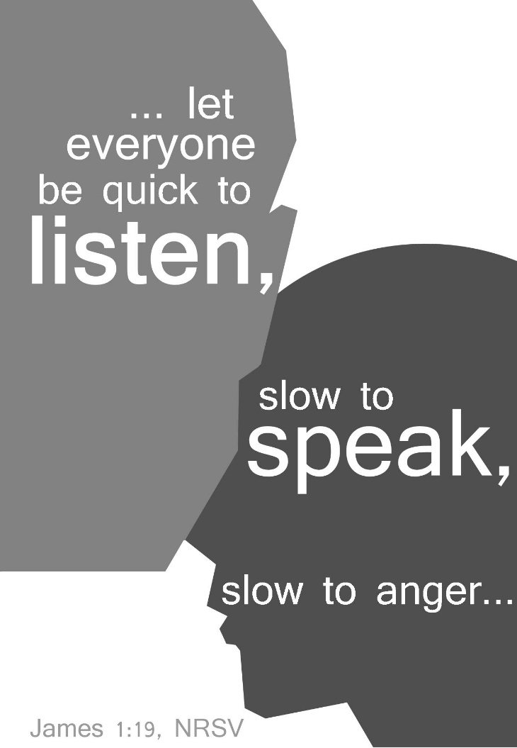

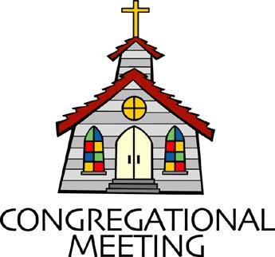
August 29, 2021 - 10:30 am

WELCOME VISITORS! We're glad you are here! Cards at the ends of each pew are for you to fill out and drop in the Offering Plate. Please let us know you are visiting, and join us for refreshments and fellowship following the service. The Sanctuary has an induction loop system to assist the hearing impaired. The system will also work on the telephone setting of hearing aids.

Springfield Presbyterian Church is rooted in the gospel of Jesus Christ, led by the Holy Spirit, and called to loving relationships through vibrant worship and service. Valuing all people, we are committed to developing disciples and fostering stewardship.
PREPARATION FOR THE WORD
(* those who are able are invited to stand)

PRELUDE

GATHERING OF THE PEOPLE

The Lord be with you! And also with you! (Greeting)

LIGHTING THE CHRIST CANDLE
Leader: Whenever we light this candle we proclaim:
People: Christ is the Light of the world and the center of our lives.

CALL TO WORSHIP [Psalm 62:1-2, 5-8]
Leader: For God alone our souls wait in silence; from Him alone comes our salvation.
People: He alone is our rock and our salvation, our fortress; we shall never be shaken.
Leader: For God alone our souls wait in silence, for our hope is from Him.
People: He alone is our rock and our salvation, our fortress; we shall not be shaken.
Leader: On God rests our deliverance and our honor; our mighty rock, our refuge is in God.
People: Trust in Him at all times, O people; pour out your heart before Him; God is a refuge for us.
All: Let us worship and praise our faithful God!

* HYMN Jesus, Thy Boundless Love to Me #703
Jesus, thy boundless love to me no thought can reach, no tongue declare;
O knit my thankful heart to thee, and reign without a rival there!
Thine wholly, thine alone, I’d live; myself to thee entirely give.

O grant that nothing in my soul may dwell, but thy pure love alone;
O may thy love possess me whole, my joy, my treasure, and my crown!
All coldness from my heart remove; may every act, word, thought be love.

PRAYER OF CONFESSION (Unison)
Faithful God, you call us to be quick to listen, yet we want to interject and be quick to speak. You call us to slow down, yet we continue to pace our lives so we are busier. You call us to not lash out in anger, but we are so embroiled in our feelings. You call us to generosity, but we fear being generous and taking a risk. You call us to follow and live like Jesus, but we have fallen short. We ask for your forgiveness, as we humbly confess our sins, and seek the renewal only you can offer us, so we may be made anew. Amen.

SILENT PRAYERS OF CONFESSION

RESPONSE Spirit of the Living God
Spirit of the living God, fall afresh on me. Spirit of the living God, fall afresh on me. Melt me; mold me; fill me; use me. Spirit of the living God, fall afresh on me.

WORDS OF ASSURANCE
Leader: The saying is sure and worthy of full acceptance, that Jesus Christ came into the world to save sinners. He himself bore our sins in His body on the cross, that we might be dead to sin, and alive to all that is good.
People: We declare, in the name of Jesus Christ, that we are forgiven. Let us live as such. Thanks be to God! Amen!

* MUSICAL RESPONSE OF PRAISE Great is Thy Faithfulness
Great is thy faithfulness! Great is thy faithfulness! Morning by morning, new mercies I see. All I have needed thy hand hath provided. Great is thy faithfulness, Lord unto me!

* THE PEACE The peace of Christ be with you! And also with you!
(You may greet those around you.)

* RESPONSE Here I Am, Lord
Here I am, Lord, Is it I, Lord? I have heard you calling in the night.
I will go, Lord, if you lead me. I will hold your people in my heart.

THE PROCLAMATION OF THE WORD

PRAYER OF ILLUMINATION
Generous God, you have declared that your kingdom is among us. Open our eyes to see it, our ears to hear it, our hearts to hold it, and our hands to serve it. This we pray in Jesus’ name. Amen.

FIRST SCRIPTURE LESSON Psalm 112
¹ Praise the Lord! Happy are those who fear the Lord, who greatly delight in his commandments. ² Their descendants will be mighty in the land; the generation of the upright will be blessed. ³ Wealth and riches are in their houses, and their righteousness endures for ever. ⁴ They rise in the darkness as a light for the upright; they are gracious, merciful, and righteous. ⁵ It is well with those who deal generously and lend, who conduct their affairs with justice. ⁶ For the righteous will never be moved; they will be remembered for ever. ⁷ They are not afraid of evil tidings; their hearts are firm, secure in the Lord. ⁸ Their hearts are steady, they will not be afraid; in the end they will look in triumph on their foes. ⁹ They have distributed freely, they have given to the poor;

their righteousness endures for ever; their horn is exalted in honor.
¹⁰ The wicked see it and are angry; they gnash their teeth and melt away; the desire of the wicked comes to nothing.

SECOND SCRIPTURE LESSON James 1:17-27
¹⁷Every generous act of giving, with every perfect gift, is from above, coming down from the Father of lights, with whom there is no variation or shadow due to change. ¹⁸In fulfilment of his own purpose he gave us birth by the word of truth, so that we would become a kind of first fruits of his creatures. ¹⁹You must understand this, my beloved: let everyone be quick to listen, slow to speak, slow to anger; ²⁰for your anger does not produce God’s righteousness. ²¹Therefore rid yourselves of all sordidness and rank growth of wickedness, and welcome with meekness the implanted word that has the power to save your souls.
²²But be doers of the word, and not merely hearers who deceive themselves. ²³For if any are hearers of the word and not doers, they are like those who look at themselves in a mirror; ²⁴for they look at themselves and, on going away, immediately forget what they were like. ²⁵But those who look into the perfect law, the law of liberty, and persevere, being not hearers who forget but doers who act—they will be blessed in their doing. ²⁶If any think they are religious, and do not bridle their tongues but deceive their hearts, their religion is worthless. ²⁷Religion that is pure and undefiled before God, the Father, is this: to care for orphans and widows in their distress, and to keep oneself unstained by the world.

Leader: Hear what the Spirit is saying to the Church.
All: Thanks be to God.

SERMON Doers of the Word Rev. Becca Crate

THE RESPONSE TO THE WORD

* HYMN Be Doers of the Word of God
(to the tune of #32 I Sing the Mighty Power of God)
Be doers of the word of God,
Not simply those who hear.
Be ones who look into God’s word,
Obey, and persevere.
Be quick to listen, slow to speak,
And slow to anger, too.
Put wrath aside; instead, be meek
And let God work in you.

Religion that is undefiled,
Religion that is pure
Will reach to help the orphaned child
And welcome all the poor.
If people come here poorly dressed,
To judge them is a sin.
The rich aren’t better than the rest;
God welcomes poor ones in.

O Christ, you save us by God’s grace
From having to obey.
Then freed to love, we can embrace
A life that seeks your way.
May we be doers of the word,
May faith shine through our deeds;
And as we seek to trust in God,
May ethics follow creeds.

PASTORAL PRAYER AND THE LORD’S PRAYER

PRESENTATION OF TITHES AND OFFERINGS
OFFERTORY
* SONG OF THANKS For the Beauty of the Earth (refrain)
Lord of all, to thee we raise this our hymn of grateful praise.
* PRAYER OF DEDICATION

* HYMN Called as Partners in Christ’s Service #761

Called as partners in Christ’s service, called to ministries of grace,
We respond with deep commitment, fresh new lines of faith to trace.
May we learn the art of sharing, side by side and friend with friend,
Equal partners in our caring, to fulfill God’s chosen end.

Christ’s example, Christ’s inspiring, Christ’s clear call to work and worth,
Let us follow, never faltering, reconciling folk on earth.
Men and women, richer, poorer, all God’s people, young and old,
Blending human skills together, gracious gifts from God unfold.

Thus new patterns for Christ’s mission, in a small or global sense,
Help us bear each other’s burdens, breaking down each wall or fence.
Words of comfort, words of vision, words of challenge, said with care,
Bring new power and strength for action, make us colleagues, free and fair.

So God grant us for tomorrow, ways to order human life.
That surround each person’s sorrow, with a calm that conquers strife.
Make us partners in our living, our compassion to increase,
Messengers of faith, thus giving hope and confidence and peace.

* CHARGE AND BENEDICTION
Leader: Let us be quick to listen,
People: To hear the words of our siblings in Christ.
Leader: Let us be slow to anger,
People: So that we may build bridges rather than walls.
Leader: Let us be generous,
People: And in doing so, reflect the love of God in all we do and say. Amen.

* UNISON AMEN

POSTLUDE

Assisting in Worship: We appreciate those who serve:

Today 8/29 Next Week 9/5
Sunday Opener Ron Holmes Jennifer Wise
Greeters & Ushers Steve & Donna Mazer Need Volunteers
Lay Leader Sharon Pappas Tim Oates
Fellowship Need Volunteer Need Volunteer

Happy Birthday! August 31 – Bridget Doyle

Happy Anniversary! September 1 – Charles & Deb Sperling
September 5 – Stephanie & John Bunting

Sunday September 5, 2021 Lectionary
Isaiah 35:4-7a; Psalm 146; James 2:1-10 (11-13) 14-17; Mark 7:24-37
Announcements

Congregational Care / Mission & Outreach: The Congregational Care/Mission & Outreach Committee would like your help. As we emerge from this pandemic, there is a greater than usual need to make every effort to connect with one another. Do you know of a member or friend of our church family who is ill, needs prayers, would like call, a visit or a card, or might benefit from meal train? If so, please contact the Church Office (410-795-6152), Cathy Marsh (410-549-6916) or Diana Steppling (862-266-2242).

Volunteer Opportunities
Looking for a Ride: We have a couple of folks in our Springfield family who need help getting to Church: Louise Clark who lives at Copper Ridge, and Angel Carbaugh who lives near Woodbine. Are you able to assist? Please contact Jennifer Wise at 443-745-7842.
Ruth Gosnell Education Fund (RGEF) Committee: A volunteer is needed to serve on the committee. Meetings are quarterly. If you are interested, please see Amy Vasbinder.
Fellowship Volunteers Needed: If you are interested, please see Barbara Cornell during Fellowship or email her at barbaracornell4@gmail.com.

Weekly Announcements: If you have an announcement to include with next week’s bulletin, please call the Office at 410-795-6152 or email to spc.office@verizon.net by Wednesday to make sure your information gets in.

Blessing Bags are in the Narthex. Please feel free to pick up a few. Handing one out to someone in need gives you a very real way to meet their immediate needs by providing them with some basic supplies.

Office Hours: Tuesday, Wednesday & Friday
Springfield Presbyterian Church

10:30 am Worship
11:30 am Fellowship
Website: www.springfield-church.org Church Office: 410-795-6152
Like us on Facebook: www.facebook.com/SpringfieldPresbyterianChurch
Pastor: Rev. Becca Crate
Email: springfieldpastor@gmail.com
Clerk of Session: Sharon Pappas
Minister of Music: Linda Caviglia
Accompanist: Aaron Thacker Organist: Jennifer Wise
Youth Group Coordinators: Charles & Deb Sperling
Sunday School Coordinator: Connie Robinson
Administrative Assistant: Donna Mazer e-mail: spc.office@verizon.net

