(Large Print)

Springfield Presbyterian Church (USA)
7300 Spout Hill Road, Sykesville, MD 21784 410-795-6152

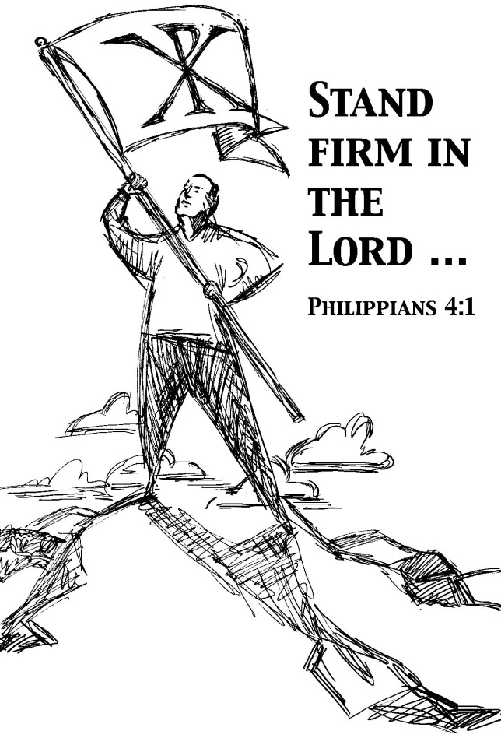

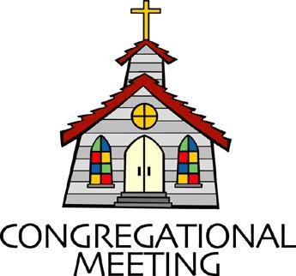
March 17, 2019 - 10:30 am

WELCOME VISITORS! We're glad you are here! Cards at the ends of each pew are for you to fill out and drop in the Offering Plate. Please let us know you are visiting, and join us for refreshments and fellowship following the service. The Sanctuary has an induction loop system to assist the hearing impaired. The system will also work on the telephone setting of hearing aids.

Springfield Presbyterian Church is rooted in the gospel of Jesus Christ, led by the Holy Spirit, and called to loving relationships through vibrant worship and service. Valuing all people, we are committed to developing disciples and fostering stewardship.
PREPARATION FOR THE WORD
(* those who are able are invited to stand)

Please prepare for worship by listening to the music of the Prelude.

PRELUDE

GATHERING OF THE PEOPLE

The Lord be with you! And also with you! (Greeting)

LIGHTING THE CHRIST CANDLE
Leader: Whenever we light this candle we proclaim:
People: Christ is the Light of the world and the center of our lives.

CALL TO WORSHIP [from Psalm 27]
Leader: The Lord is our light and our salvation; whom shall we fear?
People: The Lord is the stronghold of our lives; of whom shall we be afraid?
Leader: One thing we asked of the Lord, that we will seek after:
People: To live in the house of the Lord, all the days of our lives and to behold the beauty of the Lord and to inquire in His temple.
Leader: He will hide us in His shelter on the day of trouble.
People: He will conceal us under the cover of His tent; He will set us high on a rock.
Leader: Teach us your way, O Lord, and lead us on a level path because of our enemies.
People: Do not give us up to the will of our adversaries.
Leader: We believe that we shall see the goodness of the Lord in the land of the living.
People: We wait for the Lord; be strong, and our hearts take courage; wait for the Lord!
All: We come now to worship the Lord our God! Amen.

* HYMN Praise Ye the Lord, the Almighty
Praise ye the Lord, the Almighty, the King of creation!
O my soul, praise him, for he is thy health and salvation!
All ye who hear, now to his temple draw near;
Join me in glad adoration!

Praise ye the Lord, who o'er all things so wondrously reigneth,
Shelters thee under his wings, yea, so gently sustaineth!
Hast thou not seen how thy desires e'er have been
Granted in what he ordaineth?

Praise ye the Lord! O let all that is in me adore him!
All that hath life and breath, come now with praises before him!
Let the amen sound from his people again;
Gladly for aye we adore him.

PRAYER OF CONFESSION
Generous God, we are a people who long for status, power, and authority. We may not say it aloud, but in our actions and ways in which we conduct ourselves, we long to be respected, understood, and followed. While it is our human nature, we ask that you humble us – that you take away the need to be popular, the need to have power, and the need to be one step ahead. Reveal to us your way, O God, a way that seeks justice for all. Renew us, forgive us, and let us shelter under the safety of your promise and live out our lives in faithful discipleship. Amen.
SILENT PRAYERS OF CONFESSION

RESPONSE O Lord, Hear My Prayer (sing two times)
O Lord, hear my prayer. O Lord, hear my prayer. When I call, answer me.
O Lord, hear my prayer. O Lord, hear my prayer. Come and listen to me.

WORDS OF ASSURANCE
Leader: While it is true that we have sinned, it is a greater truth that through God’s love in Jesus Christ we are forgiven.
People: By His wounds we are healed! In the name of Jesus Christ, we are forgiven! Amen.

* MUSICAL RESPONSE OF PRAISE Magnificat
Magnificat. Magnificat. Magnificat anima mea Dominum.
Magnificat. Magnificat. Magnificat anima mea!

(Translation: Sing out, my soul. Sing out, my soul. Sing out and glorify the Lord who sets us free. Sing out, my soul. Sing out, my soul. Sing out and glorify the Lord God!)

* THE PEACE The peace of Christ be with you! And also with you!
(You may greet those around you.)

* RESPONSE Here I Am, Lord
Here I am, Lord, Is it I, Lord? I have heard you calling in the night.
I will go, Lord, if you lead me. I will hold your people in my heart.

THE PROCLAMATION OF THE WORD

PRAYER OF ILLUMINATION
Guide us, O God, by your Word, and Holy Spirit, that in your light we may see light, in your truth find freedom, and in your will discover peace; through Christ our Lord. Amen.

FIRST SCRIPTURE LESSON Philippians 3:17-4:1
¹⁷Brothers and sisters, join in imitating me, and observe those who live according to the example you have in us. ¹⁸For many live as enemies of the cross of Christ; I have often told you of them, and now I tell you even with tears. ¹⁹Their end is destruction; their god is the belly; and

their glory is in their shame; their minds are set on earthly things. ²⁰But our citizenship is in heaven, and it is from there that we are expecting a Savior, the Lord Jesus Christ. ²¹He will transform the body of our humiliation so that it may be conformed to the body of his glory, by the power that also enables him to make all things subject to himself. 4¹Therefore, my brothers and sisters, whom I love and long for, my joy and crown, stand firm in the Lord in this way, my beloved.

SECOND SCRIPTURE LESSON Luke 13:31-35
³¹At that very hour some Pharisees came and said to him, ‘Get away from here, for Herod wants to kill you.’ ³²He said to them, ‘Go and tell that fox for me, “Listen, I am casting out demons and performing cures today and tomorrow, and on the third day I finish my work. ³³Yet today, tomorrow, and the next day I must be on my way, because it is impossible for a prophet to be killed away from Jerusalem.” ³⁴Jerusalem, Jerusalem, the city that kills the prophets and stones those who are sent to it! How often have I desired to gather your children together as a hen gathers her brood under her wings, and you were not willing! ³⁵See, your house is left to you. And I tell you, you will not see me until the time comes when you say, “Blessed is the one who comes in the name of the Lord.” ’

Leader: Hear what the Spirit is saying to the Church.
All: Thanks be to God.

TIME WITH YOUNG PEOPLE

SERMON Power Play Rev. Becca Crate

THE RESPONSE TO THE WORD

* HYMN I Need Thee Every Hour

I need thee every hour, most gracious Lord;
No tender voice like thine can peace afford.

Refrain:
I need thee, O I need thee, every hour I need thee!
O bless me now, my Savior--I come to thee!

I need thee every hour; stay thou near by;
Temptations lose their power when thou art nigh. [Refrain]

I need thee every hour; teach me thy will,
And thy rich promises in me fulfill. [Refrain]

I need thee every hour, Most Holy One;
O make me thine indeed, thou blessed Son. [Refrain]

PASTORAL PRAYER AND THE LORD’S PRAYER
“For this I pray to God.” / “For this I give thanks to God.”
Congregational Response: “Hear our prayer, O God.”

PRESENTATION OF TITHES AND OFFERINGS
OFFERTORY Be Still and Know by Steven Curtis Chapman
* SONG OF THANKS In the Lord I’ll Be Ever Thankful
In the Lord I’ll be ever thankful; in the Lord I will rejoice!
Look to God; do not be afraid. Lift up your voices; the Lord is near.
Lift up your voices; the Lord is near.
* PRAYER OF DEDICATION

* HYMN Lord, Speak to Me That I May Speak
Lord, speak to me that I may speak in living echoes of your tone.
As you have sought, so let me seek your erring children, lost and lone.

O lead me, Lord, that I may lead the wandering and the wavering feet.
O feed me, Lord, that I may feed your hungering ones with manna sweet.

O teach me, Lord, that I may teach the precious truths which you impart.
And wing my words that they may reach the hidden depths of many a heart.

O fill me with your fullness, Lord, until my very heart o'erflow
In kindling thought and glowing word, your love to tell, your praise to show.

O use me, Lord, use even me, just as you will, and when, and where
Until your blessed face I see, your rest, your joy, your glory share.

* CHARGE AND BENEDICTION
Leader: In the face of power,
People: We look to the face of Christ.
Leader: In the face of power,
People: We serve Christ first.
Leader: In the face of power,
People: We use our own power to promote goodness and wholeness in this world. Amen.

* UNISON AMEN

POSTLUDE Dust in the Wind by Kerry Livgren

Sunday March 24 Lectionary
Isaiah 55:1-9; Psalm 63:1-8; 1 Corinthians 10:1-13; Luke 13:1-9

Assisting in Worship: We appreciate those who serve:

Today 3/17 Next Week 3/24
Sunday Opener Barbara Cornell Beth Oates
Greeters & Ushers Elizabeth Meirowitz Don Vasbinder &
Bob Rogers Charlie Sperling
Lay Leader Don Vasbinder Ron Holmes
Sunday School Connie Robinson Connie Robinson
Fellowship Sandy Newsome Barbara Nickell

Church Attendance: March 3 - 41 March 10 - 38
Ash Wednesday - 25

Church Cleaning: March 22, 23 or 24 - Mark Kearney

Happy Birthday! March 21 - Shirley Sluder
March 23 - Anna Halvorson
March 23 - Laura Wise

Announcements

Lenten Devotionals: The Presbyterian Lenten Devotionals are available in the Narthex. Please feel free to pick up a copy. There is also a Lent calendar with Sunday scripture readings as well as simple ideas of things to “give up” for Lent that help the environment.

Dust in the Wind - Reflection for Lent: You may be wondering why the band has chosen this song to perform. Well, the band director was sitting in an Ash Wednesday service some years ago where the pastor was making a point about "ashes" and "dust". The words repeated to every worshiper on Ash Wednesday with the imposition of ashes are "from dust you came, and to dust you shall return." It's a reminder of our mortality. It reminded the band director of this song, which speaks of the fleeting nature of life. It reminds us that all our money won't buy us any more time on this earth. Instead, we need to put our trust and hope in God and in the redemption we find through Jesus, who died for our sins.

Blessing Bags are in the Narthex. Please feel free to pick up a few. Handing one out to someone in need gives you a very real way to meet their immediate needs by providing them with some basic supplies.

C.I.A. (Community In Action) will meet TOMORROW from 4:30-6 pm at the Manse. Pizza and drinks provided. Friends are welcome and encouraged to attend! C.I.A is a group open to all religious and non-religious people as a means of providing the community with acts of kindness. We will be doing different activities throughout the school year to help people in our community who are in need. Come and be part of giving back to our community.

Weekly Announcements: If you have an announcement to include with next week’s bulletin, please call the Office at 410-795-6152 or email to spc.office@verizon.net by Wednesday each week.

The Congregational Care team wants to know what YOU or someone you know needs...a visit...a call...a meal. Please contact Diana Steppling or Connie Robinson.

Prayers & Thanksgivings

~ Prayers of comfort and strength for Mary Rhodes and family on the loss of her mother, Lois Woodwell, on March 11. Visitation will be at Haight Funeral Home on Monday, March 18 from 1 to 2pm with the memorial service at 2:00 pm.
~ Prayers for Hope Presbyterian Church from our Ministry Group.

Today:
Sunday March 17
9:00 am Red Sea Parting Practice
10:30 am Worship & Sunday School
11:30 am Fellowship
12:00 noon Inquirer’s Class (Library)

This Week:
Monday March 18
9:30 am Feed My Sheep (Wesley Freedom)
4:30 pm C.I.A. Meeting (Manse)
Tuesday March 19
7:00 pm Bible Study (Panera)
Wednesday March 20
6:30 pm Bell Choir Practice
7:45 pm Adult Choir Practice

Looking Ahead:
Sunday March 24
10:30 am Worship & Sunday School
11:30 am Fellowship
12:00 noon Inquirer’s Class (Library)
Tuesday March 26
10:30 am Prayer Group (Manse)
Wednesday March 27
6:30 pm Bell Choir Practice
7:45 pm Adult Choir Practice

Office Hours: Tuesday, Wednesday, Friday 9:00 am - 3:00 pm
Springfield Presbyterian Church

10:30 am Worship & Sunday School
11:30 am Fellowship
Website: www.springfield-church.org Church Office: 410-795-6152
Like us on Facebook: www.facebook.com/SpringfieldPresbyterianChurch
Pastor: Rev. Becca Crate
Email: springfieldpastor@gmail.com
Clerk of Session: Sharon Pappas
Minister of Music: Linda Caviglia
Accompanist: Aaron Thacker Organist: Jennifer Wise
Youth Group Coordinators: Charles & Deb Sperling
Sunday School Coordinator: Connie Robinson
Administrative Assistant: Donna Mazer
e-mail: spc.office@verizon.net

