(Large Print)

Springfield Presbyterian Church (USA)
7300 Spout Hill Road, Sykesville, MD 21784 410-795-6152

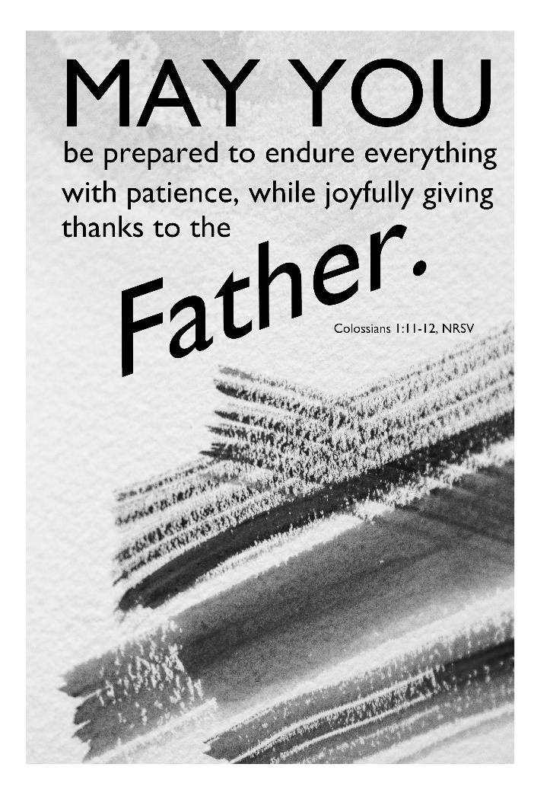

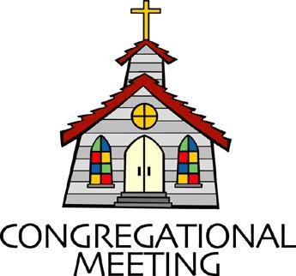
July 17, 2022 - 10:30 am

WELCOME VISITORS!
We're glad you are here! Cards at the ends of each pew are for you to fill out and drop in the Offering Plate. Please let us know you are visiting, and join us for refreshments and fellowship following the service. The Sanctuary has an induction loop system to assist the hearing impaired. The system will also work on the telephone setting of hearing aids.

Springfield Presbyterian Church is rooted in the gospel of Jesus Christ, led by the Holy Spirit, and called to loving relationships through vibrant worship and service. Valuing all people, we are committed to developing disciples and fostering stewardship.
PREPARATION FOR THE WORD
(* those who are able are invited to stand)
PRELUDE

GATHERING OF THE PEOPLE

The Lord be with you! And also with you! (Greeting)

LIGHTING THE CHRIST CANDLE
Leader: Whenever we light this candle we proclaim:
People: Christ is the Light of the world and the center of our lives.

CALL TO WORSHIP
Leader: We come to worship because Christ called us to gather together.
People: We come to learn, to listen, to sing, to pray, to feast, and to remember our baptism.
Leader: And here at Springfield, we come together as part of the Presbyterian Church (USA).
People: A faith with a rich and varied history and a faith that seeks to move forward.
Leader: As we come before God to worship, we seek to learn more about this faith.
People: So let us come and learn,
Leader: Let us delve in and explore,
People: Let us worship our Holy God.

* HYMN O Lord My God (How Great Thou Art) GTG #625

O Lord my God! When I in awesome wonder, consider all the worlds thy hands have made,
I see the stars, I hear the rolling thunder, thy power throughout the universe displayed:

Refrain:
Then sings my soul, my Savior God, to thee,
How great thou art! How great thou art!
Then sings my soul, my Savior God, to thee:
How great thou art! How great thou art!

When through the woods and forest glades I wander and hear the birds sing sweetly in the trees,
When I look down from lofty mountain grandeur and hear the brook and feel the gentle breeze: [Refrain]

And when I think that God, his Son not sparing, sent him to die, I scarce can take it in,
That on the cross, my burden gladly bearing, he bled and died to take away my sin: [Refrain]

CALL TO CONFESSION
Leader: As Presbyterians, we are given the gift of confession every Sunday. We believe we all have fallen short of the cross and it is not for us to share in a confessional, but before one another. We say this prayer in unison because we understand that there are individual and communal sins we share together. As a people of the Presbyterian faith, we also believe that when we atone with pure and sincere hearts, God will hear us and forgive us, which we celebrate in our assurance of pardon. Friends, let us come together to confess our sins:

PRAYER OF CONFESSION
Holy and Merciful God, in your presence we confess our failure to be what you created us to be. You alone know how often we have sinned in wandering from your ways, in wasting your gifts, in forgetting your love. By your loving mercy, help us to live in your light and abide in your ways, for the sake of Jesus Christ our Savior. Amen.
SILENT PRAYERS OF CONFESSION

RESPONSE The Woman Hiding in the Crowd Tune #178
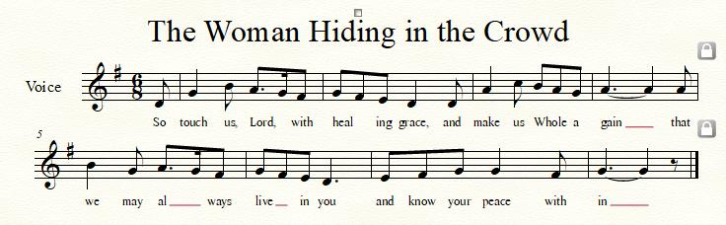

WORDS OF ASSURANCE [Psalm 103:17]
Leader: The mercy of the Lord is from everlasting to everlasting. I declare to you, in the name of Jesus Christ, you are forgiven!
People: Thanks be to God for His abundant grace! We are forgiven, forgiven indeed! Alleluia!

* MUSICAL RESPONSE OF PRAISE O My Soul, Bless Your Redeemer
Bless your Maker, all you creatures, ever under God’s control,
All throughout God’s vast dominion; bless the Lord of all, my soul!

* THE PEACE The peace of Christ be with you! And also with you!
(You may greet those around you.)

* RESPONSE Here I Am, Lord
Here I am, Lord, Is it I, Lord? I have heard you calling in the night.
I will go, Lord, if you lead me. I will hold your people in my heart.

THE PROCLAMATION OF THE WORD

PRAYER OF ILLUMINATION
Generous God, open our hearts and minds by the power of your Holy Spirit, that as the scriptures are read and your Word is proclaimed, we may hear with joy what you say to us today. Amen.
FIRST SCRIPTURE LESSON Colossians 1:3-22
³In our prayers for you we always thank God, the Father of our Lord Jesus Christ, ⁴for we have heard of your faith in Christ Jesus and of the love that you have for all the saints, ⁵because of the hope laid up for you in heaven. You have heard of this hope before in the word of the truth, the gospel ⁶that has come to you. Just as it is bearing fruit and growing in the whole world, so it has been bearing fruit among yourselves from the day you heard it and truly comprehended the grace of God. ⁷This you learned from Epaphras, our beloved fellow-servant. He is a faithful minister of Christ on your behalf, ⁸and he has made known to us your love in the Spirit. ⁹For this reason, since the day we heard it, we have not ceased praying for you and asking that you may be filled with the knowledge of God’s will in all spiritual wisdom and understanding, ¹⁰so that you may lead lives worthy of the Lord, fully pleasing to him, as you bear fruit in every good work and as you grow in the knowledge of God. ¹¹May you be made strong with all the strength that comes from his glorious power, and may you be prepared to endure everything with patience, while joyfully ¹²giving thanks to the Father, who has enabled you to share in the inheritance of the saints in the light. ¹³He has rescued us from the power of darkness and transferred us into the kingdom of his beloved Son, ¹⁴in whom we have redemption, the forgiveness of sins. ¹⁵He is the image of the invisible God, the firstborn of all creation; ¹⁶for in him all things in heaven and on earth were created, things visible and invisible, whether thrones or dominions or rulers or powers—all things have been created through him and for him. ¹⁷He himself is before all things, and in him all things hold together. ¹⁸He is the head of the body, the church; he is the beginning, the firstborn from the dead, so that he might come to have first place in everything. ¹⁹For in him all the fullness of God was pleased to dwell, ²⁰and through him God was pleased to reconcile to himself all things, whether on earth or in heaven, by making peace through the blood of his cross. ²¹And you who were once estranged and hostile in mind, doing evil deeds, ²²he has now reconciled in his fleshly body.

SECOND SCRIPTURE LESSON 1 Timothy 4:11-16
¹¹These are the things you must insist on and teach. ¹²Let no one despise your youth, but set the believers an example in speech and conduct, in love, in faith, in purity. ¹³Until I arrive, give attention to the public reading of scripture, to exhorting, to teaching. ¹⁴Do not neglect the gift that is in you, which was given to you through prophecy with the laying on of hands by the council of elders. ¹⁵Put these things into practice, devote yourself to them, so that all may see your progress. ¹⁶Pay close attention to yourself and to your teaching; continue in these things, for in doing this you will save both yourself and your hearers.

Leader: Hear what the Spirit is saying to the Church.
All: Thanks be to God.

SERMON The Presbyterian Faith Elder Bob Steppling

THE RESPONSE TO THE WORD

* HYMN Together We Serve GTG #767

Together we serve, united by love,
Inviting God's world to the glorious feast.
We work and we pray through sorrow and joy,
Extending God's love to the last and the least.

We seek to become a beacon of hope,
A lamp for the heart and a light for the feet.
We learn, year by year, to let love shine through
Until we see Christ in each person we meet.

We welcome the scarred, the wealthy, the poor,
The busy, the lonely, and all who need care.
We offer a home to those who will come,
Our hands quick to help, our hearts ready to dare.

Together, by grace, we witness and work,
Remembering Jesus, in whom we grow strong.
Together we serve in Spirit and truth,
Remembering love is the strength of our song.

PASTORAL PRAYER AND THE LORD’S PRAYER

OFFERTORY
SONG OF THANKS As Those of Old Their Firstfruits Brought #712
In gratitude and humble trust we bring our best today, to serve your cause and share your love with all along life’s way. O God who gave yourself to us in Jesus Christ your Son, help us to give ourselves each day until life’s work is done.
PRAYER OF DEDICATION

* HYMN May the God of Hope Go with Us GTG #765
(Sing through once, then repeat the last two lines.)

May the God of hope go with us every day,
filling all our lives with love and joy and peace.
May the God of justice speed us on our way,
bringing light and hope to every land and race.
Praying, let us work for peace; singing, share our joy with all;
Working for a world that's new, faithful when we hear Christ's call.

* CHARGE AND BENEDICTION
Leader: As we leave this place,
People: We acknowledge our identity.
Leader: As members of the Presbyterian faith,
People: But most importantly, as beloved children of God.
Leader: With a renewed vision and understanding,
People: We will proclaim the joy of a faith moving forward.

* UNISON AMEN

POSTLUDE

Sunday July 24, 2022 Lectionary
Genesis 18:20-32; Psalm 138; Colossians 2:6-15 (16-19); Luke 11:1-13

Assisting in Worship: We appreciate those who serve:

Today 7/17 Next Week 7/24
Sunday Opener Beth Oates Bob Rogers
Ushers/Greeters Steve & Donna Cynthia Smith
Mazer Elizabeth Meirowitz
Lay Leader Kathy Russ Don Vasbinder

Happy Birthday! July 21 – Ross Anderson
July 22 – Brian Spicer
July 24 – Becca Crate-Price

Announcements

Mask Update: Due to the uptick in COVID-19 cases, the Session has decided to strongly encourage masking and social distancing. Though it is not a mandate, we seek to love one another by keeping each other as safe as possible. Thank you for your help in this endeavor.
Sunday School is back! On the 1st and 3rd Sundays of the month, we will be offering Sunday School! See Pastor Becca for details…

Summer Mission Project: It won’t be long before school starts again. Preparing for a new school year includes buying items on the STUDENT SUPPLY LIST. For some children and their families, this can be a challenge and in some instances buying needed supplies just isn’t possible. For that reason, during July and August, we will be collecting school supplies to help these children. The GIVING TREE is in the Narthex. If you would like to help with this project, you can take a tag from the tree and buy the item written on it or simply choose from the below items (taken from Sykesville Middle School STUDENT SUPPLY LIST). Please place your donated items in the designated basket in the Narthex. Thank you! ~ CoCaMO Committee

3-ring binders-1, 1 ½ or 2” Pencil pouch Glue sticks
Loose-leaf paper Pack of #2 pencils Pair of Ear Buds
Pack of 5-tab binder dividers Pocket folders Scissors
Blue, black or red pens Block or cap erasers Sticky notes
3X5 ruled index cards Dry erase markers Crayons
Folders with brads 10-pack colored pencils
Spiral notebook-200 pgs. Pencil sharpener
Multi-colored highlighters Composition book

Pastor-Parish Committee: The Pastor-Parish Committee invites you to share your concerns, suggestions, and gratitude. We have a form in the Narthex and a lock-box that we will open weekly and we ask that you share your name and be specific. We look forward to reading your comments so that we can continue to grow into the body of Christ.

Springfield Membership: Are you interested in finding out more about our faith community and becoming a member? We would love to answer any questions you have. Please contact Pastor Becca at springfieldpastor@gmail.com for more information.

Congregational Care / Mission & Outreach: Do you know of a member or friend of our church family who is ill, needs prayers, would like call, a visit or a card, or might benefit from meal train? If so, please contact the Church Office (410-795-6152), Cathy Marsh (410-549-6916) or Diana Steppling (862-266-2242).

Fellowship Help Needed: If you are interested in helping with Fellowship, please contact Barbara Cornell (240-308-0035). A sign-up sheet will also be available.

Today:
Sunday July 17
10:30 am Worship
11:30 am Fellowship

Looking Ahead:
Sunday July 24
10:30 am Worship
11:30 am Fellowship

Office Hours: Tuesday, Wednesday & Friday
Springfield Presbyterian Church

10:30 am Worship
11:30 am Fellowship
Website: www.springfield-church.org Church Office: 410-795-6152
Like us on Facebook: www.facebook.com/SpringfieldPresbyterianChurch
Pastor: Rev. Becca Crate-Price
Email: springfieldpastor@gmail.com
Clerk of Session: Sharon Pappas
Minister of Music: Linda Caviglia
Accompanist/Organist: Aaron Thacker
Youth Group Coordinator: Dylan Vasbinder
Administrative Assistant: Donna Mazer e-mail: spc.office@verizon.net

