(Large Print)

Springfield Presbyterian Church (USA)
7300 Spout Hill Road, Sykesville, MD 21784 410-795-6152

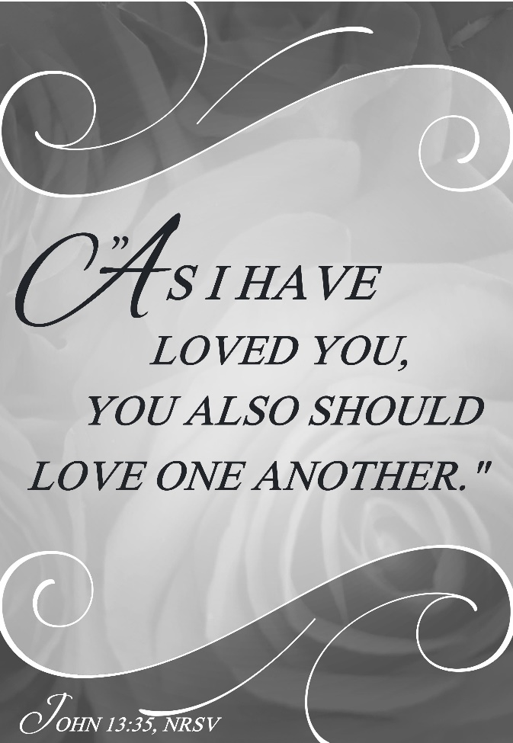

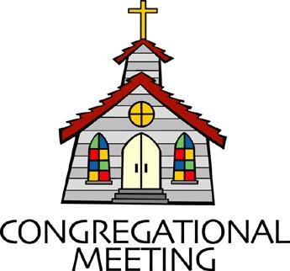
May 15, 2022 - 10:30 am

WELCOME VISITORS! We're glad you are here! Cards at the ends of each pew are for you to fill out and drop in the Offering Plate. Please let us know you are visiting, and join us for refreshments and fellowship following the service. The Sanctuary has an induction loop system to assist the hearing impaired. The system will also work on the telephone setting of hearing aids.

Springfield Presbyterian Church is rooted in the gospel of Jesus Christ, led by the Holy Spirit, and called to loving relationships through vibrant worship and service. Valuing all people, we are committed to developing disciples and fostering stewardship.
PREPARATION FOR THE WORD
(* those who are able are invited to stand)
PRELUDE

GATHERING OF THE PEOPLE

The Lord be with you! And also with you! (Greeting)

LIGHTING THE CHRIST CANDLE
Leader: Whenever we light this candle we proclaim:
People: Christ is the Light of the world and the center of our lives.

CALL TO WORSHIP
Leader: Love requires work,
People: Love is often messy,
Leader: Love is vulnerable,
People: Love can be hard,
Leader: Love is all of these things,
People: But love is also a gift.
Leader: It is the way we know God and one another.
People: So today we choose love,
Leader: Even in its complexity.
People: Let us start by worshipping the God of love, right here and right now. Amen.

* HYMN O Master, Let Me Walk with Thee #738

O Master, let me walk with thee in lowly paths of service free;
Tell me thy secret; help me bear the strain of toil, the fret of care.

Help me the slow of heart to move by some clear, winning word of love;
Teach me the wayward feet to stay, and guide them in the homeward way.

Teach me thy patience, still with thee in closer, dearer company,
In work that keeps faith sweet and strong, in trust that triumphs over wrong.

In hope that sends a shining ray far down the future's broadening way;
In peace that only thou canst give, with thee, O Master, let me live.

CALL TO CONFESSION
Leader: In a world where there is a sense of us vs. them, diversity, and busyness, it can be hard to choose love. Love makes us slow down, it makes us pay attention, and sometimes it’s easier to see the ways we are different than the ways we are alike. Love is everything; love is how all will know that we follow Christ. Yet it is easier said than done, so let us come together, not out of guilt, but out of a sincere desire to change our ways…

PRAYER OF CONFESSION
Generous God, we ask that you hear us as we admit our fault and failure before you. In the times that we could have loved, but chose not to, we ask for your forgiveness. When we decided we knew better or our ego got the best of us, we acknowledge that we have sinned. When you offered us divine love and we did not reflect that in our actions, we recognize that we have not followed your Word. We ask for your forgiveness and for a place to begin anew. Help us to reignite the call to love in our hearts and let us do that by remembering and acting your love. Amen.

SILENT PRAYERS OF CONFESSION

RESPONSE Restore in Us, O God Tune #434
Restore in us, O God, the splendor of your love;
Renew your image in our hearts, and all our sins remove.

WORDS OF ASSURANCE
Leader: The gift of God’s grace is one that is abundant. When we admit our sin, our fault, and our failure, God is quick to forgive us and renew us once again.
People: Thanks be to God who meets us where we are and forgives us because of God’s great love for us. Amen.

* MUSICAL RESPONSE OF PRAISE Alleluia, Alleluia! Give Thanks
Alleluia, alleluia! Give thanks to the risen Lord.
Alleluia, alleluia! Give praise to his name.

* THE PEACE The peace of Christ be with you! And also with you!
(You may greet those around you.)

* RESPONSE Here I Am, Lord
Here I am, Lord, Is it I, Lord? I have heard you calling in the night.
I will go, Lord, if you lead me. I will hold your people in my heart.

THE PROCLAMATION OF THE WORD

PRAYER OF ILLUMINATION
Generous God, as we hear the Word today, let it not remain an idle passing thought. Let these words jump from the page and become alive, living in us as we seek to be your disciples. When the Word challenges us, help us to find a way to reconcile it. When the Word empowers us, help us to move to action. When the Word points us to new life, let us live in it. So let us hear the Word today, what it calls us to today, and be restored again. Amen.

FIRST SCRIPTURE LESSON Psalm 148
¹ Praise the Lord! Praise the Lord from the heavens; praise him in the heights! ² Praise him, all his angels; praise him, all his host! ³ Praise him,

sun and moon; praise him, all you shining stars! ⁴ Praise him, you highest heavens, and you waters above the heavens! ⁵ Let them praise the name of the Lord, for he commanded and they were created. ⁶ He established them for ever and ever; he fixed their bounds, which cannot be passed. ⁷ Praise the Lord from the earth, you sea monsters and all deeps, ⁸ fire and hail, snow and frost, stormy wind fulfilling his command! ⁹ Mountains and all hills, fruit trees and all cedars! ¹⁰ Wild animals and all cattle, creeping things and flying birds! ¹¹ Kings of the earth and all peoples, princes and all rulers of the earth! ¹² Young men and women alike, old and young together! ¹³ Let them praise the name of the Lord, for his name alone is exalted; his glory is above earth and heaven. ¹⁴ He has raised up a horn for his people, praise for all his faithful, for the people of Israel who are close to him. Praise the Lord!

SECOND SCRIPTURE LESSON John 13:31-35
³¹When he had gone out, Jesus said, ‘Now the Son of Man has been glorified, and God has been glorified in him. ³²If God has been glorified in him, God will also glorify him in himself and will glorify him at once. ³³Little children, I am with you only a little longer. You will look for me; and as I said to the Jews so now I say to you, “Where I am going, you cannot come.” ³⁴I give you a new commandment, that you love one another. Just as I have loved you, you also should love one another. ³⁵By this everyone will know that you are my disciples, if you have love for one another.’

Leader: Hear what the Spirit is saying to the Church.
All: Thanks be to God.

SERMON The Cost of Love Rev. Becca Crate-Price

THE RESPONSE TO THE WORD

* HYMN We Are One in the Spirit #300

We are one in the Spirit; we are one in the Lord;
We are one in the Spirit; we are one in the Lord,
And we pray that all unity may one day be restored:

Refrain:
And they’ll know we are Christians by our love, by our love,
Yes, they’ll know we are Christians by our love.

We will walk with each other; we will walk hand in hand;
We will walk with each other; we will walk hand in hand,
And together we’ll spread the news that God is in our land: Refrain

We will work with each other; we will work side by side;
We will work with each other; we will work side by side,
And we’ll guard human dignity and save human pride: Refrain

All praise to the Father, from whom all things come,
And all praise to Christ Jesus, God’s only Son,
And all praise to the Spirit, who makes us one: Refrain

PASTORAL PRAYER AND THE LORD’S PRAYER

OFFERTORY God of Heaven by Heather Sorenson
SONG OF THANKS We Give Thee but Thine Own #708
We give thee but thine own, what e’er the gift may be;
All that we have is thine alone, a trust, O Lord, from thee.
PRAYER OF DEDICATION

* HYMN Today We All Are Called to Be Disciples #757

Today we all are called to be disciples of the Lord, to help to set the captive free, make plowshare out of sword, to feed the hungry, quench their thirst, make love and peace our fast, to serve the poor and homeless first, our ease and comfort last.

God made the world and at its birth ordained our human race to live as stewards of the earth, responding to God’s grace. But we are vain and sadly proud; we sow not peace but strife. Our discord spreads a deadly cloud that threatens all of life.

Pray justice may come rolling down as in a mighty stream, with righteousness in field and town to cleanse us and redeem. For God is longing to restore an earth where conflicts cease, a world that was created for a harmony of peace.

May we in service to our God act out the living word, and walk the road the saints have trod till all have seen and heard. As stewards of the earth may we give thanks in one accord to God who calls us all to be disciples of the Lord.

* CHARGE AND BENEDICTION
Leader: Let us go from this place and love,
People: Even when it is conflicting or complicated.
Leader: Let us go from this place and show love,
People: By our words and actions.
Leader: Let us go from this place and show love,
People: For God calls us to this good work, today, tomorrow, and always. Amen.

* UNISON AMEN

POSTLUDE
Sunday May 22, 2022 Lectionary
Acts 16:9-15; Psalm 67; Revelation 21:10, 22-22:5; John 14:23-29

Assisting in Worship: We appreciate those who serve:

Today 5/15 Next Week 5/22
Sunday Opener Beth Oates Ron Holmes
Ushers/Greeters Steve & Donna Elizabeth Meirowitz
Mazer Cynthia Smith
Lay Leader Bob Steppling Linda Black

Happy Birthday! May 18 – Georgia Hodges

Happy Anniversary! May 20 – Bob & Lisa Rogers

Announcements

Mask Update: Due to the uptick in COVID-19 cases, the Session has decided to strongly encourage masking and social distancing. Though it is not a mandate, we seek to love one another by keeping each other as safe as possible. Thank you for your help in this endeavor.

Pastor-Parish Committee: The Pastor-Parish Committee invites you to share your concerns, suggestions, and gratitude. We have a form in the Narthex and a lock-box that we will open weekly and we ask that you share your name and be specific. We look forward to reading your comments so that we can continue to grow into the body of Christ.

Sunday School is back! On the 1st and 3rd Sundays of the month, we will be offering Sunday School! See Pastor Becca for details…

Spring Plant Sale: Between May 1 and May 31, buy your spring plants at Buppert’s Farm and they will donate 10% of your purchase price back to Springfield’s ongoing projects and mission! Pick up a flyer in the Narthex and share it with your family and friends!

Springfield Membership: Are you interested in finding out more about our faith community and becoming a member? We would love to answer any questions you have. Please contact Pastor Becca at springfieldpastor@gmail.com for more information.

Congregational Care / Mission & Outreach: Do you know of a member or friend of our church family who is ill, needs prayers, would like call, a visit or a card, or might benefit from meal train? If so, please contact the Church Office (410-795-6152), Cathy Marsh (410-549-6916) or Diana Steppling (862-266-2242).

Fellowship Help Needed: If you are interested in helping with Fellowship, please contact Barbara Cornell (401-549-9397). A sign-up sheet will also be available.

Today:
Sunday May 15
10:30 am Worship
11:30 am Fellowship
12:00 noon Elder Training (Large Classroom)

This Week:
Wednesday May 18
6:15 – 7:15 pm Bell Choir Practice
7:30 – 8:45 pm Adult Choir Practice

Looking Ahead:
Sunday May 22 – Celebration of Graduates
10:30 am Worship
11:30 am Fellowship
Wednesday May 25
7:00 – 8:00 pm Adult Choir Practice
No Bell Choir Practice

Office Hours: Tuesday, Wednesday & Friday
Springfield Presbyterian Church

10:30 am Worship
11:30 am Fellowship
Website: www.springfield-church.org Church Office: 410-795-6152
Like us on Facebook: www.facebook.com/SpringfieldPresbyterianChurch
Pastor: Rev. Becca Crate-Price
Email: springfieldpastor@gmail.com
Clerk of Session: Sharon Pappas
Minister of Music: Linda Caviglia
Accompanist/Organist: Aaron Thacker
Youth Group Coordinator: Dylan Vasbinder
Administrative Assistant: Donna Mazer e-mail: spc.office@verizon.net

