(Large Print)

Springfield Presbyterian Church (USA)
7300 Spout Hill Road, Sykesville, MD 21784 410-795-6152

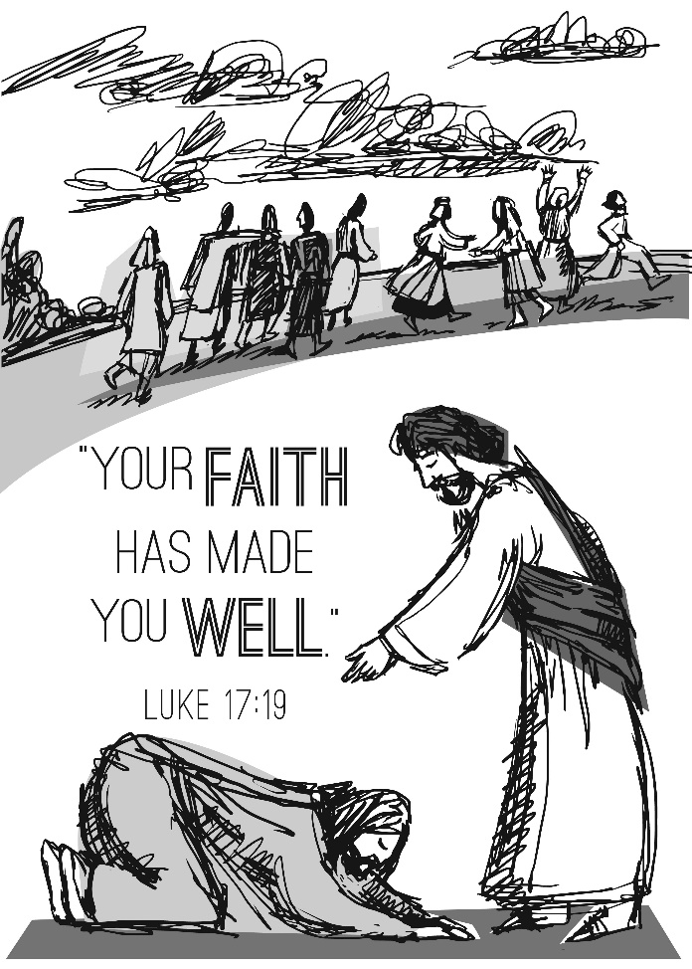

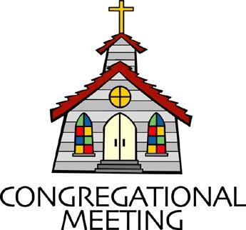
October 13, 2019 - 10:30 am

WELCOME VISITORS! We're glad you are here! Cards at the ends of each pew are for you to fill out and drop in the Offering Plate. Please let us know you are visiting, and join us for refreshments and fellowship following the service. The Sanctuary has an induction loop system to assist the hearing impaired. The system will also work on the telephone setting of hearing aids.

Springfield Presbyterian Church is rooted in the gospel of Jesus Christ, led by the Holy Spirit, and called to loving relationships through vibrant worship and service. Valuing all people, we are committed to developing disciples and fostering stewardship.
PREPARATION FOR THE WORD
(* those who are able are invited to stand)

PRELUDE

GATHERING OF THE PEOPLE

The Lord be with you! And also with you! (Greeting)

LIGHTING THE CHRIST CANDLE
Leader: Whenever we light this candle we proclaim:
People: Christ is the Light of the world and the center of our lives.

CALL TO WORSHIP [Psalm 66:1-4]
Leader: Make a joyful noise to God, all the earth!
People: Sing to the glory of His name!
Leader: Give to Him glorious praise.
People: Say to God, “How awesome are your deeds!”
Leader: Because of your great power, O God, your enemies cringe before you!
People: All the earth worships you!
Leader: All the earth sings praises to you!
People: As a faithful people, we gather together to sing praises to your name! Alleluia, amen!

* HYMN We Cannot Measure How You Heal

We cannot measure how you heal or answer every sufferer’s prayer,
Yet we believe your grace responds where faith and doubt unite to care.
Your hands, though bloodied on the cross, survive to hold and heal and warn,
To carry all through death to life and cradle children yet unborn.

The pain that will not go away, the guilt that clings from things long past,
The fear of what the future holds, are present as if meant to last.
But present too is love which tends the hurt we never hoped to find,
The private agonies inside, the memories that haunt the mind.

So some have come who need your help and some have come to make amends,
As hands which shaped and saved the world are present in the touch of friends.
Lord, let your Spirit meet us here to mend the body, mind and soul,
To disentangle peace from pain, and make your broken people whole.

PRAYER OF CONFESSION
Generous God, we are a people who long to be healed, to be made clean, to somehow start again. We look out to a world of hurting people, damaging situations, and those in the margins, knowing our nations are in need of healing too. We become overwhelmed, overbooked, overstressed, where we do not measure wholeness and health, but measure ourselves by monetary figures, clothes sizes, and our socio-economic status. We’ve lost the sense of what holistic health means, and what abundant life looks like in relationship to you. Help to transform us, renew us, and restore us. Forgive us for our distractions and help us to refocus on your call to wholeness. Amen.

SILENT PRAYERS OF CONFESSION

RESPONSE Just as I Am, without One Plea
Just as I am, thou wilt receive, wilt welcome, pardon, cleanse, relieve;
Because thy promise I believe, O Lamb of God, I come; I come!

WORDS OF ASSURANCE
Leader: As the beloved children of God, we celebrate together that because of God’s grace and mercy, unable to be measured by our own hearts, we are forgiven and freed.
People: We are forgiven, called to be a renewed people in this world. Thanks be to God. Alleluia, amen!

* MUSICAL RESPONSE OF PRAISE To God Be the Glory
Praise the Lord, praise the Lord; let the earth hear his voice!
Praise the Lord, praise the Lord; let the people rejoice!
O come to the Father through Jesus the Son,
And give him the glory: great things he has done!

* THE PEACE The peace of Christ be with you! And also with you!
(You may greet those around you.)

* RESPONSE Here I Am, Lord
Here I am, Lord, Is it I, Lord? I have heard you calling in the night.
I will go, Lord, if you lead me. I will hold your people in my heart.

THE PROCLAMATION OF THE WORD

PRAYER OF ILLUMINATION
Leader: Almighty God, in you are hidden all the treasures of wisdom and knowledge. Open our eyes that we may see the wonders of your Word; and give us grace that we may clearly understand and freely choose the way of your wisdom; through Christ our Lord. Amen.

FIRST SCRIPTURE LESSON Psalm 66:5-12
⁵ Come and see what God has done: he is awesome in his deeds among mortals. ⁶ He turned the sea into dry land; they passed through the

river on foot. There we rejoiced in him, ⁷who rules by his might for ever,
whose eyes keep watch on the nations—let the rebellious not exalt themselves. ⁸ Bless our God, O peoples, let the sound of his praise be heard, ⁹ who has kept us among the living, and has not let our feet slip.
¹⁰ For you, O God, have tested us; you have tried us as silver is tried.
¹¹ You brought us into the net; you laid burdens on our backs; ¹² you let people ride over our heads; we went through fire and through water;
yet you have brought us out to a spacious place.

SECOND SCRIPTURE LESSON Luke 17:11-19
¹¹On the way to Jerusalem Jesus was going through the region between Samaria and Galilee. ¹²As he entered a village, ten lepers approached him. Keeping their distance, ¹³they called out, saying, ‘Jesus, Master, have mercy on us!’ ¹⁴When he saw them, he said to them, ‘Go and show yourselves to the priests.’ And as they went, they were made clean. ¹⁵Then one of them, when he saw that he was healed, turned back, praising God with a loud voice. ¹⁶He prostrated himself at Jesus’ feet and thanked him. And he was a Samaritan. ¹⁷Then Jesus asked, ‘Were not ten made clean? But the other nine, where are they? ¹⁸Was none of them found to return and give praise to God except this foreigner?’ ¹⁹Then he said to him, ‘Get up and go on your way; your faith has made you well.’

Leader: Hear what the Spirit is saying to the Church.
All: Thanks be to God.

TIME WITH YOUNG PEOPLE

SERMON For a Faith that Heals Rev. Becca Crate

THE RESPONSE TO THE WORD

* HYMN O Christ, the Healer
O Christ, the healer, we have come to pray for health, to plead for friends.
How can we fail to be restored when reached by love that never ends?

From every ailment flesh endures our bodies clamor to be freed;
Yet in our hearts we would confess that wholeness is our deepest need.

How strong, O Lord, are our desires, how weak our knowledge of ourselves!
Release in us those healing truths unconscious pride resists or shelves.

In conflicts that destroy our health we recognize the world’s disease;
Our common life declares our ills. Is there no cure, O Christ, for these?

Grant that we all, made one in faith, in your community may find
The wholeness that, enriching us, shall reach the whole of humankind.

PASTORAL PRAYER AND THE LORD’S PRAYER
“For this I pray to God.” / “For this I give thanks to God.”
Congregational Response: “Hear our prayer, O God.”

PRESENTATION OF TITHES AND OFFERINGS
OFFERTORY We Thank You, Lord By Nancy Price & Don Besig
* SONG OF THANKS Lord of All Good Tune #711
Lord of all good, our gifts we bring to you; use them your holy purpose to fulfill, tokens of love and pledges brought anew, that our whole life is offered to your will.
* PRAYER OF DEDICATION

* HYMN My Life Flows On (How Can I Keep from Singing?)

My life flows on in endless song, above earth’s lamentation.
I hear the clear, though far-off hymn that hails a new creation.

Refrain:
No storm can shake my inmost calm while to that Rock I’m clinging.
Since Christ is Lord of heaven and earth, how can I keep from singing?

Through all the tumult and the strife, I hear that music ringing.
It finds an echo in my soul. How can I keep from singing? [Refrain]

What though my joys and comforts die? I know my Savior liveth.
What though the darkness gather round? Songs in the night he giveth. [Refrain]

The peace of Christ makes fresh my heart, a fountain ever springing!
All things are mine since I am his! How can I keep from singing? [Refrain]

* CHARGE AND BENEDICTION
Leader: We are called to gratitude,
People: For gratitude reframes all we do.
Leader: In gratitude, our faith is strengthened,
People: The Spirit’s call is stronger.
Leader: As grateful people, guide us outside these walls,
People: Called to serve you in all we do and say. Amen.

* UNISON AMEN

POSTLUDE

Sunday October 20 Lectionary
Jeremiah 31:27-34; Psalm 119:97-104; 2 Timothy 3:14-4:5; Luke 18:1-8
Assisting in Worship: We appreciate those who serve:

Today 10/13 Next Week 10/20
Sunday Opener Ron Holmes Bob Rogers
Greeters & Ushers Sharon Pappas & Tim Doyle &
Jim Wise Bob Rogers
Lay Leader Elizabeth Meirowitz Sharon Pappas
Sunday School Connie Robinson Connie Robinson
Fellowship Connie Gibbons & Sandy Newsome
Cathy Marsh

Church Attendance: September 29 – 42 October 6 - 30

Church Cleaning: October 18, 19 or 20 – The Oates Family

Happy Birthday! October 13 – Ron Holmes
October 15 – Jessica Lane
October 17 – Beth Oates
October 19 – Martha Streaker

Happy Anniversary! October 15 – Jim & Barbara Nickell
October 18 – Jim & Mary Rhodes

Announcements

Peace and Global Witness: TODAY we receive your Peace and Global Witness offering, which is used to engage in peacemaking and build ministries of reconciliation around the world. Half goes to the Presbyterian Mission Agency, 20% to Mid Councils for their programs, and 25% remains with us. The Mission/Outreach team again decided to send our portion to LSC America’s Partner for Equal Justice, providing legal aid to those living in poverty in our country.
Concert: TODAY at 3:00 pm, we welcome Cornerstone Saxophone Quartet, with refreshments following the performance. Bring your neighbors and friends!

Stewardship Sunday is set for November 3. At this time, we will be accepting pledges for the next year. Immediately following the service, we will have a special home-made soup luncheon that is being coordinated with Fellowship. Please plan on joining us as we celebrate all that God has given us. Stewardship letters will be coming out before the end of October. If you do not receive one by then, please contact the church office or Bob Steppling (862-266-2240).

Children/Youth Activities: If your child/youth is participating in any activities this Fall, please let Connie Robinson know as we want to be part of the activity.

Blessing Bags are in the Narthex. Please feel free to pick up a few. Handing one out to someone in need gives you a very real way to meet their immediate needs by providing them with some basic supplies.

Weekly Announcements: If you have an announcement to include with next week’s bulletin, please call the Office at 410-795-6152 or email to spc.office@verizon.net by Wednesday each week.

Prayers & Thanksgivings

~ Continued prayers of comfort and healing for Barbara Nickell who broke her wrist. If you would like to provide a meal for the Nickells, please see Connie Robinson.
~ Prayers for Mt. Paran Presbyterian Church from our Ministry Group.

The Congregational Care team wants to know what YOU or someone you know needs...a visit...a call...a meal. Please contact Diana Steppling or Connie Robinson. If you are in need of pastoral care, please contact Pastor Becca at 410-795-6152 or springfieldpastor@gmail.com.

Today:
Sunday October 13
10:30 am Worship & Sunday School
11:30 am Fellowship
3:00 pm Concert – Cornerstone Saxophone Quartet

This Week:
Monday October 14
7:00 pm Head Huggers (Manse)
Wednesday October 16
6:30 pm Bell Choir Practice
7:45 pm Adult Choir Practice
Friday October 18
7:00 pm Family Game Night

Looking Ahead:
Sunday October 20
9:00 am Red Sea Parting Practice
10:30 am Worship
11:30 am Fellowship
Monday October 21
9:30 am Feed My Sheep (Wesley Freedom)
Tuesday October 22
10:30 am Prayer Group
Wednesday October 23
6:30 pm Bell Choir Practice
7:45 pm Adult Choir Practice

Office Hours: Tuesday, Wednesday, Friday 9:00 am - 3:00 pm
Springfield Presbyterian Church

10:30 am Worship & Sunday School
11:30 am Fellowship
Website: www.springfield-church.org Church Office: 410-795-6152
Like us on Facebook: www.facebook.com/SpringfieldPresbyterianChurch
Pastor: Rev. Becca Crate
Email: springfieldpastor@gmail.com
Clerk of Session: Sharon Pappas
Minister of Music: Linda Caviglia
Accompanist: Aaron Thacker Organist: Jennifer Wise
Youth Group Coordinators: Charles & Deb Sperling
Sunday School Coordinator: Connie Robinson
Administrative Assistant: Donna Mazer
e-mail: spc.office@verizon.net

