(Large Print)

Springfield Presbyterian Church (USA)
7300 Spout Hill Road, Sykesville, MD 21784 410-795-6152

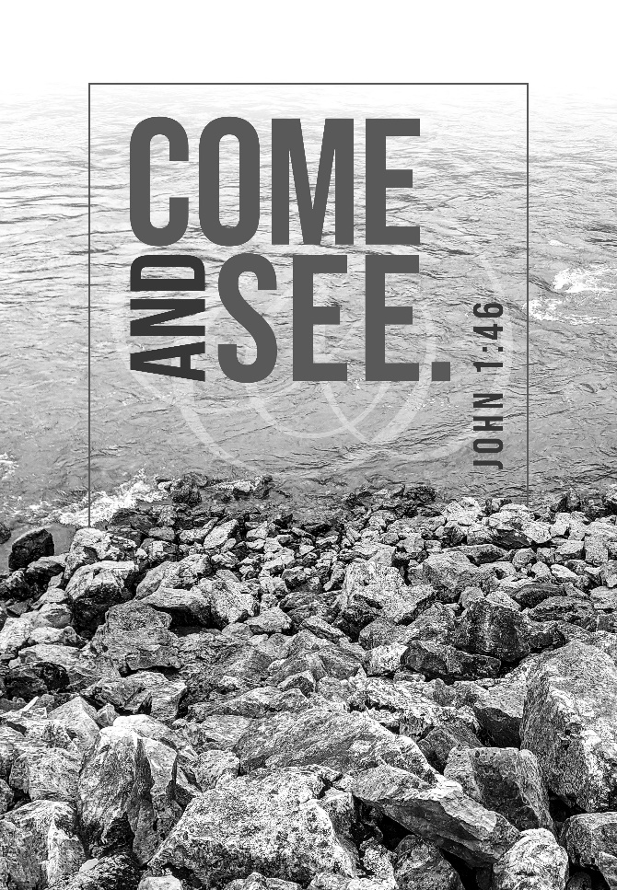

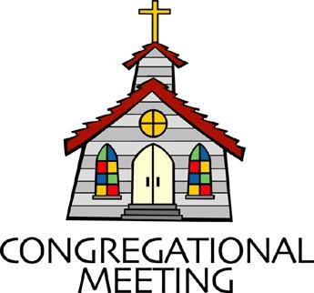
September 18, 2022 - 10:30 am

WELCOME VISITORS!
We're glad you are here! Cards at the ends of each pew are for you to fill out and drop in the Offering Plate. Please let us know you are visiting, and join us for refreshments and fellowship following the service. The Sanctuary has an induction loop system to assist the hearing impaired. The system will also work on the telephone setting of hearing aids.

Springfield Presbyterian Church is rooted in the gospel of Jesus Christ, led by the Holy Spirit, and called to loving relationships through vibrant worship and service. Valuing all people, we are committed to developing disciples and fostering stewardship.
PREPARATION FOR THE WORD
(* those who are able are invited to stand)

PRELUDE

GATHERING OF THE PEOPLE

The Lord be with you! And also with you! (Greeting)

LIGHTING THE CHRIST CANDLE
Leader: Whenever we light this candle we proclaim:
People: Christ is the Light of the world and the center of our lives.

CALL TO WORSHIP
Leader: We continue to ask the question, “Where are you from?”
People: We move into this worship space with curiosity.
Leader: We seek the ways God is calling us to claim our identity.
People: We remember that we are beloved children of God.
Leader: Let us learn from one another.
People: Let us build our community with these strengths.
Leader: Let us hold each other in weakness.
People: Let us come and worship the God who has made us and continues to call us God’s own.

* HYMN In Christ There Is No East or West GTG #318
In Christ there is no east or west, in him no south or north,
But one great fellowship of love throughout the whole wide earth.

In Christ shall true hearts everywhere their high communion find;
His service is the golden cord closebinding humankind.

Join hands, disciples of the faith, whate’er your face may be.
All children of the living God are surely kin to me.

In Christ now meet both east and west; in him meet south and north.
All Christly souls are one in him throughout the whole wide earth.
CALL TO CONFESSION
Leader: In our busy world, vulnerability and silence isn’t something we are often comfortable with and our response to “How are you?” is a muffled, “Yeah, I’m good.” Christ invites us to a vibrant, abundant life, where we can be in full relationship with one another. Let us come and confess the ways in which we can live better together.

PRAYER OF CONFESSION
Generous God, we are all guilty of asking, “How are you?” and not wanting to really know the answer. The vulnerability of human relationships can challenge us to draw closer to you and closer to the reality of the world around us. Sometimes, ignorance is bliss. Yet we know that we are called to more in this community, we know that we need one another. Forgive us for not leaning in and teach us again how to listen to one another more fully. Amen.

SILENT PRAYERS OF CONFESSION

RESPONSE Lord Jesus, Think on Me Tune #417
Lord Jesus, think on me, and purge away my sin.
From earth-born passions set me free, and make me pure within.

WORDS OF ASSURANCE
Leader: When we come to the share our sins openly and ask for forgiveness, God continues to welcome us home.
People: Thanks be to the God whose mercy draws us close again and again. Amen.

* MUSICAL RESPONSE OF PRAISE Glory to God Tune #583
Glory to God, glory to God, glory in the highest!
Glory to God, glory to God, alleluia, alleluia!

* THE PEACE The peace of Christ be with you! And also with you!
(You may greet those around you.)

* RESPONSE Here I Am, Lord
Here I am, Lord, Is it I, Lord? I have heard you calling in the night.
I will go, Lord, if you lead me. I will hold your people in my heart.

THE PROCLAMATION OF THE WORD

PRAYER OF ILLUMINATION
Generous God, turn our hearts to you, as we seek to understand your Word. Take away the distractions, even for this moment alone, for us to fully breathe in all you share with us. Help us to take this Word and manifest it in our lives. Amen.

FIRST SCRIPTURE LESSON Psalm 100
¹ Make a joyful noise to the Lord, all the earth. ² Worship the Lord with gladness; come into his presence with singing. ³ Know that the Lord is God. It is he that made us, and we are his; we are his people, and the sheep of his pasture. ⁴ Enter his gates with thanksgiving, and his courts with praise. Give thanks to him, bless his name. ⁵ For the Lord is good; his steadfast love endures for ever, and his faithfulness to all generations.

SECOND SCRIPTURE LESSON John 1:35-51
³⁵The next day John again was standing with two of his disciples, ³⁶and as he watched Jesus walk by, he exclaimed, ‘Look, here is the Lamb of God!’ ³⁷The two disciples heard him say this, and they followed Jesus. ³⁸When Jesus turned and saw them following, he said to them, ‘What are you looking for?’ They said to him, ‘Rabbi’ (which translated means Teacher), ‘where are you staying?’ ³⁹He said to them, ‘Come and see.’ They came and saw where he was staying, and they remained with him that day. It was about four o’clock in the afternoon. ⁴⁰One of the two who heard John speak and followed him was Andrew, Simon Peter’s brother. ⁴¹He first found his brother Simon and said to him, ‘We have found the Messiah’ (which is translated Anointed). ⁴²He brought Simon to Jesus, who looked at him and said, ‘You are Simon son of John. You are to be called Cephas’ (which is translated Peter). ⁴³The next day Jesus decided to go to Galilee. He found Philip and said to him, ‘Follow me.’ ⁴⁴Now Philip was from Bethsaida, the city of Andrew and Peter. ⁴⁵Philip found Nathanael and said to him, ‘We have found him about whom Moses in the law and also the prophets wrote, Jesus son of Joseph from Nazareth.’ ⁴⁶Nathanael said to him, ‘Can anything good come out of Nazareth?’ Philip said to him, ‘Come and see.’ ⁴⁷When Jesus saw Nathanael coming towards him, he said of him, ‘Here is truly an Israelite in whom there is no deceit!’ ⁴⁸Nathanael asked him, ‘Where did you come to know me?’ Jesus answered, ‘I saw you under the fig tree before Philip called you.’ ⁴⁹Nathanael replied, ‘Rabbi, you are the Son of God! You are the King of Israel!’ ⁵⁰Jesus answered, ‘Do you believe because I told you that I saw you under the fig tree? You will see greater things than these.’ ⁵¹And he said to him, ‘Very truly, I tell you, you will see heaven opened and the angels of God ascending and descending upon the Son of Man.’

Leader: Hear what the Spirit is saying to the Church.
All: Thanks be to God.

SERMON The Invisible Neighborhood Rev. Becca Price

THE RESPONSE TO THE WORD

* HYMN What Good Can Come From Nazareth
AURELIA 7.6.7.6 D (to the tune of #321 "The Church's One Foundation")
"What good can come from Nazareth? Can any good at all?"
Nathaniel said to Philip when he heard Philip's call.
The prophets never praised it — that little backwoods place.
He thought God wouldn't choose it to be a means of grace.

And yet, when he met Jesus, Nathaniel changed his ways.
His words that put down others soon turned to words of praise.
He called our Savior "Rabbi!" and "Son of God!" and "King!"
What change a little listening and openness can bring!

"What good can come from strangers?" O God, we hear the shout.
For some hate other people and seek to push them out.
May we who follow Jesus be glad to "Come and see!"
May we learn from each other with true humility.

O God of all our cultures, now make us one, we pray.
May we see your grace working in all your lands this day.
May we hear others' stories — what makes them sad or strong,
Till — listening — we find friendship, with love our common song.

Biblical Reference: John 1:43-51
Tune: Samuel Sebastian Wesley, 1864 ("The Church's One Foundation") (MIDI)
Text: Copyright © 2018 by Carolyn Winfrey Gillette. All rights reserved.
Email: carolynshymns@gmail.com New Hymns: www.carolynshymns.com/

PASTORAL PRAYER AND THE LORD’S PRAYER

OFFERTORY Just Two Words by Frombach/Lau
SONG OF THANKS Praise God, from Whom All Blessings Flow #606
Praise God, from whom all blessing flow; praise him, all creatures here below; Praise him above, ye heavenly host; praise Father, Son and Holy Ghost. Amen.
PRAYER OF DEDICATION

* HYMN Will You Come and Follow Me GTG #726
Will you come and follow me if I but call your name?
Will you go where you don’t know and never be the same?
Will you let my love be shown, will you let my name be known,
Will you let my life be grown in you and you in me?

Will you leave yourself behind if I but call your name?
Will you care for cruel and kind and never be the same?
Will you risk the hostile stare should your life attract or scare?
Will you let me answer prayer in you and you in me?

Will you let the blinded see if I but call your name?
Will you set the prisoners free and never be the same?
Will you kiss the leper clean, and do such as this unseen,
And admit to what I mean in you and you in me?

Will you love the “you” you hide if I but call your name?
Will you quell the fear inside and never be the same?
Will you use the faith you’ve found to reshape the world around,
Through my sight and touch and sound in you and you in me?

Lord, your summons echoes true when you but call my name.
Let me turn and follow you and never be the same.
In your company I’ll go where your love and footsteps show.
Thus I’ll move and live and grow in you and you in me.

* CHARGE AND BENEDICTION
Leader: As you leave this place, may God grant us,
People: The curiosity to counter assumptions,
Leader: The vulnerability to befriend,
People: The bravery to speak your truth,
Leader: The wisdom to listen,
People: The strength to ask for help,
Leader: The resiliency to choose love, even when it’s hard,
People: And the awareness of the Holy Spirit always beside us.
Leader: In the name of our Great God, who is Love itself, may you go in peace.

* UNISON AMEN POSTLUDE
Sunday, September 25, 2022 Lectionary
1 Samuel 1:1-18

Assisting in Worship: We appreciate those who serve:

Today 9/18 Next Week 9/25
Sunday Opener Bob Rogers Barbara Cornell
Ushers/Greeters Don Vasbinder Steve & Donna
Connie Gibbons Mazer
Lay Leader Diana Steppling Barbara Cornell

Happy Birthday! September 25 – Julie Ballard

Announcements

Sunday School is back! We will be offering Sunday School beginning TODAY, and on the 1st and 3rd Sundays of each month thereafter. See Pastor Becca for details…

Church picnic (rain or shine - indoors or out) is TODAY after worship. We will have “7556 Bistro” on Sykesville's Main Street cater several dishes: Mac'n'cheese, a green salad, broccoli bacon slaw, and German potato salad, and we'll offer fried chicken and lunchmeat and cheese with rolls. Please join us!

Fall Fellowship Time: The weather is changing! Time to make our plans for Fellowship through the fall. We'd love to have your help providing and serving the goodies we share as we visit after worship. If you have not hosted Fellowship, we can pair you with someone who knows the routine (and where we hide the toothpicks!).
If you don't want to host, we would be happy to have you sign up to bring something in. We always have a supply of crackers and cookies in the kitchen, but our table often includes fruit, cheese and baked goods. Let us know on the sign-up sheet in the kitchen or email me what you'd like to bring. Thanks so much!
Barbaracornell4@gmail.com or 240-308-0035

Christian Education: Our Time and Talents survey shows folks are interested in an adult bible study program, and Alex McClung is interested in leading a study group. We imagine meeting 2x/month before church, but content, format, and timing are all TBD. Please contact Alex with your suggestions, interests, and best times: akmcclungiii@gmail.com.

Mask Update: Due to the uptick in COVID-19 cases, the Session has decided to strongly encourage masking and social distancing. Though it is not a mandate, we seek to love one another by keeping each other as safe as possible. Thank you for your help in this endeavor.

Pastor-Parish Committee: The Pastor-Parish Committee invites you to share your concerns, suggestions, and gratitude. We have a form in the Narthex and a lock-box that we will open weekly and we ask that you share your name and be specific. We look forward to reading your comments so that we can continue to grow into the body of Christ.

Springfield Membership: Are you interested in finding out more about our faith community and becoming a member? We would love to answer any questions you have. Please contact Pastor Becca at springfieldpastor@gmail.com for more information.

Congregational Care / Mission & Outreach (CoCaMO): Do you know of a member or friend of our church family who is ill, needs prayers, would like call, a visit or a card, or might benefit from meal train? If so, please contact the Church Office (410-795-6152), Cathy Marsh (410-549-6916) or Diana Steppling (862-266-2242).

Prayers & Thanksgivings
~ Prayers of quick healing for Julie Ballard who suffered from a fall this week.
~ Prayers for Sue Holmes’ mom, Betty Martlew, who fell and broke her hip and is recovering from surgery.
~ Prayers for Cynthia Smith and her family on the passing of her Mom on September 1.

Today:
Sunday September 18
10:30 am Worship & Sunday School
11:30 am Picnic

This Week:
Wednesday September 21
6:15 – 7:15 pm Bell Choir Practice
7:30 – 8:45 pm Adult Choir Practice

Looking Ahead:
Sunday September 25 – Peace & Global Witness
10:30 am Worship & Sunday School
11:30 am Fellowship
Wednesday September 28
6:15 – 7:15 pm Bell Choir Practice
7:30 – 8:45 pm Adult Choir Practice

Office Hours: Tuesday, Wednesday & Friday
Springfield Presbyterian Church

10:30 am Worship & Sunday School
11:30 am Fellowship
Website: www.springfield-church.org Church Office: 410-795-6152
Like us on Facebook: www.facebook.com/SpringfieldPresbyterianChurch
Pastor: Rev. Becca Price
Email: springfieldpastor@gmail.com
Clerk of Session: Sharon Pappas
Minister of Music: Linda Caviglia
Accompanist/Organist: Aaron Thacker
Youth Group Coordinator: Dylan Vasbinder
Administrative Assistant: Donna Mazer e-mail: spc.office@verizon.net

