Springfield Presbyterian Church (USA)
7300 Spout Hill Road, Sykesville, MD 21784 410-795-6152
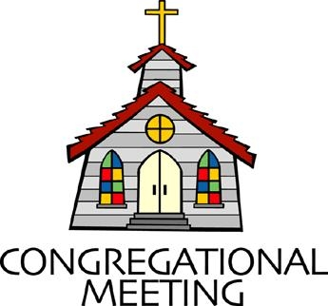

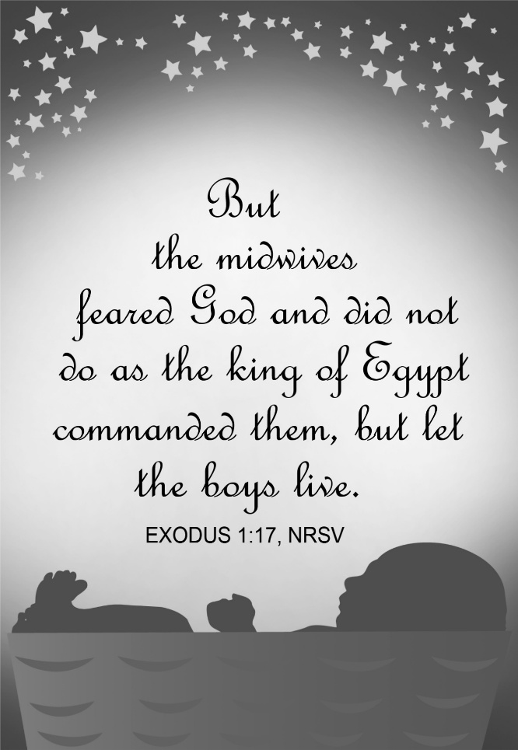

August 23, 2026 - 10:30 am

WELCOME VISITORS!

We're glad you are here! Cards at the ends of each pew are for you to fill out and drop in the Offering Plate. Please let us know you are visiting and join us for refreshments and fellowship following the service. The Sanctuary has an induction loop system to assist the hearing impaired. The system will also work on the telephone setting of hearing aids.

Springfield Presbyterian Church is rooted in the gospel of Jesus Christ, led by the Holy Spirit, and called to loving relationships through vibrant worship and service. Valuing all people, we are committed to developing disciples and fostering stewardship.
PREPARATION FOR THE WORD
(* those who are able are invited to stand)

PRELUDE

GATHERING OF THE PEOPLE

The Lord be with you! And also with you! (Greetings and Announcements)

LIGHTING THE CHRIST CANDLE
Leader: Whenever we light this candle we proclaim:
People: Christ is the Light of the world and the center of our lives.

CALL TO WORSHIP
Leader: We gather to worship God,
All: Who made heaven and earth.
Leader: We gather to worship God,
All: Whom we find in surprising places.
Leader: We gather to worship God,
All: Who cares for all of creation.
Leader: We gather to worship God,
All: Who transforms and renews us through grace.
Leader: Let us worship our Holy God together!

* HYMN We Walk by Faith and Not by Sight GTG #817

We walk by faith and not by sight; with gracious words draw near,
O Christ, who spoke as none e'er spoke: “My peace be with you here.”

We may not touch your hands and side, nor follow where you trod;
But in your promise we rejoice and cry, "My Lord and God!"

Help then, O Lord, our unbelief; and may our faith abound
To call on you when you are near and seek where you are found.

And when our life of faith is done, in realms of clearer light
May we behold you as you are, with full and endless sight.

CALL TO CONFESSION
Leader: God meets us again with patient love. Let us confess our sin as we continue growing toward grace. To embody this, I invite you to hold your fingers together like you are holding a seed and throughout the prayer, slowly open your hand. Let us pray together:

UNISON PRAYER FOR FORGIVENESS
God of grace, you are always helping us grow through the Holy Spirit. Sometimes we think we can grow all on our own. Sometimes we think that growth looks like power rather than love. Forgive us. Strengthen our faith so that we are more loving, more kind, and more just, in the name of Jesus.

SILENT PRAYERS OF CONFESSION

RESPONSE Lord, Jesus, Think on Me GTG #417 (v. 1)
Lord, Jesus, think on me, and purge away my sin.
From earth-born passions set me free, and make me pure within.

WORDS OF ASSURANCE
Heather: God is the soil in which we grow. God is gracious and merciful, slow to anger and full of love. In Jesus Christ, we are forgiven. Thanks be to God! Amen.

* MUSICAL RESPONSE OF PRAISE Praise God, from Whom All Blessings Flow GTG #607
Praise God, from whom all blessings flow; praise Christ, all people here below; praise Holy Spirit evermore; praise Triune God, whom we adore. Amen.

* THE PEACE The peace of Christ be with you! And also with you!
(You may greet those around you.)

* RESPONSE Here I Am, Lord GTG #69
Here I am, Lord. Is it I, Lord? I have heard you calling in the night.
I will go, Lord, if you lead me. I will hold your people in my heart.

THE PROCLAMATION OF THE WORD

PRAYER OF ILLUMINATION
Leader: Holy God, by the power of your Spirit, reveal your will to us today through your Word. Help us to understand your creative, redemptive, and consoling work, and lead us into the world, filled with your Spirit, to offer love in the name of Jesus Christ our Lord. Amen.

FIRST SCRIPTURE LESSON Exodus 1:8-22 OT page 47
⁸Now a new king arose over Egypt, who did not know Joseph. ⁹He said to his people, "Look, the Israelite people are more numerous and more powerful than we. ¹⁰Come, let us deal shrewdly with them, or they will increase and, in the event of war, join our enemies and fight against us and escape from the land."
¹¹Therefore they set taskmasters over them to oppress them with forced labor. They built supply cities, Pithom and Rameses, for Pharaoh. ¹²But the more they were oppressed, the more they multiplied and spread, so that the Egyptians came to dread the Israelites. ¹³The Egyptians became ruthless in imposing tasks on the Israelites, ¹⁴and made their lives bitter with hard service in mortar and brick and in every kind of field labor. They were ruthless in all the tasks that they imposed on them. ¹⁵The king of Egypt said to the Hebrew midwives, one of whom was named Shiphrah and the other Puah, ¹⁶"When you act as midwives to the Hebrew women, and see them on the birthstool, if it is a boy, kill him; but if it is a girl, she shall live." ¹⁷But the midwives feared God; they did not do as the king of Egypt commanded them, but they let the boys live. ¹⁸So the king of Egypt summoned the midwives and said to them, "Why have you done this, and allowed the boys to live?" ¹⁹The midwives said to Pharaoh, "Because the Hebrew women are not like the Egyptian women; for they are vigorous and give birth before the midwife comes to them." ²⁰So God dealt well with the midwives; and the people multiplied and became very strong. ²¹And because the midwives feared God, he gave them families. ²²Then Pharaoh commanded all his people, "Every boy that is born to the Hebrews you shall throw into the Nile, but you shall let every girl live."

TIME FOR ALL GOD’S CHILDREN

SECOND SCRIPTURE LESSON Exodus 2:1-10 OT page 47
¹Now a man from the house of Levi went and married a Levite woman. ²The woman conceived and bore a son; and when she saw that he was a fine baby, she hid him three months. ³When she could hide him no longer she got a papyrus basket for him, and plastered it with bitumen and pitch; she put the child in it and placed it among the reeds on the bank of the river. ⁴His sister stood at a distance, to see what would happen to him. ⁵The daughter of Pharaoh came down to bathe at the river, while her attendants walked beside the river. She saw the basket among the reeds and sent her maid to bring it. ⁶When she opened it, she saw the child. He was crying, and she took pity on him. "This must be one of the Hebrews' children," she said. ⁷Then his sister said to Pharaoh's daughter, "Shall I go and get you a nurse from the Hebrew women to nurse the child for you?" ⁸Pharaoh's daughter said to her, "Yes." So the girl went and called the child's mother. ⁹Pharaoh's daughter said to her, "Take this child and nurse it for me, and I will give you your wages." So the woman took the child and nursed it. ¹⁰When the child grew up, she brought him to Pharaoh's daughter, and she took him as her son. She named him Moses, "because," she said, "I drew him out of the water."

Leader: This is the Word of the Lord. All: Thanks be to God.

SERMON Delivered to Deliver By Heather Russell

THE RESPONSE TO THE WORD

* HYMN You Who Dwell in the Shelter of the Lord GTG #43

You who dwell in the shelter of the Lord, who abide in his shadow for life,
Say to the Lord, “My refuge, my rock in whom I trust!”

Refrain:
And he will raise you up on eagle’s wings, bear you on the breath of dawn, make you to shine like the sun, and hold you in the palm of his hand.

The snare of the fowler will never capture you, and famine will bring you no fear:
Under his wings, your refuge, his faithfulness your shield. [Refrain]

You need not fear the terror of the night, nor the arrow that flies by day;
Though thousands fall about you, near you it shall not come. [Refrain]

For to his angels he’s given a command to guard you in all of your ways;
Upon their hands they will bear you up, lest you dash your foot against a stone. [Refrain]

PRAYERS OF THE PEOPLE AND THE LORD’S PRAYER
Our Father, who art in heaven, hallowed be thy name, thy kingdom come, thy will be done, on earth as it is in heaven. Give us this day our daily bread; and forgive us our debts, as we forgive our debtors; and lead us not into temptation, but deliver us from evil. For thine is the kingdom, and the power, and the glory, forever, Amen.

PRESENTATION OF TITHES AND OFFERINGS
OFFERTORY
* SONG OF THANKS As Those of Old Their Firstfruits Brought
GTG #712 (v. 3)
In gratitude and humble trust we bring our best today,
To serve your cause and share your love with all along life’s way.
O God who gave yourself to us in Jesus Christ your Son,
Help us to give ourselves each day until life’s work is done.
* PRAYER OF DEDICATION

* HYMN I’m Gonna Live So God Can Use Me GTG #700

I'm gonna live so God can use me anywhere, Lord, anytime!
I'm gonna live so God can use me anywhere, Lord, anytime!

I'm gonna work so God can use me anywhere, Lord, anytime!
I'm gonna work so God can use me anywhere, Lord, anytime!

I'm gonna pray so God can use me anywhere, Lord, anytime!
I'm gonna pray so God can use me anywhere, Lord, anytime!

I'm gonna sing so God can use me anywhere, Lord, anytime!
I'm gonna sing so God can use me anywhere, Lord, anytime!

* CHARGE AND BENEDICTION
Heather: And now, may the peace of God, which passes all understanding, keep your hearts and minds in the knowledge and love of God, and of God’s Son, Jesus Christ our Lord; and the blessing of God almighty, the Father, the Son, and the Holy Spirit, remain with you always. Amen.

* UNISON AMEN GTG #601

POSTLUDE

Some liturgy adapted from Child Of Blessing Lectionary Resource, Presbyterian Association of Musicians and Sundays and Seasons

Assisting in Worship: We appreciate those who serve:

Today 8/23 Next Week 8/30
Sunday Opener: Beth Oates Mark Chaplik
Ushers/Greeters: Alex & Brenda McClung Don Vasbinder
Barbara Nickell
Lay Leader: Ron Holmes Bob Steppling
Offering Counters: Christy Y. & Volunteer Mark Chaplik & Vol.
Fellowship Hosts: Barbara Cornell Rebekah Schermer

Happy Birthday! August 27 – Connie Gibbons
August 28 – Bob Rogers

Sunday, August 30 Lectionary:
Jeremiah 15:15-21; Psalm 26:1-8; Romans 12:9-21; Matthew 16:21-28
Announcements

Mark Your Calendars: Our annual summer Giving Tree, collecting needed items for Sykesville Middle School students, officially ends on August 30. A list of those items is available in the Narthex. If you bring items after August 30, no problem, Sue Holmes promises to deliver every donation to the school.

August 30 is also the 5th Sunday of the month, Noisy Offering Sunday. This offering will be sent to Presbyterian Disaster Assistance (PDA). So, let’s make some noise and make a little change make a big difference.

On September 13, our SPC family and friends will gather after worship for a Homecoming picnic, a rain-or-shine event. A sign-up sheet will be available during fellowship for anyone who would like to bring a dish to share. Everyone is welcome - come and eat, visit, meet our new pastor, reconnect with old friends, and make new ones. ~CoCaMO Committee

Congregational Care: If you know of someone who would benefit from a card or a phone call, please text or call Diana Steppling at 862-266-2242.

Electronic Giving: Below is a QR code you can scan to make your contribution a new way! The page you get will ask for your name, email and phone

number. You can choose from a dropdown menu for selecting where the donation should go: General Fund, Capital Fund, Concert, Memorial. There is a fee for using a credit card, and you will be given the option to pay that fee along with your donation, but you don’t have to include it if you don’t want to.

Today:
Sunday August 23
10:30 am Worship
11:30 am Fellowship
12:00 noon Calendar Planning Meeting (Large Classroom)

This Week:
Thursday August 27
7:00 pm Session Meeting (Manse)

Next Week:
Sunday August 30 – Noisy Offering
10:30 am Worship
11:30 am Fellowship

Heather’s Summer Office Hours: Tuesday, Wednesday, Friday
8:30 am – 12:00 noon
Monday – Sabbath Day
springfieldpres.pastor@gmail.com
Cell 443-280-9712 (texts welcomed, please identify yourself)


Springfield Presbyterian Church
10:30 am Worship
11:30 am Fellowship
Website: www.springfield-church.org Church Office: 410-795-6152
Like us on Facebook: www.facebook.com/SpringfieldPresbyterianChurch
Ministry Associate: Heather Russell von Marko
Email: springfieldpres.pastor@gmail.com
Clerk of Session: Sharon Pappas
Music Director: Vacant
Accompanist: Michael Hall
Bell Choir Director: Robin Kochanski
Administrative Assistant: Donna Mazer
Email: springfieldpres.office@gmail.com



