Springfield Presbyterian Church (USA)
7300 Spout Hill Road, Sykesville, MD 21784 410-795-6152
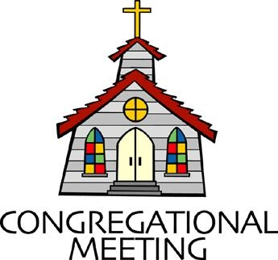

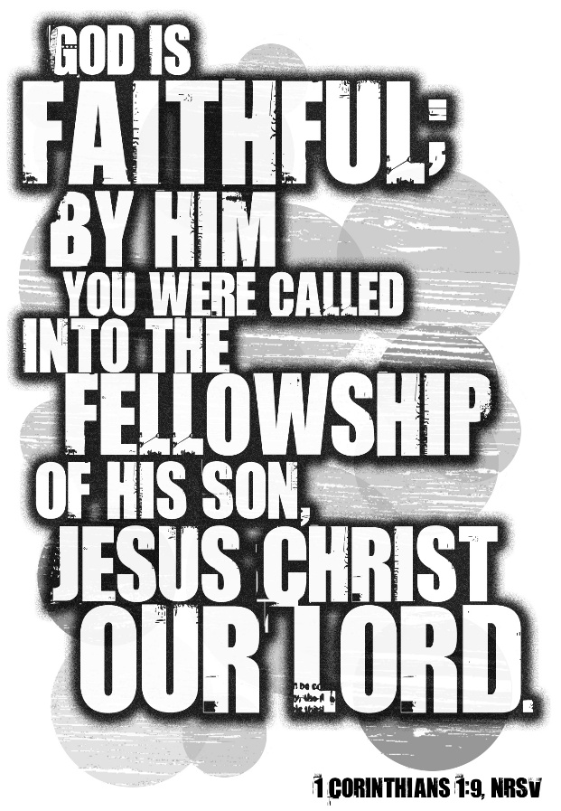

January 18, 2026 - 10:30 am

WELCOME VISITORS!

We're glad you are here! Cards at the ends of each pew are for you to fill out and drop in the Offering Plate. Please let us know you are visiting and join us for refreshments and fellowship following the service. The Sanctuary has an induction loop system to assist the hearing impaired. The system will also work on the telephone setting of hearing aids.

Springfield Presbyterian Church is rooted in the gospel of Jesus Christ, led by the Holy Spirit, and called to loving relationships through vibrant worship and service. Valuing all people, we are committed to developing disciples and fostering stewardship.
PREPARATION FOR THE WORD
(* those who are able are invited to stand)
PRELUDE

GATHERING OF THE PEOPLE

The Lord be with you! And also with you! (Greetings and Announcements)

LIGHTING THE CHRIST CANDLE
Leader: Whenever we light this candle we proclaim:
People: Christ is the Light of the world and the center of our lives.

CALL TO WORSHIP
Leader: I waited patiently for the Lord; he inclined to me and heard my cry.
He drew me up from the desolate pit, out of the miry bog, and set my feet upon a rock, making my steps secure. He put a new song in my mouth, a song of praise to our God. You have multiplied, O Lord my God, your wondrous deeds and your thoughts toward us; none can compare with you. May all who seek you rejoice and be glad in you; may those who love your salvation say continually,
“Great is the Lord!”
All: Come, let us worship the Lord!

* HYMN There’s a Sweet, Sweet Spirit GTG #408
There’s a sweet, sweet Spirit in this place, and I know that it’s the Spirit of the Lord;
There are sweet expressions on each face, and I know they feel the presence of the Lord.

Refrain:
Sweet Holy Spirit, sweet heavenly Dove, stay right here with us,
Filling us with your love; and for these blessings we lift our hearts in praise; without a doubt we’ll know that we have been revived when we shall leave this place.

There are blessings you cannot receive till you know him in his fullness and believe;
You’re the one to profit when you say, “I am going to walk with Jesus all the way.” [Refrain]
CALL TO CONFESSION
Leader: As the psalmist cried out: Do not, O Lord, withhold your mercy from me;
let your steadfast love and your faithfulness keep me safe forever. So we come before one another and before the One who loves us best. We confess without fear of retribution or condemnation, those actions or attitudes which we do not want to give power to--that nothing may stand between us and the lover of our souls.

PRAYER OF CONFESSION
Most merciful God, we confess that we have sinned against you in thought, word, and deed, by what we have done, and by what we have left undone.
We have not loved you with our whole heart; we have not loved our neighbors as ourselves. We are truly sorry and we humbly repent. For the sake of your Son Jesus Christ, have mercy on us and forgive us; that we may delight in your will, and walk in your ways, to the glory of your Name. Amen.

SILENT PRAYERS OF CONFESSION

RESPONSE Just as I Am, without One Plea GTG #442 (v. 3)
Just as I am, thou wilt receive, wilt welcome, pardon, cleanse, relieve;
Because thy promise I believe, O Lamb of God, I come; I come!

WORDS OF ASSURANCE
Leader: “If you, O Lord, kept a record of sins, O Lord, who could stand? But with you there is forgiveness; therefore you are feared.” So it is with awe and reverence we can serve the Lord. “For as far as the east is from the west, so far has he removed our transgressions from us.” Hear, and speak, the good news:
All: In Jesus Christ, we are forgiven!

* MUSICAL RESPONSE OF PRAISE We Praise You, O God GTG #612 (v. 3)
With voices united our praises we offer and gladly our songs of thanksgiving we raise.
With you, Lord, beside us, your strong arm will guide us. To you, our great Redeemer, forever be praise!

* THE PEACE The peace of Christ be with you! And also with you!
(You may greet those around you.)

* RESPONSE Here I Am, Lord GTG #69
Here I am, Lord. Is it I, Lord? I have heard you calling in the night.
I will go, Lord, if you lead me. I will hold your people in my heart.

THE PROCLAMATION OF THE WORD

PRAYER FOR ILLUMINATION
You have called us yours, O Lord; reaching out to us even before we knew you were the one doing the reaching. You faithfully walk with us, patiently waiting for us to call to you. We do so now, Holy Spirit. Gentle our hearts and enliven our thoughts, that a new word may come to us from words of old, a stream of living water that refreshes and renews. Amen.

FIRST SCRIPTURE LESSON John 1:29, 32-42 NT page 86
²⁹ The next day John [the baptizer] saw Jesus coming toward him and declared, “Here is the Lamb of God who takes away the sin of the world! ³²I saw the Spirit descending from heaven like a dove, and it remained on him. ³³ I myself did not know him, but the one who sent me to baptize with water said to me, ‘He on whom you see the Spirit descend and remain is the one who baptizes with the Holy Spirit.’ ³⁴ And I myself have seen and have testified that this is the Chosen One.” ³⁵ The next day John again was standing with two of his disciples, ³⁶ and as he watched Jesus walk by he exclaimed, “Look, here is the Lamb of God!” ³⁷ The two disciples heard him say this, and they followed Jesus. ³⁸ When Jesus turned and saw them following, he said to them, “What are you looking for?” ³⁹ He said to them, “Come and see.” They came and saw where he was staying, and they remained with him that day. ⁴⁰ One of the two who heard John speak and followed him was Andrew…⁴¹ He first found his brother Simon and said to him, “We have found the Messiah” (which is translated Anointed). ⁴² He brought Simon to Jesus, who looked at him and said, “You are Simon son of John. You are to be called Cephas” (which is translated Peter).

SECOND SCRIPTURE LESSON 1 Corinthians 1:1-9 NT page 155
¹ Paul, called to be an apostle of Christ Jesus by the will of God, and our brother Sosthenes, ² To the church of God that is in Corinth, to those who are sanctified in Christ Jesus, called to be saints, together with all those who in every place call on the name of our Lord Jesus Christ, both their Lord and ours: ³ Grace to you and peace from God our Father and the Lord Jesus Christ. ⁴ I give thanks to my God always for you because of the grace of God that has been given you in Christ Jesus, ⁵ for in every way you have been enriched in him, in speech and knowledge of every kind— ⁶ just as the testimony of Christ has been strengthened among you— ⁷ so that you are not lacking in any gift as you wait for the revealing of our Lord Jesus Christ. ⁸ He will also strengthen you to the end, so that you may be blameless on the day of our Lord Jesus Christ. ⁹ God is faithful, by whom you were called into the partnership of his Son, Jesus Christ our Lord.

Leader: Hear what the Spirit is saying to the Church.
All: Thanks be to God.

SERMON Remember Your Calling By Rev. Andrea Taylor

THE RESPONSE TO THE WORD

* HYMN You’ve Called Us Together, O God, By Your Grace
(to the tune of To God Be the Glory GTG #634)

You've called us together, O God, by your grace;
In grateful obedience, we've come to this place.
Our new common mission has only begun;
We're learning the blessings of serving as one.

Refrain:
We are called! We are freed! We are baptized as one.
In the Church, all we need can be found in your Son!
With Christ to unite us, and born from above,
We witness together to your wondrous love.

We're one in the faith, and in creeds that we share,
In worship and sacraments, scripture and prayer.
We're one in our seeking to follow Christ's way,
In Spirit-led ministry, day after day. [Refrain]

There's much to rejoice in, yet much to be done;
While some are excluded, we can't live as one.
May we as your churches uniting now see
That justice is needed for true unity. [Refrain]

Tune: William Howard Doane, 1875 ("To God Be the Glory") (MIDI)
Text: Copyright © 2001 by Carolyn Winfrey Gillette. All rights reserved.
Included in Songs of Grace: New Hymns for God and Neighbor (Upper Room Books, 2009).

PASTORAL PRAYER AND THE LORD’S PRAYER

PRESENTATION OF TITHES AND OFFERINGS
OFFERTORY
* SONG OF THANKS For the Life That You Have Given GTG #717
For the life that you have given, for the love in Christ made known,
With these fruits of time and labor, with these gifts that are your own:
Here we offer, Lord, our praises; heart and mind and strength we bring;
Give us grace to love and serve you, living what we pray and sing.
* PRAYER OF DEDICATION

* HYMN O Jesus, I Have Promised GTG #725

O Jesus, I have promised to serve you to the end;
Be now and always near me, my Master and my friend;
I shall not fear the battle if you are by my side,
Nor wander from the pathway if you will be my guide.

O let me feel you near me! The world is ever near:
I see the sights that dazzle; the tempting sounds I hear.
My foes are ever near me, around me and within;
But, Jesus, draw still nearer and shield my soul from sin.

O let me hear you speaking in accents clear and still,
Above the storms of passion, the murmurs of self-will;
O speak to reassure me, to hasten or control;
O speak, and make me listen, true guardian of my soul.

O Jesus, you have promised to all who follow you
That where you are in glory your servant shall be too.
And, Jesus, I have promised to serve you to the end;
Now give me grace to follow, my Master and my friend.

* CHARGE AND BENEDICTION

* UNISON AMEN GTG #601

POSTLUDE

Assisting in Worship: We appreciate those who serve:

Today 1/18 Next Week 1/25
Sunday Opener: Beth Oates Linda Caviglia
Ushers/Greeters: Elizabeth Meirowitz Alex & Brenda McClung
Cynthia Smith
Lay Leader: Tony Caviglia Ron Holmes
Pulpit Supply: Rev. Andrea Taylor Kathy Welsh Smith
Fellowship Hosts: Andrea Kwako
Offering Count: Andrea Kwako & Ron H. Andrea Kwako & Beth O.

Happy Anniversary! January 23 – Carl & Kari Anderson

Happy Birthday! January 20 – Christian Chaplik
January 20 – Henry Halvorson
January 21 – Max Carroll
January 23 – Natalie Halvorson

Sunday January 25, 2026 Lectionary
Isaiah 9:1-4; Psalm 27:1, 4-9; 1 Corinthians 1:10-18; Matthew 4:12-23

Announcements

Welcome! We welcome Rev. Andrea Taylor to our pulpit again today! Ordained in the Baptist tradition, Andrea and her husband, Scott, worship regularly at 1st Presbyterian of Howard County. They have two young adult bicoastal daughters, in CA and Sykesville, neither of which they see often enough.

Per Capita: We have benefited greatly from funds contributed by all the churches in our presbytery. This fund keeps the lights on, salaries paid, and funds the work of all the commissions, like Baltimore-Dakota, or the Commission on Ministry that is helping us navigate through this season. Presbytery's share is $32.24; Synod's share is $1.50; and General Assembly's share is $11.26. If you are able to contribute the $45 due for 2026, it can be added to your pledge, or use a separate check with Per capita on the memo line, or cash in an envelope. We are grateful for your contribution.

Zoom Link for Worship Services: The Zoom link for church services is on the SPC website, not on the Facebook page. The Bulletin is also available on the website as well.

Congregational Care: If you know of someone who would benefit from a card or a phone call, please text or call Connie Gibbons at 410-935-3467.

Electronic Giving: Below is a QR code you can scan to make your contribution a new way! The page you get will ask for your name, email and phone

number. You can choose from a dropdown menu for selecting where the donation should go: General Fund, Capital Fund, Concert, Memorial. There is a fee for using a credit card, and you will be given the option to pay that fee along with your donation, but you don’t have to include it if you don’t want to.

Today:
Sunday January 18
10:30 am Worship
11:30 am Fellowship
12:00 noon Nominating Committee Meeting (Library)

This Week:
Tuesday January 20
7:00 pm CoCaMO Meeting (Manse)
Wednesday January 21
6:15 – 7:15 pm Bell Choir Practice
7:30 – 8:45 pm Adult Choir Practice
Saturday January 24
7:00 pm Family Game Night (Fellowship Room)

Next Week:
Sunday January 25
10:30 am Worship
11:30 am Fellowship
Wednesday January 28
6:15 – 7:15 pm Bell Choir Practice
7:30 – 8:45 pm Adult Choir Practice

Office Hours: Tuesday, Wednesday, Friday, 10 am – 3 pm

Springfield Presbyterian Church
10:30 am Worship (and Sunday School 1st & 3rd Sundays)
11:30 am Fellowship
Website: www.springfield-church.org Church Office: 410-795-6152
Like us on Facebook: www.facebook.com/SpringfieldPresbyterianChurch
Pastor: Vacant
Email: spc.office@verizon.net
Clerk of Session: Sharon Pappas
Minister of Music/Accompanist: Aaron Thacker
Bell Choir Director: Vacant
Youth Group Coordinator: Dylan Vasbinder
Administrative Assistant: Donna Mazer Email: spc.office@verizon.net

