(Large Print)

Springfield Presbyterian Church (USA)
7300 Spout Hill Road, Sykesville, MD 21784 410-795-6152

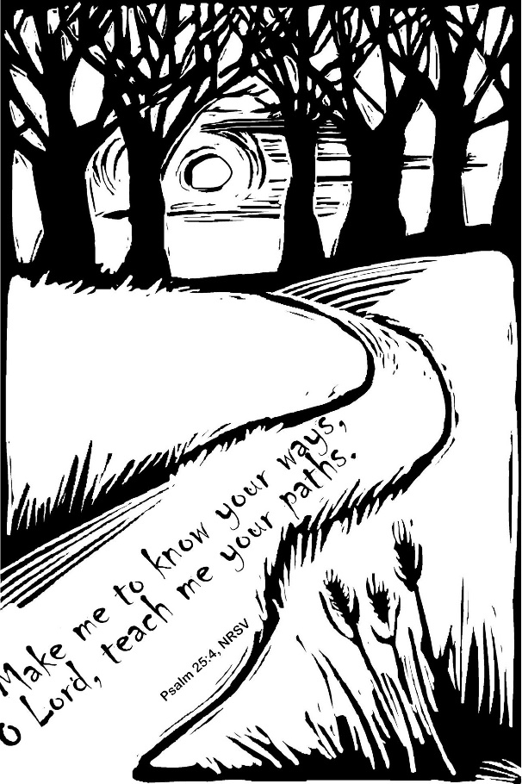

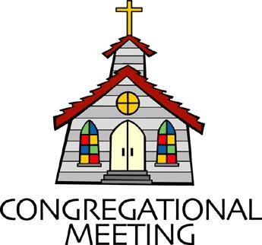
July 4, 2021 - 10:30 am

WELCOME VISITORS! We're glad you are here! Cards at the ends of each pew are for you to fill out and drop in the Offering Plate. Please let us know you are visiting, and join us for refreshments and fellowship following the service. The Sanctuary has an induction loop system to assist the hearing impaired. The system will also work on the telephone setting of hearing aids.

Springfield Presbyterian Church is rooted in the gospel of Jesus Christ, led by the Holy Spirit, and called to loving relationships through vibrant worship and service. Valuing all people, we are committed to developing disciples and fostering stewardship.
PREPARATION FOR THE WORD
(* those who are able are invited to stand)

PRELUDE

GATHERING OF THE PEOPLE

The Lord be with you! And also with you! (Greeting)

LIGHTING THE CHRIST CANDLE
Leader: Whenever we light this candle we proclaim:
People: Christ is the Light of the world and the center of our lives.

CALL TO WORSHIP [Psalm 130]
Leader: Out of the depths I cry to you, O Lord.
People: Lord, hear my voice! Let your ears be attentive to the voice of my supplications!
Leader: If you, O Lord, should mark iniquities, Lord, who could stand?
People: But there is forgiveness with you, so that you may be revered.
Leader: I wait for the Lord, my soul waits, and in His word I hope;
People: My soul waits for the Lord more than those who watch for the morning, more than those who watch for the morning.
Leader: O Israel, hope in the Lord! For with the Lord there is steadfast love, and with Him is great power to redeem.
People: It is He who will redeem Israel from all its iniquities.
ALL: Let us worship our God of steadfast love. Amen.

* HYMN My Country, ‘Tis of Thee
My country, 'tis of thee, sweet land of liberty, of thee I sing:
Land where my fathers died, land of the pilgrims' pride,
From every mountainside let freedom ring.

My native country, thee, land of the noble free, thy name I love;
I love thy rocks and rills, thy woods and templed hills;
My heart with rapture thrills like that above.

Let music swell the breeze, and ring from all the trees sweet freedom's song.
Let mortal tongues awake; let all that breathe partake;
Let rocks their silence break, the sound prolong.

Our fathers' God, to thee, author of liberty, to thee we sing.
Long may our land be bright with freedom's holy light;
Protect us by thy might, great God, our King.

PRAYER OF CONFESSION
O Lord our God, you call us to proclaim the gospel, but we remain silent in the presence of evil. You call us to be reconciled to you and one another, but we are content to live in separation. You call us to seek the good of all, but we fail to resist the powers of oppression. You call us to fight pretensions and injustice, but we sit idly by, endangering the lives of people far and near. Forgive us, O Lord. Reconcile us to you by the power of your Spirit and give us the courage and strength to be reconciled to others; through Jesus Christ, your Son, our Savior. Amen.
SILENT PRAYERS OF CONFESSION

RESPONSE Spirit of the Living God
Spirit of the living God, fall afresh on me. Spirit of the living God, fall afresh on me. Melt me; mold me; fill me; use me. Spirit of the living God, fall afresh on me.

WORDS OF ASSURANCE
Leader: Hear the good news! Hope does not disappoint us, for God’s love has been poured into our hearts through the Holy Spirit given to us in baptism.
People: Believe this good news and give thanks: In Jesus Christ we are forgiven! Amen!

* MUSICAL RESPONSE OF PRAISE Great is Thy Faithfulness
Great is thy faithfulness! Great is thy faithfulness! Morning by morning, new mercies I see. All I have needed thy hand hath provided. Great is thy faithfulness, Lord unto me!

* THE PEACE The peace of Christ be with you! And also with you!
(You may greet those around you.)

* RESPONSE Here I Am, Lord
Here I am, Lord, Is it I, Lord? I have heard you calling in the night.
I will go, Lord, if you lead me. I will hold your people in my heart.

THE PROCLAMATION OF THE WORD

PRAYER OF ILLUMINATION
Guide us, O God, by your Word and Spirit, that in your light we may see light, in your truth find freedom, and in your will discover your peace; through Jesus Christ our Lord. Amen.

FIRST SCRIPTURE LESSON Psalm 25
¹ To you, O Lord, I lift up my soul. ² O my God, in you I trust; do not let me be put to shame; do not let my enemies exult over me. ³ Do not let those who wait for you be put to shame; let them be ashamed who are wantonly treacherous. ⁴ Make me to know your ways, O Lord; teach me your paths. ⁵ Lead me in your truth, and teach me, for you are the God of my salvation; for you I wait all day long. ⁶ Be mindful of your mercy, O Lord, and of your steadfast love, for they have been from of old.
⁷ Do not remember the sins of my youth or my transgressions; according to your steadfast love remember me, for your goodness’ sake, O Lord! ⁸ Good and upright is the Lord; therefore he instructs sinners in the way. ⁹ He leads the humble in what is right, and teaches the humble his way. ¹⁰ All the paths of the Lord are steadfast love and faithfulness, for those who keep his covenant and his decrees. ¹¹ For your name’s sake, O Lord, pardon my guilt, for it is great. ¹² Who are they that fear the Lord? He will teach them the way that they should choose. ¹³ They will abide in prosperity, and their children shall possess the land. ¹⁴ The friendship of the Lord is for those who fear him, and he makes his covenant known to them. ¹⁵ My eyes are ever towards the Lord, for he will pluck my feet out of the net. ¹⁶ Turn to me and be gracious to me, for I am lonely and afflicted. ¹⁷ Relieve the troubles of my heart, and bring me out of my distress. ¹⁸ Consider my affliction and my trouble, and forgive all my sins. ¹⁹ Consider how many are my foes, and with what violent hatred they hate me. ²⁰ O guard my life, and deliver me; do not let me be put to shame, for I take refuge in you.
²¹ May integrity and uprightness preserve me, for I wait for you.
²² Redeem Israel, O God, out of all its troubles.

SECOND SCRIPTURE LESSON Mark 6:1-13
He left that place and came to his home town, and his disciples followed him. ²On the sabbath he began to teach in the synagogue, and many who heard him were astounded. They said, ‘Where did this man get all this? What is this wisdom that has been given to him? What deeds of power are being done by his hands! ³Is not this the carpenter, the son of Mary and brother of James and Joses and Judas and Simon, and are not his sisters here with us?’ And they took offence at him. ⁴Then Jesus said to them, ‘Prophets are not without honor, except in their home town, and among their own kin, and in their own house.’ ⁵And he could do no deed of power there, except that he laid his hands on a few sick people and cured them. ⁶And he was amazed at their unbelief. Then he went about among the villages teaching. ⁷He called the twelve and began to send them out two by two, and gave them authority over the unclean spirits. ⁸He ordered them to take nothing for their journey except a staff; no bread, no bag, no money in their belts; ⁹but to wear sandals and not to put on two tunics. ¹⁰He said to them, ‘Wherever you enter a house, stay there until you leave the place. ¹¹If any place will not welcome you and they refuse to hear you, as you leave, shake off the dust that is on your feet as a testimony against them.’ ¹²So they went out and proclaimed that all should repent. ¹³They cast out many demons, and anointed with oil many who were sick and cured them.

Leader: Hear what the Spirit is saying to the Church.
All: Thanks be to God.

SERMON Already Equipped Rev. Becca Crate

THE RESPONSE TO THE WORD

* HYMN Will You Come and Follow Me (The Summons) #726

Will you come and follow me if I but call your name?
Will you go where you don’t know and never be the same?
Will you let my love be shown, will you let my name be known,
Will you let my life be grown in you and you in me?

Will you leave yourself behind if I but call your name?
Will you care for cruel and kind and never be the same?
Will you risk the hostile stare should your life attract or scare?
Will you let me answer prayer in you and you in me?

Will you let the blinded see if I but call your name?
Will you set the prisoners free and never be the same?
Will you kiss the leper clean, and do such as this unseen,
And admit to what I mean in you and you in me?

Will you love the “you” you hide if I but call your name?
Will you quell the fear inside and never be the same?
Will you use the faith you’ve found to reshape the world around,
Through my sight and touch and sound in you and you in me?

Lord, your summons echoes true when you but call my name.
Let me turn and follow you and never be the same.
In your company I’ll go where your love and footsteps show.
Thus I’ll move and live and grow in you and you in me.

THE COMMUNION OF THE PEOPLE

INVITATION

THE GREAT PRAYER OF THANKSGIVING
Leader: The Lord be with you.
People: And also with you.
Leader: Lift up your hearts.
People: We lift them up to the Lord.
Leader: Let us give thanks to the Lord our God.
People: It is right to give our thanks and praise.
[The Pastor continues… “…who forever sing to the glory of your name.”]

IN PRAISE OF GOD Tune #552
Holy, holy, holy, Lord, God of Power and might.
Heaven and earth are full of your glory, Hosanna in the highest!
Blessed is He who comes in the name of the Lord.
Hosanna in the highest, hosanna in the highest.
[The Pastor continues… “…proclaim the one crucified and risen.”]

IN PRAISE OF CHRIST Tune #553
Christ has died; Christ is risen; Christ will come again.
Christ has died; Christ is risen; Christ will come again.

PASTORAL PRAYER AND THE LORD’S PRAYER
“For this I pray to God.” / “For this I give thanks to God.”
Congregational Response: “Hear our prayer, O God.”

WORDS OF INSTITUTION

SHARING OF THE MEAL

PRAYER OF DEDICATION (Unison)
Dear God, take us out to live as changed people because we have shared the living bread and cannot remain the same. Ask much of us, expect much from us, enable much by us, encourage many through us. So, Lord, may we live to your glory, both as inhabitants of the earth, and citizens of the commonwealth of Heaven. Through Christ, with Christ, in Christ, in the unity of the Holy Spirit, all glory and honor are yours, almighty God, now and forever. Amen.

PRESENTATION OF TITHES AND OFFERINGS
OFFERTORY
* SONG OF THANKS For the Beauty of the Earth (refrain)
Lord of all, to thee we raise this our hymn of grateful praise.
* PRAYER OF DEDICATION

* HYMN Lord, You Give the Great Commission #298
Lord, you give the great commission: “Heal the sick and preach the word.”
Lest the church neglect its mission, and the gospel go unheard,
Help us witness to your purpose with renewed integrity:
With the Spirit’s gifts empower us for the work of ministry.

Lord, you call us to your service: “In my name baptize and teach.”
That the world may trust your promise, life abundant meant for each,
Give us all new fervor, draw us closer in community:
With the Spirit’s gifts empower us for the work of ministry.

Lord, you make the common holy: “This, my body; this, my blood.”
Let us all, for earth’s true glory, daily lift life heavenward,
Asking that the world around us share your children’s liberty:
With the Spirit’s gifts empower us for the work of ministry.

Lord, you show us love’s true measure: “Father, what they do, forgive.”
Yet we hoard as private treasure all that you so freely give.
May your care and mercy lead us to a just society:
With the Spirit’s gifts empower us for the work of ministry.

Lord, you bless with words assuring: “I am with you to the end.”
Faith and hope and love restoring, may we serve as you intend,
And, amid the cares that claim us, hold in mind eternity:
With the Spirit’s gifts empower us for the work of ministry.

* CHARGE AND BENEDICTION [Colossians 3:12-14]
Leader: As God’s own,
People: We clothe ourselves with compassion,
Leader: We will clothe ourselves with kindness, and patience,
People: We forgive one another as God has forgiven us.

Leader: And we will do all these things with love,
People: Which binds everything together in perfect harmony.

* UNISON AMEN

POSTLUDE

Assisting in Worship: We appreciate those who serve:

Today 7/4 Next Week 7/11
Sunday Opener Jennifer Wise Beth Oates
Greeters & Ushers Connie Gibbons & Amy Vasbinder &
Cathy Marsh Bob Rogers
Lay Leader Tim Oates Sharon Pappas
Fellowship

Communion Servers:
1. Linda Caviglia 3. Kathy Russ
2. Jennifer Wise 4. Barbara Cornell

Happy Birthday! July 8 – Tony Caviglia
July 8 – Sharon Pappas
July 8 – Cynthia Smith

Happy Anniversary! July 5 – Ron & Sue Holmes
July 11 – Chad & Shannon Stewart
Sunday July 11, 2021 Lectionary
Amos 7:7-15; Psalm 85:8-13; Ephesians 1:3-14; Mark 6:14-29

Announcements

Congregational Care / Mission & Outreach: The Congregational Care/Mission & Outreach Committee would like your help. As we emerge from this pandemic, there is a greater than usual need to make every effort to connect with one another. Do you know of a member or friend of our church family who is ill, needs prayers, would like call, a visit or a card, or might benefit from meal train? If so, please contact the Church Office (410-795-6152), Cathy Marsh (410-549-6916) or Diana Steppling (862-266-2242).

Office Hours: Tuesday, Wednesday & Friday
Springfield Presbyterian Church

10:30 am Worship
11:30 am Fellowship
Website: www.springfield-church.org Church Office: 410-795-6152
Like us on Facebook: www.facebook.com/SpringfieldPresbyterianChurch
Pastor: Rev. Becca Crate
Email: springfieldpastor@gmail.com
Clerk of Session: Sharon Pappas
Minister of Music: Linda Caviglia
Accompanist: Aaron Thacker Organist: Jennifer Wise
Youth Group Coordinators: Charles & Deb Sperling
Sunday School Coordinator: Connie Robinson
Administrative Assistant: Donna Mazer e-mail: spc.office@verizon.net

