(Large Print)

Springfield Presbyterian Church (USA)
7300 Spout Hill Road, Sykesville, MD 21784 410-795-6152

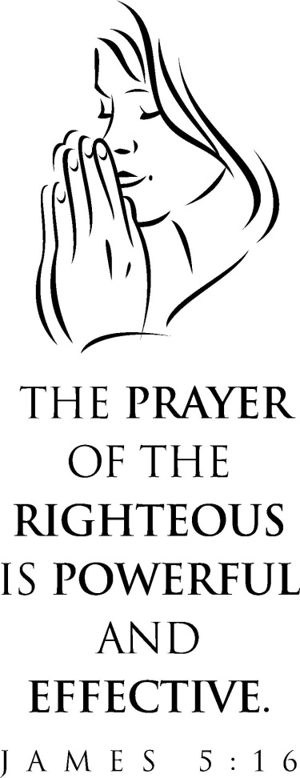

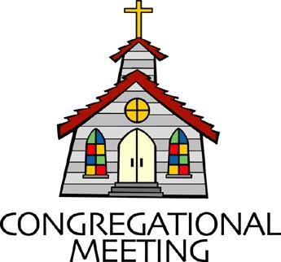
September 30, 2018 - 10:30 am

WELCOME VISITORS! We're glad you are here! Cards at the ends of each pew are for you to fill out and drop in the Offering Plate. Please let us know you are visiting, and join us for refreshments and fellowship following the service. The Sanctuary has an induction loop system to assist the hearing impaired. The system will also work on the telephone setting of hearing aids. A head set is available upon request.

Springfield Presbyterian Church is rooted in the gospel of Jesus Christ, led by the Holy Spirit, and called to loving relationships through vibrant worship and service. Valuing all people, we are committed to developing disciples and fostering stewardship.
PREPARATION FOR THE WORD
(* those who are able are invited to stand)

Please prepare for worship by listening to the music of the Prelude.

PRELUDE

GATHERING OF THE PEOPLE

The Lord be with you! And also with you! (Greeting)

LIGHTING THE CHRIST CANDLE
Leader: Whenever we light this candle we proclaim:
People: Christ is the Light of the world and the center of our lives.

CALL TO WORSHIP [Psalm 19]
Leader: The heavens are telling the glory of God and the firmament proclaims His handiwork.
People: Day to day pours forth speech, and night to night declares knowledge.
Leader: There is no speech, nor are there words; their voice is not heard;
People: Yet their voice goes out through all the earth, and their words to the end of the earth.
Leader: In the heavens He has set a tent for the sun, which comes out like a bridegroom from his wedding canopy, and like a strong man runs its course with joy.
People: Its rising is from the end of the heavens, and its circuit to the end of them; and nothing is hid from its heat.
Leader: The law of the Lord is perfect, reviving the soul; the decrees of the Lord are sure, making wise the simple.
People: The precepts of the Lord are right, rejoicing the heart; the commandment of the Lord is clear, enlightening the eyes.
Leader: The fear of the Lord is pure, enduring forever; the ordinances of the Lord are true and righteous altogether.
People: More to be desired are they than gold, even much fine gold; sweeter than honey and the drippings of the honeycomb.
Leader: Keep back your servant also from the insolent; do not let them have dominion over me. Then I shall be blameless, and innocent of great transgression.
People: Let the words of our mouths and the meditations of our hearts be acceptable to you, O Lord, our rock and our redeemer.
ALL: Let us worship God!

* HYMN Guide Me, O Thou Great Jehovah
Guide me, O Thou great Jehovah, pilgrim through this barren land;
I am weak, but Thou art mighty; hold me with Thy powerful hand;
Bread of heaven, bread of heaven, feed me till I want no more,
Feed me till I want no more.

Open now the crystal fountain, whence the healing stream doth flow;
Let the fire and cloudy pillar, lead me all my journey through;
Strong deliverer, strong deliverer, be Thou still my strength and shield,
Be Thou still my strength and shield.

When I tread the verge of Jordan, bid my anxious fears subside;
Death of death, and hell’s destruction, land me safe on Canaan’s side;
Songs of praises, songs of praises, I will ever give to Thee,
I will ever give to Thee.

PRAYER OF CONFESSION
Almighty God and Loving Parent, we thank you for placing us in covenant relationships, in homes and families and friendships. Forgive us for taking our vows and promises lightly. Forgive us for the breakdown of family life, for failing to give time to our families, for failing to teach and live by your values. Jesus, teach us

every day to love and serve, to cherish and protect those with whom we abide in this world with and are called to be caretakers. In your name we pray, amen.

SILENT PRAYERS OF CONFESSION

RESPONSE The Lone, Wild Bird
O search me, God, my heart reveal, renew my life, my spirit heal;
For I am yours, I rest in you, Great Spirit, come, rest in me, too.

WORDS OF ASSURANCE
Leader: Take comfort in the assurance that even those things that are hidden from our memory, or are too deep for our words, are not beyond God’s forgiving love.
People: Thanks be to God who knows us completely and bestows pardon and peace.

* MUSICAL RESPONSE OF PRAISE From All That Dwell Below the Skies
From all that dwell below the skies, let the Creator’s praise arise: Alleluia! Alleluia!
Let the Redeemer’s name be sung, through every land, in every tongue.
Alleluia! Alleluia! Alleluia! Alleluia! Alleluia!

* THE PEACE The peace of Christ be with you! And also with you!
(You may greet those around you.)

* RESPONSE Here I Am, Lord
Here I am, Lord, Is it I, Lord? I have heard you calling in the night.
I will go, Lord, if you lead me. I will hold your people in my heart.

THE PROCLAMATION OF THE WORD

PRAYER OF ILLUMINATION
Lord, open our hearts and minds by the power of your Holy Spirit, that as the Scriptures are read and your Word is proclaimed, we may hear with joy what you say to us today. Amen.

FIRST SCRIPTURE LESSON Psalm 124
¹ If it had not been the Lord who was on our side —let Israel now say—
² if it had not been the Lord who was on our side, when our enemies attacked us, ³ then they would have swallowed us up alive, when their anger was kindled against us; ⁴ then the flood would have swept us away, the torrent would have gone over us; ⁵ then over us would have gone the raging waters. ⁶ Blessed be the Lord, who has not given us as prey to their teeth. ⁷ We have escaped like a bird from the snare of the fowlers; the snare is broken, and we have escaped. ⁸ Our help is in the name of the Lord, who made heaven and earth.

SECOND SCRIPTURE LESSON James 5:13-20
¹³Are any among you suffering? They should pray. Are any cheerful? They should sing songs of praise. ¹⁴Are any among you sick? They should call for the elders of the church and have them pray over them, anointing them with oil in the name of the Lord. ¹⁵The prayer of faith will save the sick, and the Lord will raise them up; and anyone who has committed sins will be forgiven. ¹⁶Therefore confess your sins to one another, and pray for one another, so that you may be healed. The prayer of the righteous is powerful and effective. ¹⁷Elijah was a human being like us, and he prayed fervently that it might not rain, and for three years and six months it did not rain on the earth. ¹⁸Then he prayed again, and the heaven gave rain and the earth yielded its harvest. ¹⁹My brothers and sisters, if anyone among you wanders from the truth and is brought back by another, ²⁰you should know that whoever brings back a sinner from wandering will save the sinner’s soul from death and will cover a multitude of sins.

Leader: Hear what the Spirit is saying to the Church.
All: Thanks be to God.

TIME WITH YOUNG PEOPLE

SERMON Does Prayer Change Things? Rev. Becca Crate

THE RESPONSE TO THE WORD

* HYMN Come to Me, O Weary Traveler

Come to me, O weary traveler, come to me with your distress;
Come to me, you heavy burdened; come to me and find your rest.

Do not fear, my yoke is easy; do not fear, my burden’s light;
Do not fear the path before you; do not run from me in fright.

Take my yoke and leave your troubles; take my yoke and come with me
Take my yoke, I am beside you; take and learn humility.

Rest in me, O weary traveler; rest in me and do not fear.
Rest in me, my heart is gentle; rest and cast away your care.

PASTORAL PRAYER AND THE LORD’S PRAYER
“For this I pray to God.” / “For this I give thanks to God.”
Congregational Response: “Hear our prayer, O God.”

PRESENTATION OF TITHES AND OFFERINGS
OFFERTORY Did You Think to Pray?
* SONG OF THANKS Take My Life
Take my silver and my gold, not a mite would I withhold;
Take my intellect and use, every power as Thou shalt choose,
Every power as Thou shalt choose.
* PRAYER OF DEDICATION

* HYMN I Will Come to You (You Are Mine)
I will come to you in the silence, I will lift you from all your fear.
You will hear my voice, I claim you as my choice. Be still and know I am here.

Refrain:
Do not be afraid, I am with you. I have called you each by name.
Come and follow me, I will bring you home;
I love you and you are mine.

I am hope for all who are hopeless, I am eyes for all who long to see.
In the shadows of the night, I will be your light.
Come and rest in me. [Refrain]

I am strength for all the despairing,
Healing for the ones who dwell in shame.
All the blind will see, the lame will all run free,
And all will know my name. [Refrain]

I am the word that leads all to freedom,
I am the peace the world cannot give.
I will call your name, embracing all your pain.
Stand up, now walk and live! [Refrain]

* CHARGE AND BENEDICTION
Leader: Let us be the church,
People: That welcomes all to tell their story.
Leader: Let us be the church,
People: That embraces those who think they cannot be embraced.
Leader: Let us be the church,
People: Where all people know they are valued, loved, and claimed as God’s beloved.
* UNISON AMEN

POSTLUDE

Assisting in Worship: We appreciate those who serve:

Today 9/30 Next Week 10/7
Sunday Opener Kay Freas Bob Rogers
Greeters & Ushers Steve Mazer & Elizabeth Meirowitz &
Bob Rogers Amy Vasbinder
Lay Leader Barbara Cornell Bob Steppling
Sunday School Connie Robinson Connie Robinson
Fellowship Barbara Cornell &
Shona Klein

Church Attendance: September 16 - 35 September 23 - 44

Church Cleaning: October 5, 6 or 7 - The Anderson Family

Happy Birthday! October 1 - Elwood LaBrosse
October 1 - Evan Stinson
October 6 - Mary Rhodes

Sunday October 7 Lectionary
Job 1:1; 2:1-10; Psalm 26; Hebrews 1:1-4; 2:5-12; Mark 10:2-16
Announcements

Peace and Global Witness: TODAY we receive your Peace and Global Witness offering. This offering is used to engage in peacemaking and build ministries of reconciliation around the world. Half goes to Presbyterian Mission Agency, 25% to Mid Councils for their programs, and 25% remains with local congregations. The Mission/Outreach team decided to again send our portion to LSC America’s Partner for Equal Justice, providing legal aid to those living in poverty in our country, 1.8 million including 40,000 veterans.

Dakota Presbytery: On October 21, Chrystie Adams, the Chair of the Baltimore Dakota Steering Committee will be making a presentation about the unique relationship between Baltimore Presbytery and the Dakota Presbytery. The Dakota Presbytery is comprised of all Native American congregations representing the Eastern Sioux (Dakota) and the Western Sioux (Lakota) Nations. Chrystie will have slides and be available to answer any questions arising from her presentation during fellowship.

Weekly Announcements: If you have an announcement to include with next week’s bulletin, please call the Office at 410-795-6152 or email to spc.office@verizon.net by Wednesday each week.

Prayers & Thanksgivings

~ Prayers of thanksgiving for the birth of Harrison Joseph Rachin, born to Brittany and Danny Rachin on Monday, September 17!
~ Prayers of strength and healing for Charlie Sperling’s mom, Judy Sperling, who is facing very aggressive cancer.
~ Prayers of strength and comfort for Joy Barwick and her grandson, Dylan, while Dylan’s medical problems are addressed.
~ Prayers for Brenda McClung’s mom, Liz Old, as she transitions to memory care at Copper Ridge. Also prayers for Alex McClung’s mom, Sandy, who is struggling with memory issues. She is at Broadmead in Hunt Valley and will be transitioning from independent living to assisted living in the next few months.
~ Prayers of healing for Dr. Elwood LaBrosse, permanently moved to Room 222 in the Fairhaven Health Unit. He would love to have visitors!
~ Prayers for Korean United Presbyterian from our Ministry Group.

The Congregational Care team wants to know what YOU or someone you know needs...a visit...a call...a meal. Please contact Kay Freas or Connie Robinson.

Today:
Sunday September 30 - Peace & Global Witness Offering
10:30 am Worship & Sunday School
11:30 am Fellowship
12:00 noon Worship Committee Meeting (Library)

This Week:
Monday October 1
4:30 pm C.I.A. Meeting (Manse)
Wednesday October 3
6:30 pm Bell Choir Practice
7:45 pm Adult Choir Practice

Looking Ahead:
Sunday October 7
9:00 am Red Sea Parting Practice
6:30 pm Youth Movie Night (Manse)
Monday October 8
7:00 pm Headhuggers (Manse)
Tuesday October 9
1:30 am Prayer Group (Manse)
7:00 pm ESCAPE Lunch Packing (Manse)
Wednesday October 10
6:30 pm Bell Choir Practice
7:45 pm Adult Choir Practice
Thursday October 11
7:00 pm Session Meeting (Manse)

Office Hours: Tuesday, Wednesday, Friday 9:00 am - 3:00 pm
Springfield Presbyterian Church

10:30 am Worship
11:30 am Fellowship
Website: www.springfield-church.org Church Office: 410-795-6152
Like us on Facebook: www.facebook.com/SpringfieldPresbyterianChurch
Pastor: Rev. Becca Crate
Email: springfieldpastor@gmail.com
Clerk of Session: Sharon Pappas
Minister of Music: Linda Caviglia
Accompanist: Aaron Thacker Organist: Jennifer Wise
Youth Group Coordinators: Charles & Deb Sperling
Sunday School Coordinator: Connie Robinson
Administrative Assistant: Donna Mazer
e-mail: spc.office@verizon.net

