Springfield Presbyterian Church (USA)
7300 Spout Hill Road, Sykesville, MD 21784 410-795-6152
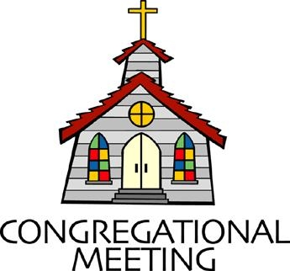

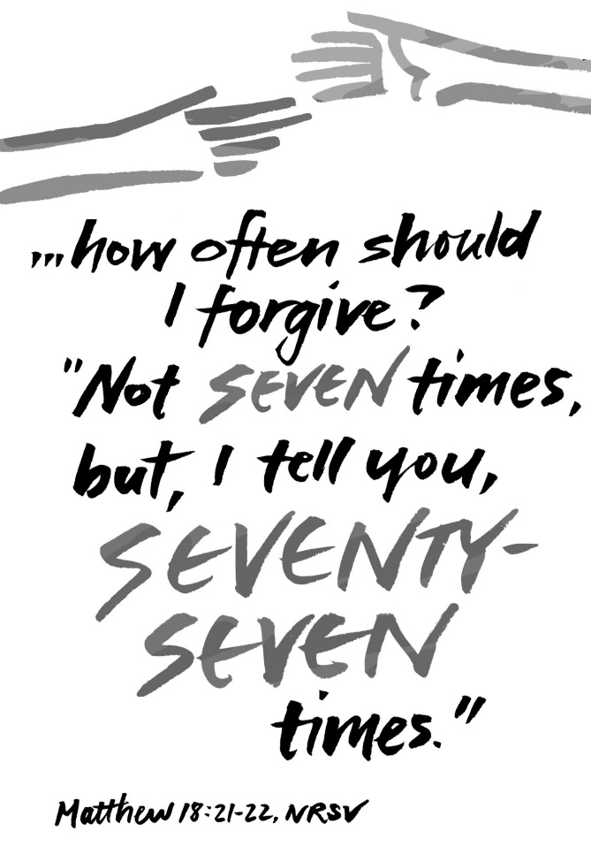

September 6, 2026 - 10:30 am

WELCOME VISITORS!

We're glad you are here! Cards at the ends of each pew are for you to fill out and drop in the Offering Plate. Please let us know you are visiting and join us for refreshments and fellowship following the service. The Sanctuary has an induction loop system to assist the hearing impaired. The system will also work on the telephone setting of hearing aids.

Springfield Presbyterian Church is rooted in the gospel of Jesus Christ, led by the Holy Spirit, and called to loving relationships through vibrant worship and service. Valuing all people, we are committed to developing disciples and fostering stewardship.

PREPARATION FOR THE WORD
(* those who are able are invited to stand)

PRELUDE

PASTOR’S WELCOME

GATHERING OF THE PEOPLE

The Lord be with you! And also with you! (Greetings and Announcements)

LIGHTING THE CHRIST CANDLE
Leader: Whenever we light this candle we proclaim:
People: Christ is the Light of the world and the center of our lives.

CALL TO WORSHIP
Leader: Praise the Lord!
All: Sing to the Lord a new song!
Leader: Praise the Lord!
All: Praise with tambourines and with dance!
Leader: Praise the Lord!
All: Praise with full voices and open hearts!
Leader: Let the children of God rejoice together! Let us worship God!

* HYMN God Is Here GTG #409

God is here! As we your people meet to offer praise and prayer,
May we find in fuller measure what it is in Christ we share.
Here, as in the world around us, all our varied skills and arts
Wait the coming of the Spirit into open minds and hearts.

Here are symbols to remind us of our lifelong need of grace;
Here are table, font, and pulpit; here the cross has central place.
Here in honesty of preaching, here in silence, as in speech,
Here, in newness and renewal, God the Spirit comes to each.

Here our children find a welcome in the Shepherd's flock and fold;
Here as bread and wine are taken, Christ sustains us as of old.
Here the servants of the Servant seek in worship to explore
What it means in daily living to believe and to adore.

Lord of all, of church and kingdom, in an age of change and doubt
Keep us faithful to the gospel; help us work your purpose out.
Here, in this day's dedication, all we have to give, receive:
We, who cannot live without you, we adore you! We believe!

CALL TO CONFESSION
Leader: God is both just and loving. We confess with humility and courage, since God both knows us and forgives us. To embody this, I invite you to bring your hands together and rest them in one another, as if holding both of these truths. Let us pray:

PRAYER OF CONFESSION
God, you are loving and just. Forgive us when we do not care for all of creation and when we do not care for one another. Guide us when things are unfair so we can learn what your justice means and share your love on earth. Hear us now as we silently share the things we’d rather not say out loud.

SILENT PRAYERS OF CONFESSION

RESPONSE Lord, Jesus, Think on Me GTG #417 (v. 1)
Lord, Jesus, think on me, and purge away my sin.
From earth-born passions set me free, and make me pure within.

WORDS OF ASSURANCE
Heather: Hear the good news: God’s love and mercy heals us when we are hurt and when we have hurt others. In Jesus Christ, we are loved, forgiven, and strengthened to begin again. Thanks be to God!

* MUSICAL RESPONSE OF PRAISE Praise God, from Whom All Blessings Flow GTG #607
Praise God, from whom all blessings flow; praise Christ, all people here below; praise Holy Spirit evermore; praise Triune God, whom we adore. Amen.

* THE PEACE The peace of Christ be with you! And also with you!
(You may greet those around you.)

* RESPONSE Here I Am, Lord GTG #69
Here I am, Lord. Is it I, Lord? I have heard you calling in the night.
I will go, Lord, if you lead me. I will hold your people in my heart.

THE PROCLAMATION OF THE WORD

PRAYER OF ILLUMINATION
Leader: Guide us, O God, by your Word and Holy Spirit, that in your light we may see light, in your truth find freedom, and in your will discover your peace; through Jesus Christ our Lord. Amen.

FIRST SCRIPTURE LESSON Ezekiel 33:7-11 OT page 755
⁷So you, mortal, I have made a sentinel for the house of Israel; whenever you hear a word from my mouth, you shall give them warning from me. ⁸If I say to the wicked, "O wicked ones, you shall surely die," and you do not speak to warn the wicked to turn from their ways, the wicked shall die in their iniquity, but their blood I will require at your hand. ⁹But if you warn the wicked to turn from their ways, and they do not turn from their ways, the wicked shall die in their iniquity, but you will have saved your life. ¹⁰Now you, mortal, say to the house of Israel, Thus you have said: "Our transgressions and our sins weigh upon us, and we waste away because of them; how then can we live?" ¹¹Say to them, As I live, says the Lord God, I have no pleasure in the death of the wicked, but that the wicked turn from their ways and live; turn back, turn back from your evil ways; for why will you die, O house of Israel?

TIME FOR ALL GOD’S CHILDREN

GOSPEL LESSON Matthew 18:15-20 NT page 19
¹⁵"If another member of the church sins against you, go and point out the fault when the two of you are alone. If the member listens to you, you have regained that one. ¹⁶But if you are not listened to, take one or two others along with you, so that every word may be confirmed by the evidence of two or three witnesses.
¹⁷If the member refuses to listen to them, tell it to the church; and if the offender refuses to listen even to the church, let such a one be to you as a Gentile and a tax collector. ¹⁸Truly I tell you, whatever you bind on earth will be bound in heaven, and whatever you loose on earth will be loosed in heaven. ¹⁹Again, truly I tell you, if two of you agree on earth about anything you ask, it will be done for you by my Father in heaven. ²⁰For where two or three are gathered in my name, I am there among them."

Leader: This is the Word of the Lord. All: Thanks be to God.

SERMON Learning to Love Our Enemies: Love Through Due Process By Heather Russell

THE RESPONSE TO THE WORD

* HYMN Draw Us in the Spirit’s Tether GTG #529

Draw us in the Spirit’s tether, for when humbly in our name two or three are met together, you are in the midst of them. Alleluia! Alleluia! Here we touch your garment’s hem.

As disciples use to gather in the name of Christ to sup,
Then with thanks to God the giver break the bread and bless the cup, Alleluia! Alleluia! So now bind our friendship up.

All our meals and all our living make as sacraments of you,
That by caring, helping, giving, we may be disciples true.
Alleluia! Alleluia! We will serve with faith anew.

PRAYERS OF THE PEOPLE

THE COMMUNION OF THE PEOPLE

INVITATION

THE GREAT PRAYER OF THANKSGIVING
Leader: The Lord be with you.
All: And also with you.
Leader: Lift up your hearts.
All: We lift them up to the Lord.
Leader: Let us give thanks to the Lord our God.
All: It is right to give our thanks and praise.

[the Pastor continues… “And this is our song:”]
All: Holy, holy, holy God, our life, our mercy, our might. Heaven and earth are full of your glory. Save us, we pray, you who are beyond all. Blessed is the one who comes in the name of the Lord. Save us, we pray, you who are beyond all.

[the Pastor continues… “… your grace our path to rebirth:”]
Leader: And so we cry, Mercy:
All: Mercy!
Leader: And so we cry, Glory:
All: Glory!
Leader: And so we cry, Come, Holy Spirit!
All: Come, Holy Spirit!

[the Pastor continues… “… praise tomorrow, praise forever.”]
Leader: Great is the mystery of faith:
All: Christ has died, Christ is risen, Christ will come again.

THE LORD’S PRAYER
Our Father, who art in heaven, hallowed be thy name, thy kingdom come, thy will be done, on earth as it is in heaven. Give us this day our daily bread; and forgive us our debts, as we forgive our debtors; and lead us not into temptation, but deliver us from evil. For thine is the kingdom, and the power, and the glory, forever, Amen.

PRAYER AFTER COMMUNION
Heather: God of grace, you renew us at your table with the bread of life. May this food strengthen us in love and help us to serve you by serving each other. We ask this in the name of Jesus Christ our Lord, Amen.

PRESENTATION OF TITHES AND OFFERINGS
OFFERTORY
* SONG OF THANKS As Those of Old Their Firstfruits Brought
GTG #712 (v. 3)
In gratitude and humble trust we bring our best today,
To serve your cause and share your love with all along life’s way.
O God who gave yourself to us in Jesus Christ your Son,
Help us to give ourselves each day until life’s work is done.
* PRAYER OF DEDICATION

* HYMN God Be with You Till We Meet Again GTG #541

God be with you till we meet again; loving counsels guide, uphold you, with a shepherd’s care enfold you: God be with you till we meet again.

God be with you till we meet again; unseen wings protecting hide you, daily manna still provide you: God be with you till we meet again.

God be with you till we meet again; when life’s perils thick confound you, put unfailing arms around you: God be with you till we meet again.

God be with you till we meet again; keep love’s banner floating o’er you; smite death’s threatening wave before you: God be with you till we meet again.

* CHARGE AND BENEDICTION
Heather: As you go out from here, love one another with mutual affection; outdo one another in showing honor. Live in harmony with one another, rejoice in hope, be patient in affliction, persevere in prayer. Love and serve the Lord, in the name of the Father, and of the Son, and of the Holy Spirit, Amen.

* UNISON AMEN GTG #601

POSTLUDE Some Liturgy adapted from Child of Blessing (Presbyterian Association of Musicians)
Sunday, September 13 Lectionary:
Genesis 50:15-21; Psalm 103:(1-7) 8-13; Romans 14:1-12; Matthew 18:21-35

Assisting in Worship: We appreciate those who serve:

Today 9/6 Next Week 9/13
Sunday Opener: Ron Holmes Linda Caviglia
Ushers/Greeters: Cynthia Smith Tim & Beth Oates
Volunteer
Lay Leader: Don Vasbinder Christy Yeager
Communion Servers: Beth Oates, Sue Holmes, Ron Holmes
Offering Counters: Ron H. & Barbara Nickell Linda C. & Volunteer
Fellowship Hosts: Christy Yeager Homecoming Picnic

Happy Anniversary! September 7 – Max and Margaret Carroll
September 7 – Becky and Mike Spicer

Happy Birthday! September 9 – Rachel Spicer
September 11 – Spencer McClung
September 13 – Mark Kearney

Announcements

Sermon Series: We are working through a sermon series this month, Learning to Love Your Enemies. The capacity for love to overcome all obstacles is easier to believe when talking about two people who want to be together, but can be especially challenging when thinking of ourselves and someone we don't want to be with, especially someone who has hurt or betrayed us. Yet our ability to overcome conflict within ourselves and find peace (despite what others may do) is an incredible opportunity to reflect the unconditional love of Jesus Christ, who loves us despite the ways we have failed. In this four-part series, we will explore practical guidance from scripture to help equip us to practice the kind of enemy love Jesus calls us to.

Homecoming Picnic: Next Sunday, September 13, our SPC family and friends will gather after worship for a Homecoming picnic, a rain-or-shine event. Fried chicken will be provided by CoCaMO! A sign-up sheet is available during fellowship for anyone who would like to bring a dish to share. Everyone is welcome - come and eat, visit, meet our new pastor, reconnect with old friends, and make new ones. ~CoCaMO Committee

Congregational Care: If you know of someone who would benefit from a card or a phone call, please text or call Diana Steppling at 862-266-2242.

Electronic Giving: Below is a QR code you can scan to make your contribution a new way! The page you get will ask for your name, email and phone

number. You can choose from a dropdown menu for selecting where the donation should go: General Fund, Capital Fund, Concert, Memorial. There is a fee for using a credit card, and you will be given the option to pay that fee along with your donation, but you don’t have to include it if you don’t want to.

Today:
Sunday September 6
10:30 am Worship
11:30 am Fellowship
12:00 noon Finance Committee Meeting

This Week:
Monday September 7
7:00 pm Headhuggers (Manse)
Tuesday September 8
3:30 pm Worship Committee Meeting (Zoom)
Wednesday September 9
6:00 pm Bell Choir Practice
7:30 pm Adult Choir Practice
Thursday September 10
7:00 pm Session Meeting (Manse)

Next Week:
Sunday September 13
10:30 am Worship
11:30 am Homecoming Picnic (rain or shine)
Tuesday September 15
7:00 pm CoCaMO Meeting (Manse)
Wednesday September 16
6:00 pm Bell Choir Practice
7:30 pm Adult Choir Practice

Heather’s In Office Hours: Tuesday, Friday, Sunday
8:30 am – 2:00 pm
Heather’s Home Office Hours: Wednesday, Thursday
8:30 am – 2:00 pm
Heather’s Sabbath Day: Mondays

Reminder: In case of an emergency, please contact Heather directly: springfieldpres.pastor@gmail.com
cell 443-280-9712 (texts welcomed, please identify yourself)


Springfield Presbyterian Church
10:30 am Worship
11:30 am Fellowship
Website: www.springfield-church.org Church Office: 410-795-6152
Like us on Facebook: www.facebook.com/SpringfieldPresbyterianChurch
Ministry Associate: Heather Russell von Marko
Email: springfieldpres.pastor@gmail.com
Clerk of Session: Sharon Pappas
Music Director: Vacant
Accompanist: Michael Hall
Bell Choir Director: Robin Kochanski
Administrative Assistant: Donna Mazer
Email: springfieldpres.office@gmail.com

