(Large Print)

Springfield Presbyterian Church (USA)
7300 Spout Hill Road, Sykesville, MD 21784 410-795-6152

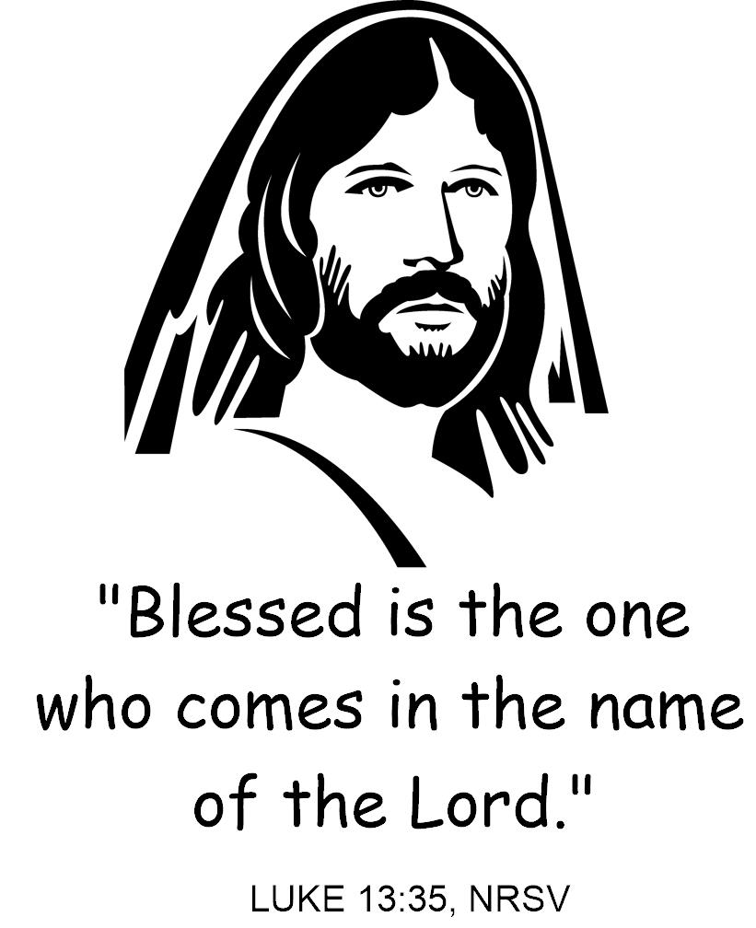

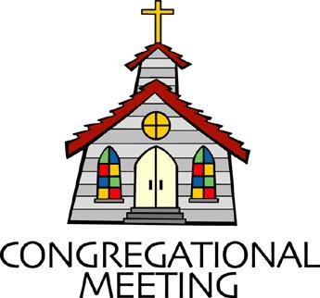
March 13, 2022 - 10:30 am

WELCOME VISITORS! We're glad you are here! Cards at the ends of each pew are for you to fill out and drop in the Offering Plate. Please let us know you are visiting, and join us for refreshments and fellowship following the service. The Sanctuary has an induction loop system to assist the hearing impaired. The system will also work on the telephone setting of hearing aids.

Springfield Presbyterian Church is rooted in the gospel of Jesus Christ, led by the Holy Spirit, and called to loving relationships through vibrant worship and service. Valuing all people, we are committed to developing disciples and fostering stewardship.
PREPARATION FOR THE WORD
(* those who are able are invited to stand)
PRELUDE Cantabile By Emily Li Presbytones Bell Choir

GATHERING OF THE PEOPLE

The Lord be with you! And also with you! (Greeting)

LIGHTING THE CHRIST CANDLE
Leader: Whenever we light this candle we proclaim:
People: Christ is the Light of the world and the center of our lives.

CALL TO WORSHIP
Leader: If God is a hen,
People: We are under God’s wing.
Leader: If God is a table,
People: We each have a seat.
Leader: If God is a house,
People: We are safe from the storm.
Leader: If God is a party,
People: We are invited to dance.
Leader: If God is a melody,
People: Our names are the lyrics.
Leader: If this is God’s house,
People: Then all are welcomed. All are loved. All belong.
ALL: Let us worship our Holy God!

* HYMN Praise Ye the Lord, the Almighty #35
Praise ye the Lord, the Almighty, the King of creation!
O my soul, praise him, for he is thy health and salvation!
All ye who hear, now to his temple draw near;
Join me in glad adoration!

Praise ye the Lord, who o'er all things so wondrously reigneth,
shelters thee under his wings, yea, so gently sustaineth!
Hast thou not seen how thy desires e'er have been
Granted in what he ordaineth?

Praise ye the Lord! O let all that is in me adore him!
All that hath life and breath, come now with praises before him!
Let the amen sound from his people again;
Gladly for aye we adore him.

CALL TO CONFESSION
Leader: Family of Faith, we come to confession not to wallow in our own guilt. Instead, we come to confession because we know that change starts with being honest. So, in a desire to grow and change, let us pray to a God who loves us like a mother hen. Let us confess our sins together…

PRAYER OF CONFESSION
Generous God, when the Pharisees tried to stop Jesus, Jesus said, “I will keep on.” I will keep on healing. I will keep on teaching. I will keep on preaching. I will keep on flipping the tables of injustice. I will keep on treating every person like a child of God. I will keep on believing that this world can change. I will keep on and keep on and keep on until God’s promised day. Forgive us, God, for the times when we stop. Amen.

SILENT PRAYERS OF CONFESSION

RESPONSE O Lord, Hear My Prayer (sing two times) Tune #471
O Lord, hear my prayer. O Lord, hear my prayer. When I call, answer me.
O Lord, hear my prayer. O Lord, hear my prayer. Come and listen to me.

WORDS OF ASSURANCE
Leader: Family of faith, because Jesus’ love just keeps going, we can trust that that love and grace exists for us.
People: Let us rest in the news that no matter what we do wrong or what we leave undone, we are under God’s wing. We are loved, held, and forgiven. Thanks be to God for a love like that! Amen.

* MUSICAL RESPONSE OF PRAISE Come, Thou Almighty King (v. 4)
To thee, great One in Three, eternal praises be, hence evermore!
Thy sovereign majesty may we in glory see, and to eternity love and adore.

* THE PEACE The peace of Christ be with you! And also with you!
(You may greet those around you.)

* RESPONSE Here I Am, Lord
Here I am, Lord, Is it I, Lord? I have heard you calling in the night.
I will go, Lord, if you lead me. I will hold your people in my heart.

THE PROCLAMATION OF THE WORD

PRAYER OF ILLUMINATION
Holy God, this life of ours is full to the brim. Our days are overflowing with emails and to-do lists, schedules and notifications, assignments, and deadlines. We wake up feeling behind, we go to sleep worrying about tomorrow, and we know – there has to be more than this. So we pray – bend down and show us the way. Leave breadcrumbs in the street. Point us toward awe and wonder. Guide us to intimacy and trust. Gift us with laughter that will make us cry and hope that will make us feel alive. We want a new kind of full to the brim. Show us the way. We are listening for your cues. Gratefully we pray, amen.

FIRST SCRIPTURE LESSON Psalm 27
¹ The Lord is my light and my salvation; whom shall I fear? The Lord is the stronghold of my life; of whom shall I be afraid? ² When evildoers assail me to devour my flesh—my adversaries and foes—they shall stumble and fall. ³ Though an army encamp against me, my heart shall not fear; though war rise up against me, yet I will be confident.
⁴ One thing I asked of the Lord, that will I seek after: to live in the house of the Lord all the days of my life, to behold the beauty of the Lord, and to inquire in his temple. ⁵ For he will hide me in his shelter in the day of trouble; he will conceal me under the cover of his tent; he will set me high on a rock. ⁶ Now my head is lifted up above my enemies all around me, and I will offer in his tent sacrifices with shouts of joy;
I will sing and make melody to the Lord. ⁷ Hear, O Lord, when I cry aloud, be gracious to me and answer me! ⁸ ‘Come,’ my heart says, ‘seek his face!’ Your face, Lord, do I seek. ⁹ Do not hide your face from me.
Do not turn your servant away in anger, you who have been my help.
Do not cast me off, do not forsake me, O God of my salvation! ¹⁰ If my father and mother forsake me, the Lord will take me up. ¹¹ Teach me your way, O Lord, and lead me on a level path because of my enemies.
¹² Do not give me up to the will of my adversaries, for false witnesses have risen against me, and they are breathing out violence. ¹³ I believe that I shall see the goodness of the Lord in the land of the living.
¹⁴ Wait for the Lord; be strong, and let your heart take courage; wait for the Lord!

SECOND SCRIPTURE LESSON Luke 13:31-35
³¹At that very hour some Pharisees came and said to him, ‘Get away from here, for Herod wants to kill you.’ ³²He said to them, ‘Go and tell that fox for me, “Listen, I am casting out demons and performing cures today and tomorrow, and on the third day I finish my work. ³³Yet today, tomorrow, and the next day I must be on my way, because it is impossible for a prophet to be killed away from Jerusalem.” ³⁴Jerusalem, Jerusalem, the city that kills the prophets and stones those who are sent to it! How often have I desired to gather your children together as a hen gathers her brood under her wings, and you were not willing! ³⁵See, your house is left to you. And I tell you, you will not see me until the time comes when you say, “Blessed is the one who comes in the name of the Lord.” ’

Leader: Hear what the Spirit is saying to the Church.
All: Thanks be to God.

SERMON The Work Ethic of Jesus Rev. Becca Crate-Price

THE RESPONSE TO THE WORD

* HYMN If Thou but Trust in God to Guide Thee #816

If thou but trust in God to guide thee,
With hopeful heart through all thy ways,
God will give strength, whate'er betide thee,
To bear thee through the evil days.
Who trusts in God's unchanging love
Builds on the rock that nought can move.

Only be still, and wait God's leisure
In cheerful hope, with heart content
To take whate'er thy Keeper's pleasure
And all-discerning love hath sent.
No doubt our inmost wants are clear
To One who holds us always dear.

Sing, pray, and swerve not from God's ways,
But do thine own part faithfully.
Trust the rich promises of grace;
So shall they be fulfilled in thee.
God never yet forsook at need
The soul secured by trust indeed.

PASTORAL PRAYER AND THE LORD’S PRAYER

SPECIAL MUSIC Just As I Am Arr. Brenda Austin
Presbytone Bell Choir

* HYMN In Christ Called to Baptize #297

In Christ called to baptize, we witness to grace
And gather a people from each land and race.
In deep, flowing waters, we share in Christ’s death,
Then, rising to new life, give thanks with each breath.

In Christ called to banquet, one table we share,
A haven of welcome, a circle of care.
Although we are many, we share in one bread.
One cup of thanksgiving proclaims Christ, our head.

In Christ called to witness, by grace we will preach
The lifegiving gospel; God’s love we will teach.
By grace may our living give proof to our praise
In costly compassion reflecting Christ’s ways.

Unite us, anoint us, O Spirit of love,
For you are within us, around us, above.
Equip us for service with gifts you bestow.
In Christ is our calling. In Christ may we grow.

* CHARGE AND BENEDICTION
Leader: As you leave this place, may we be awestruck by the beauty of this world.
People: May we laugh and may it be contagious.
Leader: May we overflow with love for those around us.
People: May we be filled with hope and quick to point out joy.
Leader: In all of our living, and breathing, and being,
People: May we find ourselves full to the brim with the God’s Holy Spirit,
Leader: And may it change our lives.
People: In the name of the Beloved and Love itself – let us go in peace, full to the brim. Amen.

* UNISON AMEN

POSTLUDE Make Me an Instrument of Thy Peace
Arr. Kevin McChesney
Presbytones Bell Choir and Aaron Thacker, Piano

Assisting in Worship: We appreciate those who serve:

Today 3/13 Next Week 3/20
Sunday Opener Bob Rogers Barbara Cornell
Greeter Elizabeth Meirowitz Don Vasbinder
Lay Leader Tony Caviglia Ron Holmes

Happy Birthday! March 16 – Alex Caviglia

Sunday March 20, 2022 Lectionary
Isaiah 55:1-9; Psalm 63:1-8; 1 Corinthians 10:1-13; Luke 13:1-9
Announcements

Springfield Membership: Are you interested in finding out more about our faith community and becoming a member? We would love to answer any questions you have. Please contact Pastor Becca at springfieldpastor@gmail.com for more information.

Mask Update: By the agreement of Session, we are now making masks optional. We do want to encourage you, if you feel compelled or have any underlying conditions, to keep your mask on. If you do wish to take off your mask though, we are also happy to see your faces. More information about fellowship and other practices will be coming as we make our way back to normalcy.

Lay Leader and Greeter Lists Correction: Corrections to phone numbers on the Lay Leader and Greeter lists: Tim Oates 443-974-1227 and Beth Oates 443-974-1078.

Per Capita: Per Capita is how we Presbyterian congregations care for each other and stay connected. It funds mission work, support and training for pastors and congregations, and administration expenses. Our portion this year is $38.13; $28 remains at Presbytery, $1.15 to Synod, and $8.98 to General Assembly. You will find this expense in our budget but you can help offset that and show your support by contributing that portion as faithful members. There is a wonderful article by J. Herbert Nelson, Stated Clerk for PC(USA) that can be found by going to baltimorepresbytery.org/percapita and then scroll to the bottom of the page to click on Stated Clerk: What per capita pays for, why it matters.

Congregational Care / Mission & Outreach: Do you know of a member or friend of our church family who is ill, needs prayers, would like call, a visit or a card, or might benefit from meal train? If so, please contact the Church Office (410-795-6152), Cathy Marsh (410-549-6916) or Diana Steppling (862-266-2242).

Today:
Sunday March 13 – 2nd Sunday in Lent
10:30 am Worship
11:30 am Fellowship

This Week:
Wednesday March 16
6:15 – 7:15 pm Bell Choir Practice
7:30 – 8:45 pm Adult Choir Practice

Looking Ahead:
Sunday March 20 – 3rd Sunday in Lent
10:30 am Worship
11:30 am Fellowship
Wednesday March 23
6:15 – 7:15 pm Bell Choir Practice
7:30 – 8:45 pm Adult Choir Practice

Office Hours: Tuesday, Wednesday & Friday
Springfield Presbyterian Church

10:30 am Worship
11:30 am Fellowship
Website: www.springfield-church.org Church Office: 410-795-6152
Like us on Facebook: www.facebook.com/SpringfieldPresbyterianChurch
Pastor: Rev. Becca Crate-Price
Email: springfieldpastor@gmail.com
Clerk of Session: Sharon Pappas
Minister of Music: Linda Caviglia
Accompanist/Organist: Aaron Thacker
Youth Group Coordinator: Dylan Vasbinder
Administrative Assistant: Donna Mazer e-mail: spc.office@verizon.net

