Springfield Presbyterian Church (USA)
7300 Spout Hill Road, Sykesville, MD 21784 410-795-6152

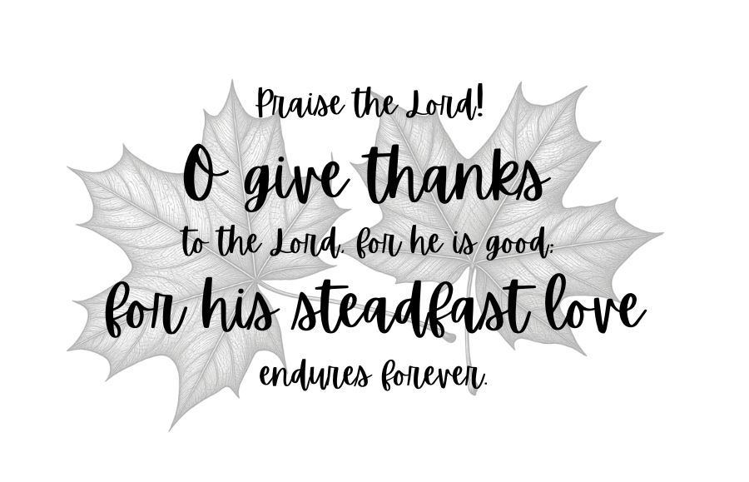

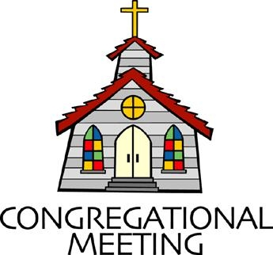
October 11, 2026 - 10:30 am

WELCOME VISITORS!

We're glad you are here! Cards at the ends of each pew are for you to fill out and drop in the Offering Plate. Please let us know you are visiting and join us for refreshments and fellowship following the service. The Sanctuary has an induction loop system to assist the hearing impaired. The system will also work on the telephone setting of hearing aids.

Springfield Presbyterian Church is rooted in the gospel of Jesus Christ, led by the Holy Spirit, and called to loving relationships through vibrant worship and service. Valuing all people, we are committed to developing disciples and fostering stewardship.
PREPARATION FOR THE WORD
(* those who are able are invited to stand)
PRELUDE

PASTOR’S WELCOME

GATHERING OF THE PEOPLE

The Lord be with you! And also with you! (Greetings and Announcements)

LIGHTING THE CHRIST CANDLE
Leader: Whenever we light this candle we proclaim:
People: Christ is the Light of the world and the center of our lives.

CALL TO WORSHIP
Leader: God is good. God is great.
All: God gives us all we need.
Leader: God is just. God is kind.
All: God gives us all we need.
Leader: We meet here to praise God!
All: We gather here to meet Jesus!
Leader: We come here to be gathered up by the Holy Spirit!
All: Let us worship God together in love.

* HYMN The King of Love My Shepherd Is GTG #802

The King of love my shepherd is, whose goodness faileth never;
I nothing lack if I am his and he is mine forever.

Where streams of living water flow my ransomed soul he leadeth,
And where the verdant pastures grow, with food celestial feedeth.

Perverse and foolish oft I strayed, but yet in love he sought me,
And on his shoulder gently laid, and home, rejoicing, brought me.

In death's dark vale I fear no ill with thee, dear Lord, beside me;
Thy rod and staff my comfort still, thy cross before to guide me.

Thou spread’st a table in my sight; thy unction grace bestoweth;
And O what transport of delight from thy pure chalice floweth!

And so through all the length of days thy goodness faileth never;
Good Shepherd, may I sing thy praise within thy house forever.

CALL TO CONFESSION
Leader: We spend so much time accusing ourselves, judging ourselves, punishing ourselves for what we have done, or not done. But God would draw us closer to the Heart of forgiveness, that we might be filled with healing and grace. Join me, as we pray together:

UNISON PRAYER FOR FORGIVENESS
God of grace, you are always helping us to grow through the Holy Spirit. Sometimes, we think we know better than you - we think we can grow all on our own. Sometimes we think that growth looks like power instead of love and service. Forgive us. Strengthen our faith so that we are more loving, more kind, and more just, in the name of Jesus.

SILENT PRAYERS OF CONFESSION

RESPONSE Hear My Prayer, O God GTG #782 (v. 1)
Hear my prayer, O God, and listen to my plea;
Faithful, righteous One, give ear and answer me.
Judge me not, I pray; no merit dare I claim;
Knowing my own faults, I trust in your just Name.

WORDS OF ASSURANCE
Heather: God leads us on the path of growth, and is patient and kind as we struggle to follow it. God is gracious and merciful, slow to anger and full of love. In Christ, we are forgiven. Thanks be to God!

* MUSICAL RESPONSE OF PRAISE O, For a Thousand Tongues to Sing
GTG #610 (v.5)
To God all glory, praise and love be now and ever given,
By saints below and saints above, the church in earth and heaven.
* THE PEACE The peace of Christ be with you! And also with you!
(You may greet those around you.)

* RESPONSE Here I Am, Lord GTG #69
Here I am, Lord. Is it I, Lord? I have heard you calling in the night.
I will go, Lord, if you lead me. I will hold your people in my heart.

THE PROCLAMATION OF THE WORD

PRAYER OF ILLUMINATION
Leader: Lord, in your mercy, give us understanding as your word is read today. May the meditations of our hearts and minds together be pleasing in your sight, our rock and our redeemer. Amen.

FIRST SCRIPTURE LESSON Exodus 32:1-14 OT page 75
¹When the people saw that Moses delayed to come down from the mountain, the people gathered around Aaron, and said to him, "Come, make gods for us, who shall go before us; as for this Moses, the man who brought us up out of the land of Egypt, we do not know what has become of him." ²Aaron said to them, "Take off the gold rings that are on the ears of your wives, your sons, and your daughters, and bring them to me." ³So all the people took off the gold rings from their ears, and brought them to Aaron. ⁴He took the gold from them, formed it in a mold, and cast an image of a calf; and they said, "These are your gods, O Israel, who brought you up out of the land of Egypt!" ⁵When Aaron saw this, he built an altar before it; and Aaron made proclamation and said, "Tomorrow shall be a festival to the Lord." ⁶They rose early the next day, and offered burnt offerings and brought sacrifices of well-being; and the people sat down to eat and drink, and rose up to revel. ⁷The Lord said to Moses, "Go down at once! Your people, whom you brought up out of the land of Egypt, have acted perversely; ⁸they have been quick to turn aside from the way that I commanded them; they have cast for themselves an image of a calf, and have worshiped it and sacrificed to it, and said, "These are your gods, O Israel, who brought you up out of the land of Egypt!' " ⁹The Lord said to Moses, "I have seen this people, how stiff-necked they are. ¹⁰Now let me alone, so that my wrath may burn hot against them and I may consume them; and of you I will

make a great nation." ¹¹But Moses implored the Lord his God, and said, "O Lord, why does your wrath burn hot against your people, whom you brought out of the land of Egypt with great power and with a mighty hand? ¹²Why should the Egyptians say, "It was with evil intent that he brought them out to kill them in the mountains, and to consume them from the face of the earth'? Turn from your fierce wrath; change your mind and do not bring disaster on your people.
¹³Remember Abraham, Isaac, and Israel, your servants, how you swore to them by your own self, saying to them, "I will multiply your descendants like the stars of heaven, and all this land that I have promised I will give to your descendants, and they shall inherit it forever.' " ¹⁴And the Lord changed his mind about the disaster that he planned to bring on his people.

TIME FOR ALL GOD’S CHILDREN

SECOND SCRIPTURE LESSON Psalm 106:1-6, 19-23 OT page 526
¹Praise the Lord! O give thanks to the Lord, for he is good; for his steadfast love endures forever. ²Who can utter the mighty doings of the Lord, or declare all his praise? ³Happy are those who observe justice, who do righteousness at all times.
⁴Remember me, O Lord, when you show favor to your people; help me when you deliver them; ⁵that I may see the prosperity of your chosen ones, that I may rejoice in the gladness of your nation, that I may glory in your heritage.
⁶Both we and our ancestors have sinned; we have committed iniquity, have done wickedly.

¹⁹They made a calf at Horeb and worshiped a cast image. ²⁰They exchanged the glory of God for the image of an ox that eats grass. ²¹They forgot God, their Savior, who had done great things in Egypt, ²²wondrous works in the land of Ham, and awesome deeds by the Red Sea. ²³Therefore he said he would destroy them— had not Moses, his chosen one, stood in the breach before him, to turn away his wrath from destroying them.

Leader: This is the Word of the Lord. All: Thanks be to God.

SERMON Building Faithfulness on the Way to the Promised Land By Rev. Heather Russell

THE RESPONSE TO THE WORD

* HYMN Jesus Calls Us GTG #720

Jesus calls us: o'er the tumult of our life's wild, restless sea;
Day by day his sweet voice soundeth saying, "Christian, follow me."

Jesus calls us from the worship of the vain world's golden store,
From each idol that would keep us, saying, "Christian, love me more."

In our joys and in our sorrows, days of toil and hours of ease,
Still he calls, in cares and pleasures, "Christian, love me more than these."

Jesus calls us: by thy mercies, Savior, may we hear thy call,
Give our hearts to thy obedience, serve and love thee best of all.

PRAYERS OF THE PEOPLE

THE LORD’S PRAYER
Our Father, who art in heaven, hallowed be thy name, thy kingdom come, thy will be done, on earth as it is in heaven. Give us this day our daily bread; and forgive us our debts, as we forgive our debtors; and lead us not
into temptation, but deliver us from evil. For thine is the kingdom, and the power, and the glory, forever, Amen.

PRESENTATION OF TITHES AND OFFERINGS
OFFERTORY
* SONG OF THANKS Great God of Every Blessing GTG #694 (v. 1)
Great God of every blessing, of faithful, loving care,
You are the fount of goodness, the daily bread we share.
How can we hope to thank you? Our praise is but a start:
Sincerely and completely I offer you my heart.
* PRAYER OF DEDICATION

* HYMN Rejoice, Ye Pure in Heart! GTG #804

Rejoice, ye pure in heart! Rejoice, give thanks, and sing!
Your festal banner wave on high, the cross of Christ your King.
Rejoice! Rejoice! Rejoice, give thanks, and sing!

With voice as full and strong as ocean’s surging praise,
Send forth the sturdy hymns of old, the psalms of ancient days. Rejoice! Rejoice! Rejoice, give thanks, and sing!

Yes, on through life's long path, still chanting as ye go,
From youth to age, by night and day, in gladness and in woe: Rejoice! Rejoice! Rejoice, give thanks, and sing!

At last the march shall end; the wearied ones shall rest;
The pilgrims find their home at last, Jerusalem the blest.
Rejoice! Rejoice! Rejoice, give thanks, and sing!

Then on, ye pure in heart! Rejoice, give thanks, and sing!
Your festal banner wave on high, the cross of Christ your King. Rejoice! Rejoice! Rejoice, give thanks, and sing!

* CHARGE AND BENEDICTION
Heather: As you go out from here, love one another with mutual affection; outdo one another in showing honor. Live in harmony with one another, rejoice in hope, be patient in affliction, persevere in prayer. Love and serve the Lord, in the name of the Father, and of the Son, and of the Holy Spirit, Amen.

* UNISON AMEN GTG #601

POSTLUDE

Some liturgy adapted from Child Of Blessing Lectionary Resource, Presbyterian Association of Musicians

Sunday, October 18 Lectionary:
Exodus 33:12-23; Psalm 99; 1 Thessalonians 1:1-10;Matthew 22:15-22
Assisting in Worship: We appreciate those who serve:

Today 10/11 Next Week 10/18
Sunday Opener: Ron Holmes Ron Holmes
Ushers/Greeters: Alex & Brenda McClung Don Vasbinder
Volunteer
Lay Leader: Max Carroll Tony Caviglia
Offering Counters: Ron H. & Volunteer Ron H. & Mark C.
Fellowship Hosts: Barbara Nickell Christy Yeager

Happy Birthday! October 10 – Sean Yeager
October 13 – Joy Barwick
October 13 – Ron Holmes
October 15 – Jessica Lane
October 17 – Beth Oates

Announcements

World Communion Sunday: When we gather around the communion table we remember God's grace, justice, and forgiveness. This offering, received TODAY, seeks to extend and support that awareness through work in racial justice, gender justice, peacemaking, global witness, and stronger ecumenical and interfaith relations. "What does the Lord require of you but to do justice, to love kindness, and to walk humbly with your God." Micah 6:8. Please note “World Communion” on the memo line of your check.

Book Group: During the month of October, we will meet to discuss the book "How We Learn to Be Brave", by Mariann Edgar Budde. Budde is the first woman to serve as the Bishop of the Episcopal Diocese of Washington, a
position she has held since her consecration in November 2011. A vocal advocate for social justice, Budde has focused on issues such as racial equity, gun violence prevention, immigration reform, LGBTQ+ inclusion, and environmental stewardship. Please purchase your own book, or check out a copy from the library. We will meet TODAY and 10/18 for discussion in the Manse after fellowship time, for about an hour. Please let Heather know if you plan to join the group.

Sermon Series: Today, we continue our sermon series for the month of October, titled Thriving. How can we as church members be charitable, but also balance burdensome debt, lifestyle maintenance, and limited retirement savings? How does the church balance its budget without harming members who struggle financially? What if our faithful stewardship leads to deepening our commitment to the church, to Jesus, and to ourselves? We will explore these questions throughout October.

Livestreaming: We are livestreaming our worship service on YouTube now. We will continue to have Zoom as an option, as well.

Congregational Care: If you know of someone who would benefit from a card or a phone call, please text or call Diana Steppling at 862-266-2242.

Electronic Giving: Below is a QR code you can scan to make your contribution a new way! The page you get will ask for your name, email and phone

number. You can choose from a dropdown menu for selecting where the donation should go: General Fund, Capital Fund, Concert, Memorial. There is a fee for using a credit card, and you will be given the option to pay that fee along with your donation, but you don’t have to include it if you don’t want to.

Today:
Sunday October 11
10:30 am Worship
11:30 am Fellowship
1:00 pm Book Group (Manse)

This Week:
Wednesday October 14
6:15 pm Bell Choir Practice
7:30 pm Adult Choir Practice

Next Week:
Sunday October 18
10:30 am Worship
11:30 am Fellowship
1:00 pm Book Group (Manse)
Tuesday October 20
7:00 pm CoCaMO Committee
Wednesday October 21
6:15 pm Bell Choir Practice
7:30 pm Adult Choir Practice
Saturday October 24
7:00 pm Family Game Night (Fellowship Room)

Heather’s In Office Hours: Tuesday, Friday, Sunday
8:30 am – 2:00 pm
Heather’s Home Office Hours: Wednesday, Thursday
8:30 am – 2:00 pm
Heather’s Sabbath Day: Mondays

Reminder: In case of an emergency, please contact Heather directly: springfieldpres.pastor@gmail.com
cell 443-280-9712 (texts welcomed, please identify yourself)


Springfield Presbyterian Church
10:30 am Worship
11:30 am Fellowship
Website: www.springfield-church.org Church Office: 410-795-6152
Like us on Facebook: www.facebook.com/SpringfieldPresbyterianChurch
Ministry Associate: Heather Russell von Marko
Email: springfieldpres.pastor@gmail.com
Clerk of Session: Sharon Pappas
Music Director: Robin Kochanski
Accompanist: Michael Hall
Office Manager: Donna Mazer
Email: springfieldpres.office@gmail.com

