(Large Print)

Springfield Presbyterian Church (USA)
7300 Spout Hill Road, Sykesville, MD 21784 410-795-6152

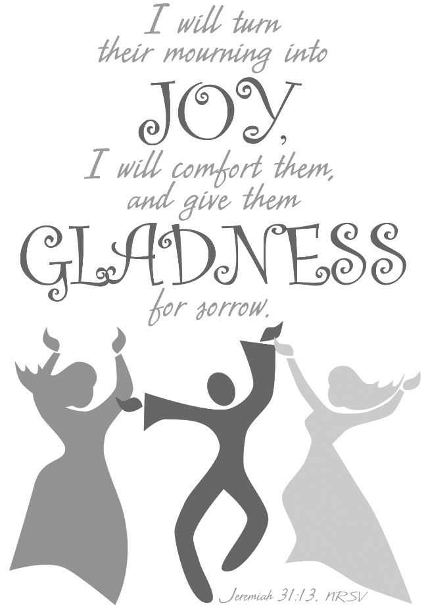

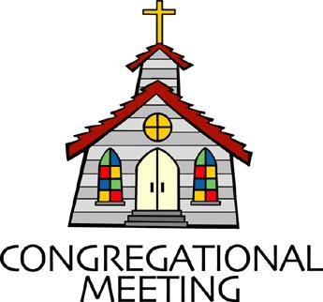
October 24, 2021 - 10:30 am

WELCOME VISITORS! We're glad you are here! Cards at the ends of each pew are for you to fill out and drop in the Offering Plate. Please let us know you are visiting, and join us for refreshments and fellowship following the service. The Sanctuary has an induction loop system to assist the hearing impaired. The system will also work on the telephone setting of hearing aids.

Springfield Presbyterian Church is rooted in the gospel of Jesus Christ, led by the Holy Spirit, and called to loving relationships through vibrant worship and service. Valuing all people, we are committed to developing disciples and fostering stewardship.
PREPARATION FOR THE WORD
(* those who are able are invited to stand)

PRELUDE

GATHERING OF THE PEOPLE

The Lord be with you! And also with you! (Greeting)

LIGHTING THE CHRIST CANDLE
Leader: Whenever we light this candle we proclaim:
People: Christ is the Light of the world and the center of our lives.

CALL TO WORSHIP [Psalm 126]
Leader: When the Lord restored the fortunes of Zion, we were like those who dream.
People: Then our mouths were filled with laughter and our tongues with shouts of joy;
Leader: Then it was said among the nations, “The Lord has done great things for them.”
People: Yes, the Lord has done great things for us, and we rejoiced.
Leader: Restore our fortunes, O Lord,
People: And may those who sow in tears now reap with shouts of joy.
Leader: May those who go out weeping, bearing the seed for sowing, instead come home with shouts of joy.
ALL: Let us worship our God who turns our sorrow into joy! Amen!

* HYMN Here in This Place (Gather Us In) #401

Here in the place the new light is streaming; now is the darkness vanished away; see in this space our fears and our dreamings brought here to you in the light of this day. Gather us in, the lost and forsaken; gather us in, the blind and the lame; call to us now, and we shall awaken; we shall arise at the sound of our name.

We are the young, our lives are a mystery. We are the old who yearn for your face. We have been sung throughout all of history, called to be light in the whole human race.
Gather us in, the rich and the haughty; gather us in, the proud and the strong; give us a heart, so meek and so lowly; give us the courage to enter the song.

Here we will take the wine and the water; here we will take the bread of new birth. Here you shall call your sons and your daughters, call us anew to be salt for the earth.
Give us to drink the wine of compassion; give us to eat the bread that is you; nourish us well, and teach us to fashion live that are holy and hearts that are true.

Not in the dark of buildings confining, not in some heaven, light years away: here in this place the new light is shining; now is the kingdom, and now is the day.
Gather us in and hold us forever; gather us in and make us your own; gather us in, all peoples together, fire of love in our flesh and our bone.

PRAYER OF CONFESSION
Generous God, in these days, it can be hard to still have faith and look towards a hopeful future. We are embroiled in global health concerns, the health of our planet, and the conflict we see locally, nationally, and globally. Yet, you ask us to continue to look toward your promises that you have made from the beginning of time. Forgive us when we forget those promises, that covenant that you made with your people from long ago. Renew us and restore us to a people who look to the future with hearts that look to how we can be the people you are calling us to be in the here and now. Amen.

SILENT PRAYERS OF CONFESSION

RESPONSE Hear My Prayer, O God Tune #782
Hear my prayer, O God, and listen to my plea;
Faithful, righteous One, give ear and answer me.

WORDS OF ASSURANCE
Leader: Your mercies are from everlasting to everlasting, never failing, sustained through all time.
People: In God’s great mercy, we are forgiven! Thanks be to God! Amen!

* MUSICAL RESPONSE OF PRAISE O My Soul, Bless Your Redeemer
Bless your Maker, all you creatures, ever under God’s control,
All throughout God’s vast dominion; bless the Lord of all, my soul!

* THE PEACE The peace of Christ be with you! And also with you!
(You may greet those around you.)

* RESPONSE Here I Am, Lord
Here I am, Lord, Is it I, Lord? I have heard you calling in the night.
I will go, Lord, if you lead me. I will hold your people in my heart.

THE PROCLAMATION OF THE WORD

PRAYER OF ILLUMINATION
O Lord our God, your Word is a lamp to our feet and a light to our path. Give us grace to receive your truth in faith and love, that we may be obedient to your will and live always for your glory; through Jesus Christ our Savior. Amen.

FIRST SCRIPTURE LESSON Psalm 34
¹ I will bless the Lord at all times; his praise shall continually be in my mouth. ² My soul makes its boast in the Lord; let the humble hear and be glad. ³ O magnify the Lord with me, and let us exalt his name together. ⁴ I sought the Lord, and he answered me, and delivered me from all my fears. ⁵ Look to him, and be radiant; so your faces shall never be ashamed. ⁶ This poor soul cried, and was heard by the Lord, and was saved from every trouble. ⁷ The angel of the Lord encamps around those who fear him, and delivers them. ⁸ O taste and see that the Lord is good; happy are those who take refuge in him. ⁹ O fear the Lord, you his holy ones, for those who fear him have no want. ¹⁰ The young lions suffer want and hunger, but those who seek the Lord lack no good thing. ¹¹ Come, O children, listen to me; I will teach you the fear of the Lord. ¹² Which of you desires life, and covets many days to enjoy good? ¹³ Keep your tongue from evil, and your lips from speaking deceit. ¹⁴ Depart from evil, and do good; seek peace, and pursue it.
¹⁵ The eyes of the Lord are on the righteous, and his ears are open to their cry. ¹⁶ The face of the Lord is against evildoers, to cut off the remembrance of them from the earth. ¹⁷ When the righteous cry for help, the Lord hears, and rescues them from all their troubles. ¹⁸ The Lord is near to the broken-hearted, and saves the crushed in spirit.
¹⁹ Many are the afflictions of the righteous, but the Lord rescues them from them all. ²⁰ He keeps all their bones; not one of them will be broken. ²¹ Evil brings death to the wicked, and those who hate the righteous will be condemned. ²² The Lord redeems the life of his servants; none of those who take refuge in him will be condemned.

SECOND SCRIPTURE LESSON Jeremiah 31:7-14
⁷ For thus says the Lord: Sing aloud with gladness for Jacob, and raise shouts for the chief of the nations; proclaim, give praise, and say, ‘Save, O Lord, your people, the remnant of Israel.’ ⁸ See, I am going to bring them from the land of the north, and gather them from the farthest parts of the earth, among them the blind and the lame, those with child and those in labor, together; a great company, they shall return here.
⁹ With weeping they shall come, and with consolations I will lead them back, I will let them walk by brooks of water, in a straight path in which they shall not stumble; for I have become a father to Israel, and Ephraim is my firstborn. ¹⁰ Hear the word of the Lord, O nations, and declare it in the coastlands far away; say, ‘He who scattered Israel will gather him, and will keep him as a shepherd a flock.’ ¹¹ For the Lord has ransomed Jacob, and has redeemed him from hands too strong for him. ¹² They shall come and sing aloud on the height of Zion, and they shall be radiant over the goodness of the Lord, over the grain, the wine, and the oil, and over the young of the flock and the herd; their life shall become like a watered garden, and they shall never languish again.
¹³ Then shall the young women rejoice in the dance, and the young men and the old shall be merry. I will turn their mourning into joy, I will comfort them, and give them gladness for sorrow. ¹⁴ I will give the priests their fill of fatness, and my people shall be satisfied with my bounty, says the Lord.

Leader: Hear what the Spirit is saying to the Church.
All: Thanks be to God.

SERMON Better Days Ahead Rev. Becca Crate-Price

THE RESPONSE TO THE WORD

* HYMN I Will Come to You (You Are Mine) #177
I will come to you in the silence,
I will lift you from all your fear.
You will hear my voice, I claim you as my choice.
Be still and know I am here.
Refrain:
Do not be afraid, I am with you.
I have called you each by name.
Come and follow me, I will bring you home;
I love you and you are mine.

I am hope for all who are hopeless,
I am eyes for all who long to see.
In the shadows of the night, I will be your light.
Come and rest in me. [Refrain]

I am strength for all the despairing,
Healing for the ones who dwell in shame.
All the blind will see, the lame will all run free,
And all will know my name. [Refrain]

I am the word that leads all to freedom,
I am the peace the world cannot give.
I will call your name, embracing all your pain.
Stand up, now walk and live! [Refrain]

PASTORAL PRAYER AND THE LORD’S PRAYER

ANTHEM

PRESENTATION OF TITHES AND OFFERINGS
* PRAYER OF DEDICATION

* HYMN Come! Live in the Light! (We Are Called) #749

Come! Live in the light! Shine with the joy and the love of the Lord.
We are called to be light for the kingdom, to live in the freedom of the city of God.

Refrain:
We are called to act with justice; we are called to love tenderly;
We are called to serve one another, to walk humbly with God.

Come! Open your heart! Show your mercy to all those in fear!
We are called to be hope for the hopeless so hatred and violence will be no more. [Refrain]

Sing! Sing a new song! Sing of that great day when all will be one!
God will reign, and we’ll walk with each other as sisters and brothers united in love. [Refrain]

* CHARGE AND BENEDICTION
Leader: Take us from this place,
People: With new eyes for the future.
Leader: Even when the vision seems too big or too overwhelming,
People: Help us to lean upon your promises.
Leader: Guide us as we take new steps,
People: To be the church for today.

* UNISON AMEN

POSTLUDE

Sunday October 31, 2021 Lectionary
Deuteronomy 6:1-9; Psalm 119:1-8; Hebrews 9:11-14; Mark 12:28-34
Assisting in Worship: We appreciate those who serve:

Today 10/24 Next Week 10/31
Sunday Opener Barbara Cornell Jennifer Wise
Greeters & Ushers Don Vasbinder & Steve & Donna
Connie Robinson Mazer
Lay Leader Sharon Pappas Bob Steppling
Fellowship Need Volunteer Need Volunteer

Happy Birthday! October 23 – Connie Robinson
October 27 – Amy Vasbinder

Happy Anniversary! October 24 – Patty & Phil Salmon

Announcements

Fellowship: Following the Worship service, we will gather downstairs for fellowship, but will not have food and will continue to wear our masks. We, as a Session, have made this decision out of an abundance of caution and the desire to keep our family of Christ safe and healthy.

Noisy Offering: Save your spare change for our last Noisy Offering for the year on October 31. The four offerings collected this year will be combined and sent to Murdered and Missing Indigenous Women (MMIWUSA), an organization that advocates to end violence against Native women and seeks to draw attention to the high rates of disappearances and murders of Native women and girls.

Congregational Care / Mission & Outreach: The Congregational Care/Mission & Outreach Committee would like your help. As we emerge from this pandemic, there is a greater than usual need to make every effort to connect with one another. Do you know of a member or friend of our church family who is ill, needs prayers, would like call, a visit or a card, or might benefit from meal train? If so, please contact the Church Office (410-795-6152), Cathy Marsh (410-549-6916) or Diana Steppling (862-266-2242).

Prayers & Thanksgivings

~ Continued prayers for Jim Nickell and the Nickell family as Jim faces significant worsening health issues.

Today:
Sunday October 24
10:30 am Worship
11:30 am Fellowship

This Week:
Wednesday October 27
6:30 pm Bell Choir Practice
7:45 pm Adult Choir Practice

Looking Ahead:
Sunday October 31
10:30 am Worship
11:30 am Fellowship

Office Hours: Tuesday, Wednesday & Friday
Springfield Presbyterian Church

10:30 am Worship
11:30 am Fellowship
Website: www.springfield-church.org Church Office: 410-795-6152
Like us on Facebook: www.facebook.com/SpringfieldPresbyterianChurch
Pastor: Rev. Becca Crate
Email: springfieldpastor@gmail.com
Clerk of Session: Sharon Pappas
Minister of Music: Linda Caviglia
Accompanist: Aaron Thacker Organist: Jennifer Wise
Youth Group Coordinators: Charles & Deb Sperling
Sunday School Coordinator: Connie Robinson
Administrative Assistant: Donna Mazer e-mail: spc.office@verizon.net

