(Large Print)

Springfield Presbyterian Church (USA)
7300 Spout Hill Road, Sykesville, MD 21784 410-795-6152

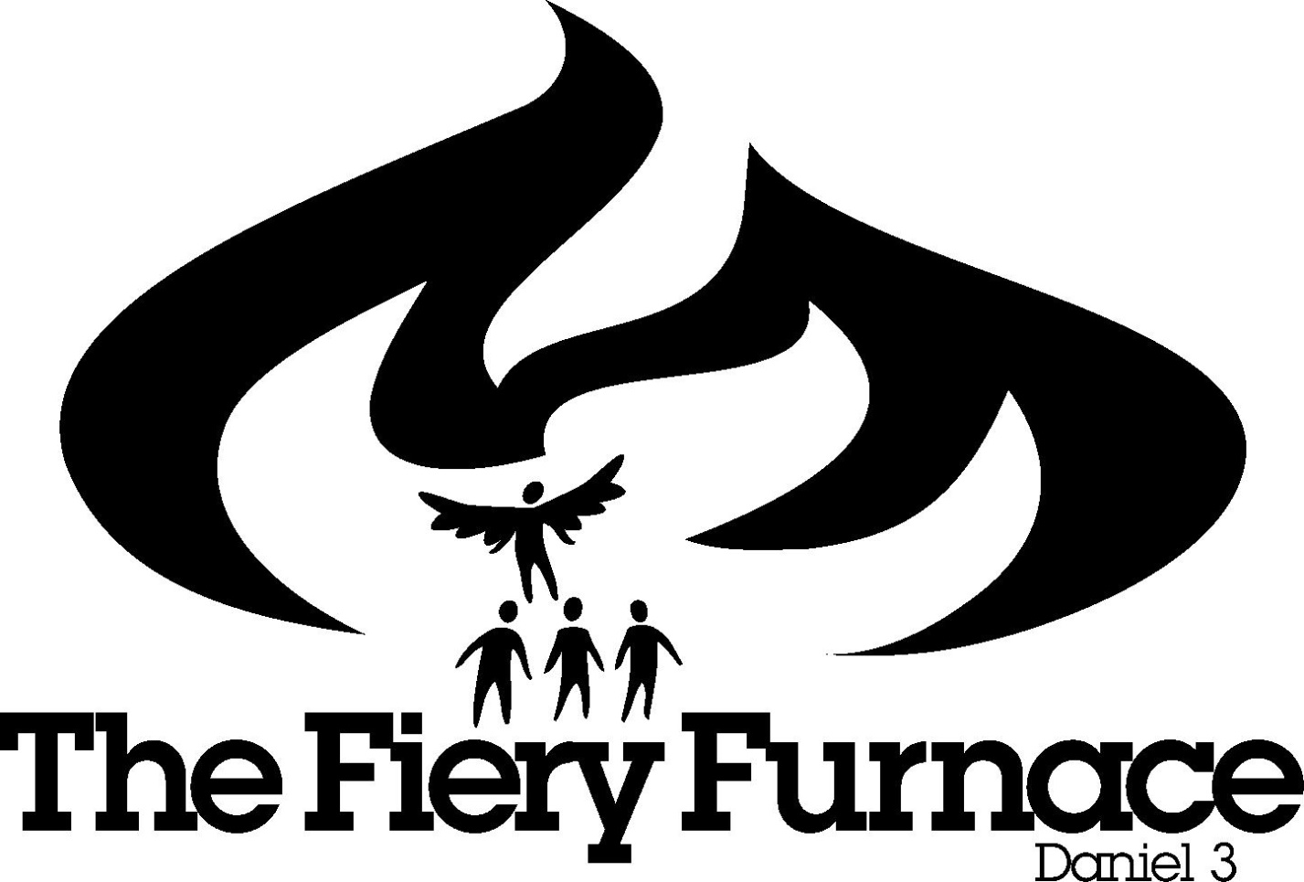

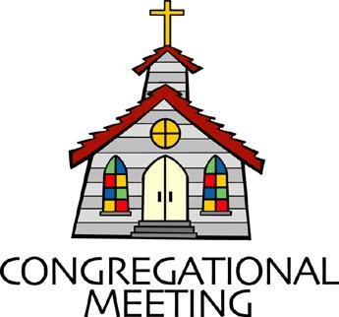
September 23, 2018 - 10:30 am

WELCOME VISITORS! We're glad you are here! Cards at the ends of each pew are for you to fill out and drop in the Offering Plate. Please let us know you are visiting, and join us for refreshments and fellowship following the service. The Sanctuary has an induction loop system to assist the hearing impaired. The system will also work on the telephone setting of hearing aids. A head set is available upon request.

Springfield Presbyterian Church is rooted in the gospel of Jesus Christ, led by the Holy Spirit, and called to loving relationships through vibrant worship and service. Valuing all people, we are committed to developing disciples and fostering stewardship.

PREPARATION FOR THE WORD
(* those who are able are invited to stand)

Please prepare for worship by listening to the music of the Prelude.

PRELUDE

GATHERING OF THE PEOPLE

The Lord be with you! And also with you! (Greeting)

LIGHTING THE CHRIST CANDLE
Leader: Whenever we light this candle we proclaim:
People: Christ is the Light of the world and the center of our lives.

INTROIT Come, Now is the Time to Worship By. B. Doerksen

CALL TO WORSHIP
Leader: People of God, God calls your name. Come and worship as this Lord’s Day begins.
All: All of us. Young and old. Sister, brother, parent, child. Neighbor and stranger.
Leader: Again and again, God calls. Come and worship.
All: All of us. The glad and the hurting. The lost and the searching. The faithful and the doubting.
Leader: From a whisper to a shout. Come and worship!
All: All of us. Word arrangers and finger-painters. Number crunchers and belly laughers. Slow walkers and rope jumpers. Quiet listeners and soul singers.
Leader: Here in this place, a new light is streaming. God is beckoning. Come, and worship. Come home.
All: All of us. Here and now, today and forever: Let us worship God.
* HYMN Gather Us In

Here in this place, new light is streaming,
Now is the darkness vanished away,
See in this space our fears and our dreamings,
Brought here to you in the light of this day.
Gather us in - the lost and forsaken, gather us in - the blind and the lame; call to us now, and we shall awaken, we shall arise at the sound of our name.

We are the young - our lives are a myst’ry,
We are the old - who yearn for your face,
We have been sung throughout all of hist’ry,
Called to be light to the whole human race.
Gather us in - the rich and the haughty, gather us in - the proud and the strong; give us a heart so meek and so lowly, give us the courage to enter the song.

Not in the dark of buildings confining,
Not in some heaven, light-years away,
But here in this place the new light is shining,
Now is the Kingdom, now is the day.
Gather us in and hold us forever, gather us in and make us your own;
Gather us in - all peoples together, fire of love in our flesh and our bone.

PRAYER OF CONFESSION
Leader: O God, you gather us to be a sign of your kingdom in the world, and sometimes this happens.
All: With the Holy Spirit guiding us, the poor are lifted up, lives are transformed, the course of history is changed for the better.
Leader: But too often, O God, we conform to the world’s expectations, not yours.

All: Comfortable and familiar, we forget who we are. Focused on institutional success, we neglect our discipleship, lost in the day’s worries, we forget your gifts surrounding us, ready to be savored, ready to be shared.
Leader: Lord, in your mercy, forgive us.
All: Strengthen and renew us to be signs of your love, and to work alongside your Spirit to mend the world’s frayed places, starting with our own. Amen.

SILENT PRAYERS OF CONFESSION

RESPONSE The Lone, Wild Bird
O search me, God, my heart reveal, renew my life, my spirit heal;
For I am yours, I rest in you, Great Spirit, come, rest in me, too.

ASSURANCE OF PARDON
God lifts us up; heals our wounds; comforts and consoles and forgives our sins! God calls us blessed, and so we are blessed. For this and for all God’s mercies, thanks be to God! Amen.

* MUSICAL RESPONSE OF PRAISE From All That Dwell Below the Skies
From all that dwell below the skies, let the Creator’s praise arise: Alleluia! Alleluia!
Let the Redeemer’s name be sung, through every land, in every tongue.
Alleluia! Alleluia! Alleluia! Alleluia! Alleluia!

* THE PEACE The peace of Christ be with you! And also with you!
(You may greet those around you.)

* RESPONSE Here I Am, Lord
Here I am, Lord, Is it I, Lord? I have heard you calling in the night.
I will go, Lord, if you lead me. I will hold your people in my heart.
THE PROCLAMATION OF THE WORD

FIRST SCRIPTURE LESSON Daniel 3:19-30
¹⁹Then Nebuchadnezzar was so filled with rage against Shadrach, Meshach, and Abednego that his face was distorted. He ordered the furnace to be heated up seven times more than was customary, ²⁰and ordered some of the strongest guards in his army to bind Shadrach, Meshach, and Abednego and to throw them into the furnace of blazing fire. ²¹So the men were bound, still wearing their tunics, their trousers, their hats, and their other garments, and they were thrown into the furnace of blazing fire. ²²Because the king’s command was urgent and the furnace was so overheated, the raging flames killed the men who lifted Shadrach, Meshach, and Abednego. ²³But the three men, Shadrach, Meshach, and Abednego, fell down, bound, into the furnace of blazing fire. ²⁴Then King Nebuchadnezzar was astonished and rose up quickly. He said to his counsellors, ‘Was it not three men that we threw bound into the fire?’ They answered the king, ‘True, O king.’ ²⁵He replied, ‘But I see four men unbound, walking in the middle of the fire, and they are not hurt; and the fourth has the appearance of a god.’ ²⁶Nebuchadnezzar then approached the door of the furnace of blazing fire and said, ‘Shadrach, Meshach, and Abednego, servants of the Most High God, come out! Come here!’ So Shadrach, Meshach, and Abednego came out from the fire. ²⁷And the satraps, the prefects, the governors, and the king’s counsellors gathered together and saw that the fire had not had any power over the bodies of those men; the hair of their heads was not singed, their tunics were not harmed, and not even the smell of fire came from them. ²⁸Nebuchadnezzar said, ‘Blessed be the God of Shadrach, Meshach, and Abednego, who has sent his angel and delivered his servants who trusted in him. They disobeyed the king’s command and yielded up their bodies rather than serve and worship any god except their own God. ²⁹Therefore I make a decree: Any people, nation, or language that utters blasphemy against the God of Shadrach, Meshach, and Abednego shall be torn limb from limb, and their houses laid in ruins; for there is no other god who is able to deliver in this way.’ ³⁰Then the king promoted Shadrach, Meshach, and Abednego in the province of Babylon.

SECOND SCRIPTURE LESSON Deuteronomy 5:14-15
¹⁴But the seventh day is a sabbath to the Lord your God; you shall not do any work—you, or your son or your daughter, or your male or female slave, or your ox or your donkey, or any of your livestock, or the resident alien in your towns, so that your male and female slave may rest as well as you. ¹⁵Remember that you were a slave in the land of Egypt, and the Lord your God brought you out from there with a mighty hand and an outstretched arm; therefore the Lord your God commanded you to keep the sabbath day.

Leader: Hear what the Spirit is saying to the Church.
All: Thanks be to God.

TIME WITH YOUNG PEOPLE

SERMON On Fire for God Rev. Dr. Karen Brown

THE RESPONSE TO THE WORD

* HYMN Your Faithfulness, O Lord, Is Sure

Your faithfulness, O Lord, is sure, in all your words, your gracious deeds;
You gently lift all burdened souls, and well provide for all our needs.

The eyes of all are fixed on you; by you their wants are all supplied;
Your open hand is bountiful, and every soul is satisfied.

Lord, you are just in all your ways, and kind in everything you do;
Forever near you stand to hear, and help all those who call on you.

My mouth shall speak your praise, O Lord, my soul shall bless your holy name;
Let all things living join in song of praise, from age to age the same.

PASTORAL PRAYER AND THE LORD’S PRAYER
“For this I pray to God.” / “For this I give thanks to God.”
Congregational Response: “Hear our prayer, O God.”

PRESENTATION OF TITHES AND OFFERINGS
OFFERTORY Healing Rain By Michael W. Smith
* SONG OF THANKS Take My Life
Take my silver and my gold, not a mite would I withhold;
Take my intellect and use, every power as Thou shalt choose,
Every power as Thou shalt choose.
* PRAYER OF DEDICATION

* HYMN Arise, Your Light Is Come!

Arise, your light is come! The Spirit’s call obey;
Show forth the glory of your God, which shines on you today.

Arise, your light is come! Fling wide the prison door;
Proclaim the captives’ liberty, good tidings to the poor.

Arise, your light is come! All you in sorrow born,
Bind up the broken-hearted ones, and comfort those who mourn.

Arise, your light is come! The mountains burst in song!
Rise up like eagles on the wing; God’s power will make us strong.

* CHARGE AND BENEDICTION

* UNISON AMEN

POSTLUDE

Assisting in Worship: We appreciate those who serve:

Today 9/23 Next Week 9/30
Sunday Opener Jennifer Wise Kay Freas
Greeters & Ushers Don Vasbinder & Steve Mazer &
Charlie Sperling Bob Rogers
Lay Leader Diana Steppling Barbara Cornell
Sunday School Connie Robinson Connie Robinson
Fellowship Barbara Nickell Barbara Cornell &
Shona Klein

Church Attendance: September 9 - 43 September 16 - 35

Church Cleaning: October 5, 6 or 7 - The Anderson Family

Happy Birthday! September 25 - Julie Ballard

Sunday September 30 Lectionary
Esther 7:1-6, 9-10; 9:20-22; Psalm 124; James 5:13-20; Mark 9:38-50
Announcements
We welcome Rev. Karen Brown to our pulpit today!

Peace and Global Witness: TODAY and on October 7 we receive your Peace and Global Witness offering. This offering is used to engage in peacemaking and build ministries of reconciliation around the world. Half goes to Presbyterian Mission Agency, 25% to Mid Councils for their programs, and 25% remains with local congregations. The Mission/Outreach team decided to again send our portion to LSC America’s Partner for Equal Justice, providing legal aid to those living in poverty in our country, 1.8 million including 40,000 veterans.

Presbyterian Disaster Assistance: Presbyterian Disaster Assistance programs are responding to Hurricane Florence relief efforts and are still working in older areas like the California mudslides, Guatemala volcano, and many other events. See their website at https://pda.pcusa.org/situations/national/ for updates on their work. If you are able, make a note on your donation check and it will be sent along to PDA. There is a line item in our Church budget for PDA and congregational donations will be added to that.

Dakota Presbytery: On October 21 during Worship, Chrystie Adams, the Chair of the Baltimore Dakota Steering Committee will be making a presentation about the unique relationship between Baltimore Presbytery and the Dakota Presbytery. The Dakota Presbytery is comprised of all Native American congregations representing the Eastern Sioux (Dakota) and the Western Sioux (Lakota) Nations. Chrystie will be available during fellowship to answer any questions arising from her presentation.

Newsletter Deadline: The deadline for submissions for the October newsletter is TODAY. Please email your information to spc.office@verizon.net.

Weekly Announcements: If you have an announcement to include with next week’s bulletin, please call the Office at 410-795-6152 or email to spc.office@verizon.net by Wednesday each week.

Prayers & Thanksgivings
~ Prayers of thanksgiving for the birth of Harrison Joseph Rachin, born to Brittany and Danny Rachin on Monday, September 17!
~ Prayers of strength and healing for Charlie Sperling’s mom, Judy Sperling, who is facing very aggressive cancer.
~ Prayers of strength and comfort for Joy Barwick and her grandson, Dylan, while Dylan’s medical problems are addressed.
~ Prayers for Brenda McClung’s mom, Liz Old, who is in Copper Ridge Rehab.
~ Prayers of quick healing for Dr. Elwood LaBrosse, in Fairhaven Health Center.
~ Prayers for Hope Presbyterian from our Ministry Group.

The Congregational Care team wants to know what YOU or someone you know needs...a visit...a call...a meal. Please contact Kay Freas or Connie Robinson.

Today:
Sunday September 23 - Peace & Global Witness Offering
9:00 am Red Sea Parting Practice
10:30 am Worship & Sunday School
11:30 am Fellowship
This Week:
Tuesday September 25
10:30 am Prayer Group (Manse)
Wednesday September 26
6:30 pm Bell Choir Practice
7:45 pm Adult Choir Practice

Looking Ahead:
Sunday September 30 - Peace & Global Witness Offering
10:30 am Worship & Sunday School
11:30 am Fellowship
12:00 noon Worship Committee Meeting (Library)
Monday October 1
4:30 pm C.I.A. Meeting (Manse)
Wednesday October 3
6:30 pm Bell Choir Practice
7:45 pm Adult Choir Practice

Office Hours: Tuesday, Wednesday, Friday 9:00 am - 3:00 pm
Springfield Presbyterian Church

10:30 am Worship
11:30 am Fellowship
Website: www.springfield-church.org Church Office: 410-795-6152
Like us on Facebook: www.facebook.com/SpringfieldPresbyterianChurch
Pastor: Rev. Becca Crate
Email: springfieldpastor@gmail.com
Clerk of Session: Sharon Pappas
Minister of Music: Linda Caviglia
Accompanist: Aaron Thacker Organist: Jennifer Wise
Youth Group Coordinators: Charles & Deb Sperling
Sunday School Coordinator: Connie Robinson
Administrative Assistant: Donna Mazer
e-mail: spc.office@verizon.net

